 | SDG 15.4.1  SDG 15 Life on Land  Water discharge guidelines and standards  Mariano Marcos State University · THE Sustainability Impact Ratings 2027
The question
Have water quality standards and guidelines for water discharges (to uphold water quality in order to protect ecosystems, wildlife, and human health and welfare).
1 Introduction
MMSU’s commitment is to take an active role in protecting and promoting sustainable use of terrestrial ecosystems, responsible land use, and biodiversity conservation. A duty to protect university waters, backed by a monitored aquifer on the MMSU Farm.
2 Body
2.1 Groundwater Quality Monitoring at the MMSU Farm
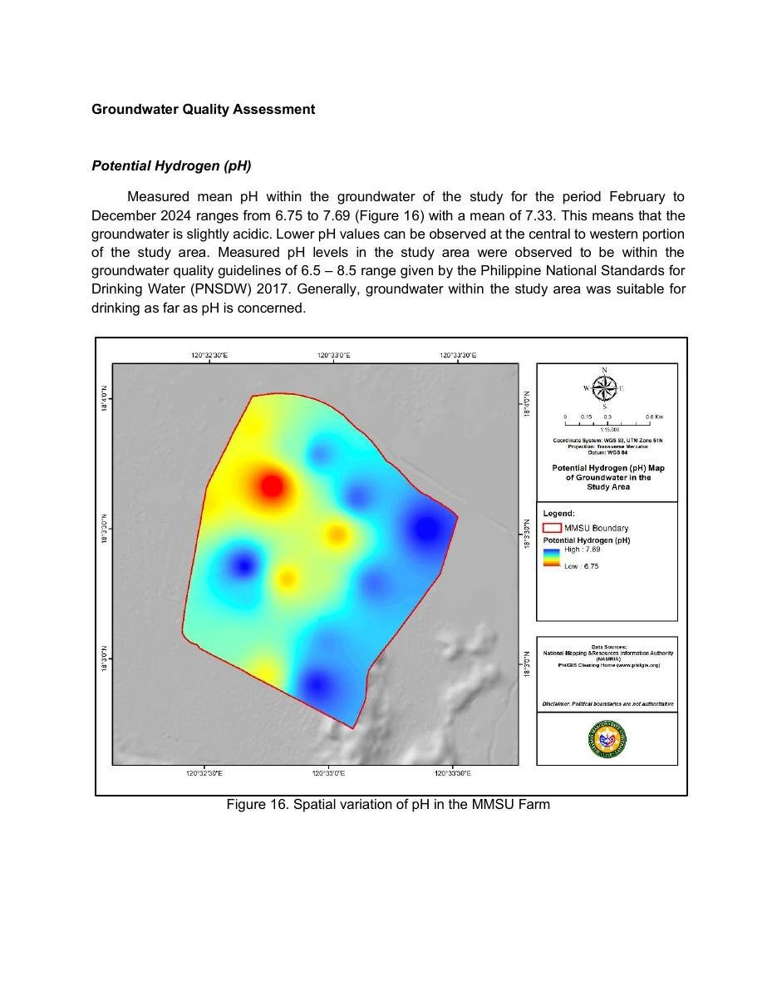
Document: Groundwater Quality Assessment of the MMSU Farm, spatial variation of pH (monitoring through June 2025).

Through June 2025, MMSU continued monthly monitoring of 17 groundwater wells on the MMSU Farm, measuring pH, total dissolved solids, electrical conductivity, chloride and nitrate-nitrogen and comparing the results with the Philippine National Standards for Drinking Water (2017). The assessment, covering February 2024 to June 2025, flags wells with persistently high dissolved solids, which rose again from January to May 2025, for continued monitoring to guide water resource management and prevent further degradation of groundwater quality.
Mean pH from February to December 2024 ranged from 6.75 to 7.69, within the 6.5–8.5 guideline of the national drinking water standards. Small campus reservoirs also collect rainwater, reduce flooding and recharge groundwater.
Resources 1
2.2 Memorandum No. 26-370 Institutionalizes MMSU’s Environmental Compliance and Hazardous Waste Procedures
Ongoing programme · 30 September 2026
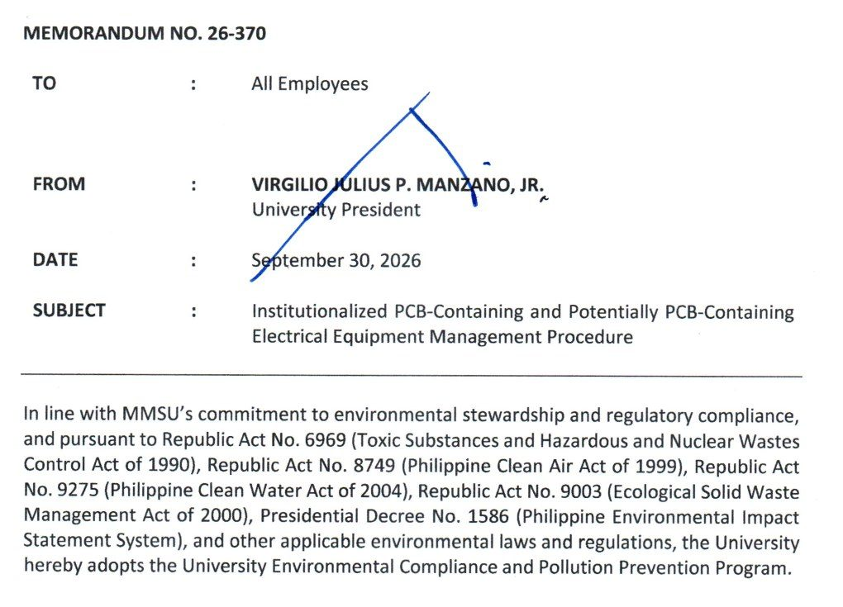  Document: Office of the President Memorandum No. 26-370, 30 September 2026, adopting the University Environmental Compliance and Pollution Prevention Program. | 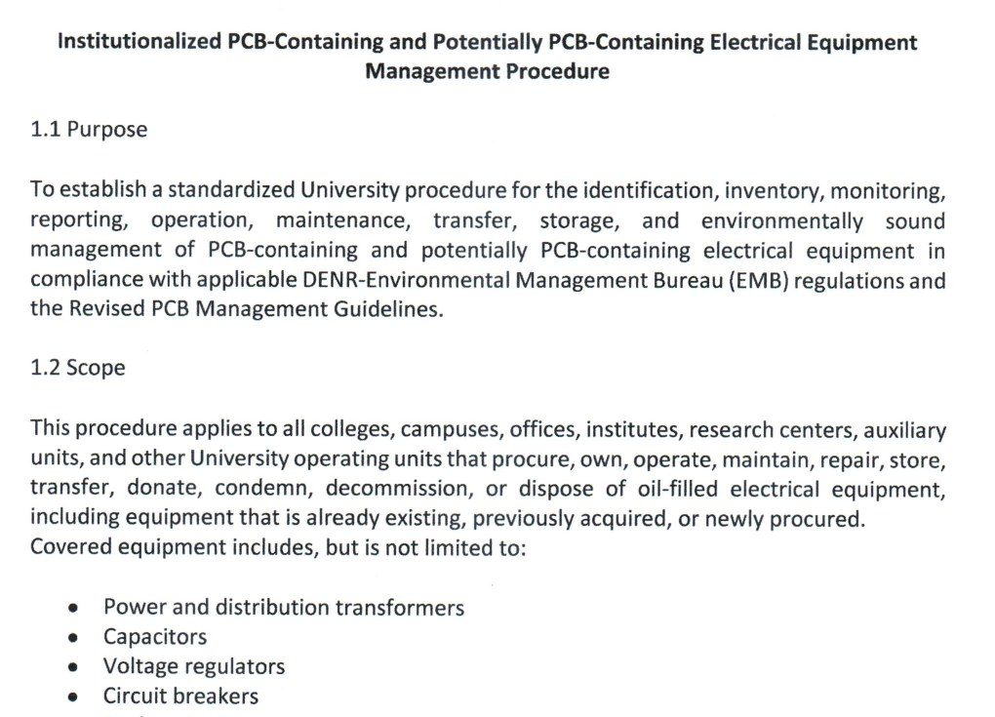  Document: attached procedure for PCB-containing and potentially PCB-containing electrical equipment (purpose, scope and inventory), Memorandum No. 26-370.

Policy | Memorandum No. 26-370, University Environmental Compliance and Pollution Prevention Program
Approved by | University President Virgilio Julius P. Manzano Jr.
Reference no. | 26-370
Date | 30 September 2026
Provisions | Environmental Compliance Procedures; PCB-containing equipment procedure

On September 30, 2026, University President Virgilio Julius P. Manzano Jr. issued Memorandum No. 26-370 to all employees, adopting the University Environmental Compliance and Pollution Prevention Program under Republic Act 6969 (Toxic Substances and Hazardous and Nuclear Wastes Control Act), Republic Act 8749 (Clean Air Act), Republic Act 9275 (Clean Water Act), Republic Act 9003 (Ecological Solid Waste Management Act) and Presidential Decree 1586 (Environmental Impact Statement System). The memorandum covers the management of hazardous wastes, wastewater, air emissions, solid wastes and chemicals, together with permits, monitoring, reporting and inspections required by the Department of Environment and Natural Resources – Environmental Management Bureau (DENR-EMB), and directs all offices, colleges, laboratories, research units and auxiliary enterprises to comply with the attached Environmental Compliance Procedures.
The attached procedure for PCB-containing and potentially PCB-containing electrical equipment, such as transformers, capacitors, voltage regulators, circuit breakers, reclosers and oil-filled switches, requires every unit to inventory its equipment and submit the inventory to the Sustainability and Futures Thinking (SFT) Office. The SFT Office validates the inventory, keeps the university’s central PCB inventory and the DENR-EMB online PCB inventory, ensures labelling, conducts inspections and annual inventory validation, and prepares the reports required by DENR-EMB. No covered equipment may be relocated, transferred, repaired through oil handling, decommissioned, condemned or disposed of without the SFT Office’s written clearance, and PCB wastes and equipment may be disposed of only through DENR-accredited transporters, treaters and disposal facilities. The SFT Office keeps hazardous waste manifests and certificates of treatment or disposal among its records.
Resources 2
2.3 MMSU Water Policy Protects University Waters from Pollution
Policy · Sirmata 2040 (2021) and Integrated Pollution and Waste Management Program (revised 2020)
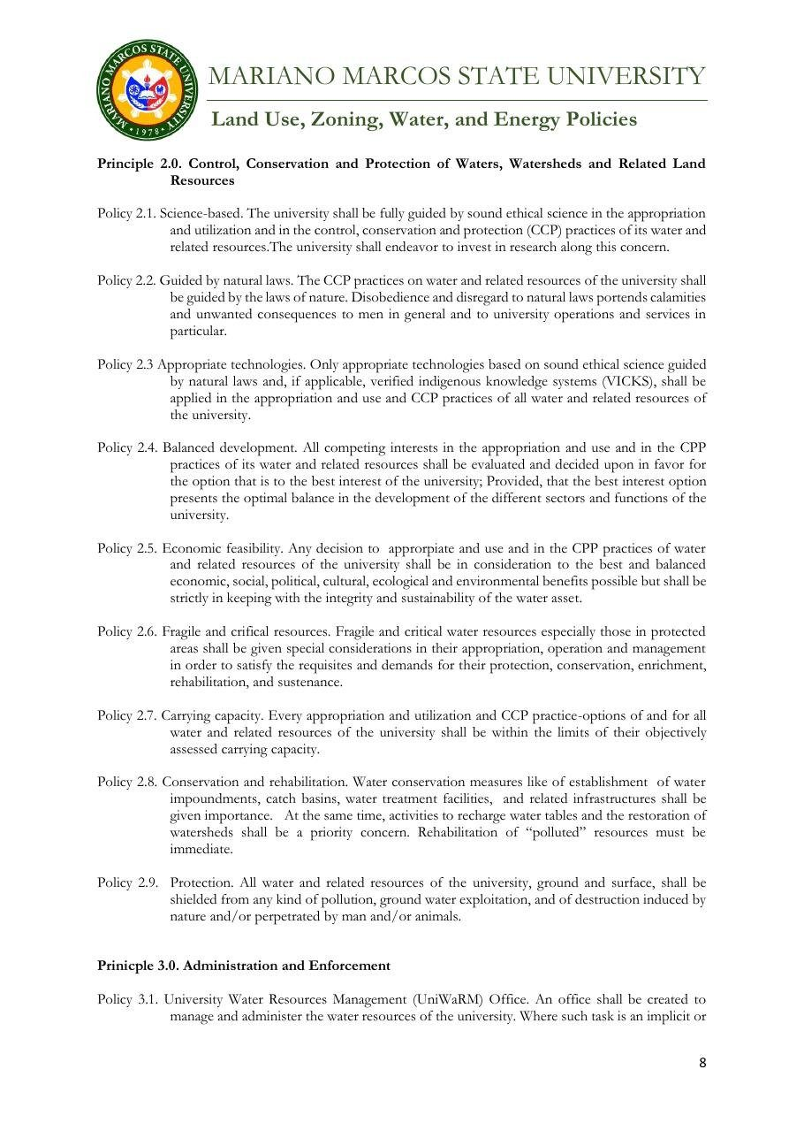
Document: MMSU Water Policy, control, conservation and protection of waters (Policies 2.6–2.9), Sirmata 2040 LUDIP.

Policy | MMSU Water Policy (Sirmata 2040 LUDIP) and Integrated Pollution and Waste Management Program
Date | Water Policy 2021; IPWMP revised 2020.
Provisions | Water Policy 2.6–2.9 (2.9 protection from pollution; 2.8 rehabilitation); IPWMP registration for wastewater discharge (RA 9275)

MMSU’s Water Policy under Sirmata 2040, based on the Water Code of the Philippines and its 2005 implementing rules, requires that “all water and related resources of the university, ground and surface, shall be shielded from any kind of pollution” (Policy 2.9) and that the rehabilitation of polluted resources be immediate, giving importance to water impoundments, catch basins and water treatment facilities (Policy 2.8).
The university’s Integrated Pollution and Waste Management Program also provides for registration as a hazardous waste generator for wastewater discharge from agro-industrial facilities such as the piggery, in compliance with Republic Act 9275, the Philippine Clean Water Act.
Resources 3, 4, 5
3 Conclusion
The Water Policy shields university waters from pollution, the pollution programme provides for registering wastewater from agro-industrial facilities, and 17 farm wells are monitored month by month.
4 Resources
1. MMSU, Groundwater Quality Assessment of the MMSU Farm (monitoring February 2024 – June 2025). https://www.mmsu.edu.ph/resources/15g9Xtys7q3Rujd0-CZvPH4OHTdJ1__Z8/data
2. MMSU Office of the President, Memorandum No. 26-370, “Institutionalized PCB-Containing and Potentially PCB-Containing Electrical Equipment Management Procedure,” 30 September 2026
3. MMSU, Land Use, Zoning, Water and Energy Policies (Sirmata 2040 LUDIP, 2021). https://www.mmsu.edu.ph/resources/19uycXrgcO_iXPdPpMQwdCRxmoD1U5i60/view
4. MMSU, Revised Integrated Pollution and Waste Management Program. https://www.mmsu.edu.ph/resources/1fNUCZwyOozOKO27L2Bm6pNN-P_cJNpLd/view
5. MMSU, Water Discharge Management (SDG 15 page). https://www.mmsu.edu.ph/resources/1l8foDfenNc7xpKp8wM8XShfZT58YyjSH/data

