 | SDG 15.2.5  SDG 15 Life on Land  Sustainable management of land for agriculture  Mariano Marcos State University · THE Sustainability Impact Ratings 2027
The question Offer educational programme/outreach for local or national communities on sustainable management of land for agriculture.
1 · Introduction
MMSU’s commitment is to take an active role in protecting and promoting sustainable use of terrestrial ecosystems, responsible land use, and biodiversity conservation. Four channels to the farmer: radio, village training, demonstration plots and on-farm practice.
2 · Body
2.1 · School-on-the-Air Brings Regenerative Vegetable Farming to 1,000 Ilocanos
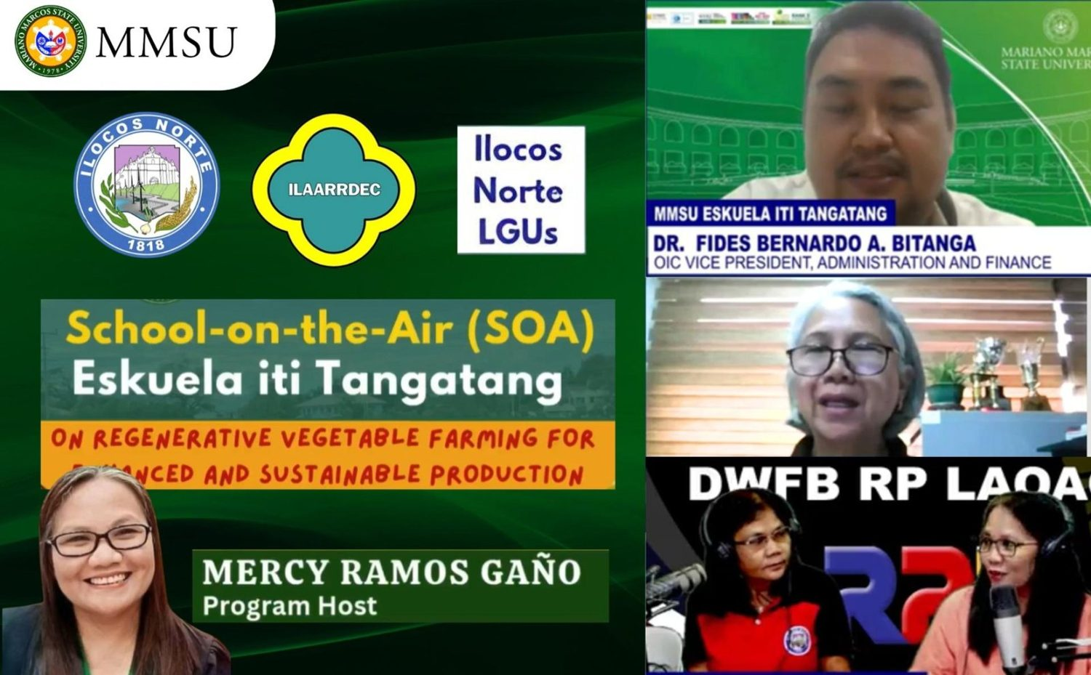
MMSU School-on-the-Air (Eskuela iti Tangatang) season on regenerative vegetable farming, June–December 2025. (Image: MMSU)

A new season of the MMSU School-on-the-Air (SOA), the university’s radio-based educational program, opened on June 24 and 25, 2025 with 1,000 enrollees from the 22 municipalities and cities of Ilocos Norte. The season focused on regenerative vegetable farming for enhanced and sustainable production, with lessons on climate-smart practices and off-season vegetable seeding.
Vegetable growers, rural improvement club members, agricultural extension workers and students followed the lessons, broadcast from June to December 2025 over DWFB Radyo Pilipinas Laoag, DWCI Radyo Adjo Piddig and DWNI Radyo Karruba Burgos. MMSU ran the program with the Provincial Government of Ilocos Norte, the Office of the Provincial Agriculturist, local government units, the Ilocos Agriculture, Aquatic and Natural Resources Research and Development Consortium, and the High-Value Crops Division of Ilocos Norte.
Resources: 1
2.2 · Parambak ditoy MMSU 2025 Showcases Extension Technologies for Farmers
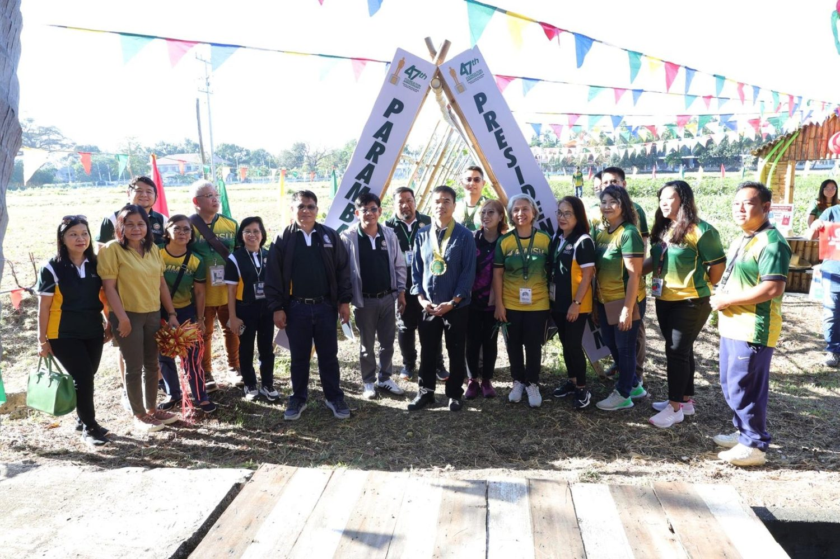
7th Parambak ditoy MMSU, in front of CAFSD, 14 February 2025. (Photo: MMSU STRATCOM)

On February 14, 2025, to close its 47th Foundation Anniversary, MMSU held the 7th Parambak ditoy MMSU in front of the College of Agriculture, Food and Sustainable Development, highlighting the impact of its extension and research programmes on community development and agricultural innovation. Thirty-seven exhibitors took part, including learning sites of the Agricultural Training Institute–Ilocos Region, Magsasaka Siyentista (farmer scientists), Balik-Probinsya beneficiaries and local government units, and the Research Directorate gave a speed talk on MMSU technologies such as off-season tomato and shallot production, Bolinao chicken, indigenous vegetables and black garlic.
Participants harvested fresh vegetables at the President’s Farm, 17 new partners of the Extension Directorate received certificates of appreciation, and beneficiaries shared how MMSU’s technologies had supported sustainable agriculture. Attendees included the Provincial Government of Ilocos Norte, LGUs, non-government organisations, farmer leaders, entrepreneurs and MMSU-assisted beneficiaries. Incoming President Virgilio Julius P. Manzano Jr. urged the units concerned to sustain sustainable farming practices.
Resources: 2
2.3 · Bamboo Propagation and Plantation Management Training in Pinili
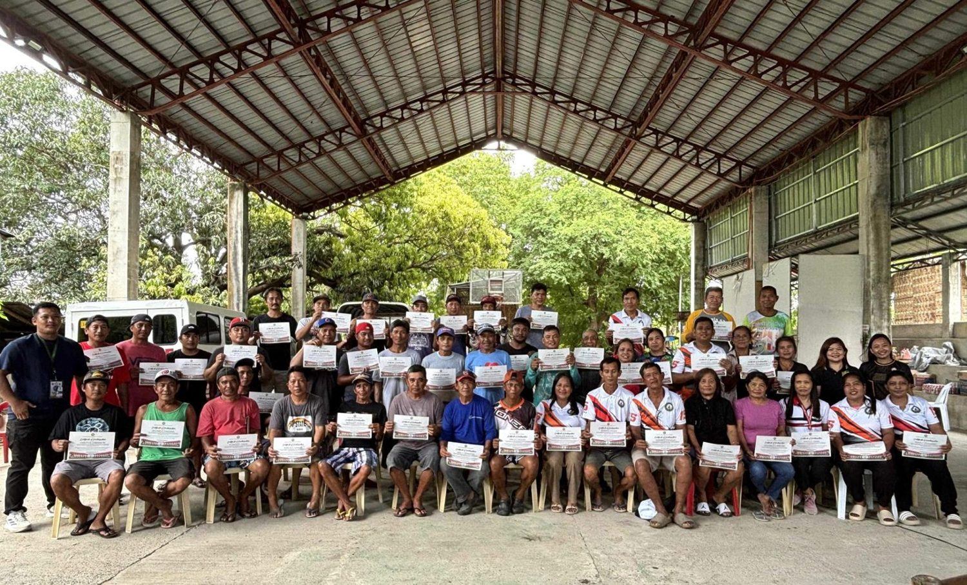
Participants of the bamboo propagation, nursery and plantation management training, Brgy. Aglipay, Pinili, 2025. (Photo: MMSU)

The MMSU Extension Directorate and the College of Agriculture, Food and Sustainable Development, in partnership with Barangay Aglipay, Pinili, Ilocos Norte, and with the support of the Ilocos Agriculture, Aquatic and Natural Resources Research and Development Consortium (ILAARRDEC), conducted a two-day training on bamboo production in 2025.
The training equipped 46 farmers, local leaders and community members with practical skills in bamboo propagation, nursery establishment and plantation management. Lectures covered the prospects of the bamboo industry and MMSU’s propagation methods, and participants helped establish a new bambusetum, a collection of bamboo species, in Barangay Aglipay. Lectures and demonstrations were given by bamboo experts Mr. Charlie Maine Cacactin of CAFSD and Mr. Bonne Jovie Orteza of MMSU. Pinili Municipal Agriculturist Philip Galang, representing Mayor Rommel T. Labasan, thanked MMSU and ILAARRDEC, and the project was championed in the community by Pinili’s Magsasaka Siyentista, Mr. Reynaldo Antalan.
Resources: 3
2.4 · Vermicast Facility Helps Pasuquin Onion Farmers Restore Degraded Soils
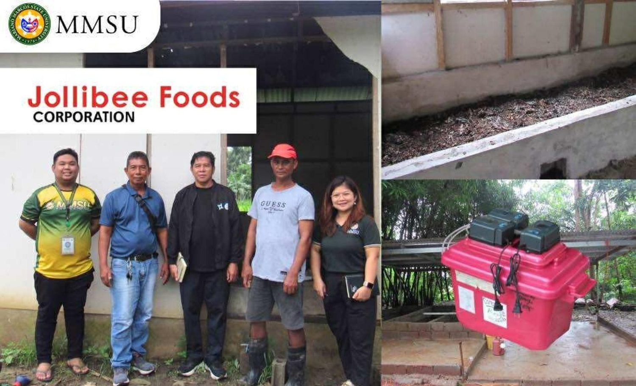
Pilot vermicomposting facility of Pasuquin white onion farmers, 2025. (Photo: MMSU STRATCOM)

In 2025, white onion farmer-leaders Mr. Marcos Palacay and Mr. Markflor Valdez of the Ayat ti Pasuquin Farmer and Irrigators Association established a pilot vermicomposting facility in Pasuquin, Ilocos Norte, under the Agri-Tech Facilitator Program of the Farmers Entrepreneurship Program of MMSU and the Jollibee Group Foundation. The facility uses African night crawlers (Eudrilus eugeniae) to convert biodegradable farm waste into vermicast, an organic fertilizer that improves soil structure, stimulates microbial activity and reduces the need for chemical inputs.
The project responds to soil degradation from prolonged reliance on chemical fertilizers, which the farmers linked to poor soil conditions and low seedling survival, and promotes sustainable solutions for white onion farming in the area.
Resources: 4
2.5 · Pasuquin Onion Farmers Trained on Good Agricultural Practices
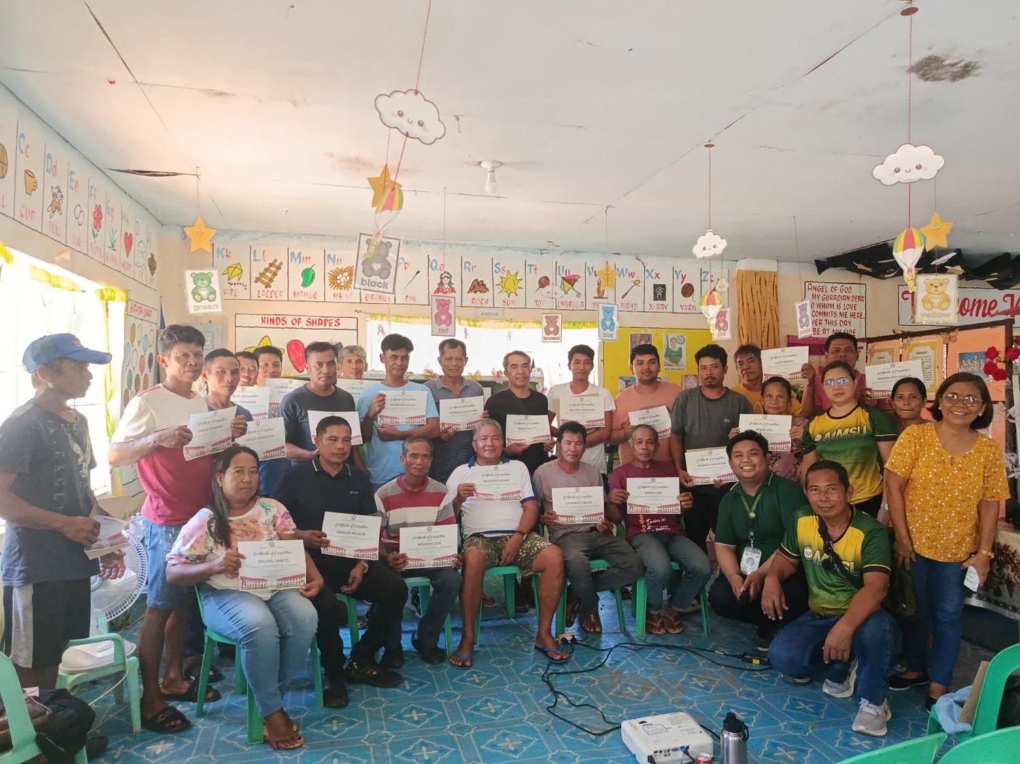
Pre-Dispersal Training on White Onion Production, Pasuquin Municipal Hall, 12 November 2025. (Photo: MMSU STRATCOM)

On November 12, 2025, the Municipality of Pasuquin, MMSU and the Jollibee Group Foundation conducted a Pre-Dispersal Training on White Onion Production at the Pasuquin Municipal Hall for farmer beneficiaries of the San Juan Icas Manuel Farmers’ Association. The training covered white onion production technology, good agricultural practices (GAP) and proper farm recording for sustainable and profitable farming.
Farmer participation in the project has doubled from 15 to 30 beneficiaries, with a collective production target of 200 tons of white onion for 2025. The Office of the Provincial Agriculturist provides seeds and planting materials, complementing MMSU’s technical support and capacity development.
Resources: 5
2.6 · President’s Farm Field Day Showcases Climate-Resilient Rice Varieties
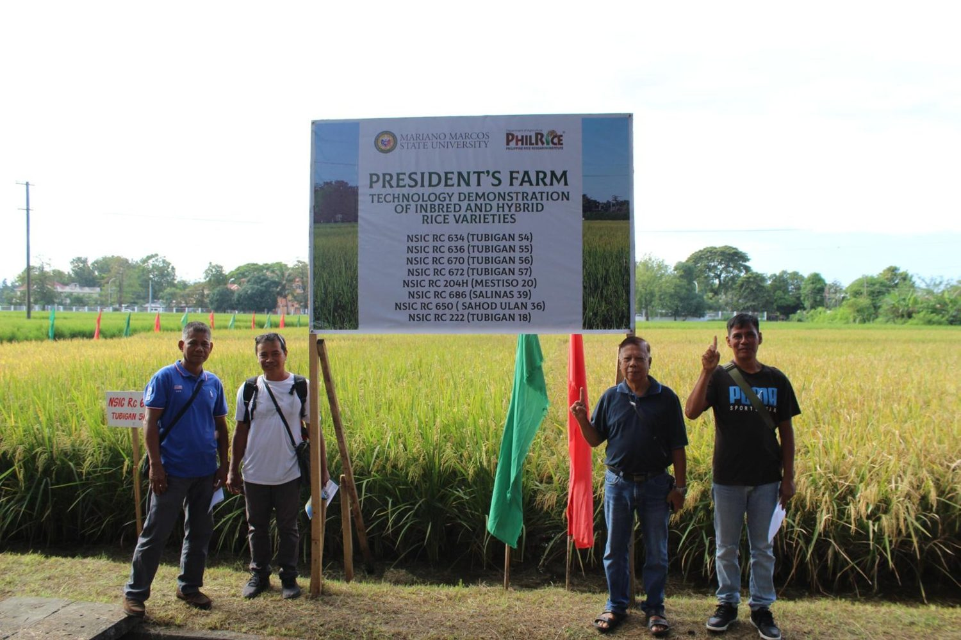  President’s Farm technology demonstration of inbred and hybrid rice varieties, 28 October 2025. (Photo: MMSU) | 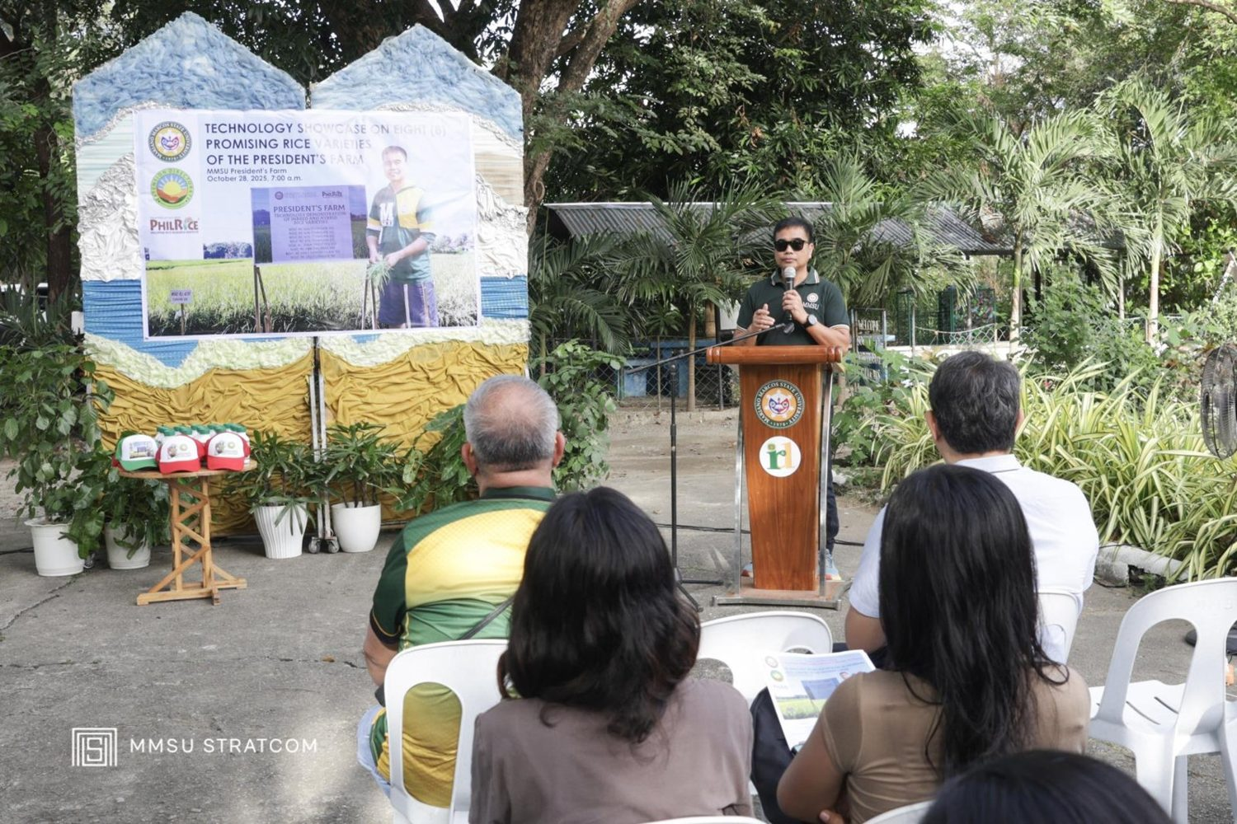  Farmers, LGU technicians and students at the President’s Farm Field Day, in front of CAFSD. (Photo: MMSU)

On October 28, 2025, the MMSU Extension Directorate, with the Philippine Rice Research Institute (PhilRice) Batac Branch, held the President’s Farm Field Day: A Technology Showcase in front of the College of Agriculture, Food and Sustainable Development. Farmers and farmer-leaders, agricultural technicians from Ilocos Norte local government units, BS Agriculture students, and MMSU and PhilRice rice specialists viewed eight rice varieties grown under wet-season conditions.
The varieties included four newly released by PhilRice, two public hybrids, and two suited to saline and rainfed conditions, among them NSIC Rc 686 (Salinas 39) and NSIC Rc 650 (Sahod Ulan 36), giving farmers options for saline-affected and rainfed fields. Speakers included MMSU President Dr. Virgilio Julius P. Manzano Jr., Extension Director Dr. Marlowe Aquino, and former MMSU President and PhilRice Executive Director Dr. Santiago R. Obien.
Resources: 6
2.7 · Science High School Students Learn Sustainable Farming at MMSU’s Demonstration Farm
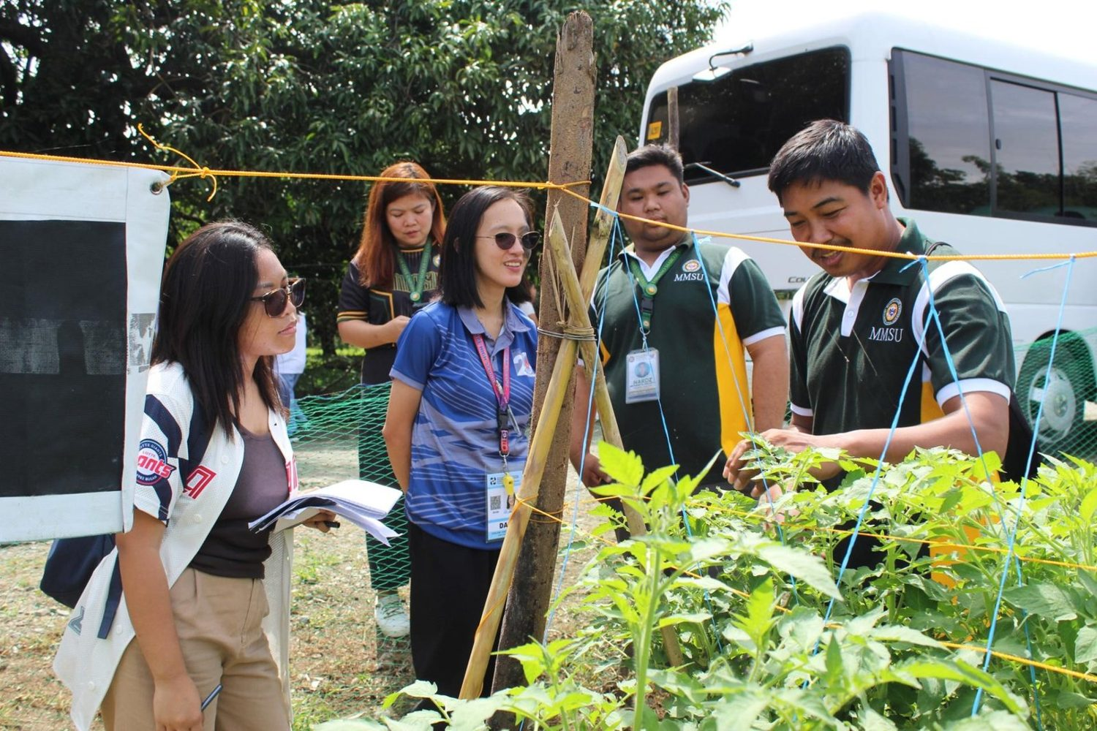
PSHS-Ilocos Region Campus students at the MMSU Technology Demonstration Farm, Sarrat, 19 September 2025. (Photo: MMSU STRATCOM)

On September 19, 2025, 59 Grade 11 and 12 students of the Philippine Science High School–Ilocos Region Campus visited MMSU’s Technology Demonstration Farm in Sta. Magdalena, Sarrat, as part of their community immersion program “The Science of Survival: A Community-Based Exploration,” held during National Biotechnology Week. After an orientation at the ILAARRDEC One-Stop Information Shop at MMSU, Extension Director Dr. Marlowe Aquino discussed the role of biotechnology in agriculture and MMSU’s hybrid off-season tomato varieties, and the students observed sustainable farming practices on site.
Resources: 7
2.8 · MMSU Leads Soil Health Research for Rice-Based Cropping Systems
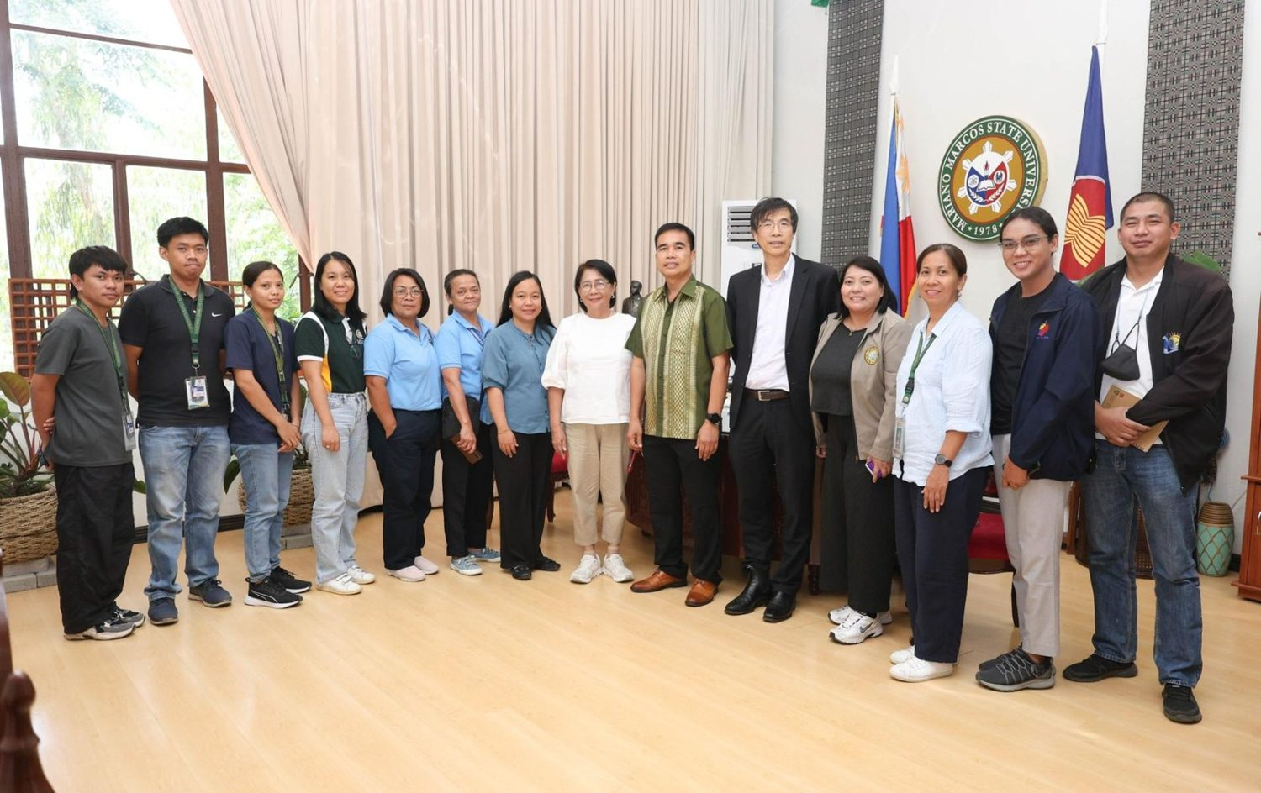
Kick-off meeting of the soil health management project with Griffith University and provincial agriculturists, 16 June 2025. (Photo: MMSU STRATCOM)

In 2025, MMSU became a key partner in a five-year research program led by Griffith University in Australia and funded by the Australian Centre for International Agricultural Research (ACIAR) and DOST-PCAARRD to develop soil knowledge, information and capacity for more productive and sustainable cropping systems in the Philippines (Project SLaM 2023/146). MMSU President Virgilio Julius P. Manzano Jr. pledged the university’s commitment at the inception meeting held March 24–26, 2025 in Balanga City, Bataan.
MMSU leads the project on enhancing the productivity of rice-based cropping systems in Ilocos Norte, Tarlac and Bataan through soil health management. Led by Dr. Janet Villamor, it evaluates nutrient management practices and develops yield-calibrated soil health indices for rice-garlic, rice-rice and rice-onion systems. The kick-off meeting on June 16, 2025 at the MMSU Center for Flexible Learning brought together Griffith University, the country project manager and the provincial agriculturists of Ilocos Norte, Bataan and Tarlac, with visits to project sites in Batac, Vintar and Pasuquin.
Resources: 8, 9
3 · Conclusion
Over the air to 1,000 enrollees in all 22 municipalities and cities, and in village trainings, field days and demonstration farms, MMSU carries regenerative and climate-smart farming to where farmers work.
4 · Resources
1. MMSU News, “MMSU draws 1K enrollees for SOA program on sustainable vegetable farming,” 26 June 2025. https://www.mmsu.edu.ph/news/mmsu-draws-1k-enrollees-for-soa-program-on-sustainable-vegetable-farming
2. MMSU Extension Directorate, “‘Parambak’ caps MMSU@47 celebration,” February 2025. https://extension.mmsu.edu.ph/news/show/368/parambak-caps-mmsu-at-47-celebration
3. MMSU News, “Sustainable livelihood: MMSU, ILAARRDEC hold bamboo training in Pinili,” 3 September 2025. https://www.mmsu.edu.ph/news/sustainable-livelihood-mmsu-ilaarrdec-hold-bamboo-training-in-pinili
4. MMSU News, “Vermicast facility established in Pasuquin as MMSU, Jollibee Group aid onion farmers,” 1 August 2025. https://www.mmsu.edu.ph/news/vermicast-facility-established-in-pasuquin-as-mmsu-jollibee-group-aid-onion-farmers
5. MMSU News, “Pasuquin onion farmers trained by MMSU and Jollibee Group Foundation,” 18 November 2025. https://www.mmsu.edu.ph/news/pasuquin-onion-farmers-trained-by-mmsu-and-jollibee-group-foundation
6. MMSU News, “MMSU President’s Farm showcases 8 rice varieties,” 4 November 2025. https://www.mmsu.edu.ph/article/news/2665/mmsu-presidents-farm-showcases-8-rice-varieties
7. MMSU News, “PSHS-IRC students visit MMSU demo farm for sustainable farming practices,” 3 October 2025. https://www.mmsu.edu.ph/news/pshs-irc-students-visit-mmsu-demo-farm-for-sustainable-farming-practices
8. MMSU News, “MMSU tapped as key partner in enhancing PH cropping systems through soil health management,” 31 March 2025. https://www.mmsu.edu.ph/news/mmsu-tapped-as-key-partner-in-enhancing-ph-cropping-systems-through-soil-health-management
9. MMSU News, “Griffith University, MMSU launch cropping system research in Luzon,” 3 July 2025. https://www.mmsu.edu.ph/news/griffith-university-mmsu-launch-cropping-system-research-in-luzon

