 | SDG 15.3.3  SDG 15 Life on Land  Local biodiversity included in planning and development  Mariano Marcos State University · THE Sustainability Impact Ratings 2027
The question Include local biodiversity into any planning and development process (e.g. construction of new buildings).
1 · Introduction
MMSU’s commitment is to take an active role in protecting and promoting sustainable use of terrestrial ecosystems, responsible land use, and biodiversity conservation. Biodiversity built into the 20-year land plan: protected land, a no-build forest reserve and science before construction.
2 · Body
2.1 · Sirmata 2040: Planning MMSU’s Campuses and Reserve Lands for Two Decades
Plan · Sirmata 2040 LUDIP (2021), a 20-year plan
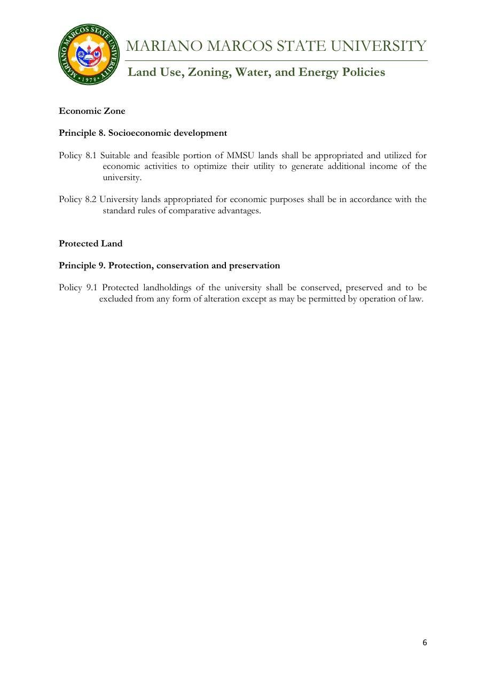
Document: MMSU Zoning Policy, Protected Land (Principle 9, Policy 9.1), Sirmata 2040 LUDIP.

Policy | Sirmata 2040: Land Use Development and Infrastructure Plan (LUDIP)
Approved by | Endorsed by the CHED Technical Working Group after validation visits.
Date | 2021 (20-year plan).
Provisions | Zoning policy, Protected Land (Policy 9.1); Forest Reserve no-build zone; Policies 7.1, 10.1 and 11.1

Sirmata 2040, MMSU’s Land Use Development and Infrastructure Plan (LUDIP), is the university’s 20-year guide for managing its land resources and infrastructure. Prepared under Republic Act 11396, which requires state universities and colleges to have a LUDIP, and supported by a Php 2 million grant from the Commission on Higher Education (CHED), the plan covers the future land use of the MMSU campuses and the university’s reserve areas in Nagbacsan, Payao, Lubbot and Sarnap, City of Batac, including the forest reserves where MMSU’s forestry and agroforestry research is set up.
Local biodiversity is built into the plan’s development rules. The zoning plan sets aside Protected Land, which “shall be conserved, preserved and to be excluded from any form of alteration except as may be permitted by operation of law” (Policy 9.1), and the MMSU Forest Reserve is kept as a no-build zone. Before any land is altered or converted, the plan requires a science-based assessment of its natural suitability and carrying capacity (Policies 7.1, 10.1 and 11.1).
The plan was developed through stakeholder consultations, sectoral studies and campus planning workshops, and was endorsed by the CHED Technical Working Group after validation visits to the campuses.
Resources: 1, 2, 3, 4
3 · Conclusion
Sirmata 2040 guides where and how the university grows, with protected land, a forest reserve closed to building and an assessment of natural suitability before land is altered.
4 · Resources
1. MMSU, Land Use, Zoning, Water and Energy Policies (Sirmata 2040 LUDIP, 2021). https://www.mmsu.edu.ph/resources/19uycXrgcO_iXPdPpMQwdCRxmoD1U5i60/view
2. MMSU, Planning and Development on Local Biodiversity (SDG 15 page). https://www.mmsu.edu.ph/resources/1tbtCaZa6Uh7ieu4epmz35VJ9jrRQGlPi/data
3. MMSU News, “CHED TWG OKs MMSU Sirmata 2040”. https://www.mmsu.edu.ph/news/ched-twg-oks-mmsu-sirmata-2040
4. MMSU News, “MMSU gets Php 2 M for LUDIP project”. https://www.mmsu.edu.ph/news/mmsu-gets-php-2-m-for-ludip-project

