 | SDG 15.3.2  SDG 15 Life on Land  Monitoring IUCN and other conservation species  Mariano Marcos State University · THE Sustainability Impact Ratings 2027
The question
Have a policy to ensure that IUCN Red List species and national conservation list species with habitats in areas affected by university operations are identified, monitored and protected.
1 Introduction
In MMSU, threatened plants have long been identified and conserved, although a species policy or register is not yet recorded. In 2003, researchers surveyed Laoag City, Batac, Pasuquin, San Nicolas and Dingras: of 124 plants that elders named as vanishing, 77 were validated, 45 as endangered and 32 as vulnerable, using IUCN criteria applied locally (this is not the IUCN Red List). A 2011 study published by SEARCA documented 46 indigenous food plants from 27 families in seven upland and remote municipalities. These findings grew into the Indigenous Food Plants Program, which protects the plants through a botanical garden, an alukon genebank at the MMSU Forest Reserve, circa situ cultivation of wild yams and community foodscapes. In 2025 it trained 64 farmers in alukon propagation and extended seedbanks to Vintar, and the Regional Development Council of Region 1 adopted it as its first research and development initiative.
2 Body
2.1 From Vanishing Plants to Regional Policy: MMSU Identifies, Conserves and Monitors Threatened Indigenous Food Plants
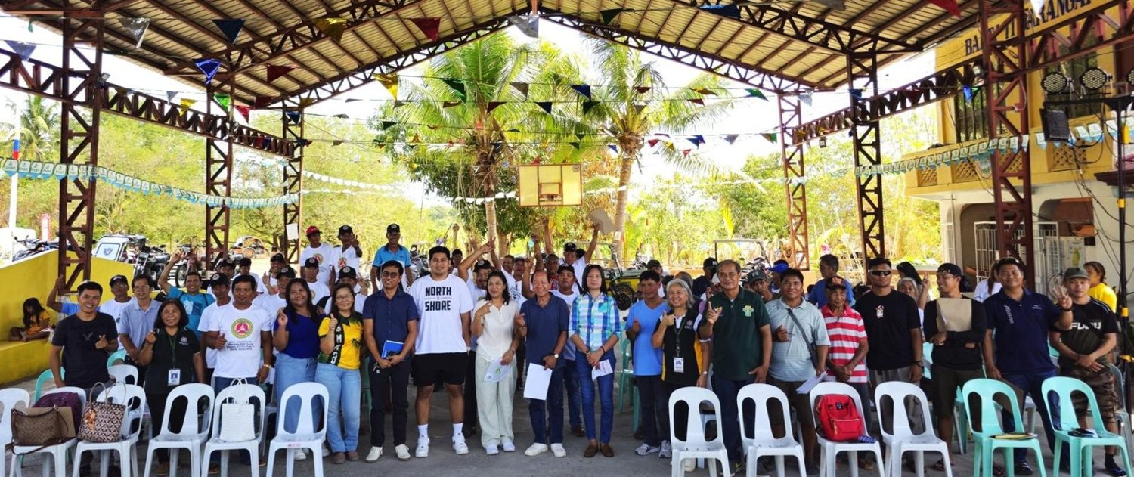  Farmers and local officials trained on alukon (himbabao) propagation, Brgy. 11 Sta. Rosa, Sarrat, 2 May 2025. (Photo: MMSU) | 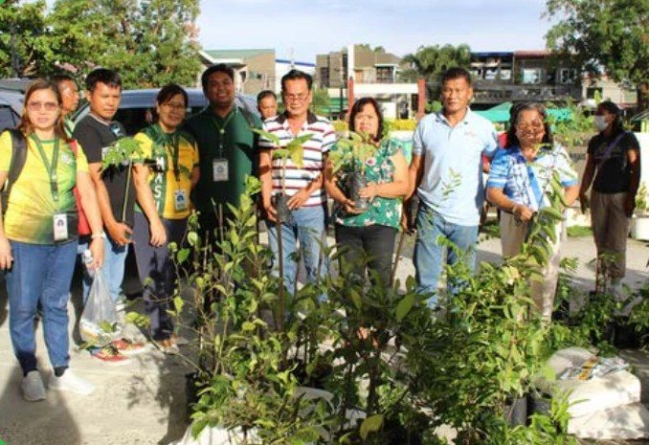  Partners receive indigenous food plant planting materials for the Community Foodscapes and Seedbanks, World Food Day 2025.

Mariano Marcos State University has long identified the plants of Ilocos Norte that are at risk of disappearing. In 2003, MMSU researchers, among them Dr. Miriam Pascua, Ms. Menisa Antonio and Dr. Dionisio Bucao, surveyed Laoag City, Batac, Pasuquin, San Nicolas and Dingras to document plants that elders perceived to be vanishing. Of the 124 plants named, 77 were validated as vanishing by the university’s agronomists and horticulturists using criteria of the International Union for Conservation of Nature (IUCN): 45 were classified as endangered and 32 as vulnerable, among them sugod-sugod (Momordica cochinchinensis), kapas-kapas and bignay (Antidesma bunius).
In 2011, the Southeast Asian Regional Center for Graduate Study and Research in Agriculture (SEARCA) published a study by MMSU researchers, “Survey and Characterization of Indigenous Food Plants in Ilocos Norte, Philippines” by Menisa A. Antonio, Rodel T. Utrera, Epifania O. Agustin, Dionisio L. Jamias, Araceli J. Badar and Miriam E. Pascua. Warning that indigenous food plants are disappearing at an alarming rate, the study documented 46 indigenous food plants from 27 plant families in seven upland and remote municipalities of Ilocos Norte, most of them wild species, recorded their identity, uses and locations, and reported that MMSU collects their germplasm and maintains it as living plants and seeds.
This work grew into MMSU’s Indigenous Food Plants (IFP) Program, led by Dr. Menisa A. Antonio of the Research Directorate, which documents IFP species in Ilocos Norte and protects them through a triad of conservation approaches: the IFP Botanical Garden (ex situ), a himbabao (alukon) genebank at the MMSU Forest Reserve, circa situ cultivation of the wild yams kamangeg and dolian, and the integration of indigenous food plants into community foodscapes. The program is also advancing omics-based molecular characterization to support their conservation and use. In 2025 it trained 64 farmers and local officials in Sarrat on the propagation of alukon (May 2, 2025) and extended its community seedbanks and foodscapes to new partner barangays in Vintar (October 2025), and its paper “From wild foods to policy innovation: MMSU’s indigenous food plants program as a model for sustainable and inclusive agriculture” won Best Paper at the 2025 SUC-ACAP Biennial Conference (August 27–29, 2025).
The IFP Program is the first research and development initiative adopted by the Regional Development Council (RDC) of Region 1, providing input for policy advocacy on the conservation and use of these species. Implementation continues: on June 6, 2026, the Philippine News Agency reported that indigenous food plants such as sugod-sugod, alokon, buga and karot are propagated at the botanical garden of the MMSU Natural Resources Conservation and Management Center and shared with schools and communities for food gardens.
Resources 1, 2, 3, 4, 5, 6
2.2 Indigenous Food Plants Propagated at the MMSU Botanical Garden Are Shared with Schools and Communities
Ongoing programme · Philippine News Agency, 6 June 2026
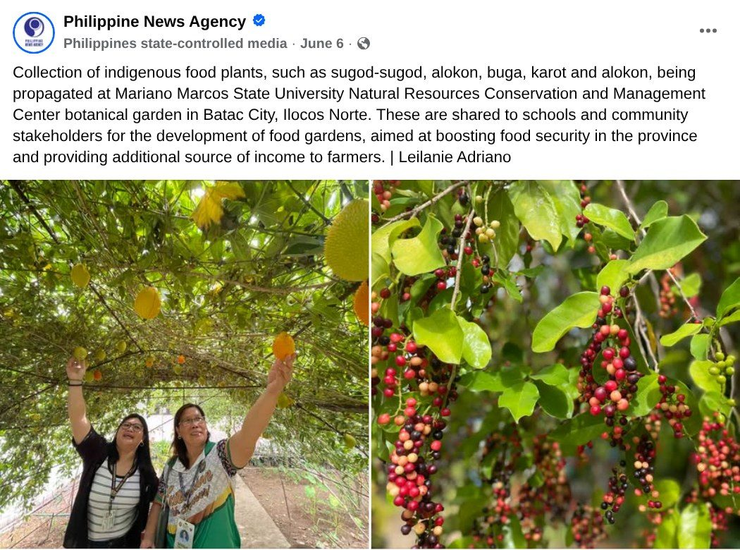  Capture: Philippine News Agency post of 6 June 2026 on indigenous food plants propagated at the MMSU NRCMC botanical garden (photos: Leilanie Adriano, PNA). | Partners receive indigenous food plant planting materials for the Community Foodscapes and Seedbanks, World Food Day 2025.

On June 6, 2026, the Philippine News Agency reported that indigenous food plants such as sugod-sugod, alokon, buga and karot are being propagated at the botanical garden of the MMSU Natural Resources Conservation and Management Center in Batac City, Ilocos Norte. The planting materials are shared with schools and community stakeholders for the development of food gardens, to boost food security in the province and provide farmers with an additional source of income.
The botanical garden is part of the ex situ arm of MMSU’s Indigenous Food Plants Program, which in 2025 extended its community foodscapes and seedbanks to new partner barangays.
Resources 6
3 Conclusion
From a 2003 survey to a regional programme, MMSU has identified vanishing plants, kept them in a botanical garden, a genebank and community seedbanks, and brought the work into regional policy.
4 Resources
1. The Philippine Star, “MMSU researchers identify vanishing plant species,” 14 September 2003. https://philstar.com/business/2003/09/14/220344/mmsu-researchers-identify-vanishing-plant-species
2. Antonio, M. A., Utrera, R. T., Agustin, E. O., Jamias, D. L., Badar, A. J. and Pascua, M. E. (2011), “Survey and Characterization of Indigenous Food Plants in Ilocos Norte, Philippines,” SEARCA Agriculture and Development Discussion Paper No. 2011-2, 61 pp. https://www.searca.org/pubs/discussion-papers?pid=130
3. MMSU Research Directorate, “MMSU research on indigenous food plants wins best paper at SUC-ACAP 2025 Conference,” 29 August 2025. https://research.mmsu.edu.ph/news/details/mmsu-research-on-indigenous-food-plants-wins-best-paper-at-suc-acap-2025-conference
4. MMSU News, “MMSU trains Sarrat farmers on alukon propagation,” 9 May 2025. https://www.mmsu.edu.ph/news/mmsu-trains-sarrat-farmers-on-alukon-propagation
5. MMSU Extension Directorate, “MMSU expands indigenous food plant seedbanks and foodscapes in LGUs,” October 2025. https://extension.mmsu.edu.ph/news/show/389/mmsu-expands-indigenous-food-plant-seedbanks-and-foodscapes-in-lgus
6. Philippine News Agency, Facebook post on indigenous food plants at the MMSU Natural Resources Conservation and Management Center botanical garden, 6 June 2026. https://www.facebook.com/pnagovph/posts/1411199747723142/

