 | SDG 15.2.4  SDG 15 Life on Land  Educational programmes on ecosystems  Mariano Marcos State University · THE Sustainability Impact Ratings 2027
The question
Offer educational programmes on ecosystems (looking at wild flora and fauna) for local or national communities.
1 Introduction
In MMSU, communities learned about the ecosystems around them in 2025. On 27–28 October, a two-day seminar-workshop trained representatives of Currimao, Pasuquin, Badoc and Burgos, with DENR-PENRO officials, in mangrove ecology, nature-based solutions, legal protection and the nursery propagation of Avicennia and Sonneratia, while the Pedada People’s Organization shared its community experience. On 2 May, 64 farmers in Barangay 11 Sta. Rosa, Sarrat, learned to propagate alukon, an indigenous vegetable tree, at the community’s request. On 3–4 December, the Information and Technology Caravan brought lectures on one-node bamboo propagation and an alukon demonstration to the Siwawer Farmers’ Festival in Vintar. In October, community foodscapes and seedbanks in San Nicolas became learning gardens for kapaskapas, alokon, pako, dalayap, wild singkamas and roselle, and the botanical garden keeps sharing planting materials with schools and communities.
2 Body
2.1 MMSU Trains Coastal Towns on Mangrove Propagation, Management and Conservation
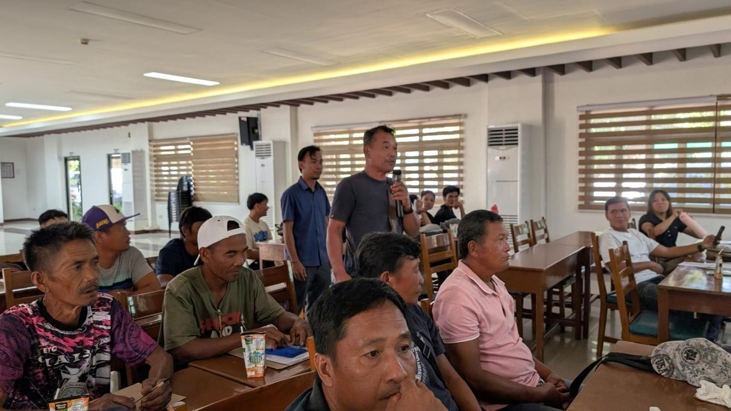  Representatives of Currimao, Pasuquin, Badoc and Burgos at the Seminar-Workshop on Mangrove Propagation, 27–28 October 2025. (Photo: MMSU) | 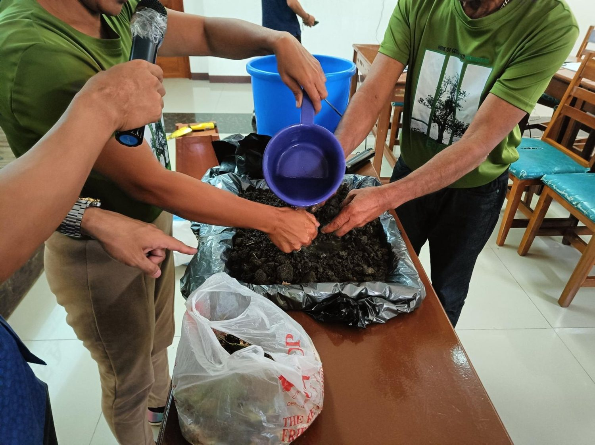  Hands-on mangrove nursery and propagation practice during the seminar-workshop. (Photo: MMSU)

MMSU conducted a two-day Seminar-Workshop on Mangrove Propagation on October 27–28, 2025 at its Center for Flexible Learning for representatives of the coastal municipalities of Currimao, Pasuquin, Badoc and Burgos, Ilocos Norte, with officials of DENR-PENRO in attendance. The training was organized under the DOST-PCAARRD-funded nature-based solutions mangrove project led by Dr. Arlene Gonzales.
Sessions covered the importance of mangrove ecosystems, nature-based solutions for conservation, legal frameworks for mangrove protection, and the roles of the academe and local government units in community-based mangrove management. Participants were also trained in nursery management and advanced propagation techniques for Avicennia and Sonneratia species and other local mangrove varieties. The Pedada People’s Organization shared its experience in establishing community-based mangrove conservation.
Resources 1
2.2 Farmers in Sarrat Trained to Propagate the Indigenous Alukon
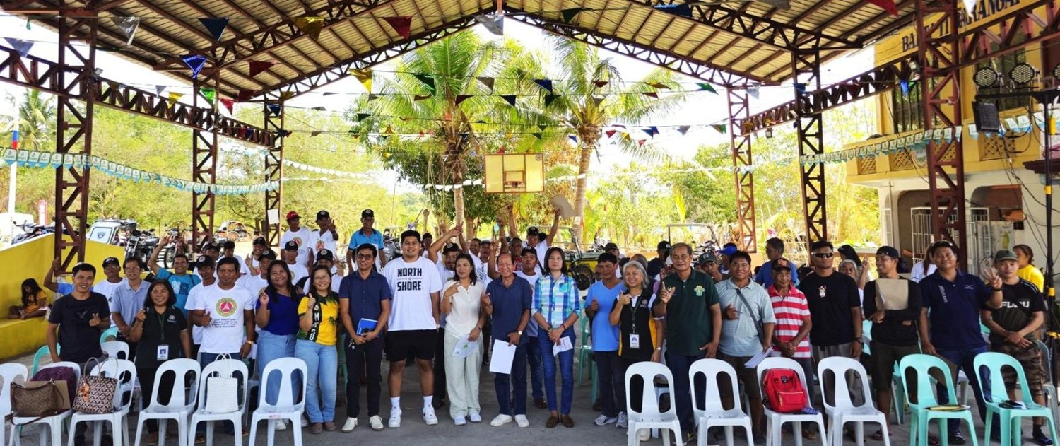
Farmers and local officials trained on alukon (himbabao) propagation, Brgy. 11 Sta. Rosa, Sarrat, 2 May 2025. (Photo: MMSU)

On May 2, 2025, the MMSU Research and Extension Directorates trained 64 farmers in Barangay 11 Sta. Rosa, Sarrat, Ilocos Norte, on the propagation of alukon (himbabao), a Philippine indigenous vegetable tree. Barangay officials, members of the Task Force Dagger Special Operations Foundation and representatives of the local government unit also attended. The training was held in response to requests from the community.
Resource speakers Dr. Menisa Antonio, Engr. Josefa Pugat and Mr. Jayson Rasay of the Research Directorate presented recommended propagation strategies to establish sustained alukon production in the community and broaden the use of the crop for food and other applications.
Resources 2
2.3 MMSU Brings Bamboo and Alukon Propagation to the 2025 Siwawer Farmers’ Festival
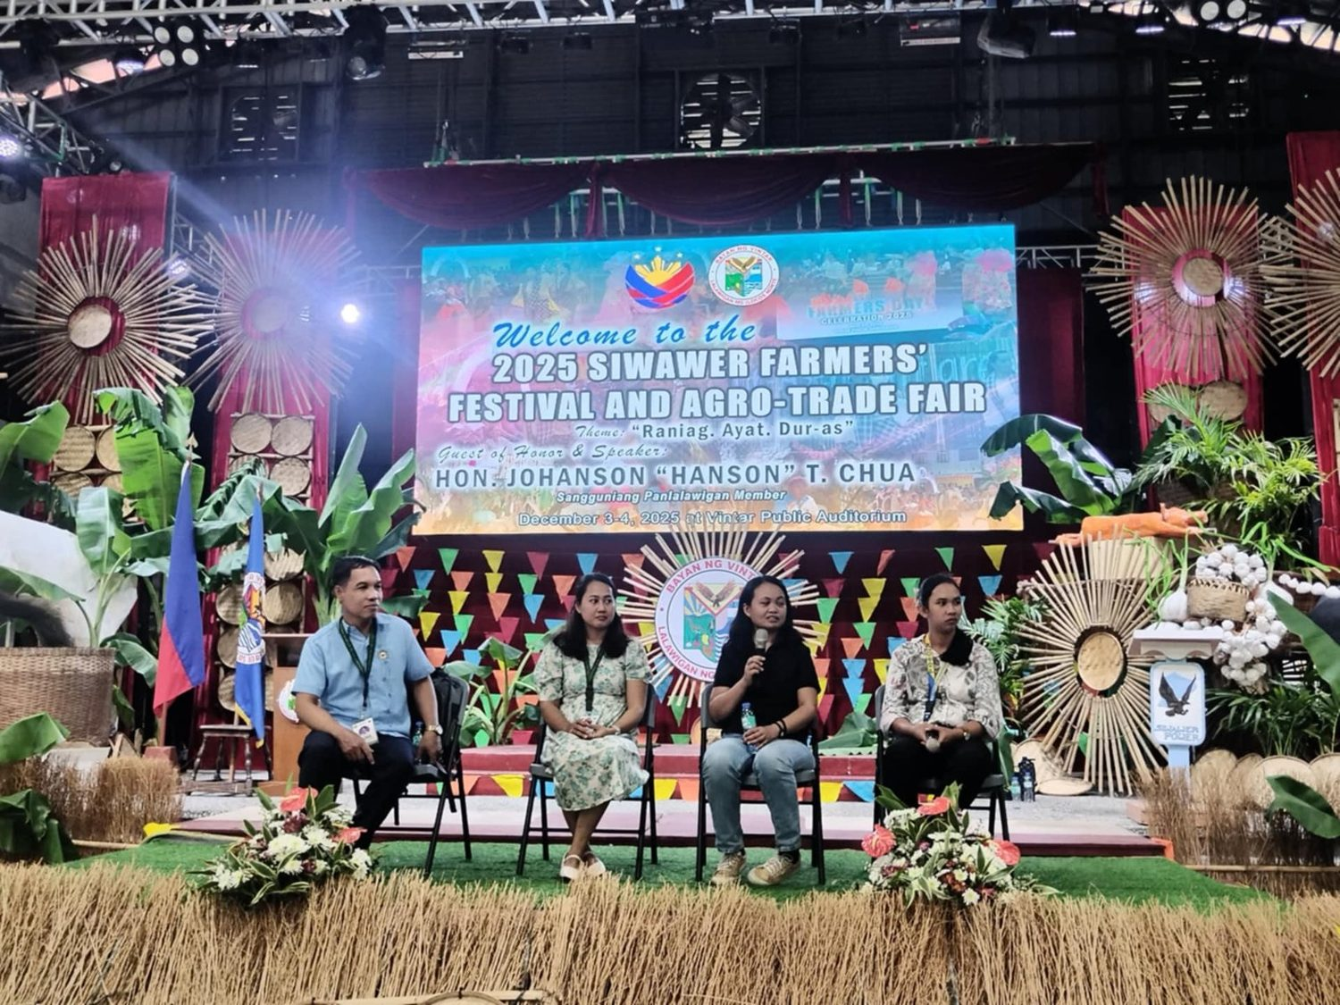
MMSU Information and Technology Caravan at the 2025 Siwawer Farmers’ Festival, Vintar, 3–4 December 2025. (Photo: MMSU STRATCOM)

Through its Information and Technology Caravan, MMSU’s Research and Extension Directorates joined the 2025 Siwawer Farmers’ Festival and Agro-Trade Fair at the Vintar Public Auditorium on December 3–4, 2025, with an exhibit of university technologies and a series of expert lectures for farmers.
Forester Shena Rose Garcia introduced sustainable bamboo production using MMSU’s one-node cutting technology, and the second day featured a demonstration on the propagation of alukon, an indigenous vegetable tree, facilitated by Ms. Josefa Pugat. Other lectures covered high-yielding glutinous corn varieties, garlic disease management and black garlic.
Resources 3
2.4 Community Foodscapes as Learning Gardens for Indigenous Plants
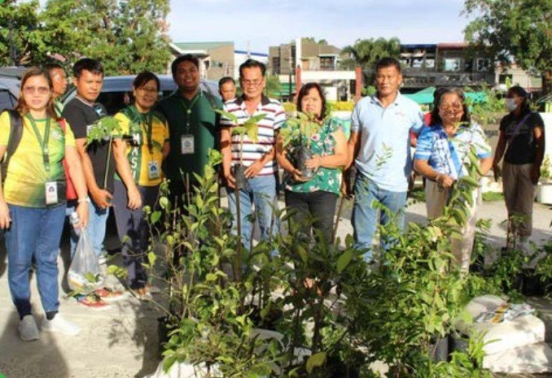
Partners receive indigenous food plant planting materials for the Community Foodscapes and Seedbanks, World Food Day 2025.

In October 2025, in celebration of World Food Day, the MMSU Extension and Research Directorates established the second batch of Community Foodscapes and Seedbanks for Indigenous Food Plants at Eladio V. Barangan Memorial Elementary School, San Nicolas, Ilocos Norte. Barangay officials of San Roque and Parut, Vintar, agricultural extension workers, school leaders and community representatives took part.
The foodscape sites serve as seedbanks and learning gardens that encourage knowledge sharing and sustainable farming practices. Communities receive planting materials and technical assistance to cultivate indigenous crops such as kapaskapas, alokon, pako, dalayap, wild singkamas and roselle, conserving indigenous food resources across Ilocos Norte.
Resources 4, 5
2.5 Indigenous Food Plants Propagated at the MMSU Botanical Garden Are Shared with Schools and Communities
Ongoing programme · Philippine News Agency, 6 June 2026
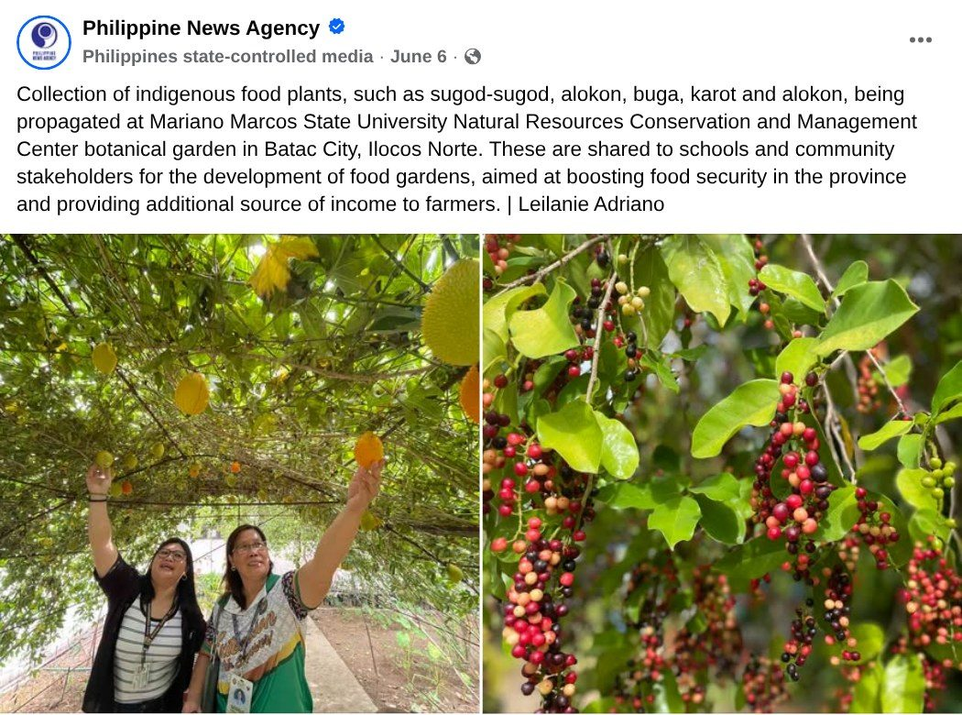  Capture: Philippine News Agency post of 6 June 2026 on indigenous food plants propagated at the MMSU NRCMC botanical garden (photos: Leilanie Adriano, PNA). | Partners receive indigenous food plant planting materials for the Community Foodscapes and Seedbanks, World Food Day 2025.

On June 6, 2026, the Philippine News Agency reported that indigenous food plants such as sugod-sugod, alokon, buga and karot are being propagated at the botanical garden of the MMSU Natural Resources Conservation and Management Center in Batac City, Ilocos Norte. The planting materials are shared with schools and community stakeholders for the development of food gardens, to boost food security in the province and provide farmers with an additional source of income.
The botanical garden is part of the ex situ arm of MMSU’s Indigenous Food Plants Program, which in 2025 extended its community foodscapes and seedbanks to new partner barangays.
Resources 6
3 Conclusion
Coastal towns learn mangrove propagation, Sarrat farmers learn to propagate alukon, and schools and barangays receive learning gardens: knowledge of wild flora and ecosystems goes out to the communities that live beside them.
4 Resources
1. MMSU News, “MMSU trains Ilocos Norte coastal towns on mangrove propagation and management,” 5 November 2025. https://www.mmsu.edu.ph/article/news/2670/mmsu-trains-ilocos-norte-coastal-towns-on-mangrove-propagation-and-management
2. MMSU News, “MMSU trains Sarrat farmers on alukon propagation,” 9 May 2025. https://www.mmsu.edu.ph/news/mmsu-trains-sarrat-farmers-on-alukon-propagation
3. MMSU News, “MMSU IT caravan goes to Vintar,” 15 December 2025. https://www.mmsu.edu.ph/news/mmsu-it-caravan-goes-to-vintar
4. MMSU Extension Directorate, “MMSU expands indigenous food plant seedbanks and foodscapes in LGUs,” October 2025. https://extension.mmsu.edu.ph/news/show/389/mmsu-expands-indigenous-food-plant-seedbanks-and-foodscapes-in-lgus
5. MMSU SDG 15 Life on Land report (2025), Office of Sustainability and Futures Thinking
6. Philippine News Agency, Facebook post on indigenous food plants at the MMSU Natural Resources Conservation and Management Center botanical garden, 6 June 2026. https://www.facebook.com/pnagovph/posts/1411199747723142/

