 | SDG 15.3.1  SDG 15 Life on Land  Sustainable use, conservation and restoration of land  Mariano Marcos State University · THE Sustainability Impact Ratings 2027
The question
Have a policy to ensure the conservation, restoration and sustainable use of terrestrial ecosystems associated with the university, in particular forests, mountains and drylands.
1 Introduction
In MMSU, the Land Use, Zoning, Water and Energy Policies, adopted in 2021 as part of Sirmata 2040, its Land Use Development and Infrastructure Plan prepared under Republic Act 11396, govern the conservation, restoration and sustainable use of all university lands. Policy 1.3 requires land use to maintain, protect, conserve, restore and enhance the integrity of the land, the environment and ecological balance on every campus. Policy 7.1 requires valid and reliable science before any land is altered or converted, and Policy 10.2 gives fragile lands and protected areas special management. Under Policy 9.1, protected landholdings are conserved and excluded from any alteration except as permitted by law, and the MMSU Forest Reserve is maintained as a no-build zone. Policy 4.3 commits the university to review, update and promptly communicate these policies regularly.
2 Body
2.1 MMSU Land Use Policy Commits the University to Conserve and Restore Its Lands
Policy · Sirmata 2040 LUDIP (2021)
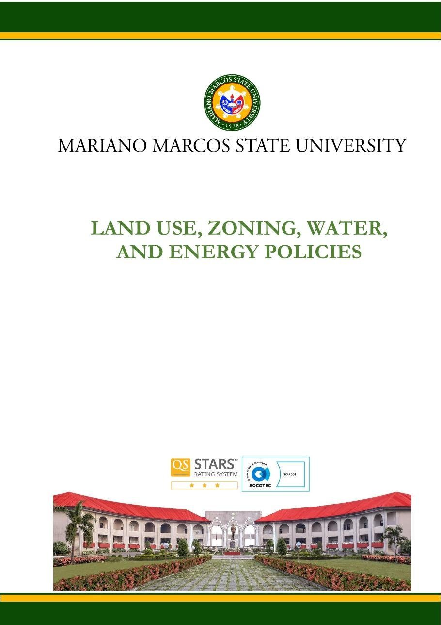
Document: MMSU Land Use, Zoning, Water and Energy Policies (Sirmata 2040 LUDIP, 2021), Land Use Policy, page 1.

Policy | MMSU Land Use, Zoning, Water and Energy Policies (Sirmata 2040 LUDIP), Land Use Policy
Date | 2021 (prepared under RA 11396).
Provisions | Policies 1.3, 7.1, 9.1, 10.2 and 4.3

MMSU’s Land Use, Zoning, Water and Energy Policies, adopted as part of Sirmata 2040, the university’s Land Use Development and Infrastructure Plan prepared in 2021 under Republic Act 11396, govern the conservation, restoration and sustainable use of all university lands across its campuses.
Under Policy 1.3, the allocation and use of university lands “shall aim to maintain, protect, conserve, restore, and enhance the integrity of the land itself, the environment and ecological balance in all its campuses.” Policy 7.1 requires decisions to be based on valid and reliable science, especially for any intent to alter or convert the natural state of any piece of university land, and Policy 10.2 gives fragile lands and protected areas special management “to protect, conserve, enrich, rehabilitate, and or sustain them.”
The zoning policy sets aside Protected Land as a distinct zone; under Policy 9.1, “protected landholdings of the university shall be conserved, preserved and to be excluded from any form of alteration except as may be permitted by operation of law.” The MMSU Forest Reserve is maintained as a no-build zone, and Policy 4.3 requires the university to regularly review, update and promptly communicate its land-use policies.
Resources 1, 2
3 Conclusion
Principles that put science before change, protect designated land from alteration and keep the Forest Reserve a no-build zone give the university’s lands a durable, written safeguard.
4 Resources
1. MMSU, Land Use, Zoning, Water and Energy Policies (Sirmata 2040 LUDIP, 2021). https://www.mmsu.edu.ph/resources/19uycXrgcO_iXPdPpMQwdCRxmoD1U5i60/view
2. MMSU, Planning and Development on Local Biodiversity (SDG 15 page). https://www.mmsu.edu.ph/resources/1tbtCaZa6Uh7ieu4epmz35VJ9jrRQGlPi/data

