 | SDG 15.4.2  SDG 15 Life on Land  Policy on plastic waste reduction  Mariano Marcos State University · THE Sustainability Impact Ratings 2027
The question
Have a policy on reducing plastic waste on campus.
1 Introduction
In MMSU, the Integrated Waste Management Program, approved by the Board of Regents in 2009, amended in 2015 and revised as the Integrated Pollution and Waste Management Program, prohibits Styrofoam for serving or packing food in the Food Service Unit and limits plastics; customers dining out bring their own containers. A policy of 11 February 2016 eliminates Styrofoam and plastic as secondary packaging in favour of paper bags, cartons, eco-bags and reusable containers. The Office of the President’s “No Bottled Water” policy, issued in Memoranda No. 22-148A (2022) and No. 23-189 (2023), ends bottled water at Administrative Council meetings, and CAFSD banned plastic bottled water in its auxiliary buildings in October 2024. On 1 July 2025 MMSU signed a commitment with DENR-EMB Region I to support solid waste management under RA 9003 and RA 11898, and on 24 October student advocates held a monthly campus clean-up that collected about 30 bags of waste.
2 Body
2.1 MMSU Commits to the DENR-EMB Region I Regional Ecology Center
On July 1, 2025, in Bauang, La Union, MMSU signed a memorandum of commitment with the DENR–Environmental Management Bureau Region I and other government agencies, private sector representatives, non-government organizations and academic institutions for the Regional Ecology Center. MMSU was represented by Vice President for Planning and Strategic Foresight Mee Jay Domingo and Campus Sustainability Chief Ronnel Pagurayan.
Under the commitment, MMSU supports improved solid waste management under Republic Act 9003 (Ecological Solid Waste Management Act) and Republic Act 11898 (Extended Producer Responsibility Act) through education and public information campaigns and the development of informational materials.
Resources 1
2.2 Student Advocates Hold Monthly Clean-Up Drive on Campus
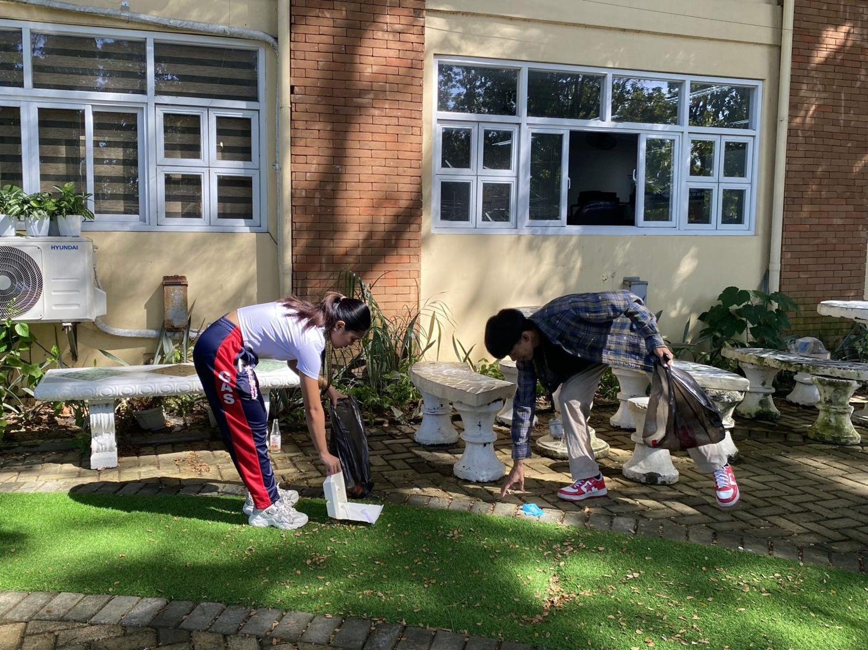
MMSU Advocates for Cultural Development clean-up drive on campus, 24 October 2025. (Photo: MMSU)

On October 24, 2025, the MMSU Advocates for Cultural Development (MACD), an organization representing students from indigenous peoples’ communities, held its monthly clean-up drive, “iPaglilinis,” around the university grounds, the Student Center and parts of the University Lagoon. About 30 bags of waste were collected and segregated into plastic, paper and tin materials.
Resources 2
2.3 MMSU Policies Eliminate Styrofoam and Reduce Plastic Waste on Campus
Policies · 2009, 2015, 2016, 2022 and 2023, with 2024 and 2025 actions
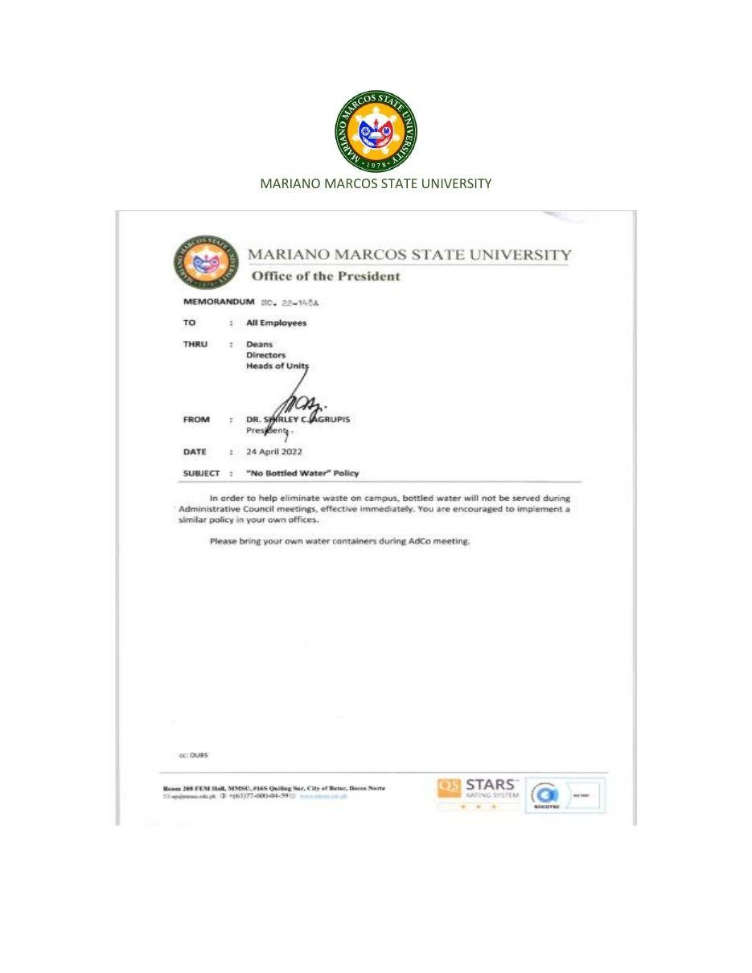  Document: Office of the President Memorandum No. 22-148A, “No Bottled Water” Policy, 24 April 2022. | 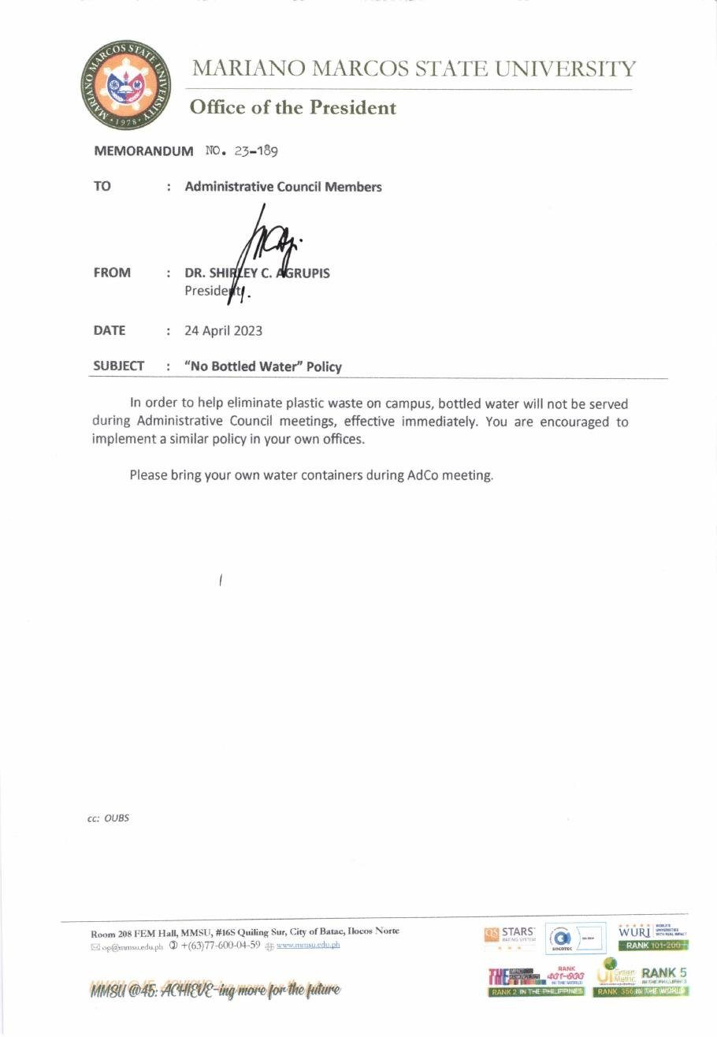  Document: Office of the President Memorandum No. 23-189, “No Bottled Water” Policy, 24 April 2023.

Policy | Integrated Waste Management Program, revised as the Integrated Pollution and Waste Management Program (IPWMP)
Approved by | Board of Regents (2009; amended 2015).
Date | 2009; amended 2015; Styrofoam and plastic packaging policy 11 Feb 2016; IPWMP revised 2020
Provisions | Styrofoam and plastic provisions; “No Bottled Water” Memoranda No. 22-148A and 23-189

MMSU reduces plastic waste under its Integrated Waste Management Program, approved by the Board of Regents in 2009 and amended in 2015, and its revised Integrated Pollution and Waste Management Program. The program prohibits Styrofoam for serving or packing food in the university Food Service Unit and limits the use of plastics, and a policy promulgated on February 11, 2016 eliminates Styrofoam and plastic as secondary packaging materials in favour of paper bags, cartons, eco-bags and reusable containers. The University Waste Management Committee develops, reviews and monitors these rules, and the food service unit requires customers dining out to bring their own food containers.
The Office of the President reissues the “No Bottled Water” Policy each year: Memorandum No. 22-148A of April 24, 2022 and Memorandum No. 23-189 of April 24, 2023 stop the serving of bottled water at Administrative Council meetings, ask members to bring their own water containers, and encourage all offices to adopt the same policy. In October 2024 the College of Agriculture, Food and Sustainable Development banned plastic bottled water in its auxiliary buildings, and on July 1, 2025 MMSU signed a memorandum of commitment with DENR-EMB Region I for the Regional Ecology Center to support solid waste management under Republic Act 9003 and the Extended Producer Responsibility Act (Republic Act 11898).
Resources 1, 3, 4, 5, 6
2.4 University Memoranda Ask Employees to Bring Their Own Tumblers
Ongoing programme · February 2024
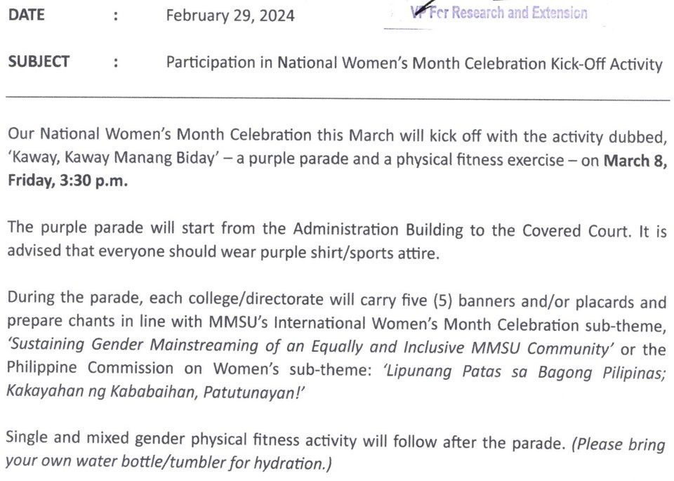  Document: Office of the President Memorandum No. 24-088, 29 February 2024, to all employees: “Please bring your own water bottle/tumbler for hydration.” | 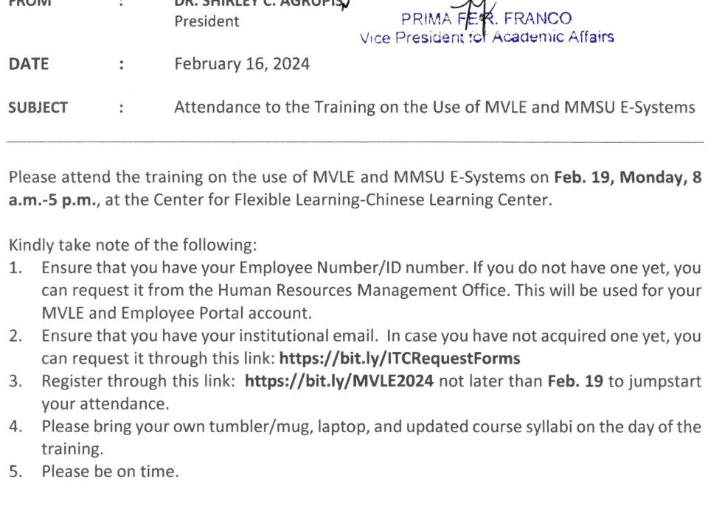  Document: Office of the President Memorandum No. 24-075, 16 February 2024, item 4: “Please bring your own tumbler/mug…”

The practice behind the No Bottled Water policy appears in the university’s own memoranda. Office of the President Memorandum No. 24-088 of February 29, 2024, sent to all employees for the National Women’s Month kick-off parade and fitness activity, asked participants to “bring your own water bottle/tumbler for hydration.” Memorandum No. 24-075 of February 16, 2024, calling newly hired faculty to training on the MVLE and MMSU e-systems, asked them to “bring your own tumbler/mug.”
In October 2024 the College of Agriculture, Food and Sustainable Development went further and banned plastic bottled water in its auxiliary building, encouraging students and staff to bring reusable tumblers instead.
Resources 6, 7, 8
3 Conclusion
Programme rules on Styrofoam, annual no-bottled-water memoranda, requests to bring tumblers, a college-level ban, a regional commitment and student clean-ups add up to a campus habit of cutting plastic.
4 Resources
1. MMSU News, “MMSU commits to ecological solid waste management in Region I,” 2 July 2025. https://www.mmsu.edu.ph/news/mmsu-commits-to-ecological-solid-waste-management-in-region-i
2. MMSU News, “MACD leads clean-up drive in MMSU,” 29 October 2025. https://www.mmsu.edu.ph/news/macd-leads-clean-up-drive-in-mmsu
3. MMSU, Plastic Waste Management (SDG 15 page). https://www.mmsu.edu.ph/resources/1NU-Qda9KG0J-PIOgKZwPKC4h_TU05zcm/data
4. MMSU, Revised Integrated Pollution and Waste Management Program. https://www.mmsu.edu.ph/resources/1fNUCZwyOozOKO27L2Bm6pNN-P_cJNpLd/view
5. MMSU Office of the President, “No Bottled Water” Policy, Memorandum No. 22-148A (2022) and No. 23-189 (2023). https://www.mmsu.edu.ph/resources/1LbnK8yYkg-47ChbXyT0r8VQ9eBGuMxRx/data
6. MMSU News, “MMSU CAFSD rolls out waste and pollution management program,” 15 October 2024. https://www.mmsu.edu.ph/news/mmsu-cafsd-rolls-out-waste-and-pollution-management-program
7. MMSU Office of the President, Memorandum No. 24-088, “Participation in National Women’s Month Celebration Kick-Off Activity,” 29 February 2024
8. MMSU Office of the President, Memorandum No. 24-075, “Attendance to the Training on the Use of MVLE and MMSU E-Systems,” 16 February 2024

