 | SDG 15.2.1  SDG 15 Life on Land  Events about sustainable use of land  Mariano Marcos State University · THE Sustainability Impact Ratings 2027
The question
Support or organise events aimed to promote conservation and sustainable utilisation of the land, including forests and wild land.
1 Introduction
In MMSU, events in 2025 brought land stewardship to students, farmers and communities. About 230 CAFSD graduating students planted 120 native guijo and yakal seedlings and 130 bamboo propagules in the University Forest Reserves on 2 July. For World Environment Day, 250 mangrove propagules went into the Currimao shoreline, and on 24 July 1,000 coconut seedlings from the Philippine Coconut Authority were planted along the Currimao beachfront under the Green Wall Program. The President’s Farm Field Day on 28 October showed eight rice varieties, including options for saline and rainfed land, and the 7th Parambak ditoy MMSU on 14 February opened extension technologies to 37 exhibitors and their partners. A regenerative-farming talk at the National Science and Technology Week forum and a wildlife photo contest for the International Day for Biological Diversity widened the reach. Graduation tree planting recurs yearly, from 2024 to 2026.
2 Body
2.1 Parambak ditoy MMSU 2025 Showcases Extension Technologies for Farmers
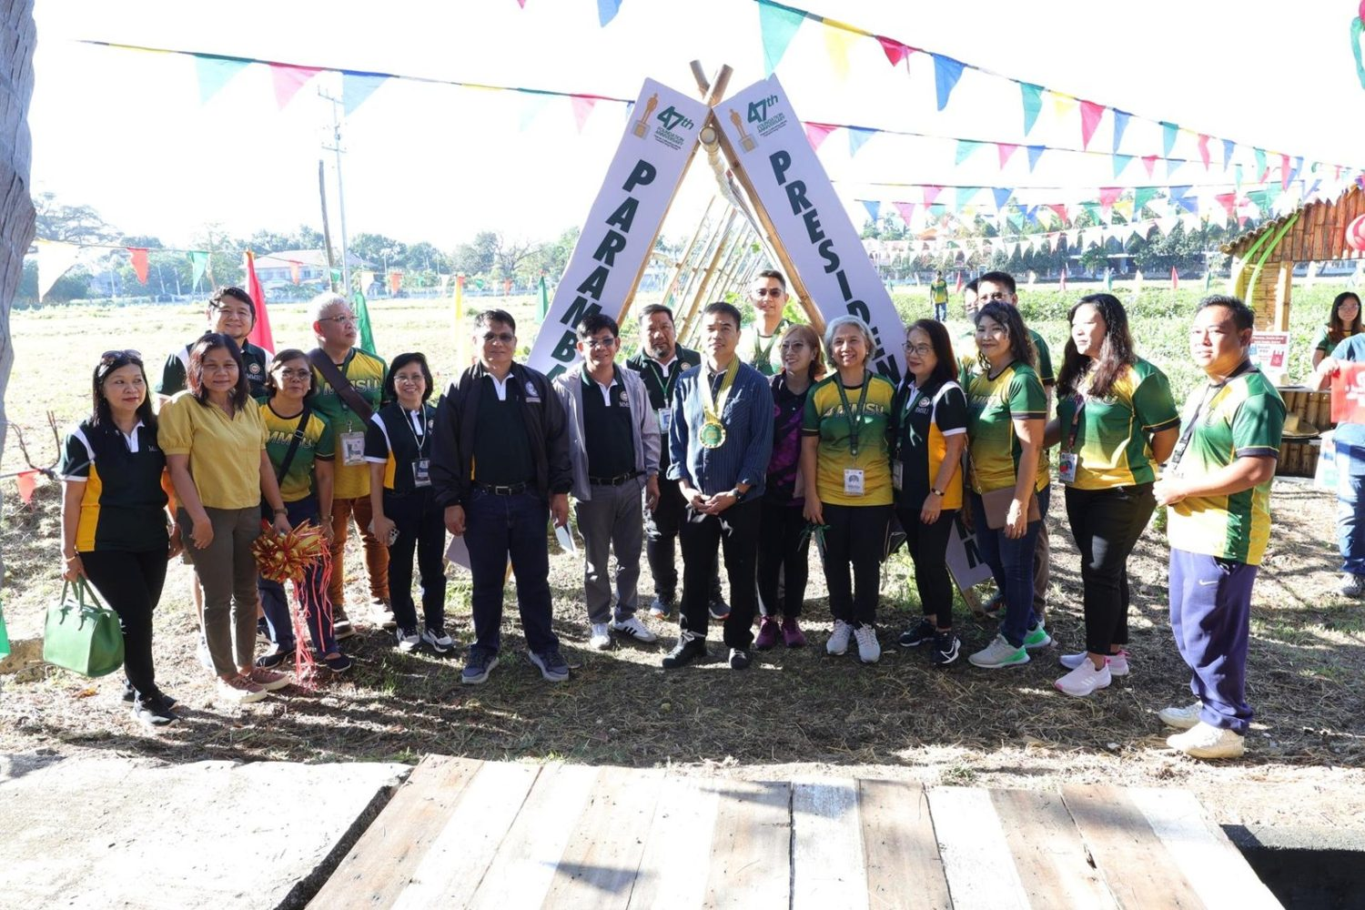
7th Parambak ditoy MMSU, in front of CAFSD, 14 February 2025. (Photo: MMSU STRATCOM)

On February 14, 2025, to close its 47th Foundation Anniversary, MMSU held the 7th Parambak ditoy MMSU in front of the College of Agriculture, Food and Sustainable Development, highlighting the impact of its extension and research programmes on community development and agricultural innovation. Thirty-seven exhibitors took part, including learning sites of the Agricultural Training Institute–Ilocos Region, Magsasaka Siyentista (farmer scientists), Balik-Probinsya beneficiaries and local government units, and the Research Directorate gave a speed talk on MMSU technologies such as off-season tomato and shallot production, Bolinao chicken, indigenous vegetables and black garlic.
Participants harvested fresh vegetables at the President’s Farm, 17 new partners of the Extension Directorate received certificates of appreciation, and beneficiaries shared how MMSU’s technologies had supported sustainable agriculture. Attendees included the Provincial Government of Ilocos Norte, LGUs, non-government organisations, farmer leaders, entrepreneurs and MMSU-assisted beneficiaries. Incoming President Virgilio Julius P. Manzano Jr. urged the units concerned to sustain sustainable farming practices.
Resources 1
2.2 CAFSD Graduands Plant Native Trees and Bamboo in the University Forest Reserves
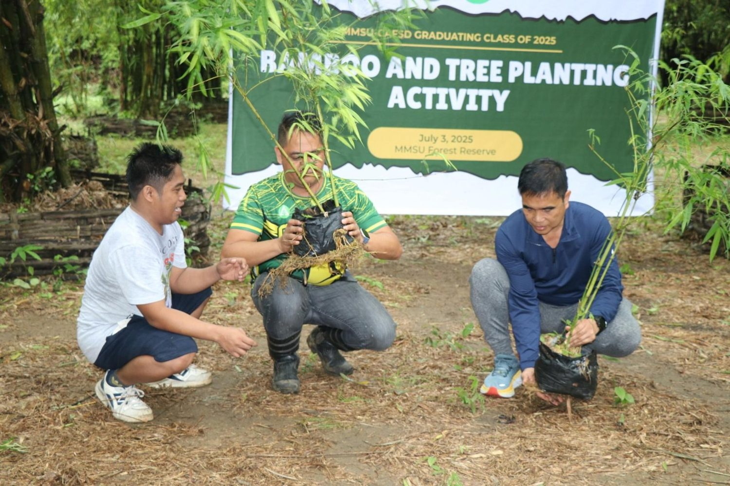  CAFSD Graduating Class 2025 “Bamboo and Tree Planting Activity,” University Forest Reserves, City of Batac, 2 July 2025. (Photo: MMSU STRATCOM) | 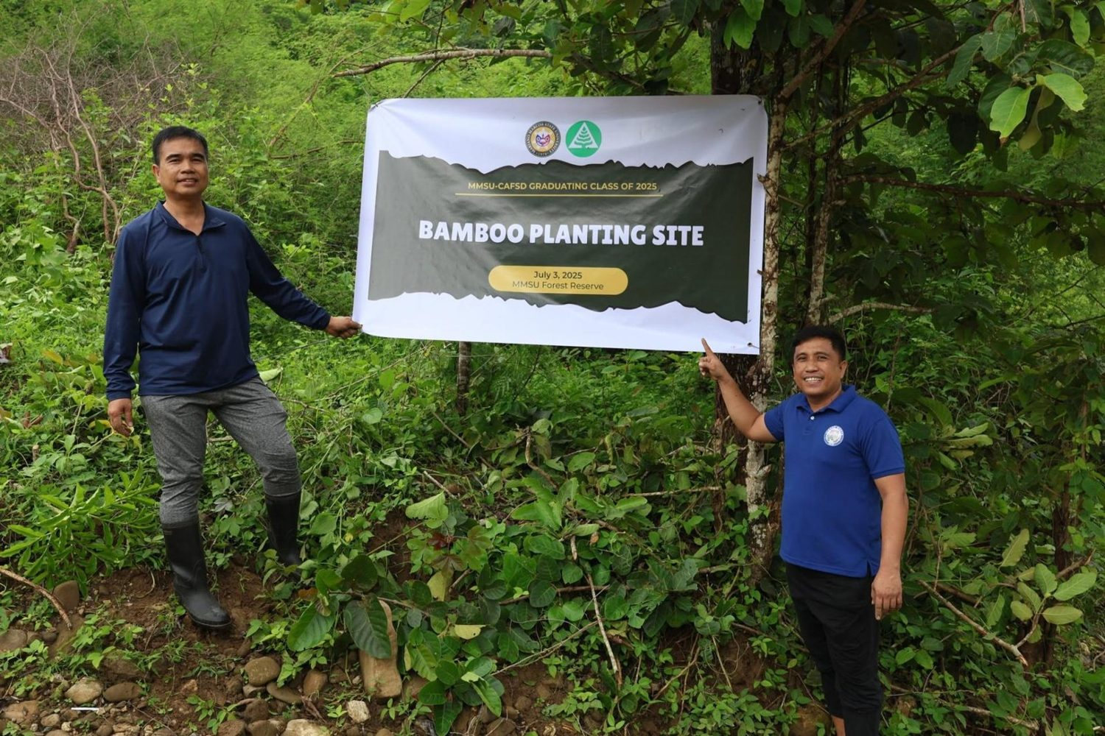  Bamboo planting site in the University Forest Reserve, Brgy. Mabaleng, 2 July 2025. (Photo: MMSU STRATCOM)

Some 230 graduating students of the College of Agriculture, Food and Sustainable Development (CAFSD) of Mariano Marcos State University (MMSU) planted trees and bamboo in the University Forest Reserves in Barangays Payao and Mabaleng, City of Batac, on July 2, 2025. The activity was led by CAFSD OIC-Dean Charlie Batin and the 2025 CAFSD Graduating Class Student Council, with Dr. Joselito Rosario, Director for Agribusiness, and Mr. Bonne Jovie Orteza of the MMSU Bamboo Research and Development Center. MMSU President Virgilio Julius P. Manzano Jr. commended the class for leaving a lasting green footprint that will further preserve the forest areas managed by the university, and Mr. Hashler Garalde, a CAFSD alumnus representing the Provincial Government of Ilocos Norte, supported the college’s sustainability efforts.
The graduands planted 120 seedlings of guijo and yakal, native dipterocarp timber species raised at the MMSU Central Nursery, in the Payao Forest Reserve, and 130 propagules of kawayan tinik, machiku and giant bamboo from the MMSU Bamboo Nursery in Mabaleng.
Resources 2, 3
2.3 MMSU Plants 250 Mangrove Propagules in Currimao on World Environment Day
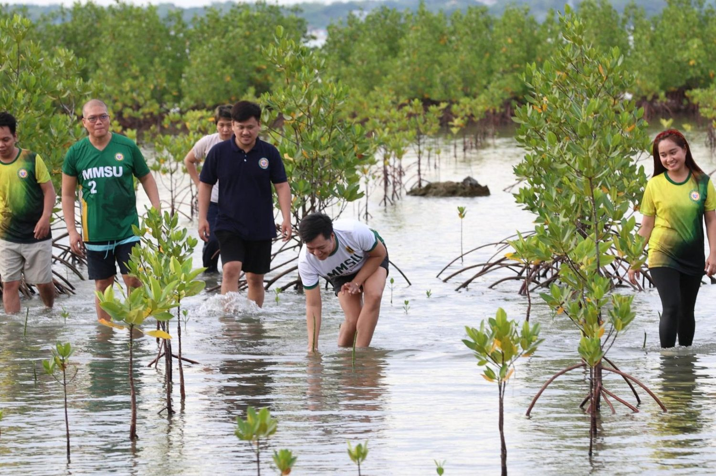  Mangrove planting for World Environment Day, Brgy. Maglaoi, Currimao, June 2025. (Photo: MMSU STRATCOM) | 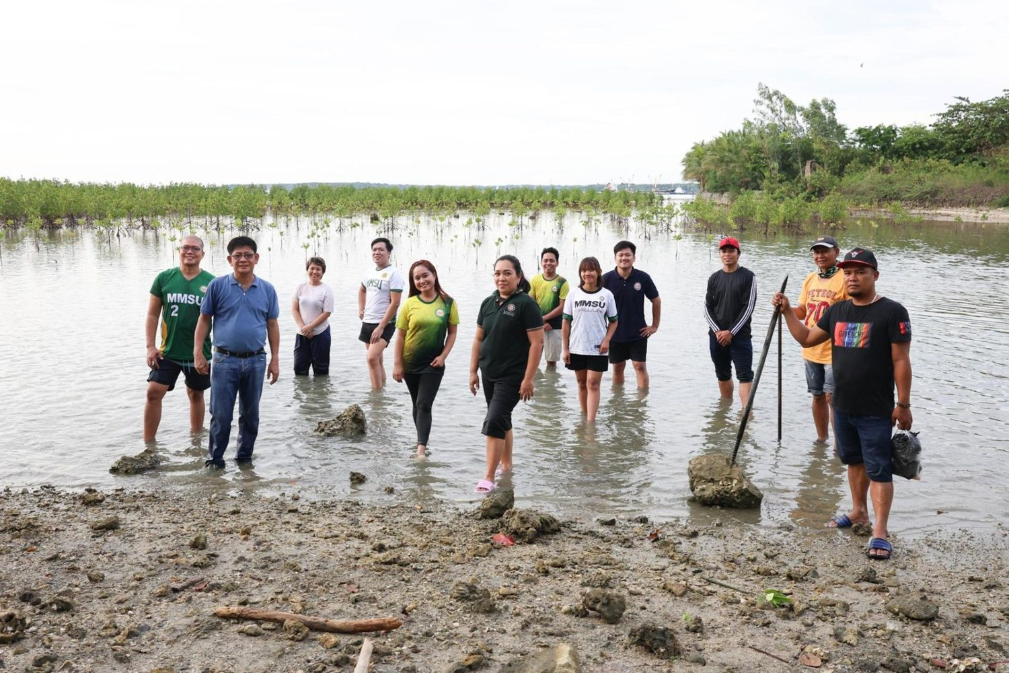  MMSU, LGU Currimao, DENR and fisherfolk volunteers at the planting site, June 2025. (Photo: MMSU STRATCOM)

In June 2025, in celebration of World Environment Day, Mariano Marcos State University planted 250 mangrove propagules along the coastal area of Barangay Maglaoi, Currimao, Ilocos Norte, to restore degraded shorelines, enhance climate resilience and promote sustainable coastal resource management. The activity was spearheaded by the MMSU Sustainability and Futures Thinking (SFT) Office with the Local Government Unit of Currimao and led by Dr. Mee Jay Domingo, Vice President for Planning and Strategic Foresight.
MMSU faculty, education support personnel and students joined representatives of the Department of Environment and Natural Resources, barangay officials, members of local fisherfolk organizations and community members. SFT Director Dr. Arlene Gonzales explained that mangroves were chosen because they act as natural filters that intercept plastic waste from land before it reaches the sea, while absorbing carbon, protecting shorelines from erosion and providing habitat for marine life.
Resources 4
2.4 Green Wall Program: Coconut Seedlings for the Currimao Coastline
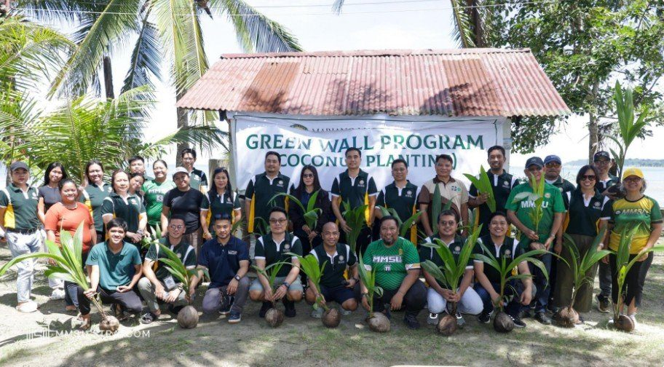
Coconut seedling planting along the Currimao beachfront under the MMSU Green Wall Program, 24 July 2025. (Photo: MMSU)

On July 24, 2025, MMSU planted coconut seedlings along the Currimao beachfront under its Green Wall Program, with 1,000 seedlings donated by the Philippine Coconut Authority (PCA), to promote environmental sustainability and coastal resilience amid growing climate threats. The activity was held in celebration of the birthday of CHED Chairperson Shirley C. Agrupis, Chair of the MMSU Board of Regents.
MMSU President Virgilio Julius P. Manzano Jr., PCA Ilocos Norte Agriculturist and In-Charge Rose Ann Cabaloan, and university officials and employees took part. CASAT OIC-Dean Pilar Carolyn Pascual highlighted the university’s commitment to protecting coastal ecosystems through the Green Wall project.
Resources 5
2.5 MMSU Promotes Regenerative Farming at the 2025 NSTW Forum
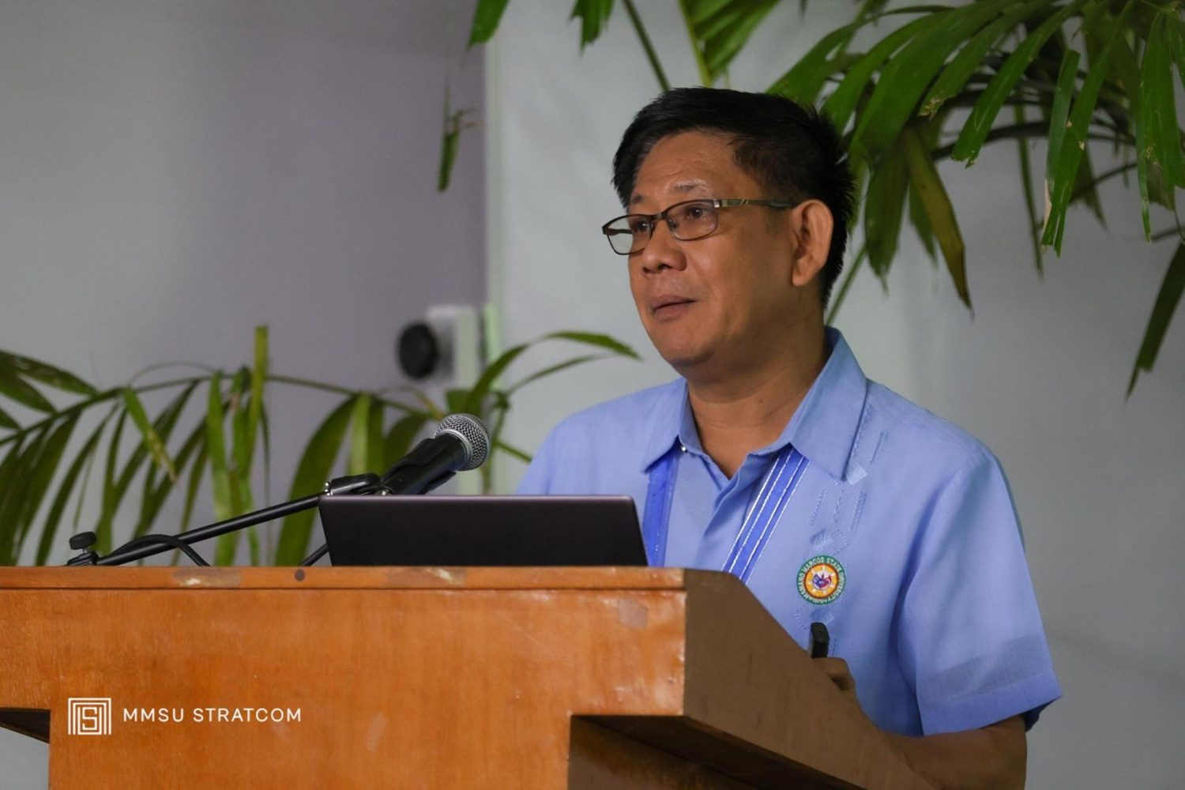
Forum series of the 2025 National Science and Technology Week, Northwestern University, Laoag City, 19 November 2025. (Photo: MMSU)

On November 19, 2025, MMSU Research Director Dr. Dionisio Bucao served as a resource speaker at the forum series of the 2025 National Science and Technology Week held at Northwestern University, Laoag City. He presented regenerative farming approaches that restore soil health, biodiversity and ecosystem function, and emphasized carbon sequestration, improved soil fertility, water conservation and climate resilience through natural processes, as well as how regenerative farming differs from conventional practice.
Resources 6
2.6 President’s Farm Field Day Showcases Climate-Resilient Rice Varieties
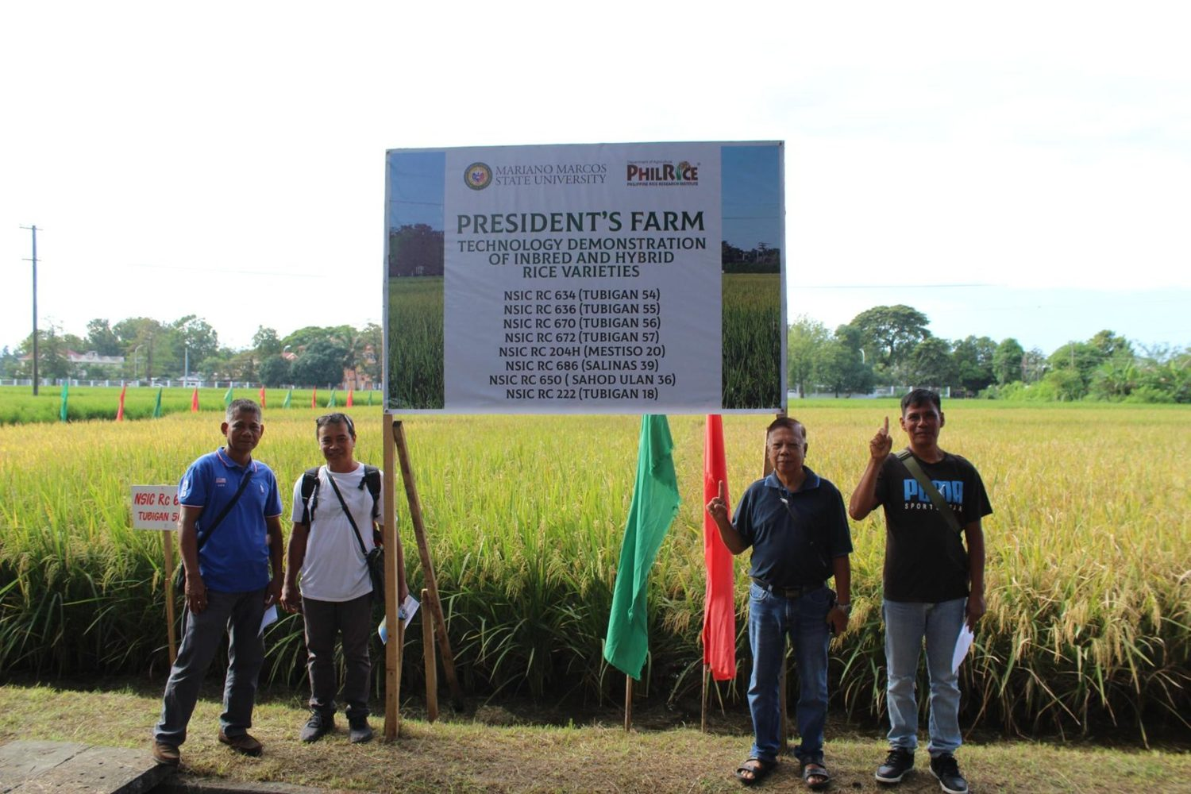  President’s Farm technology demonstration of inbred and hybrid rice varieties, 28 October 2025. (Photo: MMSU) | 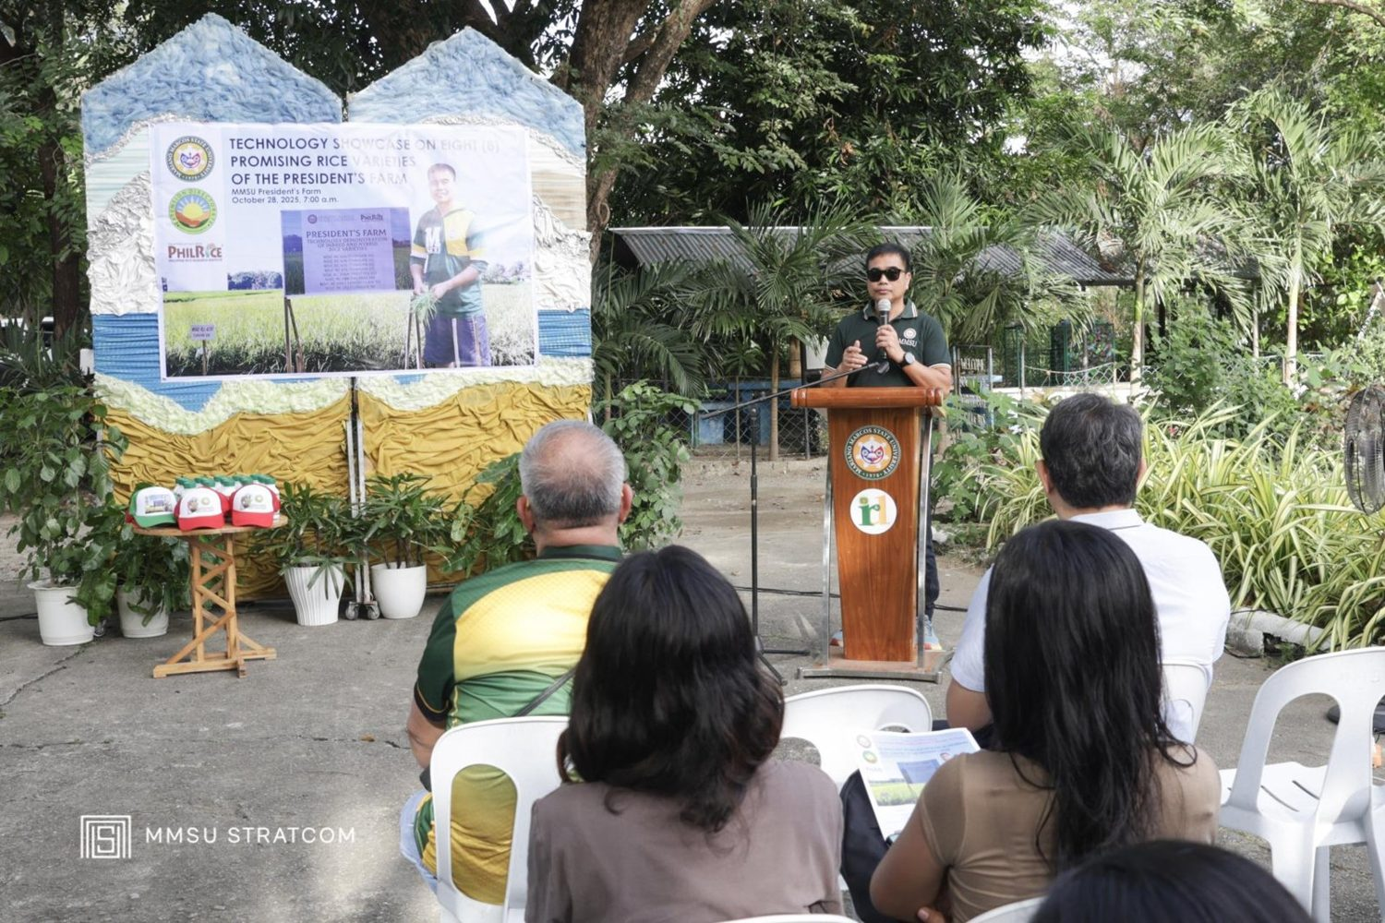  Farmers, LGU technicians and students at the President’s Farm Field Day, in front of CAFSD. (Photo: MMSU)

On October 28, 2025, the MMSU Extension Directorate, with the Philippine Rice Research Institute (PhilRice) Batac Branch, held the President’s Farm Field Day: A Technology Showcase in front of the College of Agriculture, Food and Sustainable Development. Farmers and farmer-leaders, agricultural technicians from Ilocos Norte local government units, BS Agriculture students, and MMSU and PhilRice rice specialists viewed eight rice varieties grown under wet-season conditions.
The varieties included four newly released by PhilRice, two public hybrids, and two suited to saline and rainfed conditions, among them NSIC Rc 686 (Salinas 39) and NSIC Rc 650 (Sahod Ulan 36), giving farmers options for saline-affected and rainfed fields. Speakers included MMSU President Dr. Virgilio Julius P. Manzano Jr., Extension Director Dr. Marlowe Aquino, and former MMSU President and PhilRice Executive Director Dr. Santiago R. Obien.
Resources 7
2.7 2025 International Day for Biological Diversity Wildlife Photo Contest
  Contest poster with the animal-photography ethical guidelines (deadline 30 May 2025). | 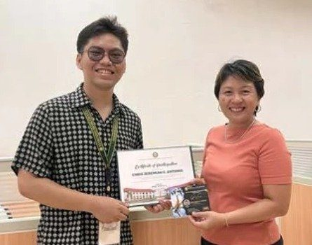  Winner Chris Jeremiah C. Antonio receives his certificate from Dr. Arlene L. Gonzales, Chief of Sustainability and Futures Thinking.

MMSU, through its Office of Sustainability and Futures Thinking, marked the 2025 International Day for Biological Diversity with a Wildlife Photo Contest that invited the university community to document local wildlife and promote awareness of biodiversity conservation. Entrants followed animal-photography ethical guidelines: avoiding flash and loud noises, never using bait or food lures, following local laws and warning signs, keeping clear of nesting sites and sensitive habitats, and captioning photographs honestly. Entries were received until May 30, 2025.
Chris Jeremiah C. Antonio, a third-year BA Communication student, was named winner and received a ₱1,000 gift voucher and a certificate from Dr. Arlene L. Gonzales, Chief of Sustainability and Futures Thinking.
Resources 8
2.8 Graduation Tree Planting Is a Standing MMSU Programme, 2024 to 2026
Ongoing programme · July 2024, July 2025, June 2026
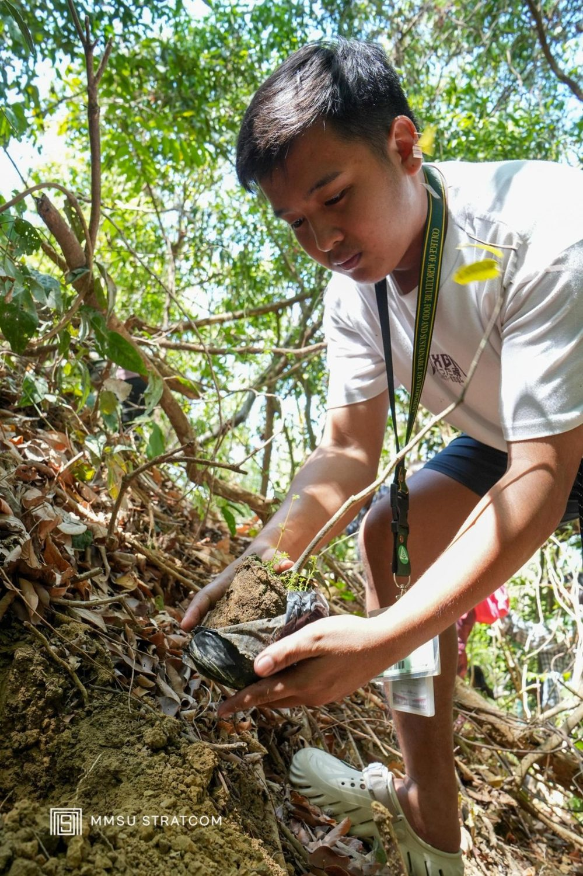
CAFSD Graduating Class 2026 enrichment planting at the MMSU Forest Reserve, Payao, 1 June 2026. (Photo: MMSU STRATCOM)

Graduating classes of the College of Agriculture, Food and Sustainable Development (CAFSD) of Mariano Marcos State University (MMSU) plant trees before they graduate, and the planting has been repeated every year. On July 9, 2024, the BS Forestry graduating class, led by CAFSD OIC-Dean Charlie Batin, enriched the Salinged Park, the university’s ecological park, with igem-dagat, balitbitan, bitaog, Cassia javanica and banaba. On July 2, 2025, 230 CAFSD graduands planted guijo, yakal and bamboo in the University Forest Reserves in Payao and Mabaleng, City of Batac.
On June 1, 2026, the CAFSD Graduating Class of 2026, led by its Student Council with the chairs and faculty of the Departments of Environmental Science and Forestry, carried out an enrichment planting at the MMSU Forest Reserve in Payao, which the CAFSD Batch 2025 had previously planted with native seedlings. They planted 50 banaba, 30 yakal saplungan and 20 guijo seedlings at the onset of the rainy season, hardened in the MMSU Forest Tree Nursery, species chosen because they improve soil quality, conserve biodiversity and absorb and store carbon dioxide. Dr. Arlene Gonzales, Director of the Sustainability and Futures Thinking Office, represented the University President and commended the college for sustaining the initiative. The activity follows Republic Act 10800, the Graduation Legacy for the Environment Act, which requires students to plant trees before graduation.
Resources 2, 3, 9
3 Conclusion
From a graduating class planting guijo and yakal, to a field day of climate-resilient rice and a wildlife photo contest, MMSU’s events invite students, farmers and communities into the care of forests, farmland, coasts and wildlife. Several are annual traditions.
4 Resources
1. MMSU Extension Directorate, “‘Parambak’ caps MMSU@47 celebration,” February 2025. https://extension.mmsu.edu.ph/news/show/368/parambak-caps-mmsu-at-47-celebration
2. MMSU News, “CAFSD graduands plant trees, bamboos in Batac forest reserves,” 4 July 2025. https://www.mmsu.edu.ph/article/news/2468/cafsd-graduands-plant-trees-bamboos-in-batac-forest-reserves
3. MMSU News, “BS Forestry seniors leave green footprints with pre-graduation tree planting,” 11 July 2024. https://www.mmsu.edu.ph/article/news/2065/bs-forestry-seniors-leave-green-footprints-with-pre-graduation-tree-planting
4. MMSU News, “MMSU plants 250 mangrove propagules in Currimao,” 11 June 2025. https://www.mmsu.edu.ph/news/mmsu-plants-250-mangrove-propagules-in-currimao
5. MMSU News, “MMSU celebrates CHED Chair Agrupis’ birthday with coconut planting activity,” 28 July 2025. https://www.mmsu.edu.ph/news/mmsu-celebrates-ched-chair-agrupis-birthday-with-coconut-planting-activity
6. MMSU News, “MMSU researchers share expertise on smart agriculture in NSTW forum,” 20 November 2025. https://www.mmsu.edu.ph/news/mmsu-researchers-share-expertise-on-smart-agriculture-in-nstw-forum
7. MMSU News, “MMSU President’s Farm showcases 8 rice varieties,” 4 November 2025. https://www.mmsu.edu.ph/article/news/2665/mmsu-presidents-farm-showcases-8-rice-varieties
8. MMSU SDG 15 Life on Land report (2025), Office of Sustainability and Futures Thinking
9. MMSU News, “CAFSD graduands grow native trees at MMSU forest reserve,” 5 June 2026. https://www.mmsu.edu.ph/news/cafsd-graduands-grow-native-trees-at-mmsu-forest-reserve

