 | SDG 15.2.2  SDG 15 Life on Land  Sustainably farmed food on campus  Mariano Marcos State University · THE Sustainability Impact Ratings 2027
The question
Have a policy that food on campus is sustainably farmed.
1 Introduction
In MMSU, a dated policy that food on campus is sustainably farmed has not yet been recorded; a sourcing memorandum from the Business Directorate would supply it. What exists is practice on university land. In May 2025, 18 researchers and farm workers trained to run a new Php 2.2-million greenhouse in the research, development and extension complex, built under HERIP with three bays for soilless, hydroponic and soil-based crops. At the 7th Parambak ditoy MMSU on 14 February 2025, participants harvested fresh vegetables at the President’s Farm while 37 exhibitors showed technologies such as off-season tomato and shallot production and indigenous vegetables, and the incoming President urged the units concerned to sustain sustainable farming practices. These activities show how food is grown and demonstrated on campus, and they are the base on which a written policy can stand.
2 Body
2.1 New Research Greenhouse and Staff Training Support Controlled-Environment Crop Production on Campus
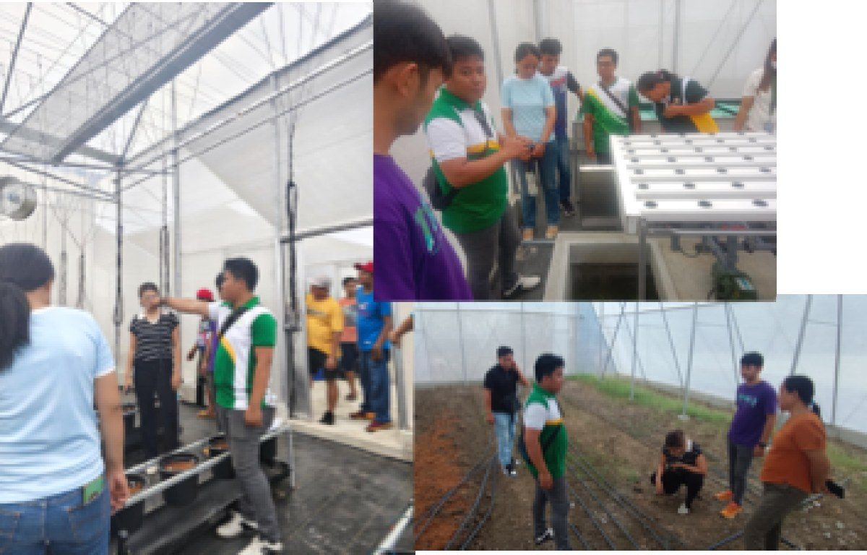
MMSU researchers and farm workers train on the new greenhouse at the RDE complex, 13 May 2025. (Photo: MMSU Research Directorate)

On May 13, 2025, eighteen researchers and farm workers of Mariano Marcos State University took part in hands-on training on the operation and management of the newly constructed greenhouse in the university’s research, development and extension (RDE) complex. The training, facilitated by the project contractor as part of the turnover, covered the basic functions and systems of the greenhouse and crop-specific management strategies; a follow-up session on May 20, 2025 covered the preparation of planting solutions for soilless and hydroponic systems.
The Php 2.2-million facility measures 10 by 6 metres and 6.1 metres high, uses combined mechanical and natural ventilation, and has an integrated planting system in three bays for soilless cultivation, hydroponics and soil-based planting. It was built under the Higher Education Reform and Innovation Program (HERIP) to strengthen research in controlled-environment agriculture and to give students immersive learning.
Resources 1, 2
2.2 Parambak ditoy MMSU 2025 Showcases Extension Technologies for Farmers
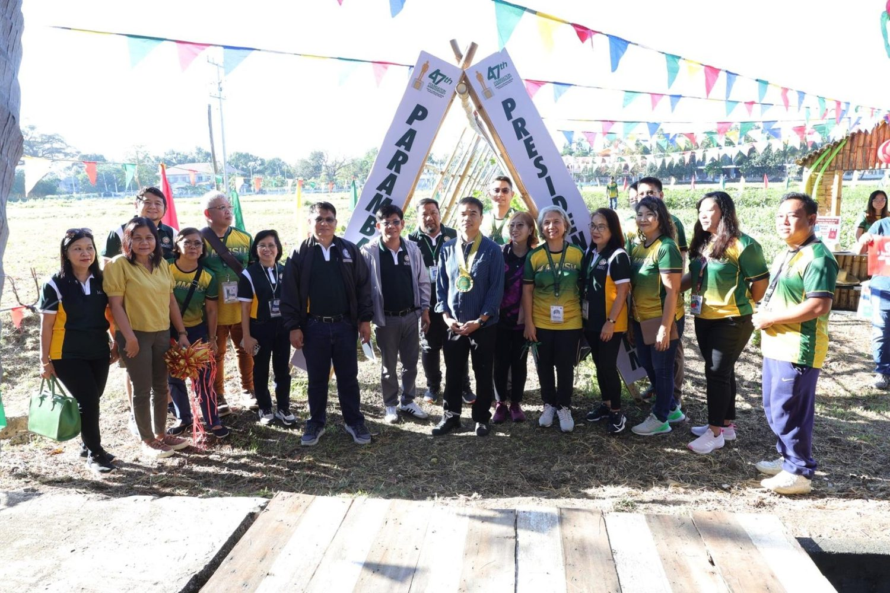
7th Parambak ditoy MMSU, in front of CAFSD, 14 February 2025. (Photo: MMSU STRATCOM)

On February 14, 2025, to close its 47th Foundation Anniversary, MMSU held the 7th Parambak ditoy MMSU in front of the College of Agriculture, Food and Sustainable Development, highlighting the impact of its extension and research programmes on community development and agricultural innovation. Thirty-seven exhibitors took part, including learning sites of the Agricultural Training Institute–Ilocos Region, Magsasaka Siyentista (farmer scientists), Balik-Probinsya beneficiaries and local government units, and the Research Directorate gave a speed talk on MMSU technologies such as off-season tomato and shallot production, Bolinao chicken, indigenous vegetables and black garlic.
Participants harvested fresh vegetables at the President’s Farm, 17 new partners of the Extension Directorate received certificates of appreciation, and beneficiaries shared how MMSU’s technologies had supported sustainable agriculture. Attendees included the Provincial Government of Ilocos Norte, LGUs, non-government organisations, farmer leaders, entrepreneurs and MMSU-assisted beneficiaries. Incoming President Virgilio Julius P. Manzano Jr. urged the units concerned to sustain sustainable farming practices.
Resources 3, 4
3 Conclusion
A Php 2.2-million greenhouse for soilless, hydroponic and soil-based crops, trained researchers and farm workers, and a President’s Farm that shares its harvest and technologies show how MMSU produces and demonstrates food crops on its own campus.
4 Resources
1. MMSU Research Directorate, “MMSU RD personnel undergo greenhouse operations training,” 19 May 2025. https://research.mmsu.edu.ph/news/details/mmsu-rd-personnel-undergo-greenhouse-operations-training
2. MMSU Research Directorate, Facebook post, “RD personnel undergo greenhouse training”. https://www.facebook.com/share/p/18mfoUpkDM/
3. MMSU Extension Directorate, “‘Parambak’ caps MMSU@47 celebration,” February 2025. https://extension.mmsu.edu.ph/news/show/368/parambak-caps-mmsu-at-47-celebration
4. MMSU College of Teacher Education, Facebook post, “Happening now: Parambak Ditoy MMSU 2025”. https://www.facebook.com/MMSUCTeacherEducation/posts/𝐇𝐀𝐏𝐏𝐄𝐍𝐈𝐍𝐆-𝐍𝐎𝐖-𝐏𝐚𝐫𝐚𝐦𝐛𝐚𝐤-𝐃𝐢𝐭𝐨𝐲-𝐌𝐌𝐒𝐔-𝟐𝟎𝟐𝟓the-mmsu-college-of-teacher-education-led-/1172901604836051/

