 | INDICATOR 15.2.2  SDG 15 Life on Land  Evidence Report 2025  Mariano Marcos State University · THE Sustainability Impact Ratings 2027
Data year 2025 · Draft for validation · prepared 6 November 2026
SDG assigned | SDG 15 · Life on Land | Data year | 2025
Team Members | [Name, position] | Date prepared | 6 November 2026
1 · Sites and platforms explored
Every site and office where evidence for this indicator was found, and where nothing was found. A list of sites is not evidence; it only shows where the team has looked.
# | Site or office | URL or location | What was found
1 | MMSU Research Directorate | https://research.mmsu.edu.ph/news | 1 item for 15.2.2: New Research Greenhouse and Staff Training Support Controlled-Environment Crop Production on Campus
2 | MMSU Extension Directorate | https://extension.mmsu.edu.ph/news | 1 item for 15.2.2: Parambak ditoy MMSU 2025 Showcases Extension Technologies for Farmers
Not yet explored
Sources the team should still search. Suggestions are listed; add your own.
# | Source to search | Assigned to
1 | College and department websites and social media pages
2 | Office records (Registrar, HR, Planning, Procurement, Physical Plant, Student Affairs)
3 | Board of Regents resolutions and memoranda
4 | Extension and Research Directorate pages and accomplishment reports
5 | Agreements (MOA, MOU) with LGUs, agencies, NGOs and industry
6 | News outlets and partner websites (DENR, LGUs, DOST, PhilRice)
7 | [Add a source]
2 · Indicators to report
SDG 15 · Life on Land · data year 2025
Indicator | Description
15.2.2 | Sustainably farmed food on campus. Policies to ensure that food on campus is sustainably farmed.
3 · Optional: what other universities submit
What other universities claim for this indicator, and where MMSU might hold the same kind of evidence.
University | What it submits (indicator and type of evidence) | What to look for at MMSU
Caraga State University | 15.2.2: a sustainably managed campus farm | A Business Directorate sourcing memorandum or a campus-farm statement; none found yet.
[Add the THE edition and URL for each result before using this page.]
4 · Evidence by indicator
SDG 15.2.2 · Sustainably farmed food on campus (policy)
Have a policy that food on campus is sustainably farmed.
Evidence year: in place by 2025
Submission pick: None yet. No dated MMSU policy that food on campus is sustainably farmed was found. Attach the policy, or a Business Directorate sourcing memorandum, before submitting.
No evidence yet | Searched: MMSU news, extension and research pages (supporting items below).  Missing: A dated policy or sourcing memorandum in force by 2025.  Follow-up: Business Directorate and the campus farm units. [assign a name]  Do not create or backdate a document to fill a gap.
Supporting practice (internal evidence, not the policy)
New Research Greenhouse and Staff Training Support Controlled-Environment Crop Production on Campus
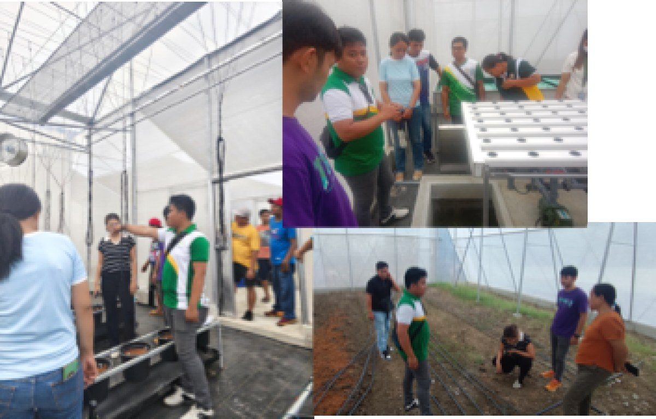
MMSU researchers and farm workers train on the new greenhouse at the RDE complex, 13 May 2025. (Photo: MMSU Research Directorate)

On May 13, 2025, eighteen researchers and farm workers of Mariano Marcos State University took part in hands-on training on the operation and management of the newly constructed greenhouse in the university’s research, development and extension (RDE) complex. The training, facilitated by the project contractor as part of the turnover, covered the basic functions and systems of the greenhouse and crop-specific management strategies; a follow-up session on May 20, 2025 covered the preparation of planting solutions for soilless and hydroponic systems.
The Php 2.2-million facility measures 10 by 6 metres and 6.1 metres high, uses combined mechanical and natural ventilation, and has an integrated planting system in three bays for soilless cultivation, hydroponics and soil-based planting. It was built under the Higher Education Reform and Innovation Program (HERIP) to strengthen research in controlled-environment agriculture and to give students immersive learning.
Source
• MMSU Research Directorate, “MMSU RD personnel undergo greenhouse operations training,” 19 May 2025. https://research.mmsu.edu.ph/news/details/mmsu-rd-personnel-undergo-greenhouse-operations-training
Parambak ditoy MMSU 2025 Showcases Extension Technologies for Farmers
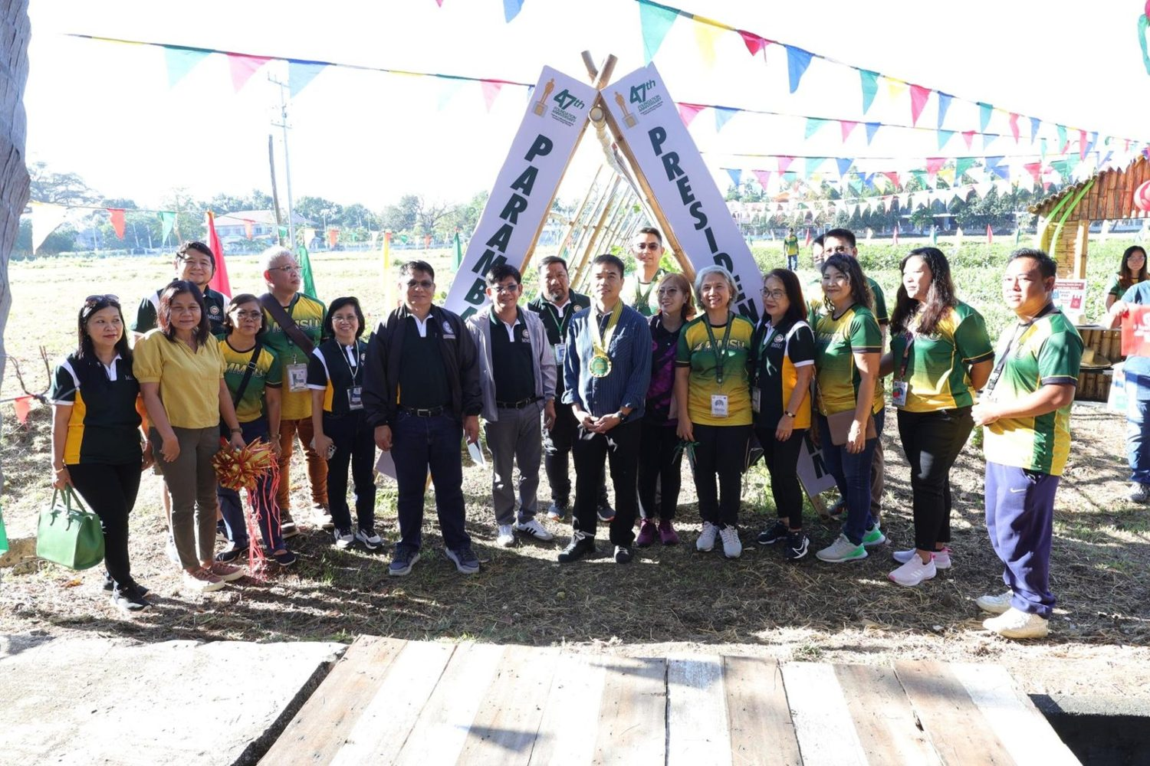
7th Parambak ditoy MMSU, in front of CAFSD, 14 February 2025. (Photo: MMSU STRATCOM)

On February 14, 2025, to close its 47th Foundation Anniversary, MMSU held the 7th Parambak ditoy MMSU in front of the College of Agriculture, Food and Sustainable Development, highlighting the impact of its extension and research programmes on community development and agricultural innovation. Thirty-seven exhibitors took part, including learning sites of the Agricultural Training Institute–Ilocos Region, Magsasaka Siyentista (farmer scientists), Balik-Probinsya beneficiaries and local government units, and the Research Directorate gave a speed talk on MMSU technologies such as off-season tomato and shallot production, Bolinao chicken, indigenous vegetables and black garlic.
Participants harvested fresh vegetables at the President’s Farm, 17 new partners of the Extension Directorate received certificates of appreciation, and beneficiaries shared how MMSU’s technologies had supported sustainable agriculture. Attendees included the Provincial Government of Ilocos Norte, LGUs, non-government organisations, farmer leaders, entrepreneurs and MMSU-assisted beneficiaries. Incoming President Virgilio Julius P. Manzano Jr. urged the units concerned to sustain sustainable farming practices.
Source
• MMSU Extension Directorate, “‘Parambak’ caps MMSU@47 celebration,” February 2025. https://extension.mmsu.edu.ph/news/show/368/parambak-caps-mmsu-at-47-celebration
Only the submission pick is entered in the portal. The other items are internal evidence.
5 · Before submission
☐ | The indicator on page 2 has a submission pick or a note that no evidence was found
☐ | One URL per indicator; no page that is only a list of links
☐ | A second person opened every URL and saw the answer on the page itself
☐ | Programmes are confirmed free of charge where the indicator asks
☐ | Every date falls in the data year, or the policy was in force by then
☐ | Nothing was created or backdated for this submission
☐ | Photo credits recorded; no personal data shown without consent
☐ | Page 1 updated; footer SDG number updated; all grey notes and example rows deleted
Open items for this indicator
☐ Attach the policy, or a Business Directorate sourcing memorandum, as the first item.
☐ THE asks for “policy created” and “policy reviewed” years: none can be given yet.

