 | INDICATOR 15.2.3  SDG 15 Life on Land  Evidence Report 2025  Mariano Marcos State University · THE Sustainability Impact Ratings 2027
Data year 2025 · Draft for validation · prepared 6 November 2026
SDG assigned | SDG 15 · Life on Land | Data year | 2025
Team Members | [Name, position] | Date prepared | 6 November 2026
1 · Sites and platforms explored
Every site and office where evidence for this indicator was found, and where nothing was found. A list of sites is not evidence; it only shows where the team has looked.
# | Site or office | URL or location | What was found
1 | MMSU Research Directorate | https://research.mmsu.edu.ph/news | 2 items for 15.2.3: Enriching MMSU’s 1,068-Hectare Forest Reserves with Native Species; Conserving Ilocos Indigenous Food Plants In Situ, Ex Situ and Circa Situ
2 | MMSU News | https://www.mmsu.edu.ph/news | 6 items for 15.2.3: Enriching MMSU’s 1,068-Hectare Forest Reserves with Native Species; Nature-based Solutions for Mangrove Ecosystems in Badoc and Currimao; MMSU, Rotary Club and Badoc LGU Restore a Typhoon-Damaged Mangrove Stand and 3 more
3 | MMSU Extension Directorate | https://extension.mmsu.edu.ph/news | 1 item for 15.2.3: Conserving Ilocos Indigenous Food Plants In Situ, Ex Situ and Circa Situ
4 | Office of Sustainability and Futures Thinking | Internal SDG 15 report (2025) | 2 items for 15.2.3: Conserving Ilocos Indigenous Food Plants In Situ, Ex Situ and Circa Situ; Nature-based Solutions for Mangrove Ecosystems in Badoc and Currimao
5 | Philippine News Agency (Facebook) | https://www.facebook.com/pnagovph | 1 item for 15.2.3: Indigenous Food Plants Propagated at the MMSU Botanical Garden Are Shared with Schools and Communities
6 | DOST-PCAARRD | https://www.pcaarrd.dost.gov.ph | 1 item for 15.2.3: Mangrove Nature-based Solutions Project Runs from 2024 to 2026
Not yet explored
Sources the team should still search. Suggestions are listed; add your own.
# | Source to search | Assigned to
1 | College and department websites and social media pages
2 | Office records (Registrar, HR, Planning, Procurement, Physical Plant, Student Affairs)
3 | Board of Regents resolutions and memoranda
4 | Extension and Research Directorate pages and accomplishment reports
5 | Agreements (MOA, MOU) with LGUs, agencies, NGOs and industry
6 | News outlets and partner websites (DENR, LGUs, DOST, PhilRice)
7 | [Add a source]
2 · Indicators to report
SDG 15 · Life on Land · data year 2025
Indicator | Description
15.2.3 | Maintain and extend current ecosystems’ biodiversity. Work directly to maintain and extend existing ecosystems and their biodiversity, especially ecosystems under threat.
3 · Optional: what other universities submit
What other universities claim for this indicator, and where MMSU might hold the same kind of evidence.
University | What it submits (indicator and type of evidence) | What to look for at MMSU
Caraga State University | 15.2.3: biodiversity surveys and a biodiversity-corridor workshop | Surveys or inventories of the forest reserves and mangrove sites, if any exist.
[Add the THE edition and URL for each result before using this page.]
4 · Evidence by indicator
SDG 15.2.3 · Maintain and extend current ecosystems’ biodiversity
Work directly to maintain and extend existing ecosystems and their biodiversity, of both plants and animals, especially ecosystems under threat.
Evidence year: 2025 (calendar year)
Submission pick: Indigenous Food Plants Program, https://extension.mmsu.edu.ph/news/show/389/mmsu-expands-indigenous-food-plant-seedbanks-and-foodscapes-in-lgus
Conserving Ilocos Indigenous Food Plants In Situ, Ex Situ and Circa Situ
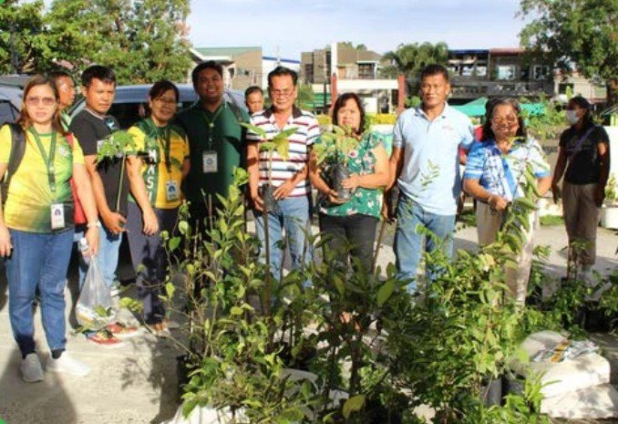
Partners receive indigenous food plant planting materials for the Community Foodscapes and Seedbanks, World Food Day 2025.

Through its Indigenous Food Plants (IFP) Program, MMSU conserves the wild and neglected food plants of Ilocos Norte, 46 of which were documented by the program in seven towns of the province. The program follows a triad of conservation approaches: an IFP Botanical Garden for ex situ conservation, a himbabao (alukon) genebank at the MMSU Forest Reserve, circa situ cultivation of the wild yams kamangeg and dolian, and the integration of IFPs into community foodscapes.
In October 2025, in celebration of World Food Day, the MMSU Extension and Research Directorates established the second batch of Community Foodscapes and Seedbanks for Indigenous Food Plants with local government units and schools, at Eladio V. Barangan Memorial Elementary School in San Nicolas, Ilocos Norte. The foodscape sites serve as seedbanks and learning gardens, and partner communities receive planting materials and technical assistance to cultivate kapaskapas, alokon, pako, dalayap, wild singkamas and roselle. The new partners join existing foodscape sites in Sarrat and Batac.
The IFP Program was adopted by the Regional Development Council of Region 1 as its first research and development initiative, and a study on the program by Dr. Menisa A. Antonio and co-authors won Best Paper in the Sustainable and Smart Agri-Aquaculture and Climate Resilience category of the SUC-ACAP 2025 Biennial Conference, held August 27–29, 2025, in Tagbilaran City, Bohol.
Source
• MMSU Research Directorate, “MMSU research on indigenous food plants wins best paper at SUC-ACAP 2025 Conference,” 29 August 2025. https://research.mmsu.edu.ph/news/details/mmsu-research-on-indigenous-food-plants-wins-best-paper-at-suc-acap-2025-conference
• MMSU Extension Directorate, “MMSU expands indigenous food plant seedbanks and foodscapes in LGUs,” October 2025. https://extension.mmsu.edu.ph/news/show/389/mmsu-expands-indigenous-food-plant-seedbanks-and-foodscapes-in-lgus
• MMSU SDG 15 Life on Land report (2025), Office of Sustainability and Futures Thinking
Enriching MMSU’s 1,068-Hectare Forest Reserves with Native Species
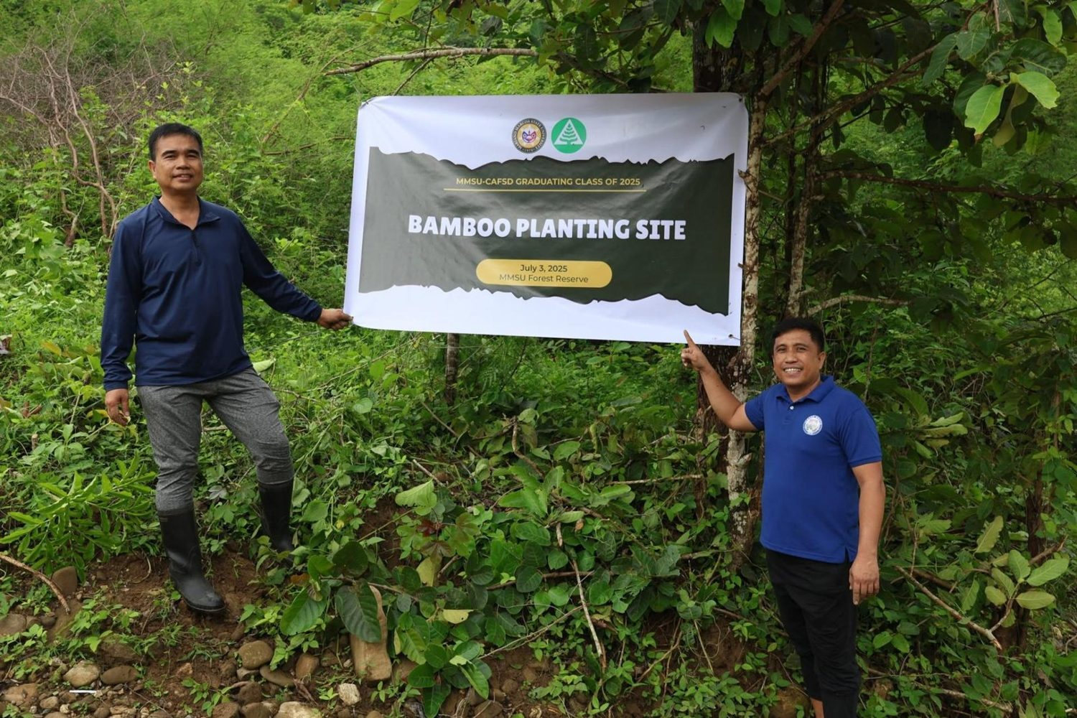
Bamboo planting site in the University Forest Reserve, Brgy. Mabaleng, 2 July 2025. (Photo: MMSU STRATCOM)

MMSU manages Forest Reserve Areas in Barangays Lubbot and Payao, City of Batac, covering a total of 1,068.13 hectares, where the university’s forestry and agroforestry research is set up. The university maintains and extends these ecosystems with planting stock raised in its own nurseries, the MMSU Central Nursery and the MMSU Bamboo Nursery.
On July 2, 2025, 230 CAFSD graduating students enriched the reserves with 120 seedlings of the native dipterocarps guijo and yakal in Payao and 130 propagules of kawayan tinik, machiku and giant bamboo in Mabaleng. The activity was led by CAFSD OIC-Dean Charlie Batin with the MMSU Bamboo Research and Development Center.
Source
• MMSU Research Directorate, Station Profile. https://research.mmsu.edu.ph/about/station-profile
• MMSU News, “CAFSD graduands plant trees, bamboos in Batac forest reserves,” 4 July 2025. https://www.mmsu.edu.ph/article/news/2468/cafsd-graduands-plant-trees-bamboos-in-batac-forest-reserves
Nature-based Solutions for Mangrove Ecosystems in Badoc and Currimao
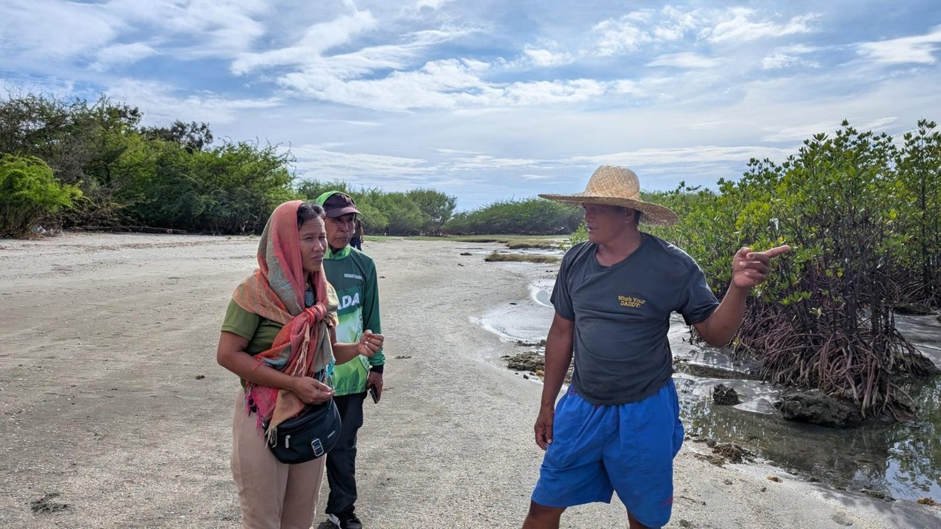  Mangrove site, from the gallery of the October 2025 seminar-workshop of the NbS mangrove project. (Photo: MMSU) | 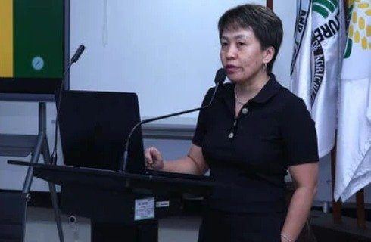  Dr. Arlene L. Gonzales at the MMSU–DENR Region 1 dialogue on mangrove conservation, ILAARRDEC.

Throughout 2025, MMSU implemented the DOST-PCAARRD-funded project “Nature-based Solutions (NbS) for Sustainable Mangrove Management and Resilient Coastal Communities Through Innovative Green Engineering Approach,” led by Dr. Arlene L. Gonzales, in Badoc and Currimao, Ilocos Norte, with DENR-PENRO Ilocos Norte, the Provincial Government of Ilocos Norte and the LGUs of Badoc and Currimao. The project uses green engineering and locally available, ecologically friendly materials, including bamboo-engineered structures that protect young mangroves and improve their survival.
In 2025, MMSU and DENR Region 1 met at ILAARRDEC to advance the work, with DENR pledging technical support and active participation in restoration, monitoring and evaluation, and the project trained representatives of Currimao, Pasuquin, Badoc and Burgos in mangrove propagation, management and conservation on October 27–28, 2025.
Source
• MMSU News, “MMSU trains Ilocos Norte coastal towns on mangrove propagation and management,” 5 November 2025. https://www.mmsu.edu.ph/article/news/2670/mmsu-trains-ilocos-norte-coastal-towns-on-mangrove-propagation-and-management
• MMSU SDG 15 Life on Land report (2025), Office of Sustainability and Futures Thinking
MMSU, Rotary Club and Badoc LGU Restore a Typhoon-Damaged Mangrove Stand
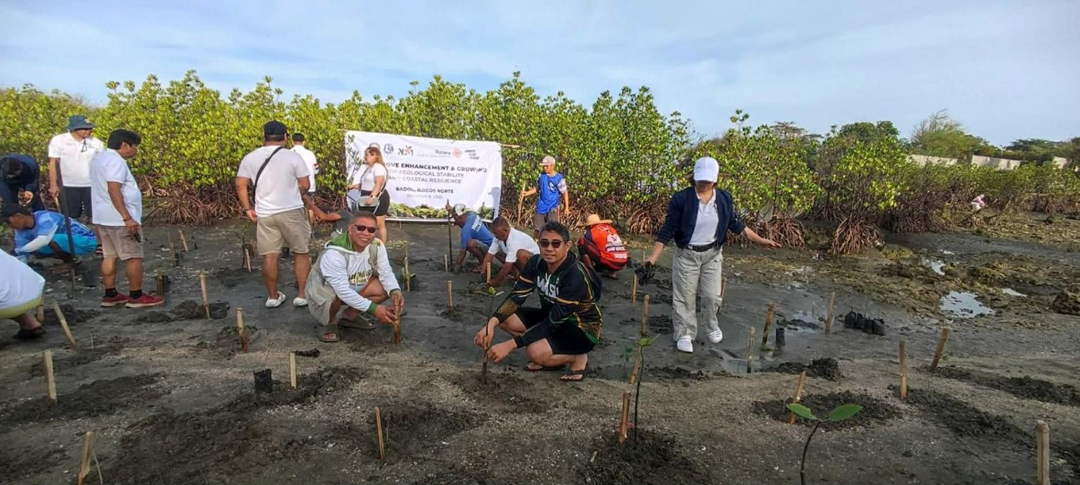  MMSU, Rotary Club of Laoag Sunshine and LGU-Badoc plant mangrove propagules in Brgy. Pagsanahan, Badoc, 6 December 2025. (Photo: MMSU) | 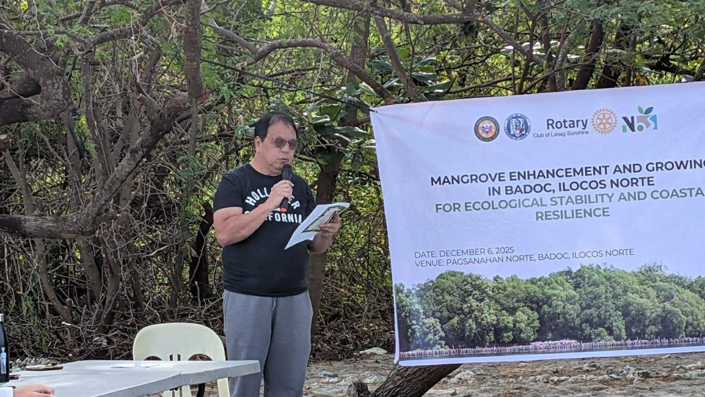  Participants of the mangrove enhancement and growing activity in Badoc, 6 December 2025. (Photo: MMSU)

On December 6, 2025, Mariano Marcos State University, the Rotary Club of Laoag Sunshine and the Local Government Unit of Badoc planted 280 mangrove propagules in Barangay Pagsanahan, Badoc, Ilocos Norte, to restore a mangrove stand extensively damaged by past typhoons and to ensure the continuity of ecological succession at the site.
The activity was led by MMSU President Virgilio Julius P. Manzano Jr., with the LGU of Badoc headed by Hon. Virgilio M. Calajate and the Rotary Club of Laoag Sunshine under Atty. Zsa Zsa Raval. MMSU’s Vice President for Resource Generation and its Directors for Extension, Curriculum Development and Innovative Learning, and Student Affairs and Development also took part.
Source
• MMSU News, “MMSU ties up with Rotary Club of Laoag Sunshine for mangrove planting in Badoc town,” 11 December 2025. https://www.mmsu.edu.ph/news/mmsu-ties-up-with-rotary-club-of-laoag-sunshine-for-mangrove-planting-in-badoc-town
A New Bambusetum in Barangay Aglipay, Pinili
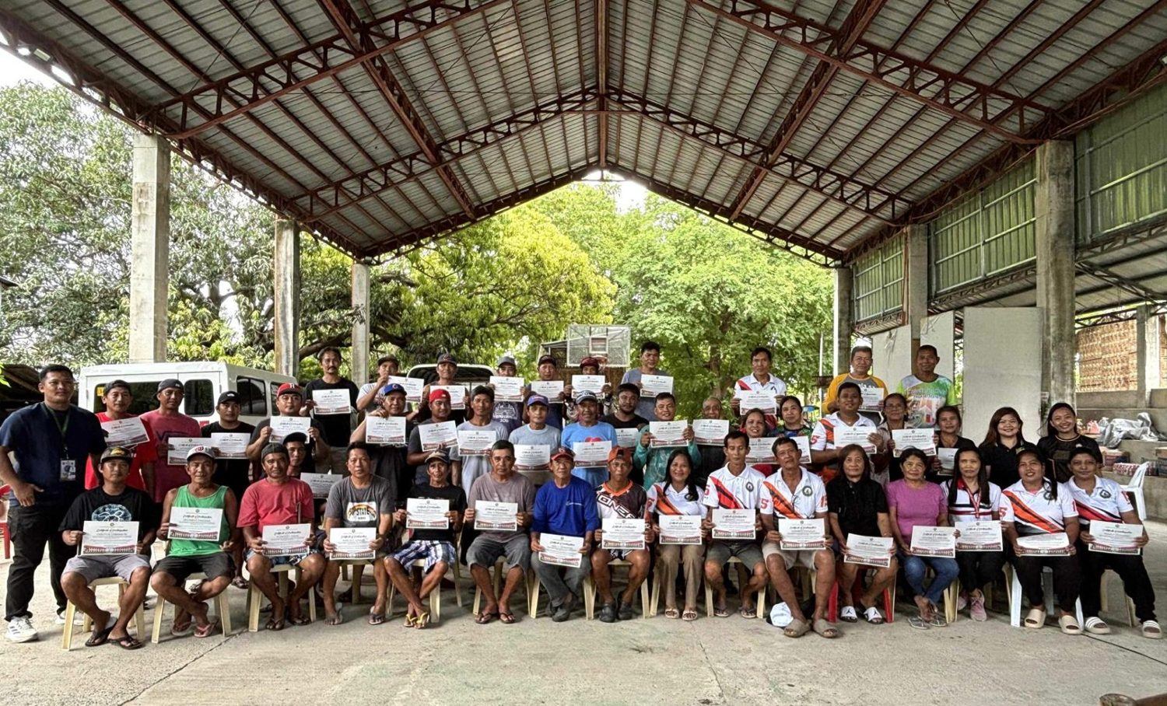
Participants of the bamboo propagation, nursery and plantation management training, Brgy. Aglipay, Pinili, 2025. (Photo: MMSU)

During a two-day bamboo production training in 2025, the MMSU Extension Directorate and CAFSD, with Barangay Aglipay, Pinili, and the support of ILAARRDEC, worked with 46 farmers, local leaders and community members to establish a new bambusetum, a collection of bamboo species, in Barangay Aglipay. The training covered bamboo propagation, nursery establishment and plantation management.
Source
• MMSU News, “Sustainable livelihood: MMSU, ILAARRDEC hold bamboo training in Pinili,” 3 September 2025. https://www.mmsu.edu.ph/news/sustainable-livelihood-mmsu-ilaarrdec-hold-bamboo-training-in-pinili
Indigenous Food Plants Propagated at the MMSU Botanical Garden Are Shared with Schools and Communities
Dated 6 June 2026, after the data year. Internal evidence only; the 2025 foodscape items carry the claim.
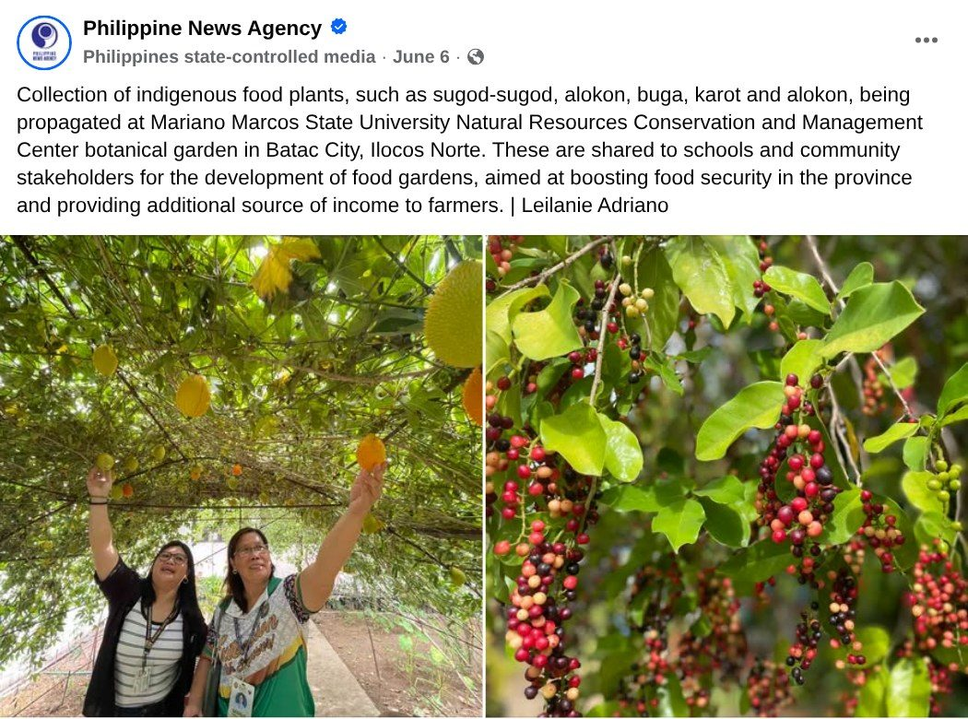  Capture: Philippine News Agency post of 6 June 2026 on indigenous food plants propagated at the MMSU NRCMC botanical garden (photos: Leilanie Adriano, PNA). | Partners receive indigenous food plant planting materials for the Community Foodscapes and Seedbanks, World Food Day 2025.

On June 6, 2026, the Philippine News Agency reported that indigenous food plants such as sugod-sugod, alokon, buga and karot are being propagated at the botanical garden of the MMSU Natural Resources Conservation and Management Center in Batac City, Ilocos Norte. The planting materials are shared with schools and community stakeholders for the development of food gardens, to boost food security in the province and provide farmers with an additional source of income.
The botanical garden is part of the ex situ arm of MMSU’s Indigenous Food Plants Program, which in 2025 extended its community foodscapes and seedbanks to new partner barangays (see the 2025 evidence for this indicator).
Source
• Philippine News Agency, Facebook post on indigenous food plants at the MMSU Natural Resources Conservation and Management Center botanical garden, 6 June 2026. https://www.facebook.com/pnagovph/posts/1411199747723142/
Mangrove Nature-based Solutions Project Runs from 2024 to 2026
Project term 1 May 2024 to 30 April 2026, which covers the data year.
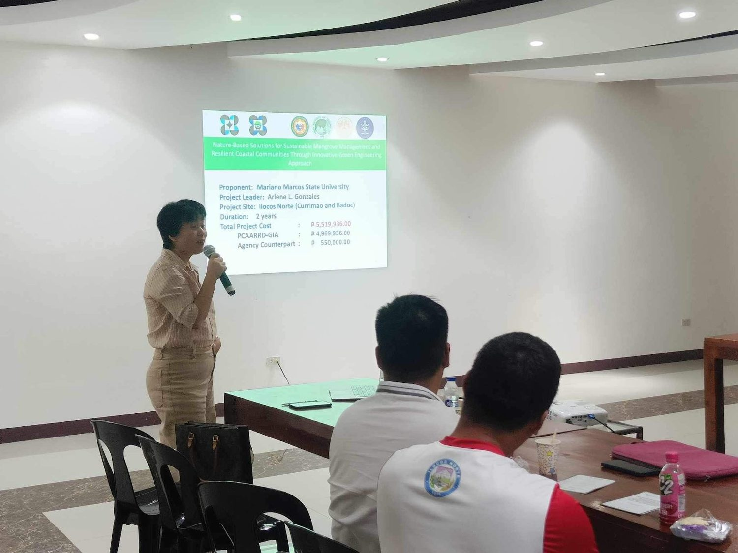  Project Leader Dr. Arlene L. Gonzales presents the project at its launch, MMSU Review Center, 27 June 2024. (Image credit: TTPD, DOST-PCAARRD) | 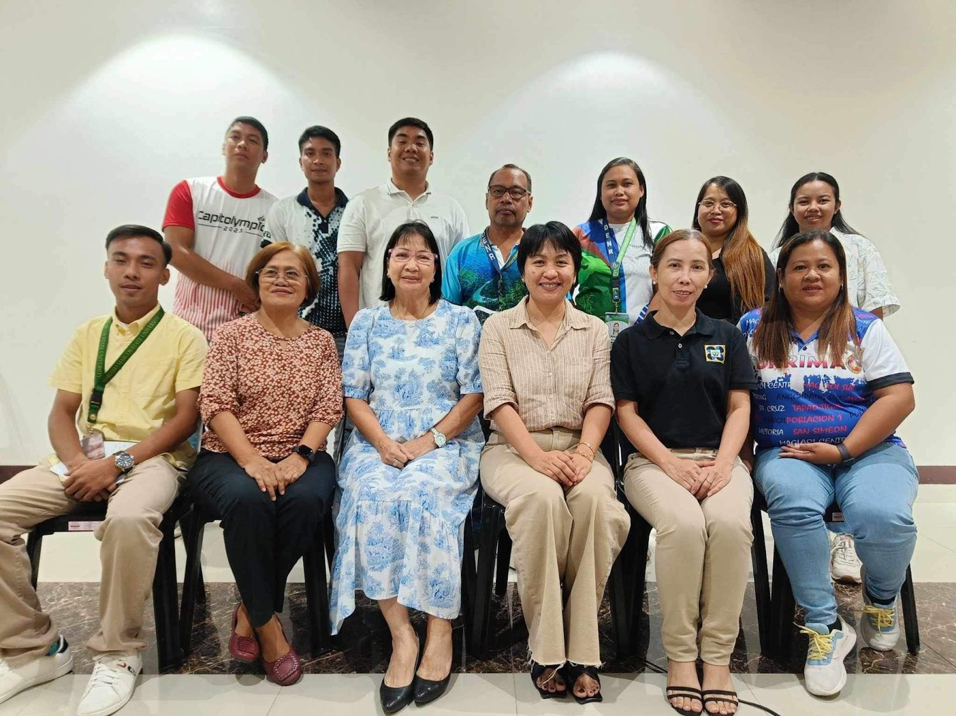  The MMSU project team with DOST-PCAARRD, DENR-PENRO Ilocos Norte, the Provincial Government of Ilocos Norte and the LGUs of Badoc and Currimao at the launch. (Image credit: TTPD, DOST-PCAARRD)

The DOST-PCAARRD-funded project “Nature-based Solutions (NbS) for Sustainable Mangrove Management and Resilient Coastal Communities Through Innovative Green Engineering Approach,” led by Dr. Arlene L. Gonzales of MMSU, was launched at the MMSU Review Center on June 27, 2024, and runs from May 1, 2024 to April 30, 2026 in Badoc and Currimao, Ilocos Norte. DENR-PENRO Ilocos Norte, the Provincial Government of Ilocos Norte and the local government units of Badoc and Currimao support the project.
The project addresses the poor hydrological conditions that keep young mangrove propagules from surviving, using technology-assisted plantations and locally available, ecologically friendly materials, including bamboo-engineered structures that protect young mangroves and improve their survival.
The 2025 activities of the project, including the dialogue with DENR Region 1 and the October 2025 mangrove propagation seminar-workshop, are described under Indicators 15.2.3 and 15.2.4.
Source
• DOST-PCAARRD, “DOST-PCAARRD, MMSU launch nature-based solutions project on mangrove management in Ilocos Norte,” 7 August 2024. https://www.pcaarrd.dost.gov.ph/index.php/quick-information-dispatch-qid-articles/dost-pcaarrd-mmsu-launch-nature-based-solutions-project-on-mangrove-management-in-ilocos-norte
Bambusetums Create Living Collections for Bamboo Conservation and Learning
Dingras launch dated 30 September 2026, after the data year. Internal evidence only.
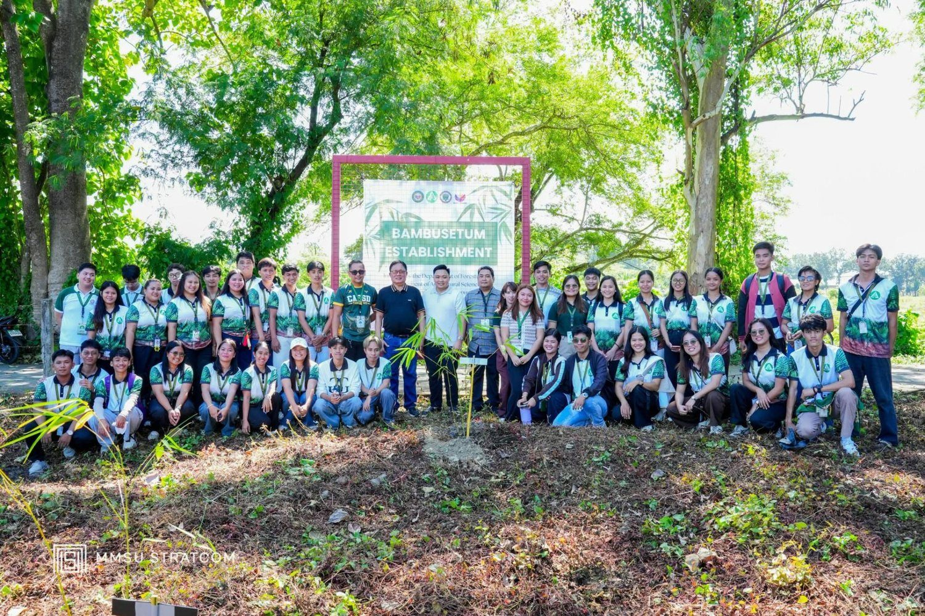
Launch of the bambusetum at the MMSU Dingras Campus, 30 September 2026. (Photo: MMSU STRATCOM)

In celebration of Bamboo Month, the MMSU Dingras Campus, through CAFSD, launched its bambusetum on September 30, 2026, to advance bamboo research, education and sustainable use. Students, faculty, field workers and stakeholders joined the planting, where For. Charlie Maine Cacactin demonstrated the proper planting of various bamboo species, and members of the Association of Young Agriculturists, Green Triangle Organization, Health and Wellness Club and Junior Foresters’ Association supported the activity. The bambusetum is the second in the university, after the one at the Main Campus.
The bambusetum will serve as a living collection of bamboo species and a learning site for teaching, research, technology development and community extension, showcasing bamboo’s ecological and socioeconomic benefits for food security, livelihood, environmental conservation and climate resilience. It follows the bambusetum that training participants established in Barangay Aglipay, Pinili, in 2025. CAFSD Dean Charlie Batin said the work responds to environmental problems such as climate change.
Source
• MMSU News, “MMSU CAFSD-Dingras launches bambusetum to advance bamboo research and education,” 2 October 2026. https://www.mmsu.edu.ph/article/news/3206/mmsu-cafsd-dingras-launches-bambusetum-to-advance-bamboo-research-and-education
• MMSU News, “Sustainable livelihood: MMSU, ILAARRDEC hold bamboo training in Pinili,” 3 September 2025. https://www.mmsu.edu.ph/news/sustainable-livelihood-mmsu-ilaarrdec-hold-bamboo-training-in-pinili
Biodiversity Conservation Learning Center and Leisure Park Is Enriched with 28 Native Tree Species
In place since 2023. No photo is attached yet.
On January 13, 2023, MMSU planted 120 more seedlings of 28 native tree species and two bamboo species at the Biodiversity Conservation Learning Center and Leisure Park on the Main Campus, led by then President Shirley C. Agrupis with administrators, faculty, staff and students. The park is used as a field laboratory for classes and was identified for development into a health and wellness tourism hub, a plan endorsed by the provincial government and aligned with the Health and Wellness Complex of the College of Medicine.
The planting continues a tradition that began in 2017 with the Green Wall project on the Batac campus and extends to the Nagbacsan site and the Currimao, Dingras and Laoag campuses, as the university’s contribution to the provincial “Green Wall of Ilocos Norte” and the National Greening Program of the Department of Environment and Natural Resources.
Source
• MMSU News, “More trees planted at MMSU to establish ‘health tourism’ hub,” 13 January 2023. https://www.mmsu.edu.ph/news/more-trees-planted-at-mmsu-to-establish-health-tourism-hub
Only the submission pick is entered in the portal. The other items are internal evidence.
5 · Before submission
☐ | The indicator on page 2 has a submission pick or a note that no evidence was found
☐ | One URL per indicator; no page that is only a list of links
☐ | A second person opened every URL and saw the answer on the page itself
☐ | Programmes are confirmed free of charge where the indicator asks
☐ | Every date falls in the data year, or the policy was in force by then
☐ | Nothing was created or backdated for this submission
☐ | Photo credits recorded; no personal data shown without consent
☐ | Page 1 updated; footer SDG number updated; all grey notes and example rows deleted
Open items for this indicator
☐ Add a source link or screenshot for the NbS and IFP items cited to the SFT Office report.

