 | INDICATOR 15.2.4  SDG 15 Life on Land  Evidence Report 2025  Mariano Marcos State University · THE Sustainability Impact Ratings 2027
Data year 2025 · Draft for validation · prepared 6 November 2026
SDG assigned | SDG 15 · Life on Land | Data year | 2025
Team Members | [Name, position] | Date prepared | 6 November 2026
1 · Sites and platforms explored
Every site and office where evidence for this indicator was found, and where nothing was found. A list of sites is not evidence; it only shows where the team has looked.
# | Site or office | URL or location | What was found
1 | MMSU News | https://www.mmsu.edu.ph/news | 3 items for 15.2.4: MMSU Trains Coastal Towns on Mangrove Propagation, Management and Conservation; Farmers in Sarrat Trained to Propagate the Indigenous Alukon; MMSU Brings Bamboo and Alukon Propagation to the 2025 Siwawer Farmers’ Festival
2 | MMSU Extension Directorate | https://extension.mmsu.edu.ph/news | 1 item for 15.2.4: Community Foodscapes as Learning Gardens for Indigenous Plants
3 | Office of Sustainability and Futures Thinking | Internal SDG 15 report (2025) | 1 item for 15.2.4: Community Foodscapes as Learning Gardens for Indigenous Plants
4 | Philippine News Agency (Facebook) | https://www.facebook.com/pnagovph | 1 item for 15.2.4: Indigenous Food Plants Propagated at the MMSU Botanical Garden Are Shared with Schools and Communities
Not yet explored
Sources the team should still search. Suggestions are listed; add your own.
# | Source to search | Assigned to
1 | College and department websites and social media pages
2 | Office records (Registrar, HR, Planning, Procurement, Physical Plant, Student Affairs)
3 | Board of Regents resolutions and memoranda
4 | Extension and Research Directorate pages and accomplishment reports
5 | Agreements (MOA, MOU) with LGUs, agencies, NGOs and industry
6 | News outlets and partner websites (DENR, LGUs, DOST, PhilRice)
7 | [Add a source]
2 · Indicators to report
SDG 15 · Life on Land · data year 2025
Indicator | Description
15.2.4 | Educational programmes on ecosystems. Programmes on wild flora and fauna for local or national communities.
4 · Evidence by indicator
SDG 15.2.4 · Educational programmes on ecosystems
Offer educational programmes on ecosystems (looking at wild flora and fauna) for local or national communities.
Evidence year: 2025 (calendar year)
Submission pick: Mangrove seminar-workshop, https://www.mmsu.edu.ph/article/news/2670/mmsu-trains-ilocos-norte-coastal-towns-on-mangrove-propagation-and-management Confirm that the seminar was free of charge.
MMSU Trains Coastal Towns on Mangrove Propagation, Management and Conservation
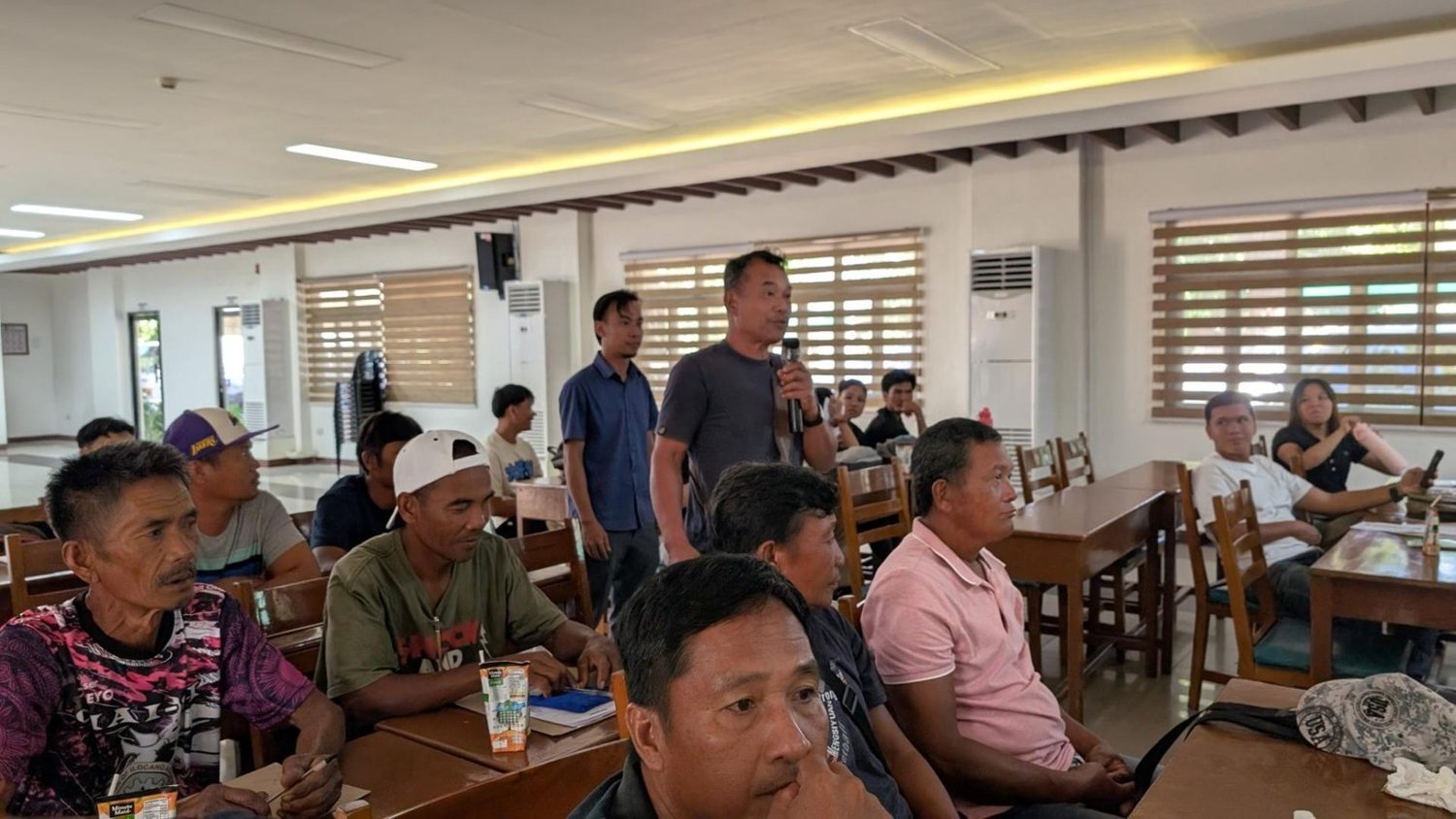  Representatives of Currimao, Pasuquin, Badoc and Burgos at the Seminar-Workshop on Mangrove Propagation, 27–28 October 2025. (Photo: MMSU) | 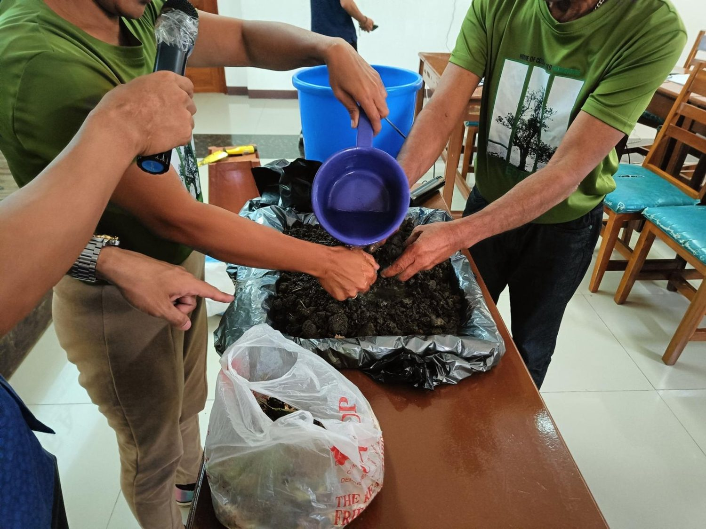  Hands-on mangrove nursery and propagation practice during the seminar-workshop. (Photo: MMSU)

MMSU conducted a two-day Seminar-Workshop on Mangrove Propagation on October 27–28, 2025 at its Center for Flexible Learning for representatives of the coastal municipalities of Currimao, Pasuquin, Badoc and Burgos, Ilocos Norte, with officials of DENR-PENRO in attendance. The training was organized under the DOST-PCAARRD-funded nature-based solutions mangrove project led by Dr. Arlene Gonzales.
Sessions covered the importance of mangrove ecosystems, nature-based solutions for conservation, legal frameworks for mangrove protection, and the roles of the academe and local government units in community-based mangrove management. Participants were also trained in nursery management and advanced propagation techniques for Avicennia and Sonneratia species and other local mangrove varieties. The Pedada People’s Organization shared its experience in establishing community-based mangrove conservation.
Source
• MMSU News, “MMSU trains Ilocos Norte coastal towns on mangrove propagation and management,” 5 November 2025. https://www.mmsu.edu.ph/article/news/2670/mmsu-trains-ilocos-norte-coastal-towns-on-mangrove-propagation-and-management
Farmers in Sarrat Trained to Propagate the Indigenous Alukon
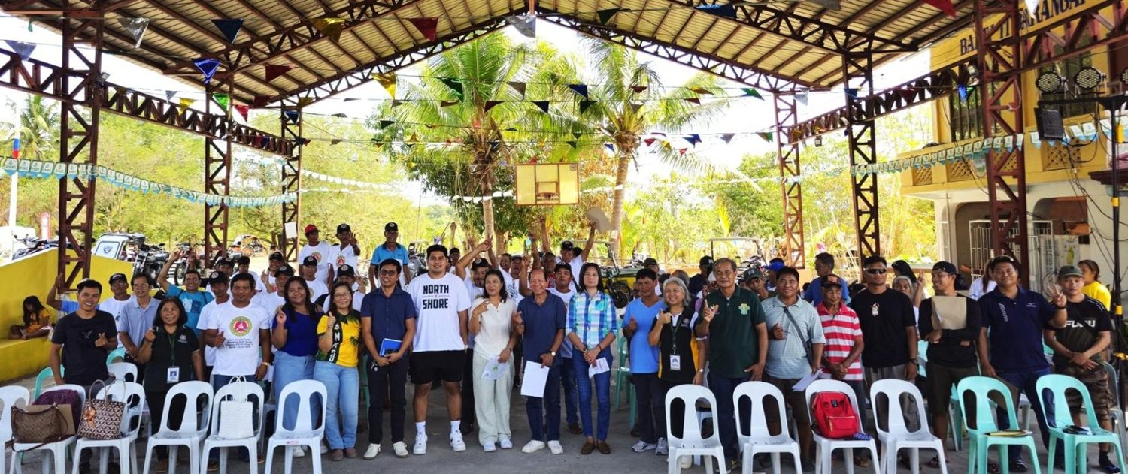
Farmers and local officials trained on alukon (himbabao) propagation, Brgy. 11 Sta. Rosa, Sarrat, 2 May 2025. (Photo: MMSU)

On May 2, 2025, the MMSU Research and Extension Directorates trained 64 farmers in Barangay 11 Sta. Rosa, Sarrat, Ilocos Norte, on the propagation of alukon (himbabao), a Philippine indigenous vegetable tree. Barangay officials, members of the Task Force Dagger Special Operations Foundation and representatives of the local government unit also attended. The training was held in response to requests from the community.
Resource speakers Dr. Menisa Antonio, Engr. Josefa Pugat and Mr. Jayson Rasay of the Research Directorate presented recommended propagation strategies to establish sustained alukon production in the community and broaden the use of the crop for food and other applications.
Source
• MMSU News, “MMSU trains Sarrat farmers on alukon propagation,” 9 May 2025. https://www.mmsu.edu.ph/news/mmsu-trains-sarrat-farmers-on-alukon-propagation
MMSU Brings Bamboo and Alukon Propagation to the 2025 Siwawer Farmers’ Festival
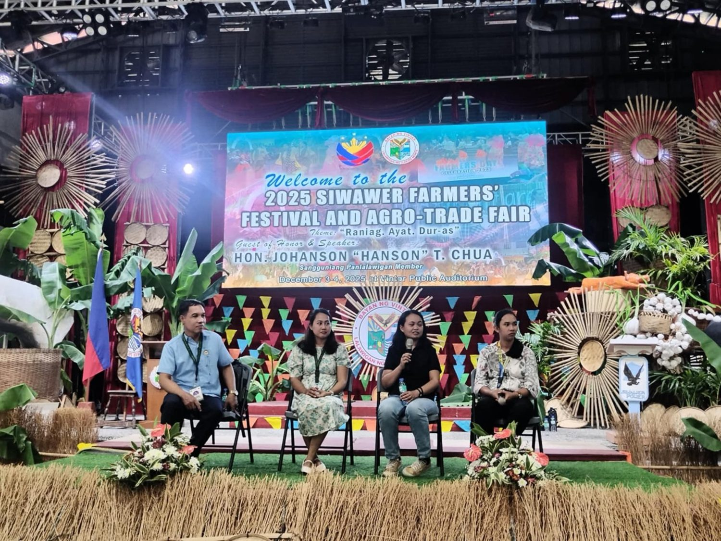
MMSU Information and Technology Caravan at the 2025 Siwawer Farmers’ Festival, Vintar, 3–4 December 2025. (Photo: MMSU STRATCOM)

Through its Information and Technology Caravan, MMSU’s Research and Extension Directorates joined the 2025 Siwawer Farmers’ Festival and Agro-Trade Fair at the Vintar Public Auditorium on December 3–4, 2025, with an exhibit of university technologies and a series of expert lectures for farmers.
Forester Shena Rose Garcia introduced sustainable bamboo production using MMSU’s one-node cutting technology, and the second day featured a demonstration on the propagation of alukon, an indigenous vegetable tree, facilitated by Ms. Josefa Pugat. Other lectures covered high-yielding glutinous corn varieties, garlic disease management and black garlic.
Source
• MMSU News, “MMSU IT caravan goes to Vintar,” 15 December 2025. https://www.mmsu.edu.ph/news/mmsu-it-caravan-goes-to-vintar
Community Foodscapes as Learning Gardens for Indigenous Plants
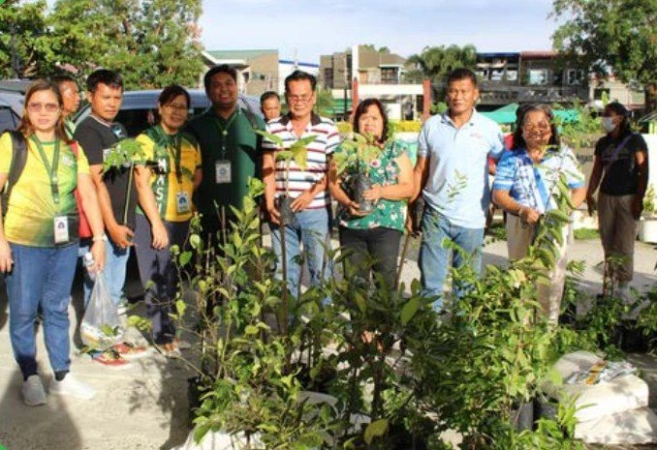
Partners receive indigenous food plant planting materials for the Community Foodscapes and Seedbanks, World Food Day 2025.

In October 2025, in celebration of World Food Day, the MMSU Extension and Research Directorates established the second batch of Community Foodscapes and Seedbanks for Indigenous Food Plants at Eladio V. Barangan Memorial Elementary School, San Nicolas, Ilocos Norte. Barangay officials of San Roque and Parut, Vintar, agricultural extension workers, school leaders and community representatives took part.
The foodscape sites serve as seedbanks and learning gardens that encourage knowledge sharing and sustainable farming practices. Communities receive planting materials and technical assistance to cultivate indigenous crops such as kapaskapas, alokon, pako, dalayap, wild singkamas and roselle, conserving indigenous food resources across Ilocos Norte.
Source
• MMSU Extension Directorate, “MMSU expands indigenous food plant seedbanks and foodscapes in LGUs,” October 2025. https://extension.mmsu.edu.ph/news/show/389/mmsu-expands-indigenous-food-plant-seedbanks-and-foodscapes-in-lgus
• MMSU SDG 15 Life on Land report (2025), Office of Sustainability and Futures Thinking
Indigenous Food Plants Propagated at the MMSU Botanical Garden Are Shared with Schools and Communities
Dated 6 June 2026, after the data year. Internal evidence only; the 2025 foodscape items carry the claim.
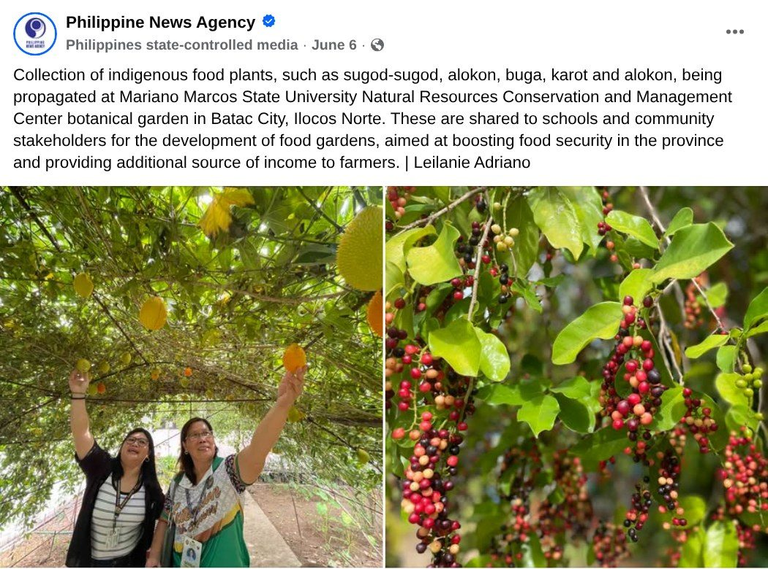  Capture: Philippine News Agency post of 6 June 2026 on indigenous food plants propagated at the MMSU NRCMC botanical garden (photos: Leilanie Adriano, PNA). | Partners receive indigenous food plant planting materials for the Community Foodscapes and Seedbanks, World Food Day 2025.

On June 6, 2026, the Philippine News Agency reported that indigenous food plants such as sugod-sugod, alokon, buga and karot are being propagated at the botanical garden of the MMSU Natural Resources Conservation and Management Center in Batac City, Ilocos Norte. The planting materials are shared with schools and community stakeholders for the development of food gardens, to boost food security in the province and provide farmers with an additional source of income.
The botanical garden is part of the ex situ arm of MMSU’s Indigenous Food Plants Program, which in 2025 extended its community foodscapes and seedbanks to new partner barangays (see the 2025 evidence for this indicator).
Source
• Philippine News Agency, Facebook post on indigenous food plants at the MMSU Natural Resources Conservation and Management Center botanical garden, 6 June 2026. https://www.facebook.com/pnagovph/posts/1411199747723142/
Only the submission pick is entered in the portal. The other items are internal evidence.
5 · Before submission
☐ | The indicator on page 2 has a submission pick or a note that no evidence was found
☐ | One URL per indicator; no page that is only a list of links
☐ | A second person opened every URL and saw the answer on the page itself
☐ | Programmes are confirmed free of charge where the indicator asks
☐ | Every date falls in the data year, or the policy was in force by then
☐ | Nothing was created or backdated for this submission
☐ | Photo credits recorded; no personal data shown without consent
☐ | Page 1 updated; footer SDG number updated; all grey notes and example rows deleted
Open items for this indicator
☐ Free access: state that the mangrove seminar and alukon training were free of charge, if true. THE gives full credit only to free programmes.
☐ Confirm whether the Siwawer caravan and foodscape activities were free.

