 | INDICATOR 15.2.6  SDG 15 Life on Land  Evidence Report 2025  Mariano Marcos State University · THE Sustainability Impact Ratings 2027
Data year 2025 · Draft for validation · prepared 6 November 2026
SDG assigned | SDG 15 · Life on Land | Data year | 2025
Team Members | [Name, position] | Date prepared | 6 November 2026
1 · Sites and platforms explored
Every site and office where evidence for this indicator was found, and where nothing was found. A list of sites is not evidence; it only shows where the team has looked.
# | Site or office | URL or location | What was found
1 | MMSU News | https://www.mmsu.edu.ph/news | 3 items for 15.2.6: Rice Paddy Art Brings Visitors to MMSU’s Farm-Tourism Demonstration Fields; DOST-PCAARRD and UP-ISSI Assess MMSU’s Proposed TALON Farm Tourism Project; Biodiversity Conservation Learning Center and Leisure Park Is Enriched with 28 Native Tree Species
2 | MMSU SDG 15 and policy resource pages | https://www.mmsu.edu.ph/resources | 1 item for 15.2.6: MMSU Expert Serves on the Kalbario-Patapat Natural Park Technical Working Group
Not yet explored
Sources the team should still search. Suggestions are listed; add your own.
# | Source to search | Assigned to
1 | College and department websites and social media pages
2 | Office records (Registrar, HR, Planning, Procurement, Physical Plant, Student Affairs)
3 | Board of Regents resolutions and memoranda
4 | Extension and Research Directorate pages and accomplishment reports
5 | Agreements (MOA, MOU) with LGUs, agencies, NGOs and industry
6 | News outlets and partner websites (DENR, LGUs, DOST, PhilRice)
7 | [Add a source]
2 · Indicators to report
SDG 15 · Life on Land · data year 2025
Indicator | Description
15.2.6 | Sustainable management of land for tourism. Educational programme or outreach for local or national communities.
4 · Evidence by indicator
SDG 15.2.6 · Sustainable management of land for tourism (educational outreach)
Offer educational programme/outreach for local or national communities on sustainable management of land for tourism.
Evidence year: 2025 (calendar year)
Submission pick: Rice paddy art, https://www.mmsu.edu.ph/article/news/2527/2025-rice-paddy-art-features-ched-chair-agrupis Weak fit: a farm-tourism attraction with student guides, not a structured training for communities. Add visitor or tour numbers and any briefing given to visitors.
Rice Paddy Art Brings Visitors to MMSU’s Farm-Tourism Demonstration Fields
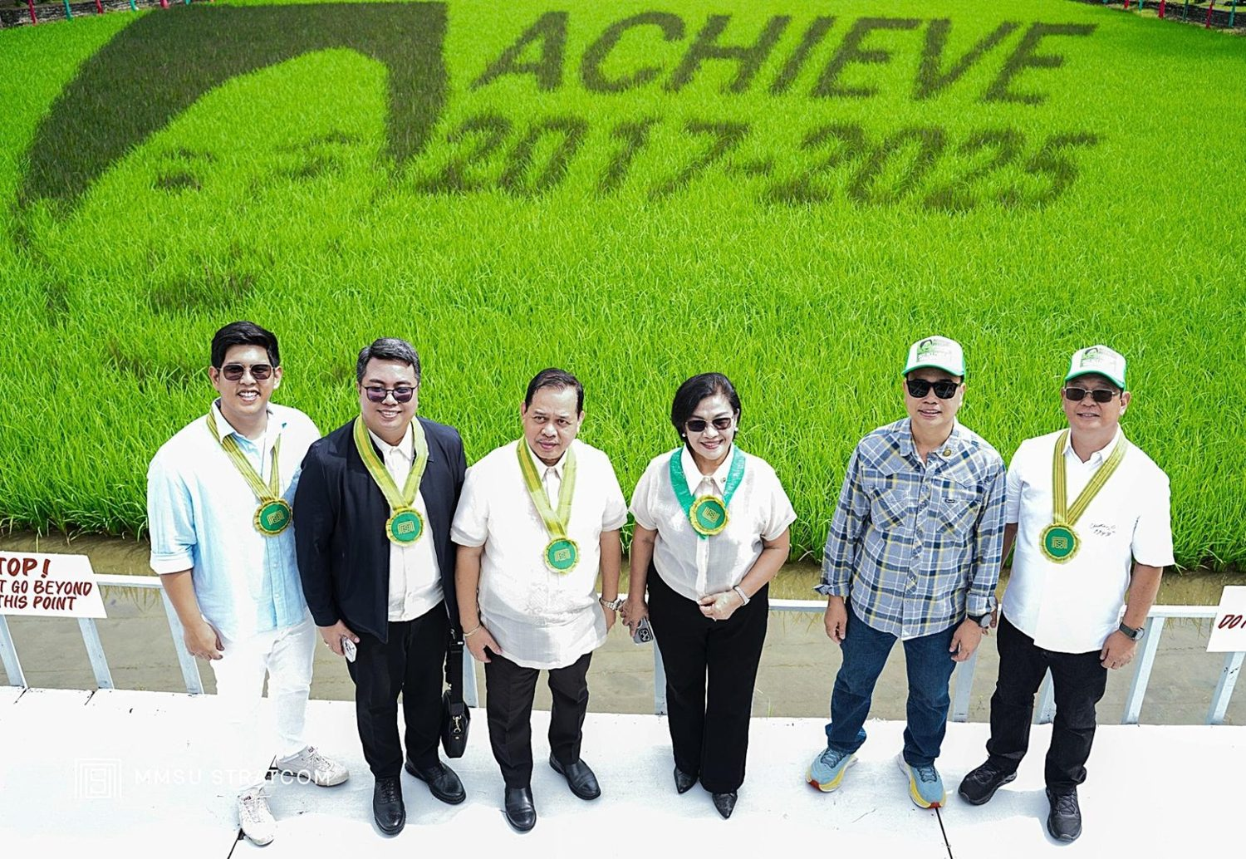  Unveiling of the 2025 rice paddy art featuring CHED Chairperson Shirley C. Agrupis and her ACHIEVE agenda, MMSU Extension Demonstration Area, 22 August 2025. (Photo: MMSU STRATCOM) | 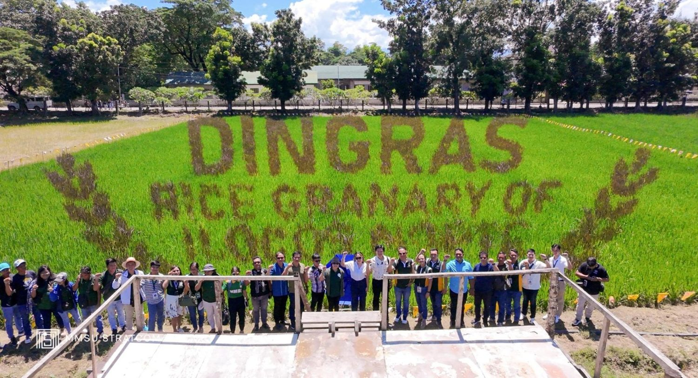  Rice paddy art featuring Dingras as the Rice Granary of Ilocos Norte, MMSU Dingras Campus, unveiled 9 September 2025. (Photo: MMSU STRATCOM)

In partnership with the Department of Agriculture–Philippine Rice Research Institute (DA-PhilRice), Mariano Marcos State University held the ceremonial transplanting of its eighth annual rice paddy art on July 7, 2025, at the Extension Demonstration Area near the Twin Gate of the Batac campus, and unveiled it on August 22, 2025. The design, featuring CHED Chairperson Shirley C. Agrupis and her ACHIEVE agenda, was realized with the PalayCheck System, the Carrageenan Plant Growth Regulator, and two rice varieties, purple rice (IR 1552) and green rice (NSIC Rc222). About 50 BS Agriculture students, with MMSU extension and research staff and PhilRice, served as guides and transplanters. MMSU President Virgilio Julius P. Manzano Jr. said the paddy art “attracts visitors, promotes research, and showcases innovation,” and Extension Director Dr. Marilou Lucas described it as a statement of commitment to agri-tourism, research and rice appreciation.
On September 9, 2025, the MMSU Dingras Campus unveiled its second rice paddy art, featuring Dingras as the Rice Granary of Ilocos Norte, created by MMSU student planters with PhilRice Ilocos Norte and the Local Government Unit of Dingras. Initiated in 2024, the Dingras paddy art is aligned with Republic Act 10816, the Farm Tourism Development Act, and CAFSD Dean Dr. Charlie B. Batin commended it for boosting agro-tourism and enrolment in agriculture programmes.
Source
• MMSU News, “CHED Chairperson Agrupis to be featured in MMSU-PhilRice paddy art,” 8 July 2025. https://www.mmsu.edu.ph/article/news/2472/ched-chairperson-agrupis-to-be-featured-in-mmsu-philrice-paddy-art
• MMSU News, “2025 Rice Paddy art features CHED Chair Agrupis,” 22 August 2025. https://www.mmsu.edu.ph/article/news/2527/2025-rice-paddy-art-features-ched-chair-agrupis
• MMSU News, “Dingras campus launches rice paddy art,” 12 September 2025. https://www.mmsu.edu.ph/article/news/2560/dingras-campus-launches-rice-paddy-art
DOST-PCAARRD and UP-ISSI Assess MMSU’s Proposed TALON Farm Tourism Project
Site visit of 15 January 2026, after the data year. Internal evidence only.
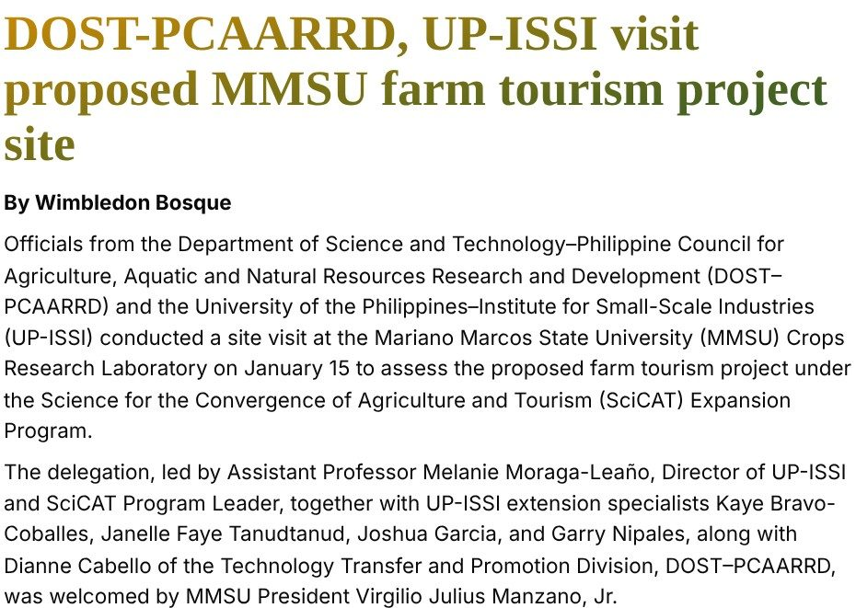  Capture: MMSU News, 20 January 2026, “DOST-PCAARRD, UP-ISSI visit proposed MMSU farm tourism project site” (headline and opening paragraphs). | 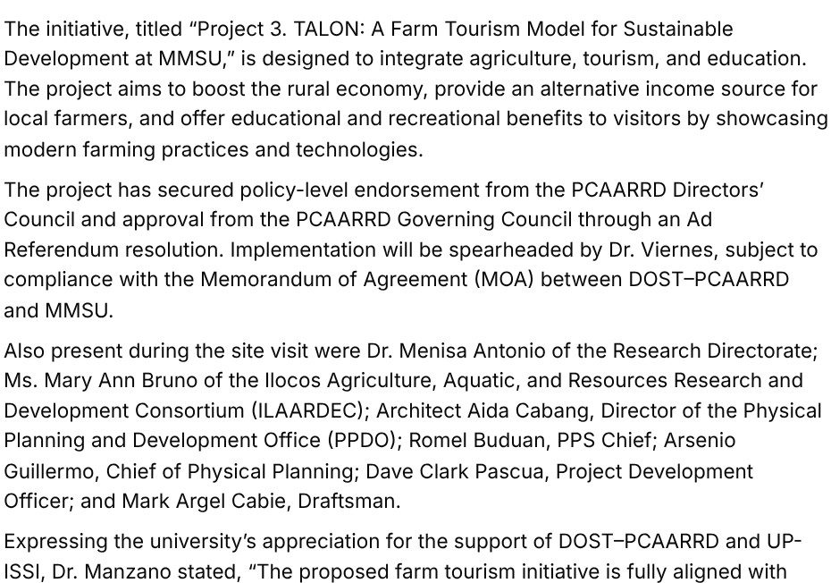  Capture: the same article, on Project 3 TALON and the approval of the PCAARRD Governing Council.

On January 15, 2026, officials of the Department of Science and Technology–Philippine Council for Agriculture, Aquatic and Natural Resources Research and Development (DOST-PCAARRD) and the University of the Philippines–Institute for Small-Scale Industries (UP-ISSI) visited the MMSU Crops Research Laboratory to assess a proposed farm tourism project under the Science for the Convergence of Agriculture and Tourism (SciCAT) Expansion Program. The delegation, led by UP-ISSI Director and SciCAT Program Leader Asst. Prof. Melanie Moraga-Leaño, was welcomed by MMSU President Virgilio Julius P. Manzano Jr. and guided through an on-site technical walkthrough by MMSU’s Vice President for Research, Development and Innovation, the Director for Research, Innovation and Technology, the dean of the College of Business, Economics and Accountancy, and project members from its Department of Tourism and Hospitality Management led by Dr. Eva Jean Viernes. Planners of the Physical Planning and Development Office and the Ilocos Agriculture, Aquatic and Natural Resources Research and Development Consortium (ILAARRDEC) also took part.
The project, “Project 3. TALON: A Farm Tourism Model for Sustainable Development at MMSU,” is designed to integrate agriculture, tourism and education. It aims to boost the rural economy, provide an alternative income source for local farmers, and offer educational and recreational benefits to visitors by showcasing modern farming practices and technologies. The project has the endorsement of the PCAARRD Directors’ Council and the approval of the PCAARRD Governing Council through an Ad Referendum resolution, and its implementation, led by Dr. Viernes, is subject to the memorandum of agreement between DOST-PCAARRD and MMSU. MMSU is among the select institutions developing science-and-technology-based agri-tourism hubs under SciCAT, which turns farms into tourism sites to promote innovation, entrepreneurship and community development.
Source
• MMSU News, “DOST-PCAARRD, UP-ISSI visit proposed MMSU farm tourism project site,” 20 January 2026. https://www.mmsu.edu.ph/article/news/2869/dost-pcaarrd-up-issi-visit-proposed-mmsu-farm-tourism-project-site
Biodiversity Conservation Learning Center and Leisure Park Is Enriched with 28 Native Tree Species
In place since 2023. No photo is attached yet.
On January 13, 2023, MMSU planted 120 more seedlings of 28 native tree species and two bamboo species at the Biodiversity Conservation Learning Center and Leisure Park on the Main Campus, led by then President Shirley C. Agrupis with administrators, faculty, staff and students. The park is used as a field laboratory for classes and was identified for development into a health and wellness tourism hub, a plan endorsed by the provincial government and aligned with the Health and Wellness Complex of the College of Medicine.
The planting continues a tradition that began in 2017 with the Green Wall project on the Batac campus and extends to the Nagbacsan site and the Currimao, Dingras and Laoag campuses, as the university’s contribution to the provincial “Green Wall of Ilocos Norte” and the National Greening Program of the Department of Environment and Natural Resources.
Source
• MMSU News, “More trees planted at MMSU to establish ‘health tourism’ hub,” 13 January 2023. https://www.mmsu.edu.ph/news/more-trees-planted-at-mmsu-to-establish-health-tourism-hub
MMSU Expert Serves on the Kalbario-Patapat Natural Park Technical Working Group
Appointment of 29 March 2023, still in effect as far as the records show.
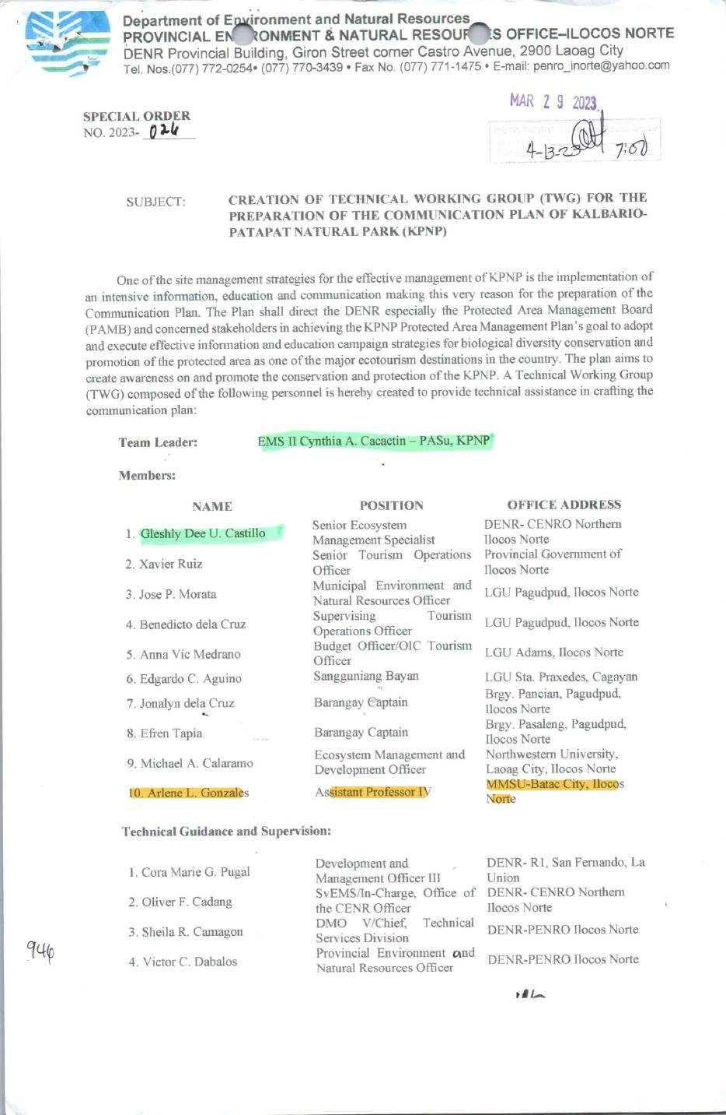
Document: DENR-PENRO Ilocos Norte Special Order No. 2023-024 (29 March 2023) naming Dr. Arlene L. Gonzales of MMSU to the KPNP Technical Working Group.

Through DENR-PENRO Ilocos Norte Special Order No. 2023-024, dated March 29, 2023, Dr. Arlene L. Gonzales of MMSU was named a member of the Technical Working Group that prepares the Communication Plan of the Kalbario-Patapat Natural Park (KPNP), a protected area in Ilocos Norte. The group, led by the KPNP Protected Area Superintendent, brings together DENR offices, the Provincial Government of Ilocos Norte, the LGUs of Pagudpud and Adams in Ilocos Norte and Sta. Praxedes in Cagayan, barangay officials and Northwestern University.
The Communication Plan supports the goal of the KPNP Protected Area Management Plan to adopt and carry out effective information and education campaigns for biological diversity conservation and for the promotion of the protected area as a major ecotourism destination.
Source
• DENR-PENRO Ilocos Norte Special Order No. 2023-024, 29 March 2023 (MMSU SDG 15 page). https://www.mmsu.edu.ph/resources/1TCpM-DxbkgfOh4QGwlfVr8QavCchKWKu/data
Only the submission pick is entered in the portal. The other items are internal evidence.
5 · Before submission
☐ | The indicator on page 2 has a submission pick or a note that no evidence was found
☐ | One URL per indicator; no page that is only a list of links
☐ | A second person opened every URL and saw the answer on the page itself
☐ | Programmes are confirmed free of charge where the indicator asks
☐ | Every date falls in the data year, or the policy was in force by then
☐ | Nothing was created or backdated for this submission
☐ | Photo credits recorded; no personal data shown without consent
☐ | Page 1 updated; footer SDG number updated; all grey notes and example rows deleted
Open items for this indicator
☐ Add visitor or tour numbers and any briefing given to visitors.
☐ Neither paddy art nor TALON is yet a structured training for communities.

