 | INDICATOR 15.3.1  SDG 15 Life on Land  Evidence Report 2025  Mariano Marcos State University · THE Sustainability Impact Ratings 2027
Data year 2025 · Draft for validation · prepared 6 November 2026
SDG assigned | SDG 15 · Life on Land | Data year | 2025
Team Members | [Name, position] | Date prepared | 6 November 2026
1 · Sites and platforms explored
Every site and office where evidence for this indicator was found, and where nothing was found. A list of sites is not evidence; it only shows where the team has looked.
# | Site or office | URL or location | What was found
1 | MMSU SDG 15 and policy resource pages | https://www.mmsu.edu.ph/resources | 1 item for 15.3.1: MMSU Land Use Policy Commits the University to Conserve and Restore Its Lands
Not yet explored
Sources the team should still search. Suggestions are listed; add your own.
# | Source to search | Assigned to
1 | College and department websites and social media pages
2 | Office records (Registrar, HR, Planning, Procurement, Physical Plant, Student Affairs)
3 | Board of Regents resolutions and memoranda
4 | Extension and Research Directorate pages and accomplishment reports
5 | Agreements (MOA, MOU) with LGUs, agencies, NGOs and industry
6 | News outlets and partner websites (DENR, LGUs, DOST, PhilRice)
7 | [Add a source]
2 · Indicators to report
SDG 15 · Life on Land · data year 2025
Indicator | Description
15.3.1 | Sustainable use, conservation and restoration of land. Policy for terrestrial ecosystems associated with the university, in particular forests, mountains and drylands.
3 · Optional: what other universities submit
What other universities claim for this indicator, and where MMSU might hold the same kind of evidence.
University | What it submits (indicator and type of evidence) | What to look for at MMSU
Visayas State University | 15.3.1: Board-approved Policy on Tree Management (BOR Resolution No. 146, s. 2025) | A 2025 Board resolution or review of the 2021 land use policy, or of the forest reserves, would add the review point.
[Add the THE edition and URL for each result before using this page.]
4 · Evidence by indicator
SDG 15.3.1 · Sustainable use, conservation and restoration of land (policy)
Have a policy to ensure the conservation, restoration and sustainable use of terrestrial ecosystems associated with the university, in particular forests, mountains and drylands.
Evidence year: in place by 2025
Submission pick: Sirmata 2040 Land Use Policy, https://www.mmsu.edu.ph/resources/19uycXrgcO_iXPdPpMQwdCRxmoD1U5i60/view Open the link without a login and confirm the policy sections show on the page.
MMSU Land Use Policy Commits the University to Conserve and Restore Its Lands
Policy in force since 2021.
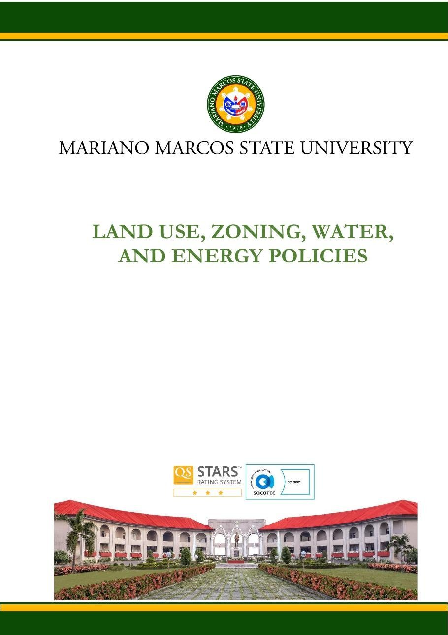
Document: MMSU Land Use, Zoning, Water and Energy Policies (Sirmata 2040 LUDIP, 2021), Land Use Policy, page 1.

Policy title | MMSU Land Use, Zoning, Water and Energy Policies (Sirmata 2040 LUDIP), Land Use Policy
Approved by | [to add]
Reference no. | [to add]
Date approved or last reviewed | 2021 (prepared under RA 11396). Last reviewed: [to add]
Section that answers the question | Policies 1.3, 7.1, 9.1, 10.2 and 4.3

MMSU’s Land Use, Zoning, Water and Energy Policies, adopted as part of Sirmata 2040, the university’s Land Use Development and Infrastructure Plan prepared in 2021 under Republic Act 11396, govern the conservation, restoration and sustainable use of all university lands across its campuses.
Under Policy 1.3, the allocation and use of university lands “shall aim to maintain, protect, conserve, restore, and enhance the integrity of the land itself, the environment and ecological balance in all its campuses.” Policy 7.1 requires decisions to be based on valid and reliable science, especially for any intent to alter or convert the natural state of any piece of university land, and Policy 10.2 gives fragile lands and protected areas special management “to protect, conserve, enrich, rehabilitate, and or sustain them.”
The zoning policy sets aside Protected Land as a distinct zone; under Policy 9.1, “protected landholdings of the university shall be conserved, preserved and to be excluded from any form of alteration except as may be permitted by operation of law.” The MMSU Forest Reserve is maintained as a no-build zone, and Policy 4.3 requires the university to regularly review, update and promptly communicate its land-use policies.
Source
• MMSU, Land Use, Zoning, Water and Energy Policies (Sirmata 2040 LUDIP, 2021). https://www.mmsu.edu.ph/resources/19uycXrgcO_iXPdPpMQwdCRxmoD1U5i60/view
• MMSU, Planning and Development on Local Biodiversity (SDG 15 evidence page). https://www.mmsu.edu.ph/resources/1tbtCaZa6Uh7ieu4epmz35VJ9jrRQGlPi/data
Only the submission pick is entered in the portal. The other items are internal evidence.
5 · Before submission
☐ | The indicator on page 2 has a submission pick or a note that no evidence was found
☐ | One URL per indicator; no page that is only a list of links
☐ | A second person opened every URL and saw the answer on the page itself
☐ | Programmes are confirmed free of charge where the indicator asks
☐ | Every date falls in the data year, or the policy was in force by then
☐ | Nothing was created or backdated for this submission
☐ | Photo credits recorded; no personal data shown without consent
☐ | Page 1 updated; footer SDG number updated; all grey notes and example rows deleted
Open items for this indicator
☐ Confirm the policy is still in force and give a “last reviewed” year (Policy 4.3 requires regular review).
☐ Peer benchmark: a 2025 Board resolution or review would add the review point.

