 | INDICATOR 15.3.3  SDG 15 Life on Land  Evidence Report 2025  Mariano Marcos State University · THE Sustainability Impact Ratings 2027
Data year 2025 · Draft for validation · prepared 6 November 2026
SDG assigned | SDG 15 · Life on Land | Data year | 2025
Team Members | [Name, position] | Date prepared | 6 November 2026
1 · Sites and platforms explored
Every site and office where evidence for this indicator was found, and where nothing was found. A list of sites is not evidence; it only shows where the team has looked.
# | Site or office | URL or location | What was found
1 | MMSU SDG 15 and policy resource pages | https://www.mmsu.edu.ph/resources | 1 item for 15.3.3: Sirmata 2040: Planning MMSU’s Campuses and Reserve Lands for Two Decades
2 | MMSU News | https://www.mmsu.edu.ph/news | 1 item for 15.3.3: Sirmata 2040: Planning MMSU’s Campuses and Reserve Lands for Two Decades
Not yet explored
Sources the team should still search. Suggestions are listed; add your own.
# | Source to search | Assigned to
1 | College and department websites and social media pages
2 | Office records (Registrar, HR, Planning, Procurement, Physical Plant, Student Affairs)
3 | Board of Regents resolutions and memoranda
4 | Extension and Research Directorate pages and accomplishment reports
5 | Agreements (MOA, MOU) with LGUs, agencies, NGOs and industry
6 | News outlets and partner websites (DENR, LGUs, DOST, PhilRice)
7 | [Add a source]
2 · Indicators to report
SDG 15 · Life on Land · data year 2025
Indicator | Description
15.3.3 | Local biodiversity included in planning and development. Include local biodiversity in planning and development, such as construction of new buildings.
3 · Optional: what other universities submit
What other universities claim for this indicator, and where MMSU might hold the same kind of evidence.
University | What it submits (indicator and type of evidence) | What to look for at MMSU
Caraga State University | 15.3.3: campus planning that consults biodiversity data | Sirmata 2040 LUDIP, with its protected-land and forest-reserve provisions quoted.
Eastern Visayas State University | 15.3.3: Board-approved Land Use Development and Infrastructure Plan | Sirmata 2040 LUDIP presented as the plan in force; quote its forest-reserve and green-space provisions.
[Add the THE edition and URL for each result before using this page.]
4 · Evidence by indicator
SDG 15.3.3 · Local biodiversity included in planning and development
Include local biodiversity into any planning and development process (e.g. construction of new buildings).
Evidence year: in place by 2025
Submission pick: Sirmata 2040 LUDIP, https://www.mmsu.edu.ph/resources/19uycXrgcO_iXPdPpMQwdCRxmoD1U5i60/view No 2025 planning record is attached; the plan was in force by 2025.
Sirmata 2040: Planning MMSU’s Campuses and Reserve Lands for Two Decades
Plan in force since 2021.
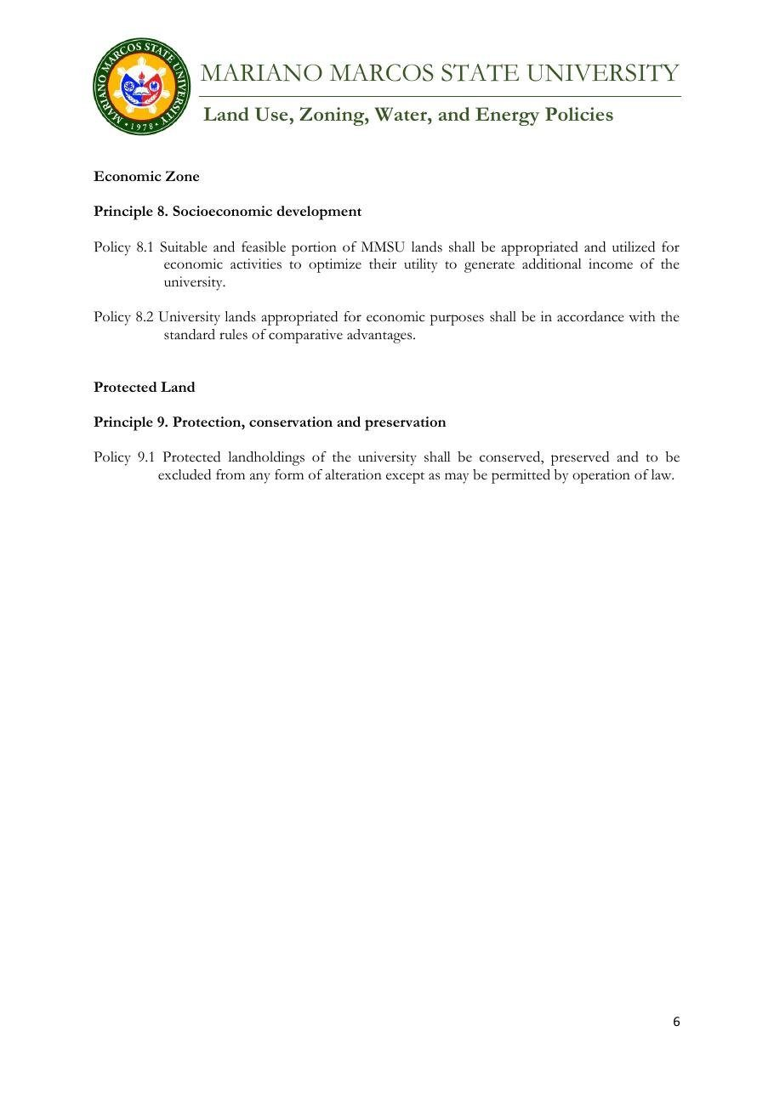
Document: MMSU Zoning Policy, Protected Land (Principle 9, Policy 9.1), Sirmata 2040 LUDIP.

Policy title | Sirmata 2040: Land Use Development and Infrastructure Plan (LUDIP)
Approved by | Endorsed by the CHED Technical Working Group after validation visits. Board approval: [to add]
Reference no. | [to add]
Date approved or last reviewed | 2021 (20-year plan). Last reviewed: [to add]
Section that answers the question | Zoning policy, Protected Land (Policy 9.1); Forest Reserve no-build zone; Policies 7.1, 10.1 and 11.1

Sirmata 2040, MMSU’s Land Use Development and Infrastructure Plan (LUDIP), is the university’s 20-year guide for managing its land resources and infrastructure. Prepared under Republic Act 11396, which requires state universities and colleges to have a LUDIP, and supported by a Php 2 million grant from the Commission on Higher Education (CHED), the plan covers the future land use of the MMSU campuses and the university’s reserve areas in Nagbacsan, Payao, Lubbot and Sarnap, City of Batac, including the forest reserves where MMSU’s forestry and agroforestry research is set up.
Local biodiversity is built into the plan’s development rules. The zoning plan sets aside Protected Land, which “shall be conserved, preserved and to be excluded from any form of alteration except as may be permitted by operation of law” (Policy 9.1), and the MMSU Forest Reserve is kept as a no-build zone. Before any land is altered or converted, the plan requires a science-based assessment of its natural suitability and carrying capacity (Policies 7.1, 10.1 and 11.1).
The plan was developed through stakeholder consultations, sectoral studies and campus planning workshops, and was endorsed by the CHED Technical Working Group after validation visits to the campuses.
Source
• MMSU, Land Use, Zoning, Water and Energy Policies (Sirmata 2040 LUDIP, 2021). https://www.mmsu.edu.ph/resources/19uycXrgcO_iXPdPpMQwdCRxmoD1U5i60/view
• MMSU, Planning and Development on Local Biodiversity (SDG 15 evidence page). https://www.mmsu.edu.ph/resources/1tbtCaZa6Uh7ieu4epmz35VJ9jrRQGlPi/data
• MMSU News, “CHED TWG OKs MMSU Sirmata 2040”. https://www.mmsu.edu.ph/news/ched-twg-oks-mmsu-sirmata-2040
• MMSU News, “MMSU gets Php 2 M for LUDIP project”. https://www.mmsu.edu.ph/news/mmsu-gets-php-2-m-for-ludip-project
Only the submission pick is entered in the portal. The other items are internal evidence.
5 · Before submission
☐ | The indicator on page 2 has a submission pick or a note that no evidence was found
☐ | One URL per indicator; no page that is only a list of links
☐ | A second person opened every URL and saw the answer on the page itself
☐ | Programmes are confirmed free of charge where the indicator asks
☐ | Every date falls in the data year, or the policy was in force by then
☐ | Nothing was created or backdated for this submission
☐ | Photo credits recorded; no personal data shown without consent
☐ | Page 1 updated; footer SDG number updated; all grey notes and example rows deleted
Open items for this indicator
☐ Quote the forest-reserve and green-space provisions in the final version (peer benchmark).
☐ No 2025 item: show a 2025 development decision that applied the plan, if one exists.

