 | INDICATOR 15.4.1  SDG 15 Life on Land  Evidence Report 2025  Mariano Marcos State University · THE Sustainability Impact Ratings 2027
Data year 2025 · Draft for validation · prepared 6 November 2026
SDG assigned | SDG 15 · Life on Land | Data year | 2025
Team Members | [Name, position] | Date prepared | 6 November 2026
1 · Sites and platforms explored
Every site and office where evidence for this indicator was found, and where nothing was found. A list of sites is not evidence; it only shows where the team has looked.
# | Site or office | URL or location | What was found
1 | MMSU SDG 15 and policy resource pages | https://www.mmsu.edu.ph/resources | 2 items for 15.4.1: Groundwater Quality Monitoring at the MMSU Farm; MMSU Water Policy Protects University Waters from Pollution
2 | Office of the President (memoranda) | Office records, not public | 1 item for 15.4.1: Memorandum No. 26-370 Institutionalizes MMSU’s Environmental Compliance and Hazardous Waste Procedures
Not yet explored
Sources the team should still search. Suggestions are listed; add your own.
# | Source to search | Assigned to
1 | College and department websites and social media pages
2 | Office records (Registrar, HR, Planning, Procurement, Physical Plant, Student Affairs)
3 | Board of Regents resolutions and memoranda
4 | Extension and Research Directorate pages and accomplishment reports
5 | Agreements (MOA, MOU) with LGUs, agencies, NGOs and industry
6 | News outlets and partner websites (DENR, LGUs, DOST, PhilRice)
7 | [Add a source]
2 · Indicators to report
SDG 15 · Life on Land · data year 2025
Indicator | Description
15.4.1 | Water discharge guidelines and standards. Water quality standards and guidelines for water discharges.
3 · Optional: what other universities submit
What other universities claim for this indicator, and where MMSU might hold the same kind of evidence.
University | What it submits (indicator and type of evidence) | What to look for at MMSU
Caraga State University | 15.4.1: an Adopt-an-Estero commitment | A comparable water-body commitment, or a discharge or effluent standard.
[Add the THE edition and URL for each result before using this page.]
4 · Evidence by indicator
SDG 15.4.1 · Water discharge guidelines and standards
Have water quality standards and guidelines for water discharges (to uphold water quality in order to protect ecosystems, wildlife, and human health and welfare).
Evidence year: in place by 2025
Submission pick: MMSU Water Policy (Sirmata 2040), https://www.mmsu.edu.ph/resources/19uycXrgcO_iXPdPpMQwdCRxmoD1U5i60/view The groundwater report below is supporting only: it compares well water with drinking-water standards and is not a discharge standard.
MMSU Water Policy Protects University Waters from Pollution
In force since 2021 (Sirmata 2040); the IPWMP was revised in 2020.
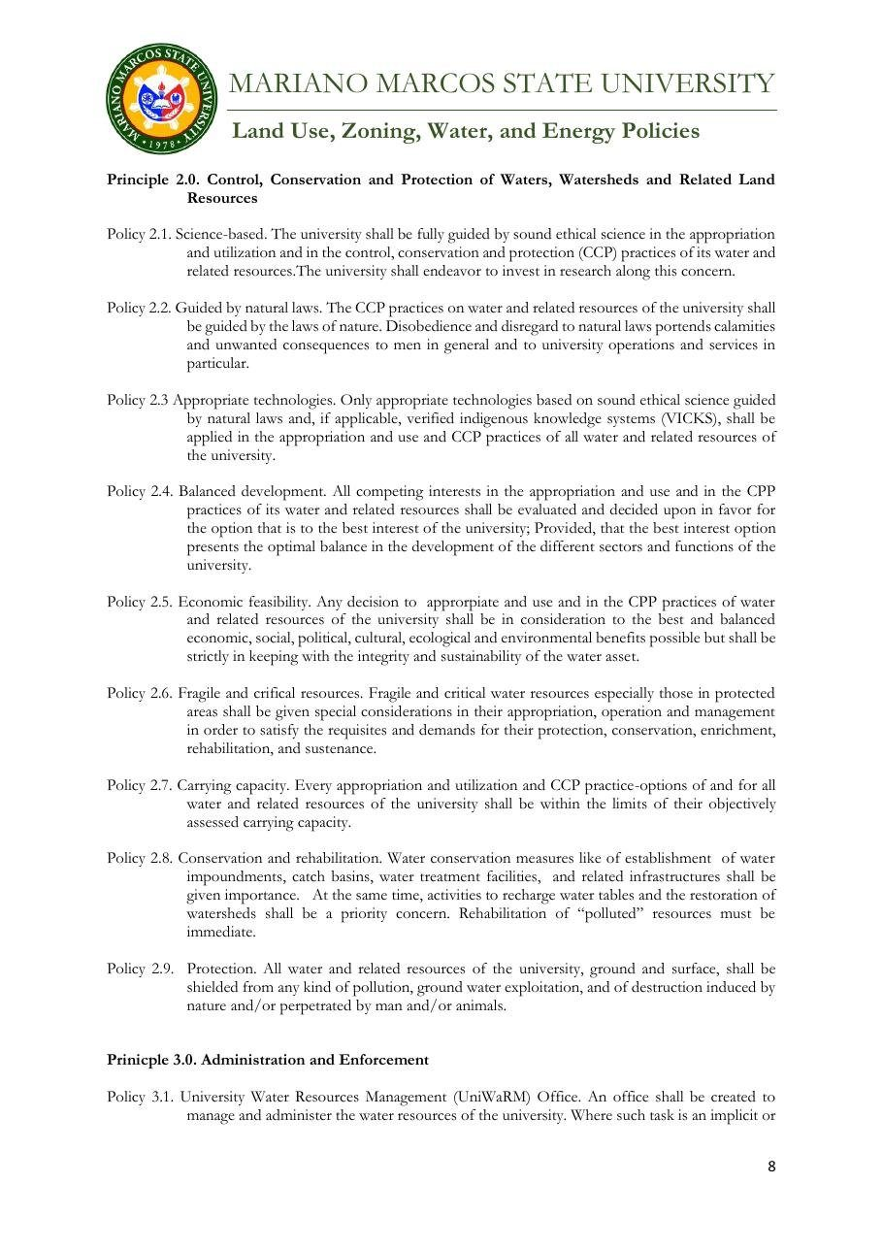
Document: MMSU Water Policy, control, conservation and protection of waters (Policies 2.6–2.9), Sirmata 2040 LUDIP.

Policy title | MMSU Water Policy (Sirmata 2040 LUDIP) and Integrated Pollution and Waste Management Program
Approved by | [to add]
Reference no. | [to add]
Date approved or last reviewed | Water Policy 2021; IPWMP revised 2020. Last reviewed: [to add]
Section that answers the question | Water Policy 2.6–2.9 (2.9 protection from pollution; 2.8 rehabilitation); IPWMP registration for wastewater discharge (RA 9275)

MMSU’s Water Policy under Sirmata 2040, based on the Water Code of the Philippines and its 2005 implementing rules, requires that “all water and related resources of the university, ground and surface, shall be shielded from any kind of pollution” (Policy 2.9) and that the rehabilitation of polluted resources be immediate, giving importance to water impoundments, catch basins and water treatment facilities (Policy 2.8).
The university’s Integrated Pollution and Waste Management Program also provides for registration as a hazardous waste generator for wastewater discharge from agro-industrial facilities such as the piggery, in compliance with Republic Act 9275, the Philippine Clean Water Act.
Source
• MMSU, Land Use, Zoning, Water and Energy Policies (Sirmata 2040 LUDIP, 2021). https://www.mmsu.edu.ph/resources/19uycXrgcO_iXPdPpMQwdCRxmoD1U5i60/view
• MMSU, Revised Integrated Pollution and Waste Management Program. https://www.mmsu.edu.ph/resources/1fNUCZwyOozOKO27L2Bm6pNN-P_cJNpLd/view
• MMSU, Water Discharge Management (SDG 15 evidence page). https://www.mmsu.edu.ph/resources/1l8foDfenNc7xpKp8wM8XShfZT58YyjSH/data
Groundwater Quality Monitoring at the MMSU Farm
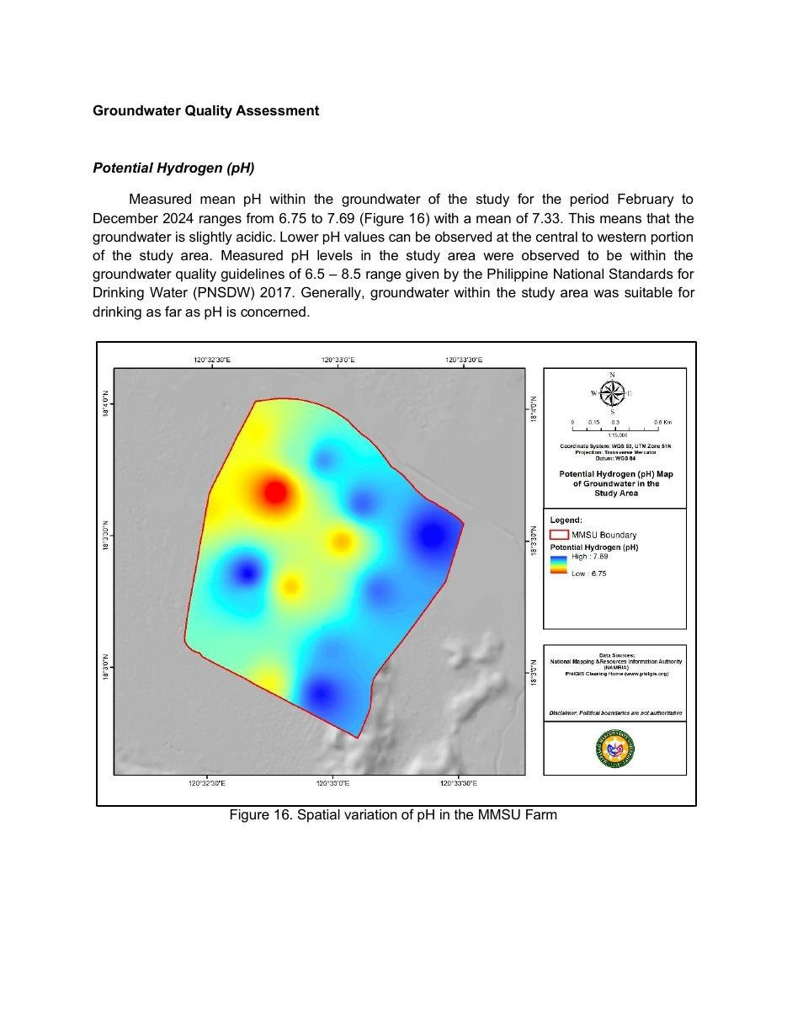
Document: Groundwater Quality Assessment of the MMSU Farm, spatial variation of pH (monitoring through June 2025).

Through June 2025, MMSU continued monthly monitoring of 17 groundwater wells on the MMSU Farm, measuring pH, total dissolved solids, electrical conductivity, chloride and nitrate-nitrogen and comparing the results with the Philippine National Standards for Drinking Water (2017). The assessment, covering February 2024 to June 2025, flags wells with persistently high dissolved solids, which rose again from January to May 2025, for continued monitoring to guide water resource management and prevent further degradation of groundwater quality.
Mean pH from February to December 2024 ranged from 6.75 to 7.69, within the 6.5–8.5 guideline of the national drinking water standards. Small campus reservoirs also collect rainwater, reduce flooding and recharge groundwater.
Source
• MMSU, Groundwater Quality Assessment of the MMSU Farm (monitoring February 2024 – June 2025). https://www.mmsu.edu.ph/resources/15g9Xtys7q3Rujd0-CZvPH4OHTdJ1__Z8/data
Memorandum No. 26-370 Institutionalizes MMSU’s Environmental Compliance and Hazardous Waste Procedures
Dated 30 September 2026, after the data year. Internal evidence only; no public page yet.
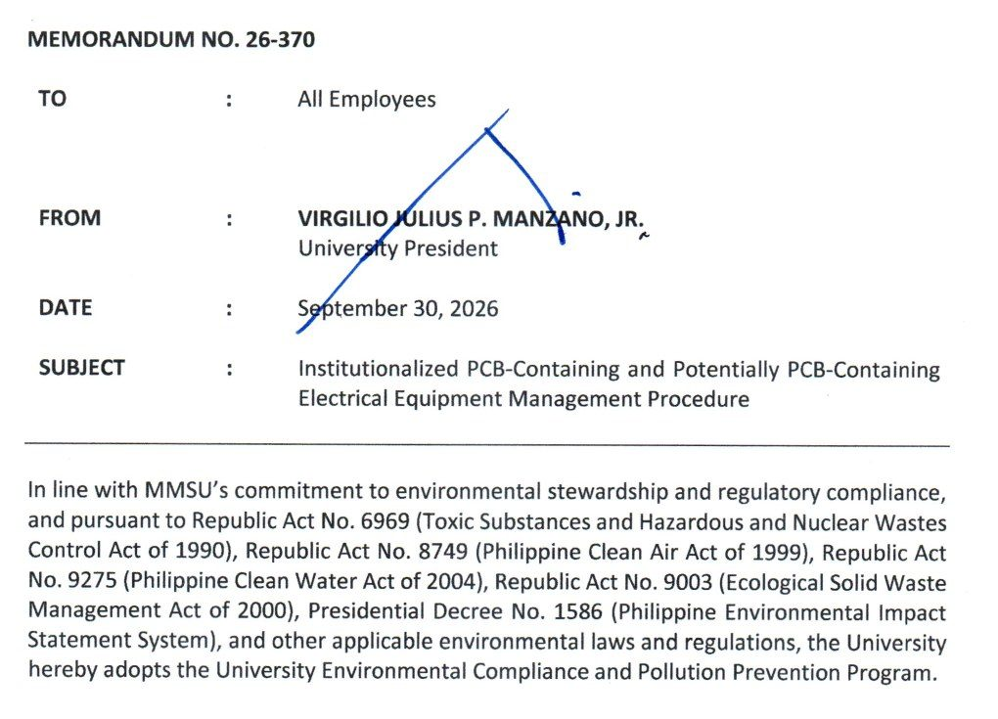  Document: Office of the President Memorandum No. 26-370, 30 September 2026, adopting the University Environmental Compliance and Pollution Prevention Program. | 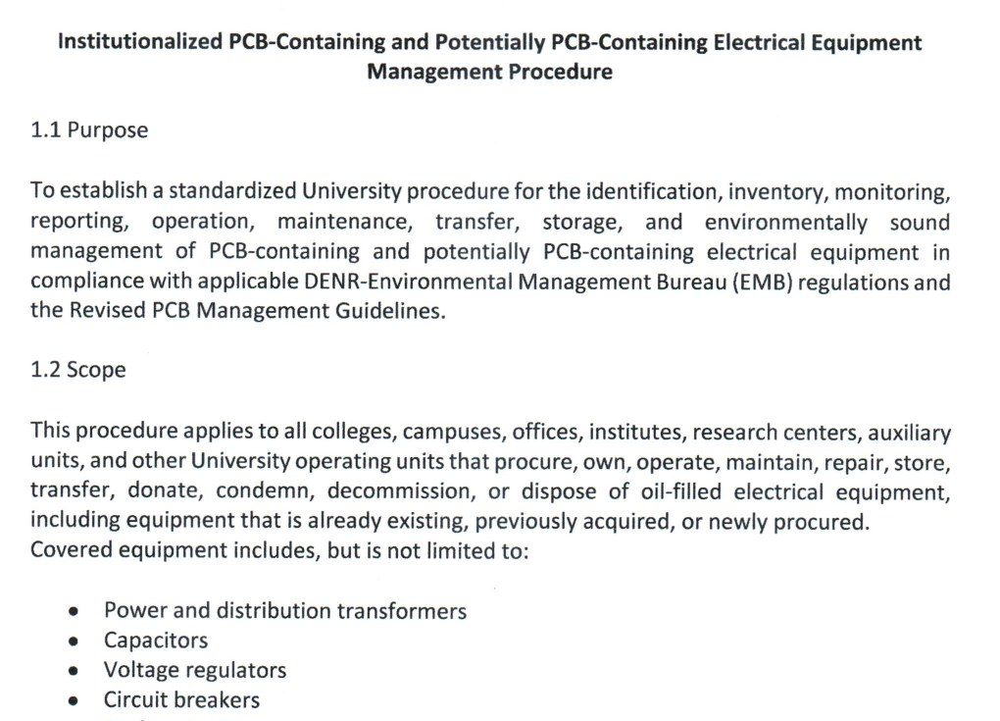  Document: attached procedure for PCB-containing and potentially PCB-containing electrical equipment (purpose, scope and inventory), Memorandum No. 26-370.

Policy title | Memorandum No. 26-370, University Environmental Compliance and Pollution Prevention Program
Approved by | University President Virgilio Julius P. Manzano Jr.
Reference no. | 26-370
Date approved or last reviewed | 30 September 2026
Section that answers the question | Environmental Compliance Procedures; PCB-containing equipment procedure

On September 30, 2026, University President Virgilio Julius P. Manzano Jr. issued Memorandum No. 26-370 to all employees, adopting the University Environmental Compliance and Pollution Prevention Program under Republic Act 6969 (Toxic Substances and Hazardous and Nuclear Wastes Control Act), Republic Act 8749 (Clean Air Act), Republic Act 9275 (Clean Water Act), Republic Act 9003 (Ecological Solid Waste Management Act) and Presidential Decree 1586 (Environmental Impact Statement System). The memorandum covers the management of hazardous wastes, wastewater, air emissions, solid wastes and chemicals, together with permits, monitoring, reporting and inspections required by the Department of Environment and Natural Resources – Environmental Management Bureau (DENR-EMB), and directs all offices, colleges, laboratories, research units and auxiliary enterprises to comply with the attached Environmental Compliance Procedures.
The attached procedure for PCB-containing and potentially PCB-containing electrical equipment, such as transformers, capacitors, voltage regulators, circuit breakers, reclosers and oil-filled switches, requires every unit to inventory its equipment and submit the inventory to the Sustainability and Futures Thinking (SFT) Office. The SFT Office validates the inventory, keeps the university’s central PCB inventory and the DENR-EMB online PCB inventory, ensures labelling, conducts inspections and annual inventory validation, and prepares the reports required by DENR-EMB. No covered equipment may be relocated, transferred, repaired through oil handling, decommissioned, condemned or disposed of without the SFT Office’s written clearance, and PCB wastes and equipment may be disposed of only through DENR-accredited transporters, treaters and disposal facilities. The SFT Office keeps hazardous waste manifests and certificates of treatment or disposal among its records.
Source
• MMSU Office of the President, Memorandum No. 26-370, “Institutionalized PCB-Containing and Potentially PCB-Containing Electrical Equipment Management Procedure,” 30 September 2026
Only the submission pick is entered in the portal. The other items are internal evidence.
5 · Before submission
☐ | The indicator on page 2 has a submission pick or a note that no evidence was found
☐ | One URL per indicator; no page that is only a list of links
☐ | A second person opened every URL and saw the answer on the page itself
☐ | Programmes are confirmed free of charge where the indicator asks
☐ | Every date falls in the data year, or the policy was in force by then
☐ | Nothing was created or backdated for this submission
☐ | Photo credits recorded; no personal data shown without consent
☐ | Page 1 updated; footer SDG number updated; all grey notes and example rows deleted
Open items for this indicator
☐ Confirm the water and waste policies are still in force.
☐ Obtain the full Environmental Compliance Procedures under Memorandum No. 26-370.
☐ Groundwater monitoring compares to drinking-water standards, not discharge standards: say so, and lead with the policy.

