 | INDICATOR 15.4.2  SDG 15 Life on Land  Evidence Report 2025  Mariano Marcos State University · THE Sustainability Impact Ratings 2027
Data year 2025 · Draft for validation · prepared 6 November 2026
SDG assigned | SDG 15 · Life on Land | Data year | 2025
Team Members | [Name, position] | Date prepared | 6 November 2026
1 · Sites and platforms explored
Every site and office where evidence for this indicator was found, and where nothing was found. A list of sites is not evidence; it only shows where the team has looked.
# | Site or office | URL or location | What was found
1 | MMSU News | https://www.mmsu.edu.ph/news | 4 items for 15.4.2: MMSU Commits to the DENR-EMB Region I Regional Ecology Center; Student Advocates Hold Monthly Clean-Up Drive on Campus; MMSU Policies Eliminate Styrofoam and Reduce Plastic Waste on Campus and 1 more
2 | MMSU SDG 15 and policy resource pages | https://www.mmsu.edu.ph/resources | 1 item for 15.4.2: MMSU Policies Eliminate Styrofoam and Reduce Plastic Waste on Campus
3 | Office of the President (memoranda) | Office records, not public | 1 item for 15.4.2: University Memoranda Ask Employees to Bring Their Own Tumblers
Not yet explored
Sources the team should still search. Suggestions are listed; add your own.
# | Source to search | Assigned to
1 | College and department websites and social media pages
2 | Office records (Registrar, HR, Planning, Procurement, Physical Plant, Student Affairs)
3 | Board of Regents resolutions and memoranda
4 | Extension and Research Directorate pages and accomplishment reports
5 | Agreements (MOA, MOU) with LGUs, agencies, NGOs and industry
6 | News outlets and partner websites (DENR, LGUs, DOST, PhilRice)
7 | [Add a source]
2 · Indicators to report
SDG 15 · Life on Land · data year 2025
Indicator | Description
15.4.2 | Policy on plastic waste reduction. Policy on reducing plastic waste on campus.
3 · Optional: what other universities submit
What other universities claim for this indicator, and where MMSU might hold the same kind of evidence.
University | What it submits (indicator and type of evidence) | What to look for at MMSU
Caraga State University | 15.4.2: dated memorandum on plastic waste (Memo No. 33, s. 2024) | A 2025 memorandum or review of the plastic policies would add the review point.
[Add the THE edition and URL for each result before using this page.]
4 · Evidence by indicator
SDG 15.4.2 · Policy on plastic waste reduction
Have a policy on reducing plastic waste on campus.
Evidence year: in place by 2025
Submission pick: Plastic Waste Management page, https://www.mmsu.edu.ph/resources/1NU-Qda9KG0J-PIOgKZwPKC4h_TU05zcm/data
MMSU Policies Eliminate Styrofoam and Reduce Plastic Waste on Campus
Policies from 2009 to 2023, with 2024 and 2025 actions; in force by the data year.
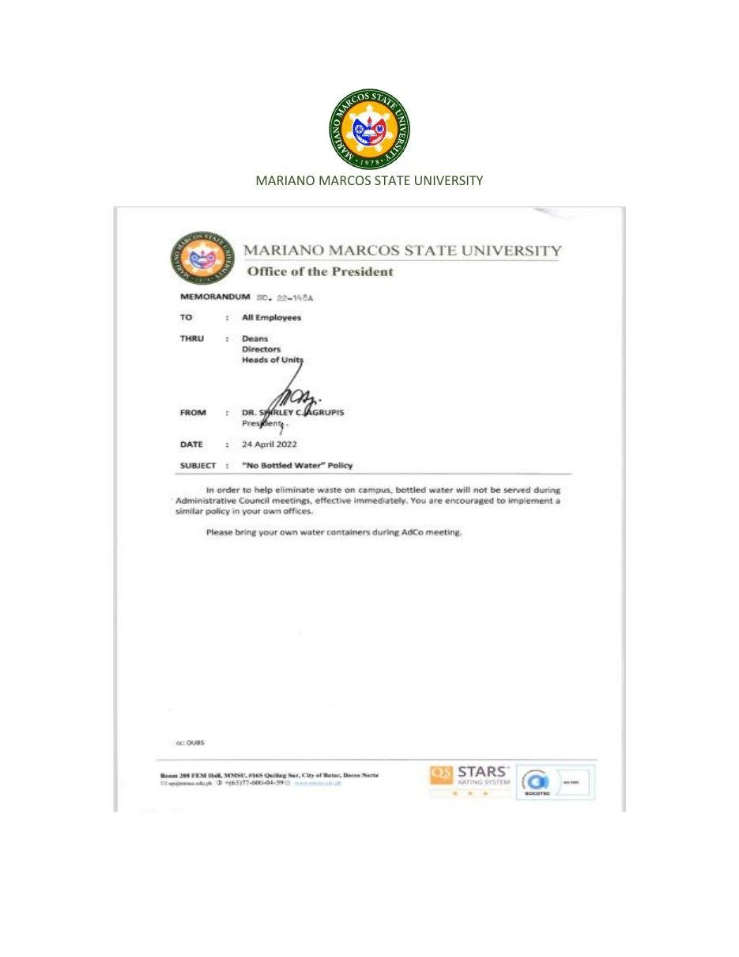  Document: Office of the President Memorandum No. 22-148A, “No Bottled Water” Policy, 24 April 2022. | 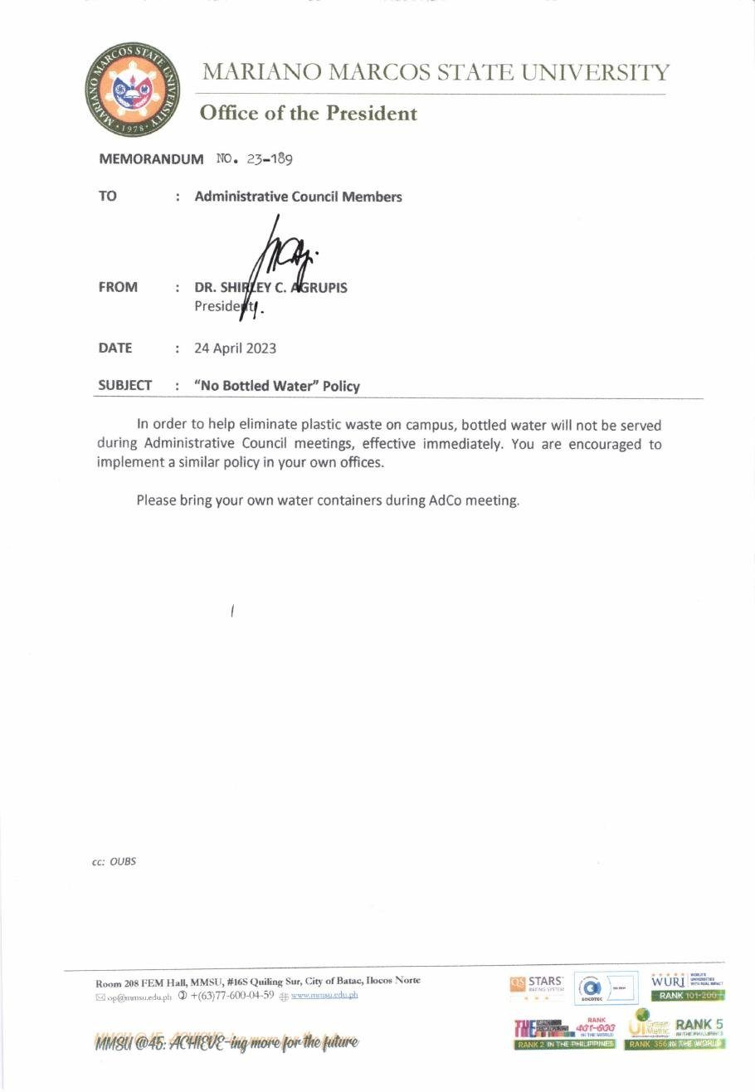  Document: Office of the President Memorandum No. 23-189, “No Bottled Water” Policy, 24 April 2023.

Policy title | Integrated Waste Management Program, revised as the Integrated Pollution and Waste Management Program (IPWMP)
Approved by | Board of Regents (2009; amended 2015). Revision: [to add]
Reference no. | [to add]
Date approved or last reviewed | 2009; amended 2015; Styrofoam and plastic packaging policy 11 Feb 2016; IPWMP revised 2020
Section that answers the question | Styrofoam and plastic provisions; “No Bottled Water” Memoranda No. 22-148A and 23-189

MMSU reduces plastic waste under its Integrated Waste Management Program, approved by the Board of Regents in 2009 and amended in 2015, and its revised Integrated Pollution and Waste Management Program. The program prohibits Styrofoam for serving or packing food in the university Food Service Unit and limits the use of plastics, and a policy promulgated on February 11, 2016 eliminates Styrofoam and plastic as secondary packaging materials in favour of paper bags, cartons, eco-bags and reusable containers. The University Waste Management Committee develops, reviews and monitors these rules, and the food service unit requires customers dining out to bring their own food containers.
The Office of the President reissues the “No Bottled Water” Policy each year: Memorandum No. 22-148A of April 24, 2022 and Memorandum No. 23-189 of April 24, 2023 stop the serving of bottled water at Administrative Council meetings, ask members to bring their own water containers, and encourage all offices to adopt the same policy. In October 2024 the College of Agriculture, Food and Sustainable Development banned plastic bottled water in its auxiliary buildings, and on July 1, 2025 MMSU signed a memorandum of commitment with DENR-EMB Region I for the Regional Ecology Center to support solid waste management under Republic Act 9003 and the Extended Producer Responsibility Act (Republic Act 11898).
Source
• MMSU, Plastic Waste Management (SDG 15 evidence page). https://www.mmsu.edu.ph/resources/1NU-Qda9KG0J-PIOgKZwPKC4h_TU05zcm/data
• MMSU, Revised Integrated Pollution and Waste Management Program. https://www.mmsu.edu.ph/resources/1fNUCZwyOozOKO27L2Bm6pNN-P_cJNpLd/view
• MMSU Office of the President, “No Bottled Water” Policy, Memorandum No. 22-148A (2022) and No. 23-189 (2023). https://www.mmsu.edu.ph/resources/1LbnK8yYkg-47ChbXyT0r8VQ9eBGuMxRx/data
• MMSU News, “MMSU CAFSD rolls out waste and pollution management program,” 15 October 2024. https://www.mmsu.edu.ph/news/mmsu-cafsd-rolls-out-waste-and-pollution-management-program
• MMSU News, “MMSU commits to ecological solid waste management in Region I,” 2 July 2025. https://www.mmsu.edu.ph/news/mmsu-commits-to-ecological-solid-waste-management-in-region-i
MMSU Commits to the DENR-EMB Region I Regional Ecology Center
On July 1, 2025, in Bauang, La Union, MMSU signed a memorandum of commitment with the DENR–Environmental Management Bureau Region I and other government agencies, private sector representatives, non-government organizations and academic institutions for the Regional Ecology Center. MMSU was represented by Vice President for Planning and Strategic Foresight Mee Jay Domingo and Campus Sustainability Chief Ronnel Pagurayan.
Under the commitment, MMSU supports improved solid waste management under Republic Act 9003 (Ecological Solid Waste Management Act) and Republic Act 11898 (Extended Producer Responsibility Act) through education and public information campaigns and the development of informational materials.
Source
• MMSU News, “MMSU commits to ecological solid waste management in Region I,” 2 July 2025. https://www.mmsu.edu.ph/news/mmsu-commits-to-ecological-solid-waste-management-in-region-i
Student Advocates Hold Monthly Clean-Up Drive on Campus
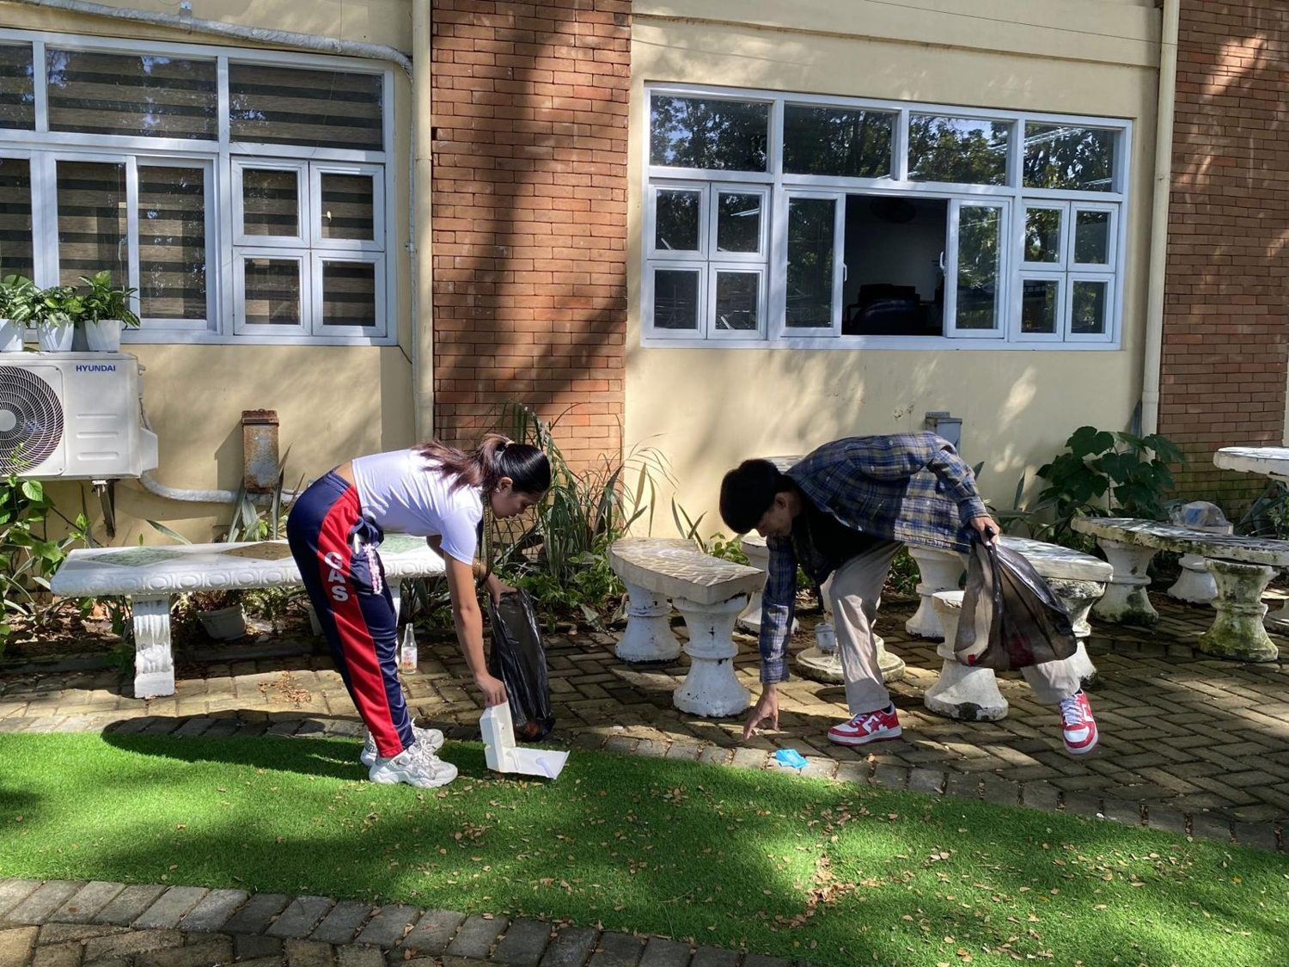
MMSU Advocates for Cultural Development clean-up drive on campus, 24 October 2025. (Photo: MMSU)

On October 24, 2025, the MMSU Advocates for Cultural Development (MACD), an organization representing students from indigenous peoples’ communities, held its monthly clean-up drive, “iPaglilinis,” around the university grounds, the Student Center and parts of the University Lagoon. About 30 bags of waste were collected and segregated into plastic, paper and tin materials.
Source
• MMSU News, “MACD leads clean-up drive in MMSU,” 29 October 2025. https://www.mmsu.edu.ph/news/macd-leads-clean-up-drive-in-mmsu
University Memoranda Ask Employees to Bring Their Own Tumblers
February 2024 memoranda, in force by the data year.
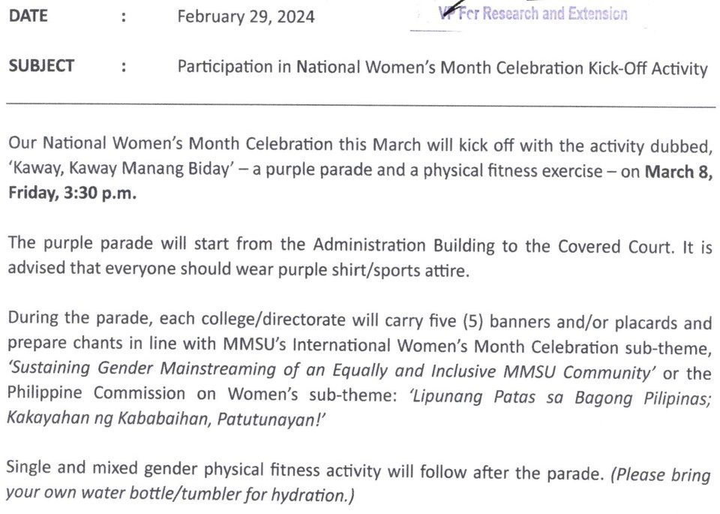  Document: Office of the President Memorandum No. 24-088, 29 February 2024, to all employees: “Please bring your own water bottle/tumbler for hydration.” | 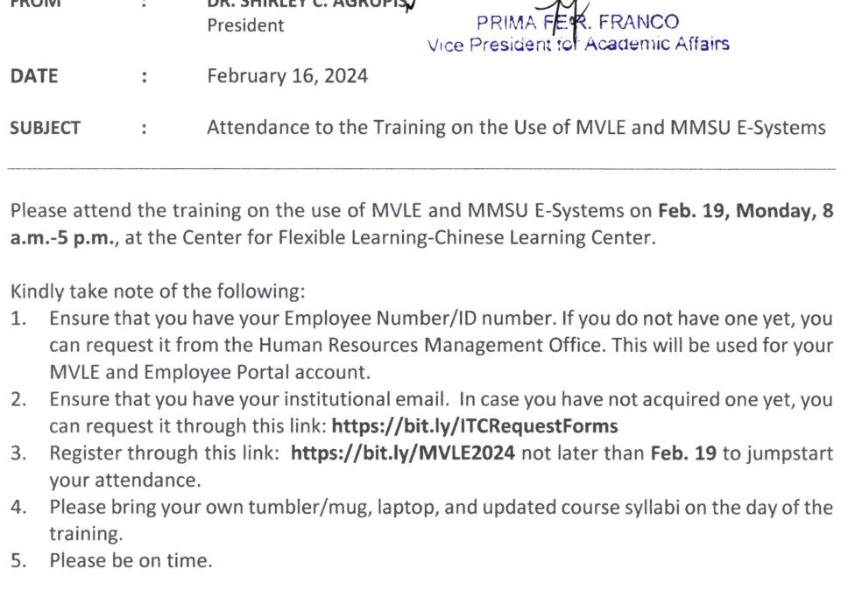  Document: Office of the President Memorandum No. 24-075, 16 February 2024, item 4: “Please bring your own tumbler/mug…”

The practice behind the No Bottled Water policy appears in the university’s own memoranda. Office of the President Memorandum No. 24-088 of February 29, 2024, sent to all employees for the National Women’s Month kick-off parade and fitness activity, asked participants to “bring your own water bottle/tumbler for hydration.” Memorandum No. 24-075 of February 16, 2024, calling newly hired faculty to training on the MVLE and MMSU e-systems, asked them to “bring your own tumbler/mug.”
In October 2024 the College of Agriculture, Food and Sustainable Development went further and banned plastic bottled water in its auxiliary building, encouraging students and staff to bring reusable tumblers instead.
Source
• MMSU Office of the President, Memorandum No. 24-088, “Participation in National Women’s Month Celebration Kick-Off Activity,” 29 February 2024
• MMSU Office of the President, Memorandum No. 24-075, “Attendance to the Training on the Use of MVLE and MMSU E-Systems,” 16 February 2024
• MMSU News, “MMSU CAFSD rolls out waste and pollution management program,” 15 October 2024. https://www.mmsu.edu.ph/news/mmsu-cafsd-rolls-out-waste-and-pollution-management-program
Only the submission pick is entered in the portal. The other items are internal evidence.
5 · Before submission
☐ | The indicator on page 2 has a submission pick or a note that no evidence was found
☐ | One URL per indicator; no page that is only a list of links
☐ | A second person opened every URL and saw the answer on the page itself
☐ | Programmes are confirmed free of charge where the indicator asks
☐ | Every date falls in the data year, or the policy was in force by then
☐ | Nothing was created or backdated for this submission
☐ | Photo credits recorded; no personal data shown without consent
☐ | Page 1 updated; footer SDG number updated; all grey notes and example rows deleted
Open items for this indicator
☐ Confirm which year to enter as “policy created” (compendium shows 2009, 2016, 2020; the 2026 form shows 2021).
☐ Obtain the 2024 and 2025 reiterations of the No Bottled Water memorandum.
☐ Attach the signed DENR-EMB memorandum of commitment; no copy or photo on file.
☐ Screenshot dated Facebook posts (CCIS SipSmart, BioCircle refilling station, hydration stations).

