 | INDICATOR 15.4.3  SDG 15 Life on Land  Evidence Report 2025  Mariano Marcos State University · THE Sustainability Impact Ratings 2027
Data year 2025 · Draft for validation · prepared 6 November 2026
SDG assigned | SDG 15 · Life on Land | Data year | 2025
Team Members | [Name, position] | Date prepared | 6 November 2026
1 · Sites and platforms explored
Every site and office where evidence for this indicator was found, and where nothing was found. A list of sites is not evidence; it only shows where the team has looked.
# | Site or office | URL or location | What was found
1 | Office of the President (memoranda) | Office records, not public | 1 item for 15.4.3: Memorandum No. 26-370 Institutionalizes MMSU’s Environmental Compliance and Hazardous Waste Procedures
2 | MMSU SDG 15 and policy resource pages | https://www.mmsu.edu.ph/resources | 1 item for 15.4.3: Hazardous Waste Disposal under MMSU’s Integrated Pollution and Waste Management Program
Not yet explored
Sources the team should still search. Suggestions are listed; add your own.
# | Source to search | Assigned to
1 | College and department websites and social media pages
2 | Office records (Registrar, HR, Planning, Procurement, Physical Plant, Student Affairs)
3 | Board of Regents resolutions and memoranda
4 | Extension and Research Directorate pages and accomplishment reports
5 | Agreements (MOA, MOU) with LGUs, agencies, NGOs and industry
6 | News outlets and partner websites (DENR, LGUs, DOST, PhilRice)
7 | [Add a source]
2 · Indicators to report
SDG 15 · Life on Land · data year 2025
Indicator | Description
15.4.3 | Policy on hazardous waste disposal. Policy, process or practice on waste disposal covering hazardous materials.
3 · Optional: what other universities submit
What other universities claim for this indicator, and where MMSU might hold the same kind of evidence.
University | What it submits (indicator and type of evidence) | What to look for at MMSU
Caraga State University | 15.4.3: dated memorandum on hazardous waste (Memo No. 50, s. 2024) with EMB seminars | A 2025 memorandum or review would add the review point; Memorandum No. 26-370 (30 Sep 2026) is the latest.
[Add the THE edition and URL for each result before using this page.]
4 · Evidence by indicator
SDG 15.4.3 · Policy on hazardous waste disposal
Have a policy, process or practice on waste disposal covering hazardous materials.
Evidence year: in place by 2025
Submission pick: Hazardous Waste Disposal page, https://www.mmsu.edu.ph/resources/1jo6-3cVqxRAIllIxEhnSCgyT5ef5LGOW/data Memorandum No. 26-370 (30 Sep 2026) has no public page yet.
Hazardous Waste Disposal under MMSU’s Integrated Pollution and Waste Management Program
IPWMP revised in 2020; in force by the data year.
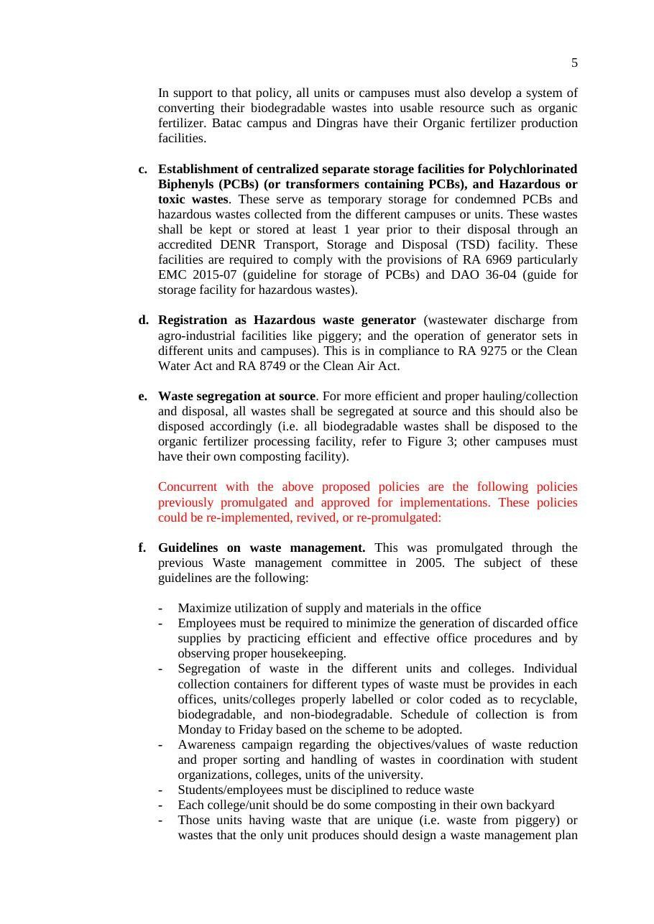
Document: Revised Integrated Pollution and Waste Management Program of MMSU, provisions on PCB and hazardous waste storage and registration.

Policy title | Integrated Pollution and Waste Management Program (IPWMP)
Approved by | [to add]
Reference no. | [to add]
Date approved or last reviewed | 2020 (compendium). The 2026 form entered 2021: confirm the year. Last reviewed: [to add]
Section that answers the question | Hazardous waste provisions: focal persons, labelling, central storage, DENR-accredited disposal (RA 6969)

MMSU’s Integrated Waste Management Program was revised in 2020 into the Integrated Pollution and Waste Management Program (IPWMP), implemented by the Pollution Control Unit and the General Services directorate, to cover hazardous materials. The IPWMP assigns focal persons for hazardous wastes (chemical and related wastes), air and water pollution, solid wastes, and PCBs and related industrial wastes, and requires the waste coordinators of every unit to store and label generated hazardous wastes properly before collection.
The program establishes centralized, separate storage facilities for polychlorinated biphenyls (PCBs) and other hazardous or toxic wastes collected from the campuses, where the wastes are kept for up to one year before disposal through a DENR-accredited transport, storage and disposal facility, in compliance with Republic Act 6969 and its storage guidelines. Units that generate hazardous waste are registered as hazardous waste generators, and the university coordinates with the Environmental Management Bureau of DENR for final collection and disposal.
Source
• MMSU, Hazardous Waste Disposal (SDG 15 evidence page). https://www.mmsu.edu.ph/resources/1jo6-3cVqxRAIllIxEhnSCgyT5ef5LGOW/data
• MMSU, Revised Integrated Pollution and Waste Management Program. https://www.mmsu.edu.ph/resources/1fNUCZwyOozOKO27L2Bm6pNN-P_cJNpLd/view
Memorandum No. 26-370 Institutionalizes MMSU’s Environmental Compliance and Hazardous Waste Procedures
Dated 30 September 2026, after the data year. Internal evidence only; no public page yet.
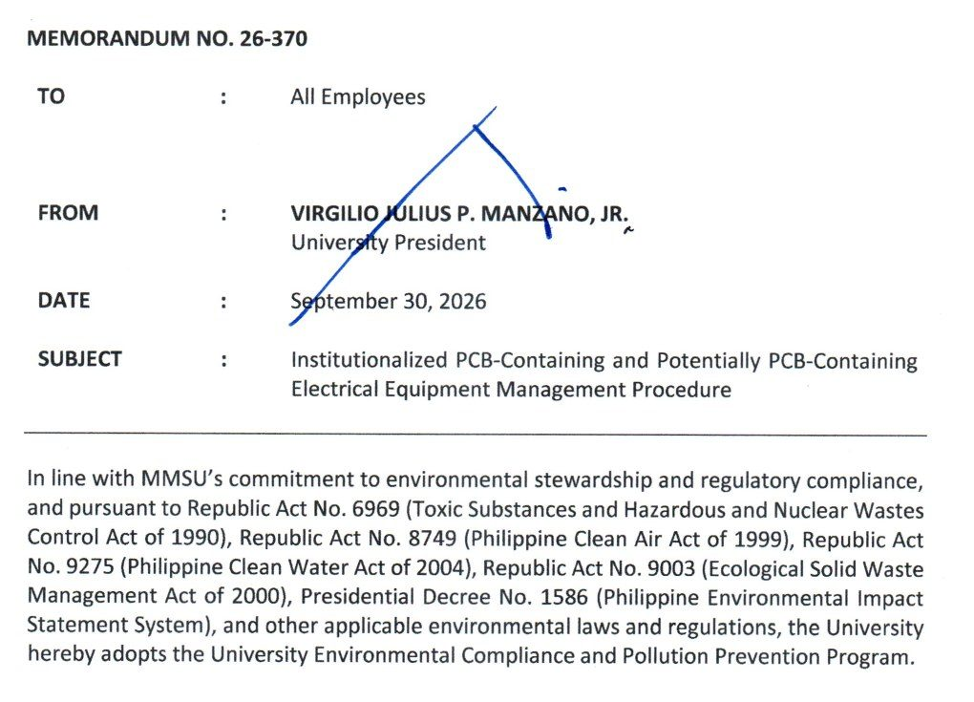  Document: Office of the President Memorandum No. 26-370, 30 September 2026, adopting the University Environmental Compliance and Pollution Prevention Program. | 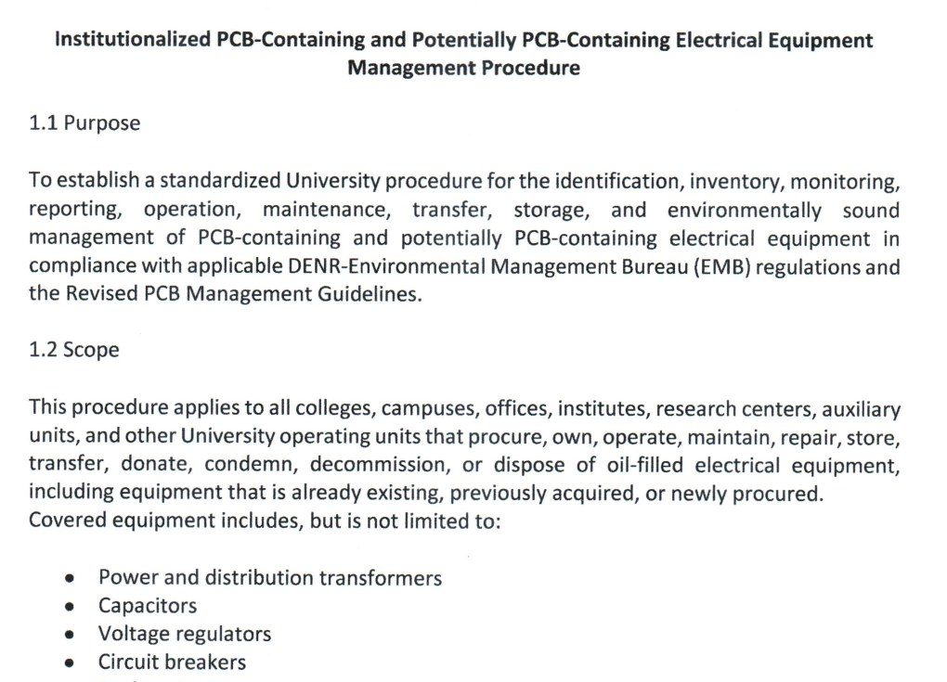  Document: attached procedure for PCB-containing and potentially PCB-containing electrical equipment (purpose, scope and inventory), Memorandum No. 26-370.

Policy title | Memorandum No. 26-370, University Environmental Compliance and Pollution Prevention Program
Approved by | University President Virgilio Julius P. Manzano Jr.
Reference no. | 26-370
Date approved or last reviewed | 30 September 2026
Section that answers the question | Environmental Compliance Procedures; PCB-containing equipment procedure

On September 30, 2026, University President Virgilio Julius P. Manzano Jr. issued Memorandum No. 26-370 to all employees, adopting the University Environmental Compliance and Pollution Prevention Program under Republic Act 6969 (Toxic Substances and Hazardous and Nuclear Wastes Control Act), Republic Act 8749 (Clean Air Act), Republic Act 9275 (Clean Water Act), Republic Act 9003 (Ecological Solid Waste Management Act) and Presidential Decree 1586 (Environmental Impact Statement System). The memorandum covers the management of hazardous wastes, wastewater, air emissions, solid wastes and chemicals, together with permits, monitoring, reporting and inspections required by the Department of Environment and Natural Resources – Environmental Management Bureau (DENR-EMB), and directs all offices, colleges, laboratories, research units and auxiliary enterprises to comply with the attached Environmental Compliance Procedures.
The attached procedure for PCB-containing and potentially PCB-containing electrical equipment, such as transformers, capacitors, voltage regulators, circuit breakers, reclosers and oil-filled switches, requires every unit to inventory its equipment and submit the inventory to the Sustainability and Futures Thinking (SFT) Office. The SFT Office validates the inventory, keeps the university’s central PCB inventory and the DENR-EMB online PCB inventory, ensures labelling, conducts inspections and annual inventory validation, and prepares the reports required by DENR-EMB. No covered equipment may be relocated, transferred, repaired through oil handling, decommissioned, condemned or disposed of without the SFT Office’s written clearance, and PCB wastes and equipment may be disposed of only through DENR-accredited transporters, treaters and disposal facilities. The SFT Office keeps hazardous waste manifests and certificates of treatment or disposal among its records.
Source
• MMSU Office of the President, Memorandum No. 26-370, “Institutionalized PCB-Containing and Potentially PCB-Containing Electrical Equipment Management Procedure,” 30 September 2026
Only the submission pick is entered in the portal. The other items are internal evidence.
5 · Before submission
☐ | The indicator on page 2 has a submission pick or a note that no evidence was found
☐ | One URL per indicator; no page that is only a list of links
☐ | A second person opened every URL and saw the answer on the page itself
☐ | Programmes are confirmed free of charge where the indicator asks
☐ | Every date falls in the data year, or the policy was in force by then
☐ | Nothing was created or backdated for this submission
☐ | Photo credits recorded; no personal data shown without consent
☐ | Page 1 updated; footer SDG number updated; all grey notes and example rows deleted
Open items for this indicator
☐ Confirm the policy is still in force and obtain the full Environmental Compliance Procedures under Memorandum No. 26-370.
☐ Peer benchmark: a dated 2025 memorandum or review would add the review point.
☐ Confirm the 2020 vs 2021 revision year.

