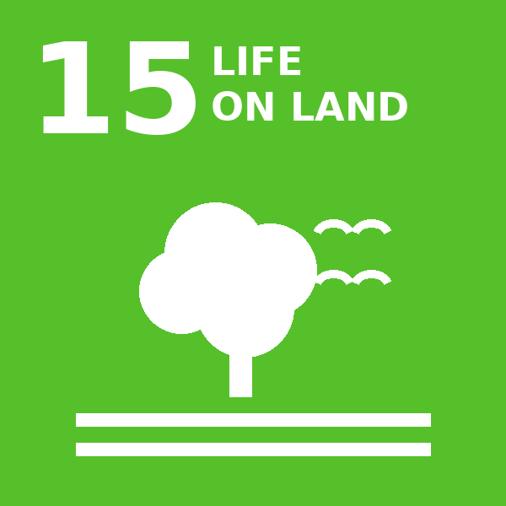
SDG 15 Life on Land
Evidence Compendium 2025
Mariano Marcos State University · THE Sustainability Impact Ratings 2027
Compiled from MMSU, DOST-PCAARRD and news sources for the 2027 data submission (due 9 November 2026). Each section corresponds to one THE SDG 15 indicator. Evidence year: 2025 (calendar year).
Draft for validation, prepared 13 October 2026. Photos marked “PHOTO TO INSERT” and the items on the last pages must be completed before submission.

Contents by indicator
Indicator | THE question | Evidence in this compendium
15.2.1 | Events about sustainable use of land | CAFSD Graduands Plant Native Trees and Bamboo in the University Forest Reserves  President’s Farm Field Day Showcases Climate-Resilient Rice Varieties  2025 International Day for Biological Diversity Wildlife Photo Contest
15.2.3 | Maintain and extend current ecosystems’ biodiversity | Enriching MMSU’s 1,068-Hectare Forest Reserves with Native Species  Conserving Ilocos Indigenous Food Plants In Situ, Ex Situ and Circa Situ  A New Bambusetum in Barangay Aglipay, Pinili  Nature-based Solutions to Restore Mangrove Ecosystems in Badoc and Currimao
15.2.4 | Educational programmes on ecosystems | MMSU Trains Coastal Towns on Mangrove Propagation, Management and Conservation  Farmers in Sarrat Trained to Propagate the Indigenous Alukon  Community Foodscapes as Learning Gardens for Indigenous Plants
15.2.5 | Sustainable management of land for agriculture (educational outreach) | School-on-the-Air Brings Regenerative Vegetable Farming to 1,000 Ilocanos  Bamboo Propagation and Plantation Management Training in Pinili  President’s Farm Field Day Showcases Climate-Resilient Rice Varieties  Farmers in Sarrat Trained to Propagate the Indigenous Alukon
15.3.1 | Sustainable use, conservation and restoration of land (policy) | MMSU Land Use Policy Commits the University to Conserve and Restore Its Lands
15.3.3 | Local biodiversity included in planning and development | Sirmata 2040: Planning MMSU’s Campuses and Reserve Lands for Two Decades
15.3.5 | Collaboration for shared land ecosystems | MMSU, Pasuquin LGU and TMP Foundation Join to Restore a Mangrove Forest  MMSU and DENR Region 1 Strengthen Partnership for Mangrove Conservation  MMSU Expert Serves on the Kalbario-Patapat Natural Park Technical Working Group  Indigenous Food Plant Foodscapes Established with Vintar and San Nicolas Partners  A New Bambusetum in Barangay Aglipay, Pinili
15.4.1 | Water discharge guidelines and standards | Water Policy and Groundwater Quality Monitoring at the MMSU Farm
15.4.2 | Policy on plastic waste reduction | MMSU Policies Eliminate Styrofoam and Reduce Plastic Waste on Campus
15.4.3 | Policy on hazardous waste disposal | Hazardous Waste Disposal under MMSU’s Integrated Pollution and Waste Management Program

What top-rated universities submit for SDG 15
Evidence pages of Philippine universities that score well on SDG 15 were reviewed to see what kinds of accomplishments they claim for each indicator. MMSU’s search was then repeated for the same kinds of evidence, including MMSU’s own SDG 15 page and policy documents; the additions in this edition (School-on-the-Air, the President’s Farm Field Day, the Sirmata 2040 land use and water policies, the plastic and hazardous waste policies, the groundwater monitoring report and the Kalbario-Patapat appointment) came from that step.
University | What it submits for SDG 15 | Applied to MMSU
Visayas State University (VSU) | 91st of 658 universities in SDG 15 (2026) and the top-rated state university in the Philippines overall (301–400). Evidence includes a Board-approved Policy on Tree Management (BOR Resolution No. 146, s. 2025), forest landscape restoration with ACIAR and DENR, rainforestation training, a forester capacity-building partnership (Project CAPABUILD), and a Technical Working Group led by its International Affairs and Relations Office that compiles evidence for all 17 SDGs. | MMSU’s Sirmata 2040 Land Use Policy now answers 15.3.1. A Board resolution adopting it, and a standing SDG working group with unit focal persons, would strengthen the next cycle.
Caraga State University (CarSU) | An SDG 15 page organised indicator by indicator: forums, a natural science museum launch and an agroforestry field day (15.2.1); a sustainably managed campus farm (15.2.2); biodiversity surveys and a biodiversity-corridor workshop (15.2.3); farmer trainings and seedling distribution (15.2.5); campus planning that consults biodiversity data (15.3.3); agreements with DENR and barangays (15.3.5); an Adopt-an-Estero commitment (15.4.1); and dated memoranda on plastic waste (Memo No. 33, s. 2024) and hazardous waste (Memo No. 50, s. 2024) with EMB seminars (15.4.2, 15.4.3). | Field day and School-on-the-Air added for 15.2.1 and 15.2.5; Sirmata 2040 for 15.3.1 and 15.3.3; the No Bottled Water memoranda (2022, 2023) and IPWMP for 15.4.2 and 15.4.3; the water policy and groundwater monitoring for 15.4.1. A campus-farm statement for 15.2.2 is still needed.
Eastern Visayas State University (EVSU) | Lists its Board-approved Land Use Development and Infrastructure Plan and an arboretum among its SDG 15 evidence. | MMSU’s Sirmata 2040 LUDIP is now presented under 15.3.3; quote its forest-reserve and green-space provisions in the final version.
University of Manchester | Ranked first in the world for SDG 15 in 2026 (658 universities ranked) and first overall. | Shows the weight of documented policies and campus biodiversity management alongside research.

SDG 15.2.1 · Events about sustainable use of land
MMSU’s Commitment
Take an active role in protecting and promoting sustainable use of terrestrial ecosystems, responsible land use, and biodiversity conservation.

SDG 15.2.1 · Events about sustainable use of land
Support or organise events aimed to promote conservation and sustainable utilisation of the land, including forests and wild land.
Evidence year: 2025 (calendar year)

CAFSD Graduands Plant Native Trees and Bamboo in the University Forest Reserves
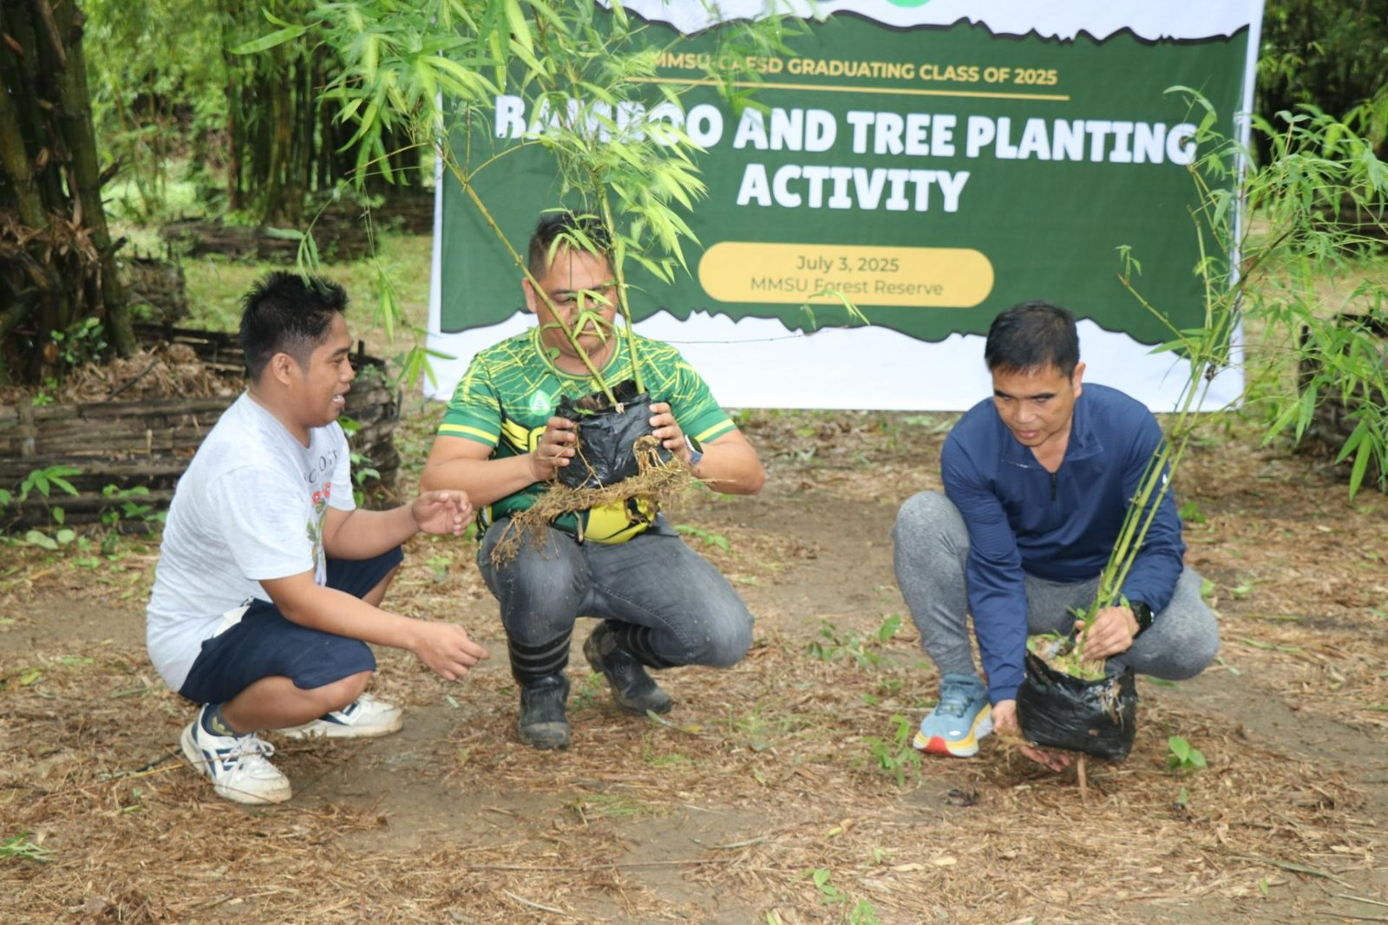 |  | 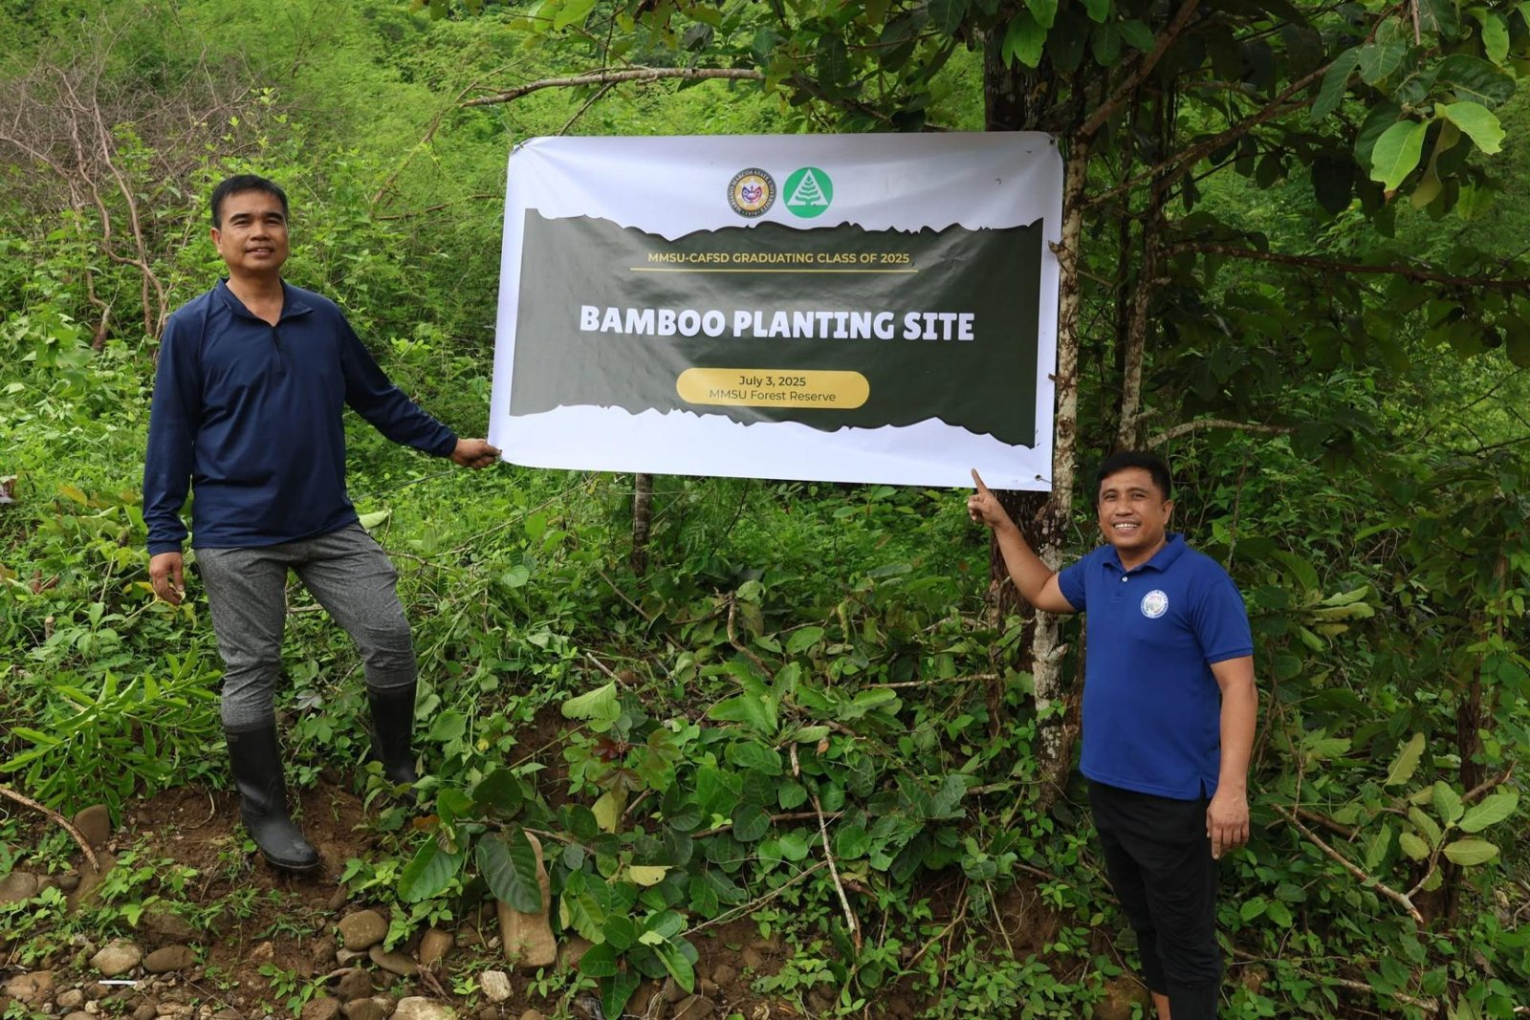
CAFSD Graduating Class 2025 “Bamboo and Tree Planting Activity,” University Forest Reserves, City of Batac, 2 July 2025. (Photo: MMSU STRATCOM) |  | Bamboo planting site in the University Forest Reserve, Brgy. Mabaleng, 2 July 2025. (Photo: MMSU STRATCOM)
Some 230 graduating students of the College of Agriculture, Food and Sustainable Development (CAFSD) of Mariano Marcos State University (MMSU) planted trees and bamboo in the University Forest Reserves in Barangays Payao and Mabaleng, City of Batac, on July 2, 2025. The activity was led by CAFSD OIC-Dean Charlie Batin and the 2025 CAFSD Graduating Class Student Council, with Dr. Joselito Rosario, Director for Agribusiness, and Mr. Bonne Jovie Orteza of the MMSU Bamboo Research and Development Center. MMSU President Virgilio Julius P. Manzano Jr. commended the class for leaving a lasting green footprint that will further preserve the forest areas managed by the university, and Mr. Hashler Garalde, a CAFSD alumnus representing the Provincial Government of Ilocos Norte, supported the college’s sustainability efforts.
The graduands planted 120 seedlings of guijo and yakal, native dipterocarp timber species raised at the MMSU Central Nursery, in the Payao Forest Reserve, and 130 propagules of kawayan tinik, machiku and giant bamboo from the MMSU Bamboo Nursery in Mabaleng. The planting continues CAFSD’s pre-graduation tree-planting tradition, held in July 2024 by the BS Forestry graduates at Salinged Park, the university’s ecological park, and repeated by the CAFSD Class of 2026 at the Payao Forest Reserve in June 2026.
Source
- MMSU News, “CAFSD graduands plant trees, bamboos in Batac forest reserves,” 4 July 2025 https://www.mmsu.edu.ph/article/news/2468/cafsd-graduands-plant-trees-bamboos-in-batac-forest-reserves
- MMSU News, “BS Forestry seniors leave green footprints with pre-graduation tree planting,” 11 July 2024 https://www.mmsu.edu.ph/article/news/2065/bs-forestry-seniors-leave-green-footprints-with-pre-graduation-tree-planting

President’s Farm Field Day Showcases Climate-Resilient Rice Varieties
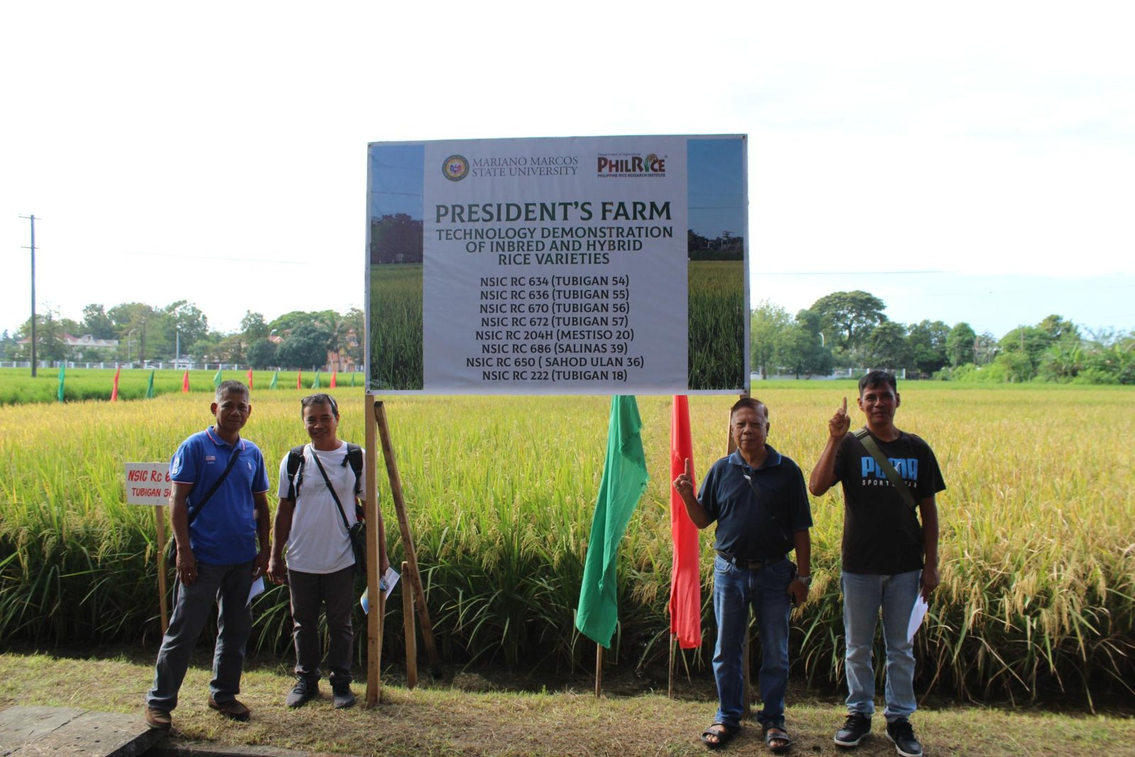 |  | 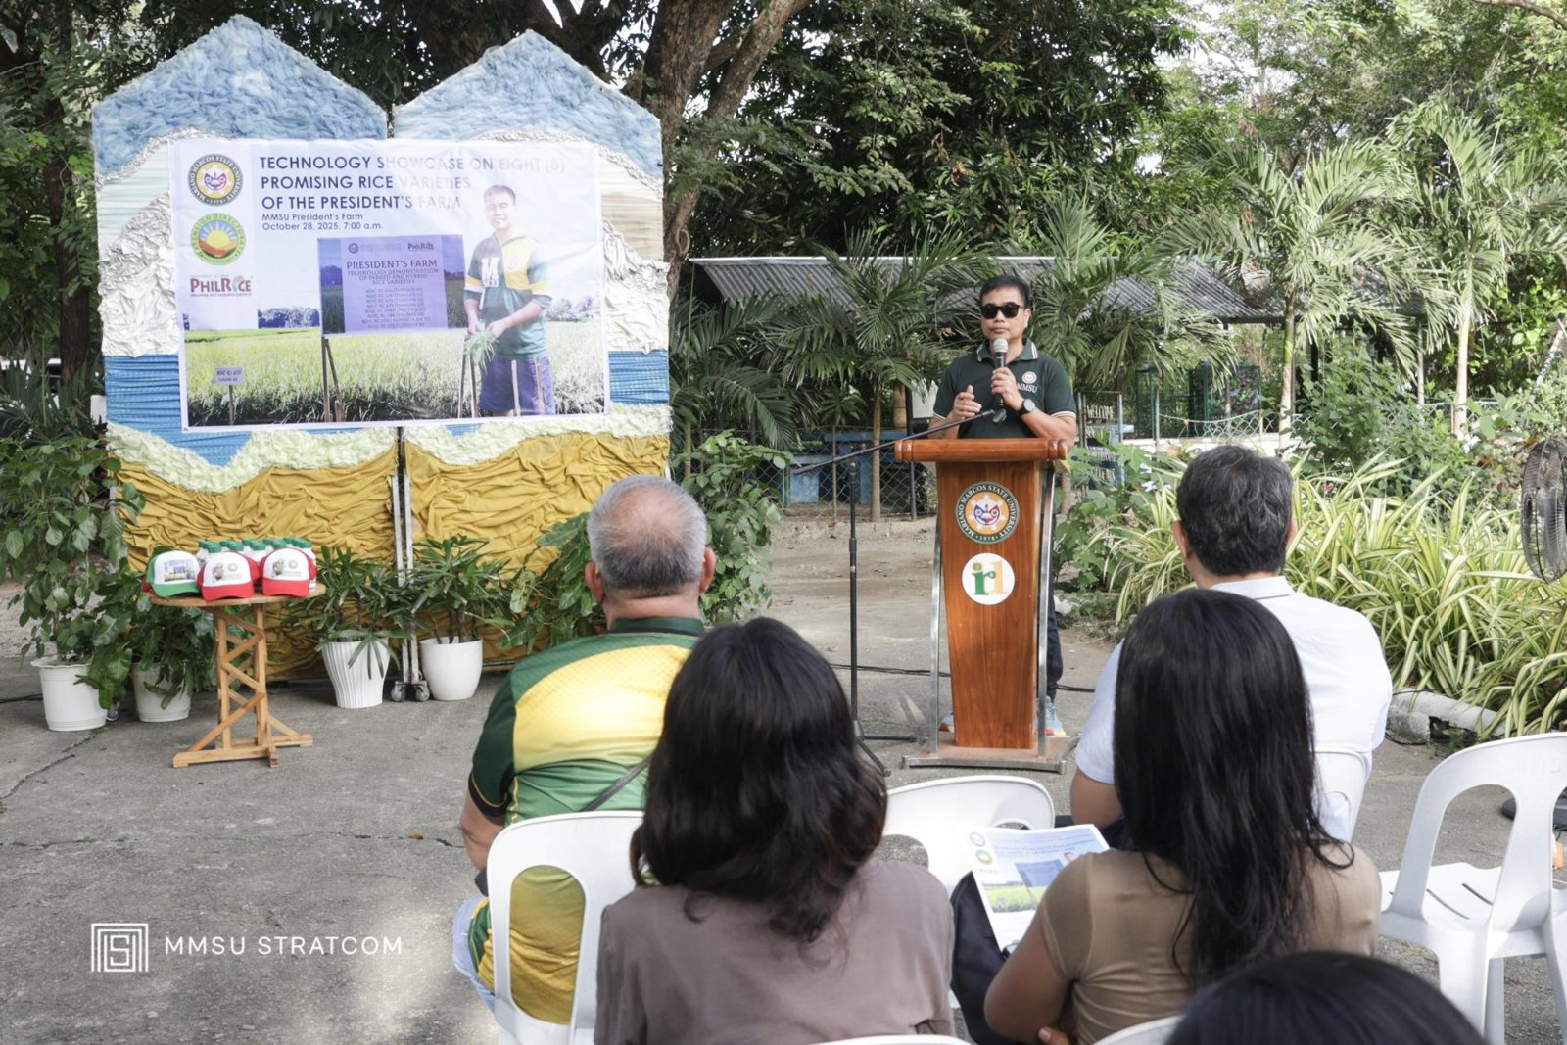
President’s Farm technology demonstration of inbred and hybrid rice varieties, 28 October 2025. (Photo: MMSU) |  | Farmers, LGU technicians and students at the President’s Farm Field Day, in front of CAFSD. (Photo: MMSU)
On October 28, 2025, the MMSU Extension Directorate, with the Philippine Rice Research Institute (PhilRice) Batac Branch, held the President’s Farm Field Day: A Technology Showcase in front of the College of Agriculture, Food and Sustainable Development. Farmers and farmer-leaders, agricultural technicians from Ilocos Norte local government units, BS Agriculture students, and MMSU and PhilRice rice specialists viewed eight rice varieties grown under wet-season conditions.
The varieties included four newly released by PhilRice, two public hybrids, and two suited to saline and rainfed conditions, among them NSIC Rc 686 (Salinas 39) and NSIC Rc 650 (Sahod Ulan 36), giving farmers options for saline-affected and rainfed fields. Speakers included MMSU President Dr. Virgilio Julius P. Manzano Jr., Extension Director Dr. Marlowe Aquino, and former MMSU President and PhilRice Executive Director Dr. Santiago R. Obien.
Source
- MMSU News, “MMSU President’s Farm showcases 8 rice varieties,” 4 November 2025 https://www.mmsu.edu.ph/article/news/2665/mmsu-presidents-farm-showcases-8-rice-varieties

2025 International Day for Biological Diversity Wildlife Photo Contest
 |  | 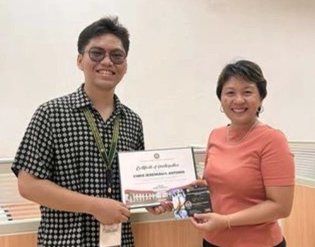
Contest poster with the animal-photography ethical guidelines (deadline 30 May 2025). |  | Winner Chris Jeremiah C. Antonio receives his certificate from Dr. Arlene L. Gonzales, Chief of Sustainability and Futures Thinking.
MMSU, through its Office of Sustainability and Futures Thinking, marked the 2025 International Day for Biological Diversity with a Wildlife Photo Contest that invited the university community to document local wildlife and promote awareness of biodiversity conservation. Entrants followed animal-photography ethical guidelines: avoiding flash and loud noises, never using bait or food lures, following local laws and warning signs, keeping clear of nesting sites and sensitive habitats, and captioning photographs honestly. Entries were received until May 30, 2025.
Chris Jeremiah C. Antonio, a third-year BA Communication student, was named winner and received a ₱1,000 gift voucher and a certificate from Dr. Arlene L. Gonzales, Chief of Sustainability and Futures Thinking.
Source
- MMSU SDG 15 Life on Land report (2025), Office of Sustainability and Futures Thinking

SDG 15.2.3 · Maintain and extend current ecosystems’ biodiversity
MMSU’s Commitment
Take an active role in protecting and promoting sustainable use of terrestrial ecosystems, responsible land use, and biodiversity conservation.

SDG 15.2.3 · Maintain and extend current ecosystems’ biodiversity
Work directly to maintain and extend existing ecosystems and their biodiversity, of both plants and animals, especially ecosystems under threat.
Evidence year: 2025 (calendar year)

Enriching MMSU’s 1,068-Hectare Forest Reserves with Native Species
Bamboo planting site in the University Forest Reserve, Brgy. Mabaleng, 2 July 2025. (Photo: MMSU STRATCOM)
MMSU manages Forest Reserve Areas in Barangays Lubbot and Payao, City of Batac, covering a total of 1,068.13 hectares, where the university’s forestry and agroforestry research is set up. The university maintains and extends these ecosystems with planting stock raised in its own nurseries, the MMSU Central Nursery and the MMSU Bamboo Nursery.
On July 2, 2025, 230 CAFSD graduating students enriched the reserves with 120 seedlings of the native dipterocarps guijo and yakal in Payao and 130 propagules of kawayan tinik, machiku and giant bamboo in Mabaleng. The activity was led by CAFSD OIC-Dean Charlie Batin with the MMSU Bamboo Research and Development Center.
Source
- MMSU Research Directorate, Station Profile https://research.mmsu.edu.ph/about/station-profile
- MMSU News, “CAFSD graduands plant trees, bamboos in Batac forest reserves,” 4 July 2025 https://www.mmsu.edu.ph/article/news/2468/cafsd-graduands-plant-trees-bamboos-in-batac-forest-reserves

Conserving Ilocos Indigenous Food Plants In Situ, Ex Situ and Circa Situ
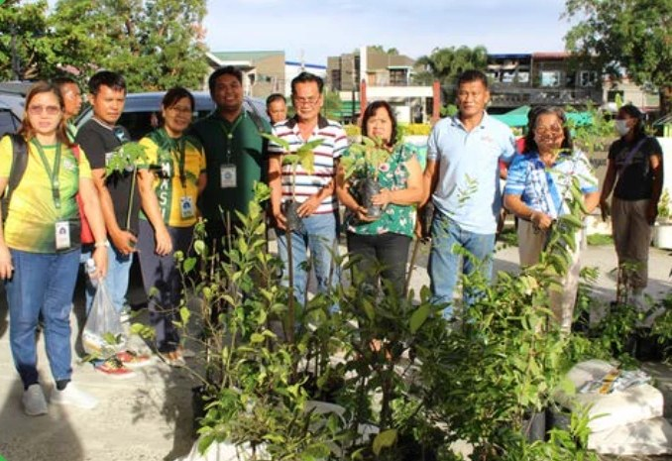
Partners receive indigenous food plant planting materials for the Community Foodscapes and Seedbanks, World Food Day 2025.
Through its Indigenous Food Plants (IFP) Program, MMSU conserves the wild and neglected food plants of Ilocos Norte, 46 of which were documented by the program in seven towns of the province. The program follows a triad of conservation approaches: an IFP Botanical Garden for ex situ conservation, a himbabao (alukon) genebank at the MMSU Forest Reserve, circa situ cultivation of the wild yams kamangeg and dolian, and the integration of IFPs into community foodscapes.
In October 2025, in celebration of World Food Day, the MMSU Extension and Research Directorates established the second batch of Community Foodscapes and Seedbanks for Indigenous Food Plants with local government units and schools, at Eladio V. Barangan Memorial Elementary School in San Nicolas, Ilocos Norte. The foodscape sites serve as seedbanks and learning gardens, and partner communities receive planting materials and technical assistance to cultivate kapaskapas, alokon, pako, dalayap, wild singkamas and roselle. The new partners join existing foodscape sites in Sarrat and Batac.
The IFP Program was adopted by the Regional Development Council of Region 1 as its first research and development initiative, and a study on the program by Dr. Menisa A. Antonio and co-authors won Best Paper in the Sustainable and Smart Agri-Aquaculture and Climate Resilience category of the SUC-ACAP 2025 Biennial Conference, held August 27–29, 2025, in Tagbilaran City, Bohol.
Source
- MMSU Research Directorate, “MMSU research on indigenous food plants wins best paper at SUC-ACAP 2025 conference” https://research.mmsu.edu.ph/news/details/mmsu-research-on-indigenous-food-plants-wins-best-paper-at-suc-acap-2025-conference
- MMSU Extension Directorate, “MMSU expands indigenous food plant seedbanks and foodscapes in LGUs,” October 2025 https://extension.mmsu.edu.ph/news/show/389/mmsu-expands-indigenous-food-plant-seedbanks-and-foodscapes-in-lgus
- MMSU SDG 15 Life on Land report (2025), Office of Sustainability and Futures Thinking

A New Bambusetum in Barangay Aglipay, Pinili
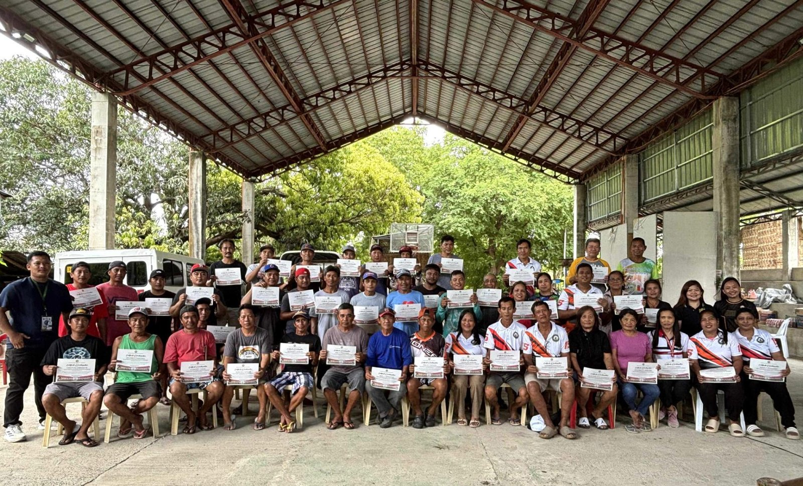
Participants of the bamboo propagation, nursery and plantation management training, Brgy. Aglipay, Pinili, 2025. (Photo: MMSU)
During a two-day bamboo production training in 2025, the MMSU Extension Directorate and CAFSD, with Barangay Aglipay, Pinili, and the support of ILAARRDEC, worked with 46 farmers, local leaders and community members to establish a new bambusetum, a collection of bamboo species, in Barangay Aglipay. The training covered bamboo propagation, nursery establishment and plantation management.
Source
- MMSU News, “Sustainable livelihood: MMSU, ILAARRDEC hold bamboo training in Pinili,” 3 September 2025 https://www.mmsu.edu.ph/news/sustainable-livelihood-mmsu-ilaarrdec-hold-bamboo-training-in-pinili

Nature-based Solutions to Restore Mangrove Ecosystems in Badoc and Currimao
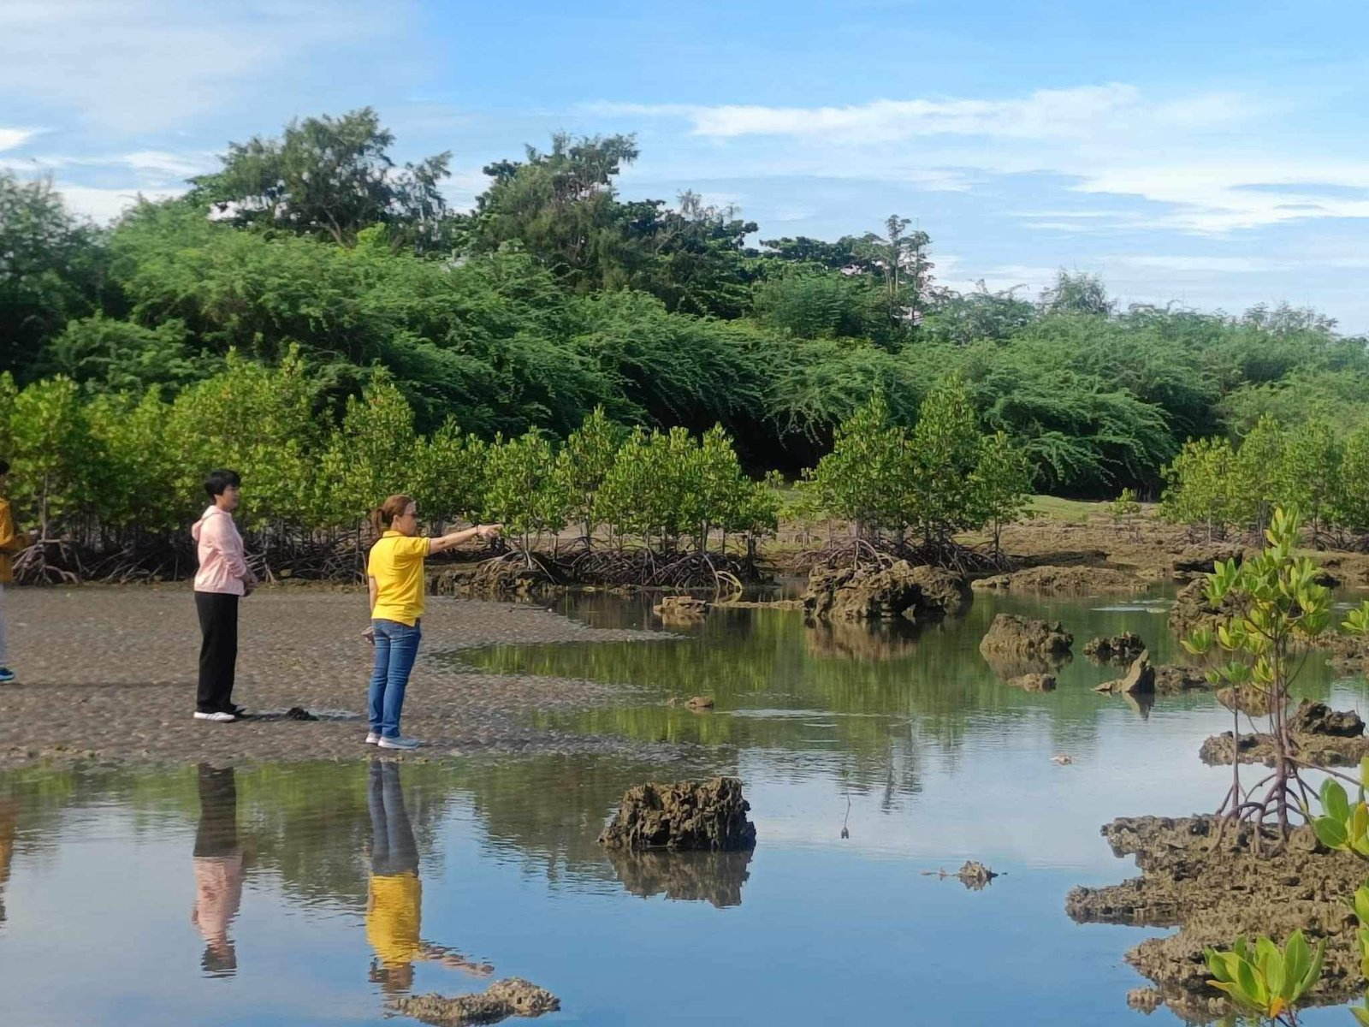 |  | 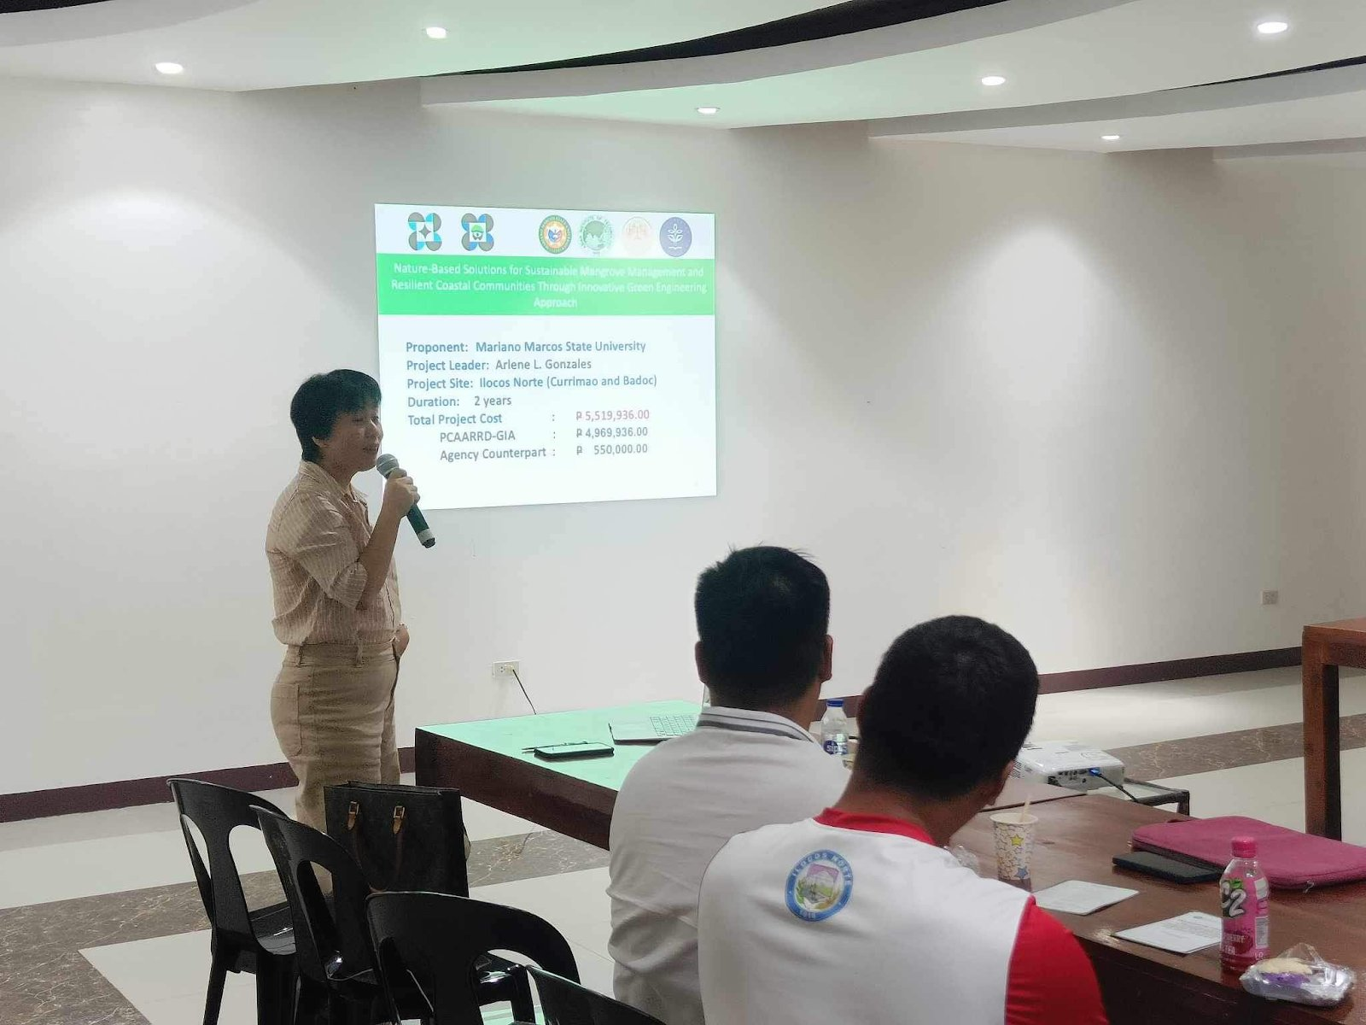
Project site in Badoc, Ilocos Norte. (Image credit: TTPD, DOST-PCAARRD) |  | Project Leader Dr. Arlene L. Gonzales presents the project at its launch, MMSU Review Center, 27 June 2024. (Image credit: TTPD, DOST-PCAARRD)
MMSU leads the DOST-PCAARRD-funded project “Nature-based Solutions (NbS) for Sustainable Mangrove Management and Resilient Coastal Communities Through Innovative Green Engineering Approach,” implemented from May 1, 2024 to April 30, 2026 under Project Leader Dr. Arlene L. Gonzales. Launched on June 27, 2024 at the MMSU Review Center, the project works in Badoc and Currimao, Ilocos Norte, with DENR-PENRO Ilocos Norte, the Provincial Government of Ilocos Norte, the LGUs of Badoc and Currimao, and local communities.
The project addresses the poor hydrological conditions that keep young mangrove propagules from surviving, using technology-assisted plantations and locally available, ecologically friendly materials, including bamboo-engineered structures that protect young mangroves and improve their survival. In 2025 MMSU and DENR Region 1 met at ILAARRDEC to advance the work; DENR officials pledged technical support and active participation in restoration, monitoring and evaluation, building on a memorandum of understanding signed in October 2024.
Source
- DOST-PCAARRD, “DOST-PCAARRD, MMSU launch nature-based solutions project on mangrove management in Ilocos Norte,” 7 August 2024 https://www.pcaarrd.dost.gov.ph/index.php/quick-information-dispatch-qid-articles/dost-pcaarrd-mmsu-launch-nature-based-solutions-project-on-mangrove-management-in-ilocos-norte
- MMSU SDG 15 Life on Land report (2025), Office of Sustainability and Futures Thinking

SDG 15.2.4 · Educational programmes on ecosystems
MMSU’s Commitment
Take an active role in protecting and promoting sustainable use of terrestrial ecosystems, responsible land use, and biodiversity conservation.

SDG 15.2.4 · Educational programmes on ecosystems
Offer educational programmes on ecosystems (looking at wild flora and fauna) for local or national communities.
Evidence year: 2025 (calendar year)

MMSU Trains Coastal Towns on Mangrove Propagation, Management and Conservation
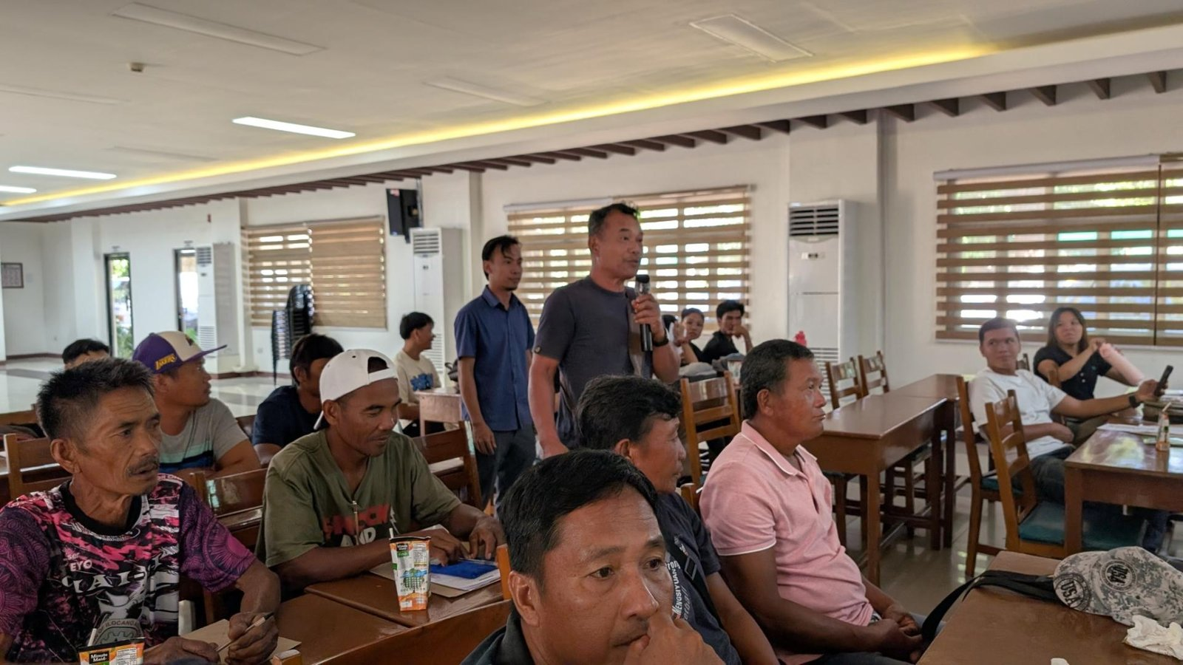 |  | 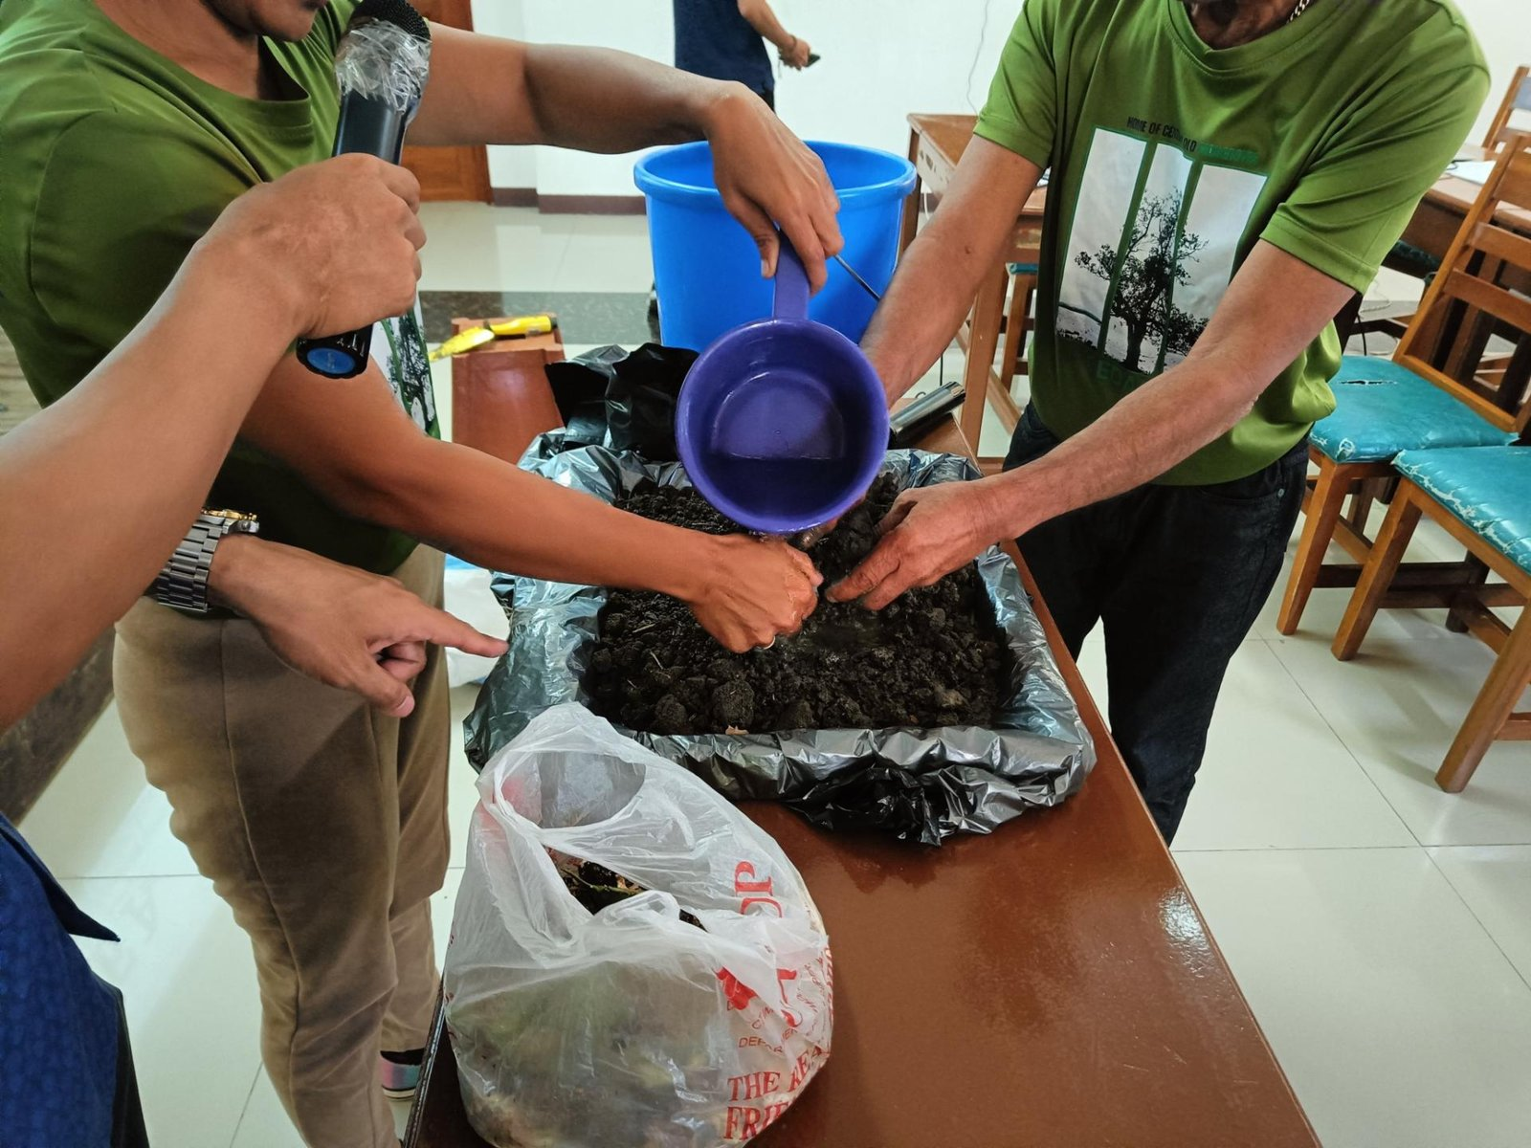
Representatives of Currimao, Pasuquin, Badoc and Burgos at the Seminar-Workshop on Mangrove Propagation, 27–28 October 2025. (Photo: MMSU) |  | Hands-on mangrove nursery and propagation practice during the seminar-workshop. (Photo: MMSU)
MMSU conducted a two-day Seminar-Workshop on Mangrove Propagation on October 27–28, 2025 at its Center for Flexible Learning for representatives of the coastal municipalities of Currimao, Pasuquin, Badoc and Burgos, Ilocos Norte, with officials of DENR-PENRO in attendance. The training was organized under the DOST-PCAARRD-funded nature-based solutions mangrove project led by Dr. Arlene Gonzales.
Sessions covered the importance of mangrove ecosystems, nature-based solutions for conservation, legal frameworks for mangrove protection, and the roles of the academe and local government units in community-based mangrove management. Participants were also trained in nursery management and advanced propagation techniques for Avicennia and Sonneratia species and other local mangrove varieties. The Pedada People’s Organization shared its experience in establishing community-based mangrove conservation.
Source
- MMSU News, “MMSU trains Ilocos Norte coastal towns on mangrove propagation and management,” 5 November 2025 https://www.mmsu.edu.ph/article/news/2670/mmsu-trains-ilocos-norte-coastal-towns-on-mangrove-propagation-and-management

Farmers in Sarrat Trained to Propagate the Indigenous Alukon
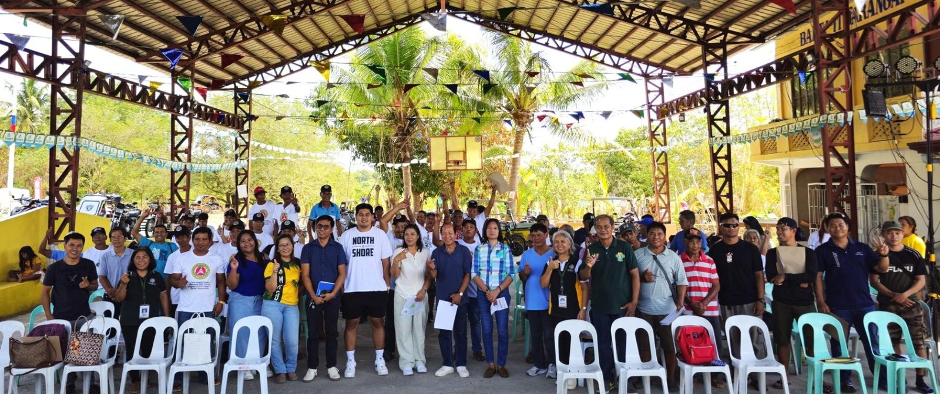
Farmers and local officials trained on alukon (himbabao) propagation, Brgy. 11 Sta. Rosa, Sarrat, 2 May 2025. (Photo: MMSU)
On May 2, 2025, the MMSU Research and Extension Directorates trained 64 farmers in Barangay 11 Sta. Rosa, Sarrat, Ilocos Norte, on the propagation of alukon (himbabao), a Philippine indigenous vegetable tree. Barangay officials, members of the Task Force Dagger Special Operations Foundation and representatives of the local government unit also attended. The training was held in response to requests from the community.
Resource speakers Dr. Menisa Antonio, Engr. Josefa Pugat and Mr. Jayson Rasay of the Research Directorate presented recommended propagation strategies to establish sustained alukon production in the community and broaden the use of the crop for food and other applications.
Source
- MMSU News, “MMSU trains Sarrat farmers on alukon propagation,” 9 May 2025 https://www.mmsu.edu.ph/news/mmsu-trains-sarrat-farmers-on-alukon-propagation

Community Foodscapes as Learning Gardens for Indigenous Plants
Partners receive indigenous food plant planting materials for the Community Foodscapes and Seedbanks, World Food Day 2025.
In October 2025, in celebration of World Food Day, the MMSU Extension and Research Directorates established the second batch of Community Foodscapes and Seedbanks for Indigenous Food Plants at Eladio V. Barangan Memorial Elementary School, San Nicolas, Ilocos Norte. Barangay officials of San Roque and Parut, Vintar, agricultural extension workers, school leaders and community representatives took part.
The foodscape sites serve as seedbanks and learning gardens that encourage knowledge sharing and sustainable farming practices. Communities receive planting materials and technical assistance to cultivate indigenous crops such as kapaskapas, alokon, pako, dalayap, wild singkamas and roselle, conserving indigenous food resources across Ilocos Norte.
Source
- MMSU Extension Directorate, “MMSU expands indigenous food plant seedbanks and foodscapes in LGUs,” October 2025 https://extension.mmsu.edu.ph/news/show/389/mmsu-expands-indigenous-food-plant-seedbanks-and-foodscapes-in-lgus
- MMSU SDG 15 Life on Land report (2025), Office of Sustainability and Futures Thinking

SDG 15.2.5 · Sustainable management of land for agriculture (educational outreach)
MMSU’s Commitment
Take an active role in protecting and promoting sustainable use of terrestrial ecosystems, responsible land use, and biodiversity conservation.

SDG 15.2.5 · Sustainable management of land for agriculture (educational outreach)
Offer educational programme/outreach for local or national communities on sustainable management of land for agriculture.
Evidence year: 2025 (calendar year)

School-on-the-Air Brings Regenerative Vegetable Farming to 1,000 Ilocanos
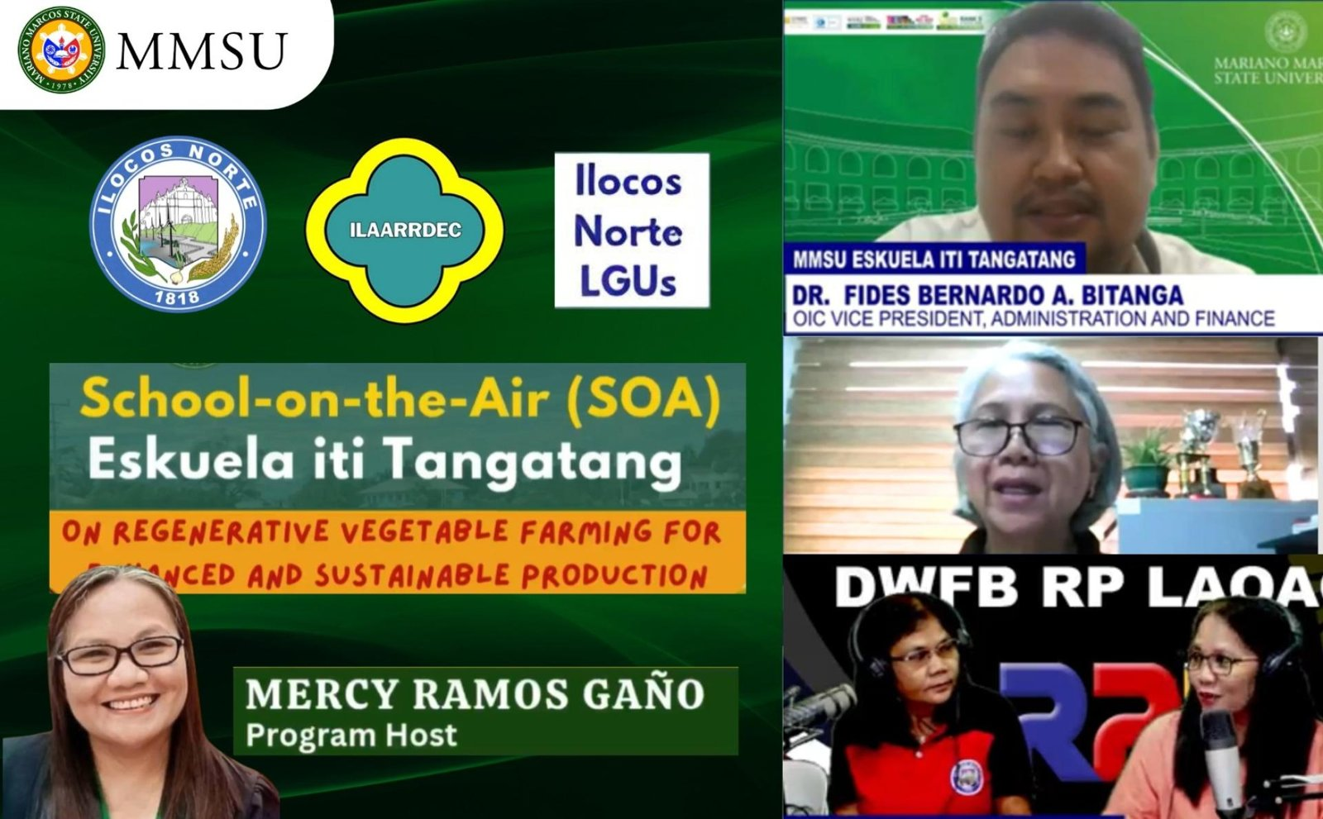
MMSU School-on-the-Air (Eskuela iti Tangatang) season on regenerative vegetable farming, June–December 2025. (Image: MMSU)
A new season of the MMSU School-on-the-Air (SOA), the university’s radio-based educational program, opened on June 24 and 25, 2025 with 1,000 enrollees from the 22 municipalities and cities of Ilocos Norte. The season focused on regenerative vegetable farming for enhanced and sustainable production, with lessons on climate-smart practices and off-season vegetable seeding.
Vegetable growers, rural improvement club members, agricultural extension workers and students followed the lessons, broadcast from June to December 2025 over DWFB Radyo Pilipinas Laoag, DWCI Radyo Adjo Piddig and DWNI Radyo Karruba Burgos. MMSU ran the program with the Provincial Government of Ilocos Norte, the Office of the Provincial Agriculturist, local government units, the Ilocos Agriculture, Aquatic and Natural Resources Research and Development Consortium, and the High-Value Crops Division of Ilocos Norte.
Source
- MMSU News, “MMSU draws 1K enrollees for SOA program on sustainable vegetable farming,” 26 June 2025 https://www.mmsu.edu.ph/news/mmsu-draws-1k-enrollees-for-soa-program-on-sustainable-vegetable-farming

Bamboo Propagation and Plantation Management Training in Pinili
Participants of the bamboo propagation, nursery and plantation management training, Brgy. Aglipay, Pinili, 2025. (Photo: MMSU)
The MMSU Extension Directorate and the College of Agriculture, Food and Sustainable Development, in partnership with Barangay Aglipay, Pinili, Ilocos Norte, and with the support of the Ilocos Agriculture, Aquatic and Natural Resources Research and Development Consortium (ILAARRDEC), conducted a two-day training on bamboo production in 2025.
The training equipped 46 farmers, local leaders and community members with practical skills in bamboo propagation, nursery establishment and plantation management. Lectures covered the prospects of the bamboo industry and MMSU’s propagation methods, and participants helped establish a new bambusetum, a collection of bamboo species, in Barangay Aglipay. Lectures and demonstrations were given by bamboo experts Mr. Charlie Maine Cacactin of CAFSD and Mr. Bonne Jovie Orteza of MMSU. Pinili Municipal Agriculturist Philip Galang, representing Mayor Rommel T. Labasan, thanked MMSU and ILAARRDEC, and the project was championed in the community by Pinili’s Magsasaka Siyentista, Mr. Reynaldo Antalan.
Source
- MMSU News, “Sustainable livelihood: MMSU, ILAARRDEC hold bamboo training in Pinili,” 3 September 2025 https://www.mmsu.edu.ph/news/sustainable-livelihood-mmsu-ilaarrdec-hold-bamboo-training-in-pinili

President’s Farm Field Day Showcases Climate-Resilient Rice Varieties
President’s Farm technology demonstration of inbred and hybrid rice varieties, 28 October 2025. (Photo: MMSU) |  | Farmers, LGU technicians and students at the President’s Farm Field Day, in front of CAFSD. (Photo: MMSU)
On October 28, 2025, the MMSU Extension Directorate, with the Philippine Rice Research Institute (PhilRice) Batac Branch, held the President’s Farm Field Day: A Technology Showcase in front of the College of Agriculture, Food and Sustainable Development. Farmers and farmer-leaders, agricultural technicians from Ilocos Norte local government units, BS Agriculture students, and MMSU and PhilRice rice specialists viewed eight rice varieties grown under wet-season conditions.
The varieties included four newly released by PhilRice, two public hybrids, and two suited to saline and rainfed conditions, among them NSIC Rc 686 (Salinas 39) and NSIC Rc 650 (Sahod Ulan 36), giving farmers options for saline-affected and rainfed fields. Speakers included MMSU President Dr. Virgilio Julius P. Manzano Jr., Extension Director Dr. Marlowe Aquino, and former MMSU President and PhilRice Executive Director Dr. Santiago R. Obien.
Source
- MMSU News, “MMSU President’s Farm showcases 8 rice varieties,” 4 November 2025 https://www.mmsu.edu.ph/article/news/2665/mmsu-presidents-farm-showcases-8-rice-varieties

Farmers in Sarrat Trained to Propagate the Indigenous Alukon
Farmers and local officials trained on alukon (himbabao) propagation, Brgy. 11 Sta. Rosa, Sarrat, 2 May 2025. (Photo: MMSU)
On May 2, 2025, the MMSU Research and Extension Directorates trained 64 farmers in Barangay 11 Sta. Rosa, Sarrat, Ilocos Norte, on the propagation of alukon (himbabao), a Philippine indigenous vegetable tree. Barangay officials, members of the Task Force Dagger Special Operations Foundation and representatives of the local government unit also attended. The training was held in response to requests from the community.
Resource speakers Dr. Menisa Antonio, Engr. Josefa Pugat and Mr. Jayson Rasay of the Research Directorate presented recommended propagation strategies to establish sustained alukon production in the community and broaden the use of the crop for food and other applications.
Source
- MMSU News, “MMSU trains Sarrat farmers on alukon propagation,” 9 May 2025 https://www.mmsu.edu.ph/news/mmsu-trains-sarrat-farmers-on-alukon-propagation

SDG 15.3.1 · Sustainable use, conservation and restoration of land (policy)
MMSU’s Commitment
Take an active role in protecting and promoting sustainable use of terrestrial ecosystems, responsible land use, and biodiversity conservation.

SDG 15.3.1 · Sustainable use, conservation and restoration of land (policy)
Have a policy to ensure the conservation, restoration and sustainable use of terrestrial ecosystems associated with the university, in particular forests, mountains and drylands.
Evidence year: 2025 (calendar year)

MMSU Land Use Policy Commits the University to Conserve and Restore Its Lands
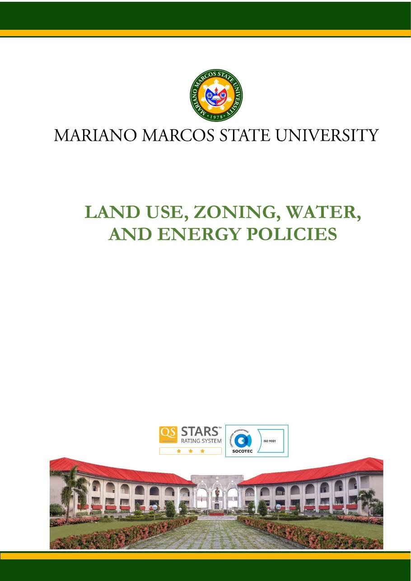
Document: MMSU Land Use, Zoning, Water and Energy Policies (Sirmata 2040 LUDIP, 2021), Land Use Policy, page 1.
MMSU’s Land Use, Zoning, Water and Energy Policies, adopted as part of Sirmata 2040, the university’s Land Use Development and Infrastructure Plan prepared in 2021 under Republic Act 11396, govern the conservation, restoration and sustainable use of all university lands across its campuses.
Under Policy 1.3, the allocation and use of university lands “shall aim to maintain, protect, conserve, restore, and enhance the integrity of the land itself, the environment and ecological balance in all its campuses.” Policy 7.1 requires decisions to be based on valid and reliable science, especially for any intent to alter or convert the natural state of any piece of university land, and Policy 10.2 gives fragile lands and protected areas special management “to protect, conserve, enrich, rehabilitate, and or sustain them.”
The zoning policy sets aside Protected Land as a distinct zone; under Policy 9.1, “protected landholdings of the university shall be conserved, preserved and to be excluded from any form of alteration except as may be permitted by operation of law.” The MMSU Forest Reserve is maintained as a no-build zone, and Policy 4.3 requires the university to regularly review, update and promptly communicate its land-use policies.
Source
- MMSU, Land Use, Zoning, Water and Energy Policies (Sirmata 2040 LUDIP, 2021) https://www.mmsu.edu.ph/resources/19uycXrgcO_iXPdPpMQwdCRxmoD1U5i60/view
- MMSU, Planning and Development on Local Biodiversity (SDG 15 evidence page) https://www.mmsu.edu.ph/resources/1tbtCaZa6Uh7ieu4epmz35VJ9jrRQGlPi/data

SDG 15.3.3 · Local biodiversity included in planning and development
MMSU’s Commitment
Take an active role in protecting and promoting sustainable use of terrestrial ecosystems, responsible land use, and biodiversity conservation.

SDG 15.3.3 · Local biodiversity included in planning and development
Include local biodiversity into any planning and development process (e.g. construction of new buildings).
Evidence year: 2025 (calendar year)

Sirmata 2040: Planning MMSU’s Campuses and Reserve Lands for Two Decades
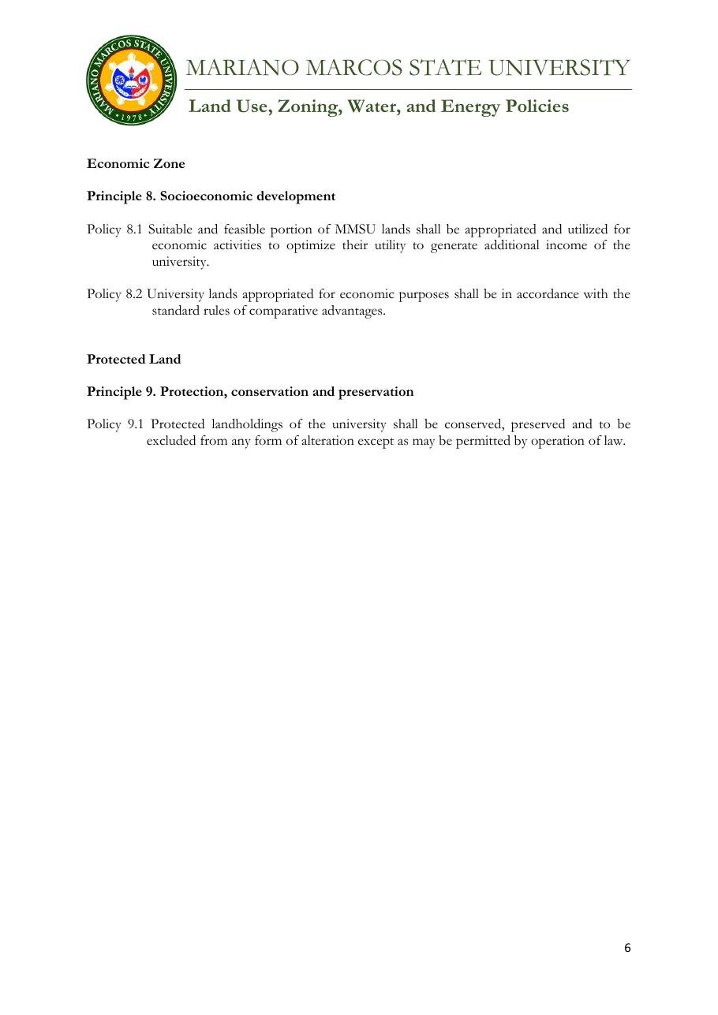
Document: MMSU Zoning Policy, Protected Land (Principle 9, Policy 9.1), Sirmata 2040 LUDIP.
Sirmata 2040, MMSU’s Land Use Development and Infrastructure Plan (LUDIP), is the university’s 20-year guide for managing its land resources and infrastructure. Prepared under Republic Act 11396, which requires state universities and colleges to have a LUDIP, and supported by a Php 2 million grant from the Commission on Higher Education (CHED), the plan covers the future land use of the MMSU campuses and the university’s reserve areas in Nagbacsan, Payao, Lubbot and Sarnap, City of Batac, including the forest reserves where MMSU’s forestry and agroforestry research is set up.
Local biodiversity is built into the plan’s development rules. The zoning plan sets aside Protected Land, which “shall be conserved, preserved and to be excluded from any form of alteration except as may be permitted by operation of law” (Policy 9.1), and the MMSU Forest Reserve is kept as a no-build zone. Before any land is altered or converted, the plan requires a science-based assessment of its natural suitability and carrying capacity (Policies 7.1, 10.1 and 11.1).
The plan was developed through stakeholder consultations, sectoral studies and campus planning workshops, and was endorsed by the CHED Technical Working Group after validation visits to the campuses.
Source
- MMSU, Land Use, Zoning, Water and Energy Policies (Sirmata 2040 LUDIP, 2021) https://www.mmsu.edu.ph/resources/19uycXrgcO_iXPdPpMQwdCRxmoD1U5i60/view
- MMSU, Planning and Development on Local Biodiversity (SDG 15 evidence page) https://www.mmsu.edu.ph/resources/1tbtCaZa6Uh7ieu4epmz35VJ9jrRQGlPi/data
- MMSU News, “CHED TWG OKs MMSU Sirmata 2040” https://www.mmsu.edu.ph/news/ched-twg-oks-mmsu-sirmata-2040
- MMSU News, “MMSU gets Php 2 M for LUDIP project” https://www.mmsu.edu.ph/news/mmsu-gets-php-2-m-for-ludip-project

SDG 15.3.5 · Collaboration for shared land ecosystems
MMSU’s Commitment
Take an active role in protecting and promoting sustainable use of terrestrial ecosystems, responsible land use, and biodiversity conservation.

SDG 15.3.5 · Collaboration for shared land ecosystems
Collaborate with the local community to maintain shared land ecosystems.
Evidence year: 2025 (calendar year)

MMSU, Pasuquin LGU and TMP Foundation Join to Restore a Mangrove Forest
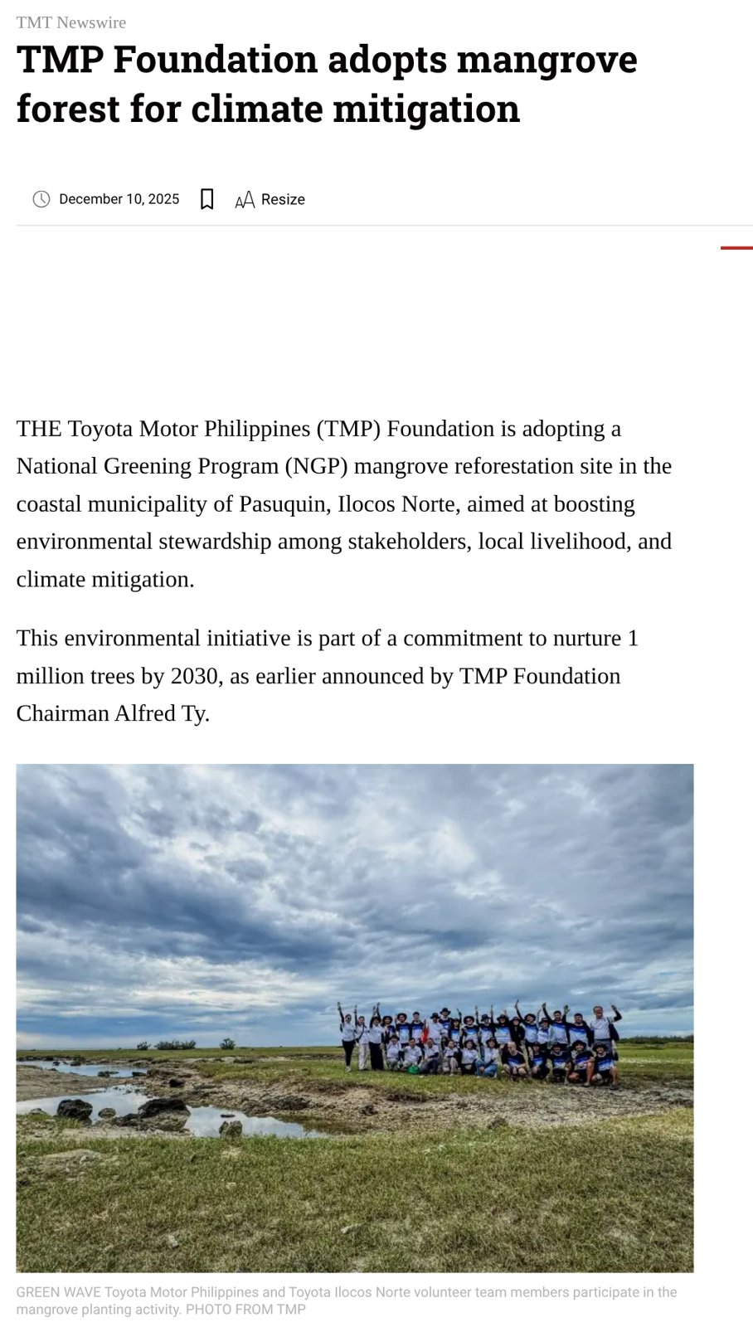
Capture of The Manila Times report of 10 December 2025 on the Pasuquin mangrove planting and agreement (photo in article: TMP Foundation).
In late 2025, Mariano Marcos State University entered into a tripartite agreement with the Municipal Government of Pasuquin, Ilocos Norte, and the Toyota Motor Philippines (TMP) Foundation for the conservation of a degraded two-hectare mangrove forest, a National Greening Program site in Barangay Davila, Pasuquin.
The agreement was signed at the close of a planting activity in which about 110 volunteers, including members of the MMSU College of Industrial Technology, DENR-CENRO Bangui, the Municipal Environment and Natural Resources Office and residents of Barangay Davila, planted 1,750 mangrove seedlings. Over two years, the partners will plant 3,500 seedlings of the native mangrove species lapis-lapis and arinaya to strengthen the community’s natural defense against climate-related impacts and enhance biodiversity.
Source
- The Manila Times, “TMP Foundation adopts mangrove forest for climate mitigation,” 10 December 2025 https://www.manilatimes.net/2025/12/10/tmt-newswire/tmp-foundation-adopts-mangrove-forest-for-climate-mitigation/2239598

MMSU and DENR Region 1 Strengthen Partnership for Mangrove Conservation
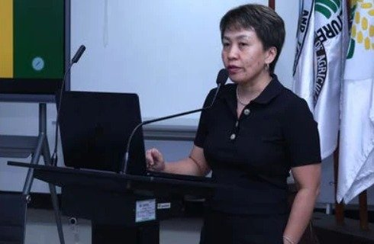 |  | 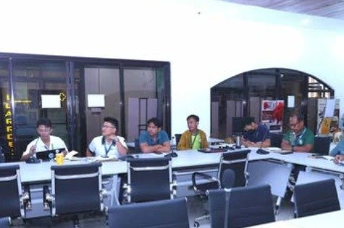
Dr. Arlene L. Gonzales at the MMSU–DENR Region 1 dialogue on mangrove conservation, ILAARRDEC. |  | MMSU and DENR Region 1 officials during the dialogue at ILAARRDEC.
MMSU, in partnership with the Department of Environment and Natural Resources (DENR) Region 1, convened a dialogue at ILAARRDEC to advance mangrove conservation and coastal resilience in the Ilocos Region through science-based and community-centered approaches. Central to the dialogue was the DOST-PCAARRD-funded nature-based solutions mangrove project led by Dr. Arlene Gonzales.
DENR officials pledged technical support and active participation in restoration, monitoring and evaluation activities, solidifying the partnership formalized through a memorandum of understanding signed in October 2024. The same project brought representatives of Currimao, Pasuquin, Badoc and Burgos, with DENR-PENRO, to MMSU’s mangrove propagation seminar-workshop on October 27–28, 2025.
Source
- MMSU SDG 15 Life on Land report (2025), Office of Sustainability and Futures Thinking
- MMSU News, “MMSU trains Ilocos Norte coastal towns on mangrove propagation and management,” 5 November 2025 https://www.mmsu.edu.ph/article/news/2670/mmsu-trains-ilocos-norte-coastal-towns-on-mangrove-propagation-and-management

MMSU Expert Serves on the Kalbario-Patapat Natural Park Technical Working Group
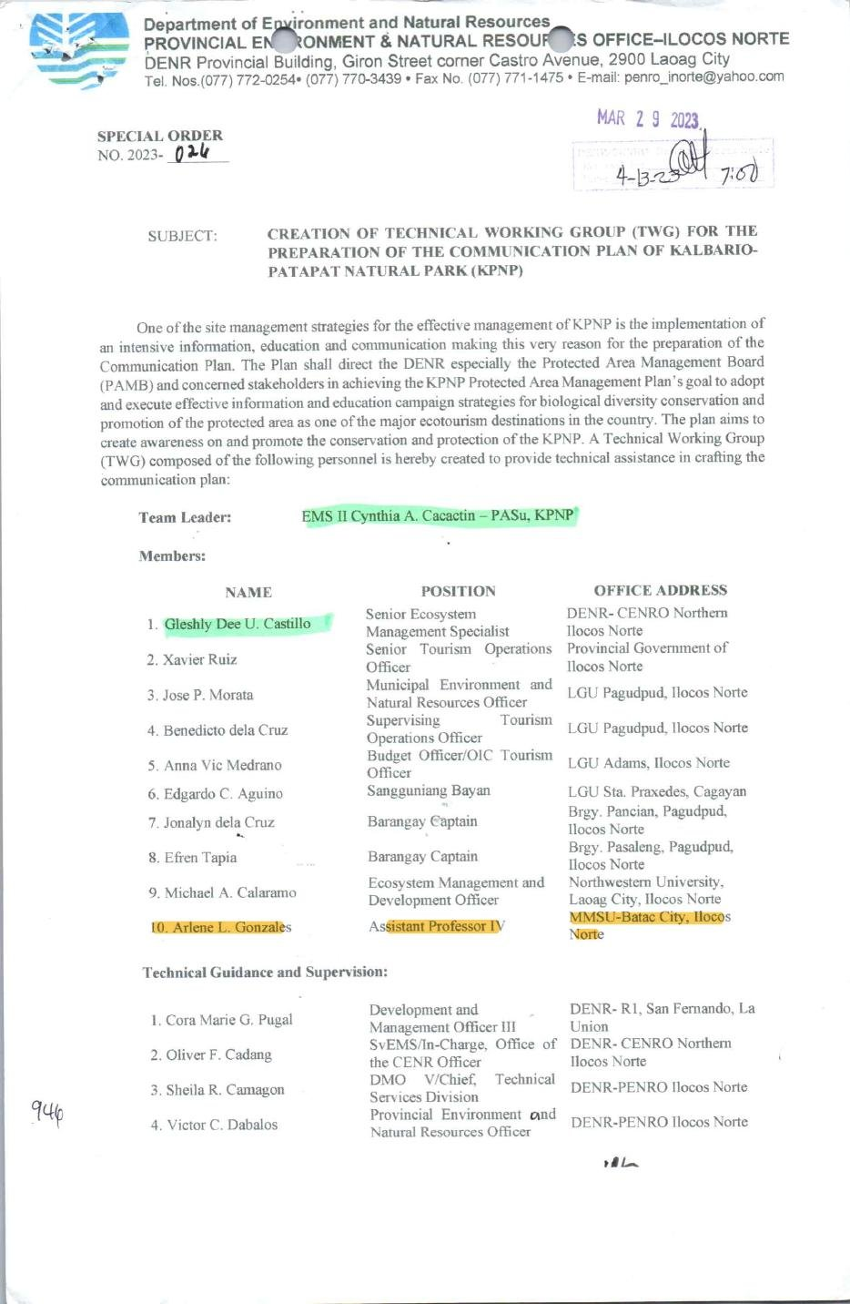
Document: DENR-PENRO Ilocos Norte Special Order No. 2023-024 (29 March 2023) naming Dr. Arlene L. Gonzales of MMSU to the KPNP Technical Working Group.
Through DENR-PENRO Ilocos Norte Special Order No. 2023-024, dated March 29, 2023, Dr. Arlene L. Gonzales of MMSU was named a member of the Technical Working Group that prepares the Communication Plan of the Kalbario-Patapat Natural Park (KPNP), a protected area in Ilocos Norte. The group, led by the KPNP Protected Area Superintendent, brings together DENR offices, the Provincial Government of Ilocos Norte, the LGUs of Pagudpud and Adams in Ilocos Norte and Sta. Praxedes in Cagayan, barangay officials and Northwestern University.
The Communication Plan supports the goal of the KPNP Protected Area Management Plan to adopt and carry out effective information and education campaigns for biological diversity conservation and for the promotion of the protected area as a major ecotourism destination.
Source
- DENR-PENRO Ilocos Norte Special Order No. 2023-024, 29 March 2023 (MMSU SDG 15 page) https://www.mmsu.edu.ph/resources/1TCpM-DxbkgfOh4QGwlfVr8QavCchKWKu/data

Indigenous Food Plant Foodscapes Established with Vintar and San Nicolas Partners
Partners receive indigenous food plant planting materials for the Community Foodscapes and Seedbanks, World Food Day 2025.
In October 2025, the MMSU Extension and Research Directorates partnered with local government units and schools to establish Community Foodscapes and Seedbanks for Indigenous Food Plants. Held at Eladio V. Barangan Memorial Elementary School in San Nicolas, Ilocos Norte, the activity brought together officials of Barangays San Roque and Parut, Vintar, the Municipal Agriculture Office of Vintar, agricultural extension workers, school leaders and community representatives as the second batch of partner sites.
The partner communities maintain the foodscapes as shared seedbanks and learning gardens, with planting materials and technical assistance from MMSU, to conserve indigenous food resources such as kapaskapas, alokon, pako, dalayap, wild singkamas and roselle. They join existing foodscape sites in Sarrat and Batac.
Source
- MMSU Extension Directorate, “MMSU expands indigenous food plant seedbanks and foodscapes in LGUs,” October 2025 https://extension.mmsu.edu.ph/news/show/389/mmsu-expands-indigenous-food-plant-seedbanks-and-foodscapes-in-lgus
- MMSU SDG 15 Life on Land report (2025), Office of Sustainability and Futures Thinking

A New Bambusetum in Barangay Aglipay, Pinili
Participants of the bamboo propagation, nursery and plantation management training, Brgy. Aglipay, Pinili, 2025. (Photo: MMSU)
During a two-day bamboo production training in 2025, the MMSU Extension Directorate and CAFSD, with Barangay Aglipay, Pinili, and the support of ILAARRDEC, worked with 46 farmers, local leaders and community members to establish a new bambusetum, a collection of bamboo species, in Barangay Aglipay. The training covered bamboo propagation, nursery establishment and plantation management.
Source
- MMSU News, “Sustainable livelihood: MMSU, ILAARRDEC hold bamboo training in Pinili,” 3 September 2025 https://www.mmsu.edu.ph/news/sustainable-livelihood-mmsu-ilaarrdec-hold-bamboo-training-in-pinili

SDG 15.4.1 · Water discharge guidelines and standards
MMSU’s Commitment
Take an active role in protecting and promoting sustainable use of terrestrial ecosystems, responsible land use, and biodiversity conservation.

SDG 15.4.1 · Water discharge guidelines and standards
Have water quality standards and guidelines for water discharges (to uphold water quality in order to protect ecosystems, wildlife, and human health and welfare).
Evidence year: 2025 (calendar year)

Water Policy and Groundwater Quality Monitoring at the MMSU Farm
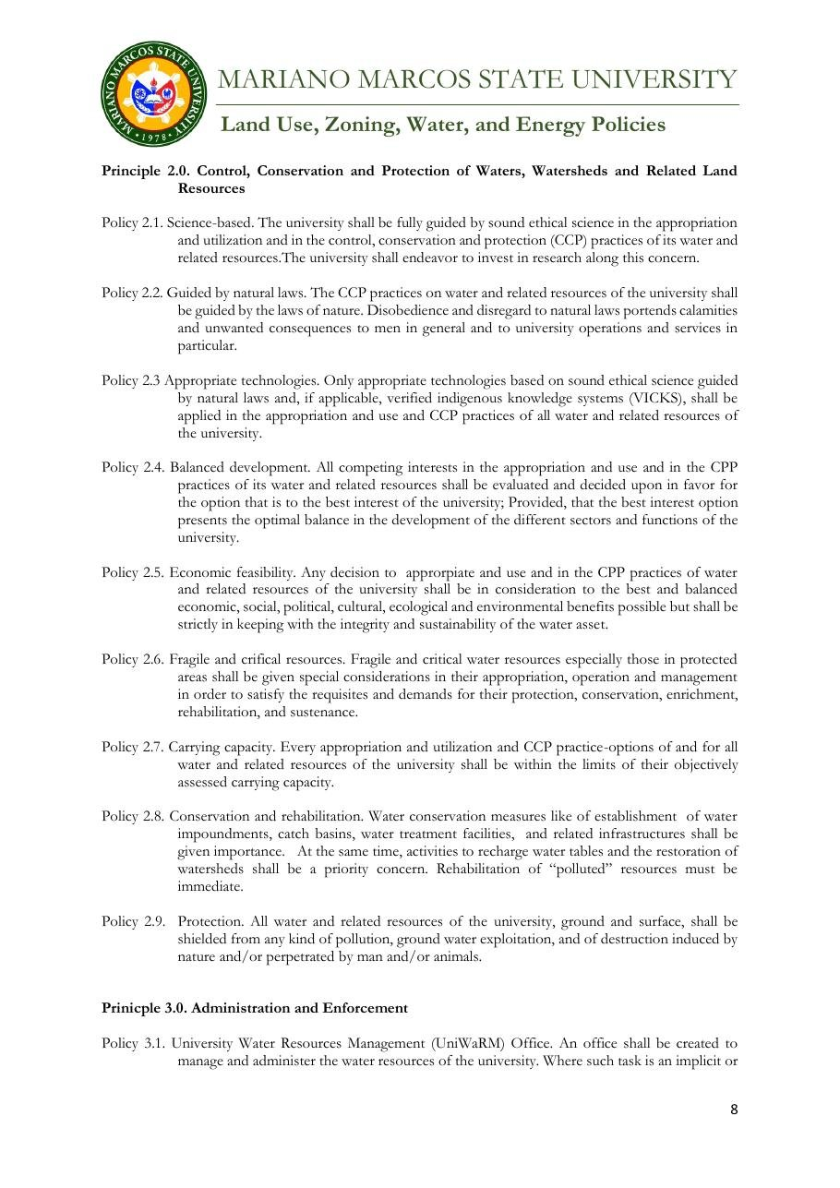 |  | 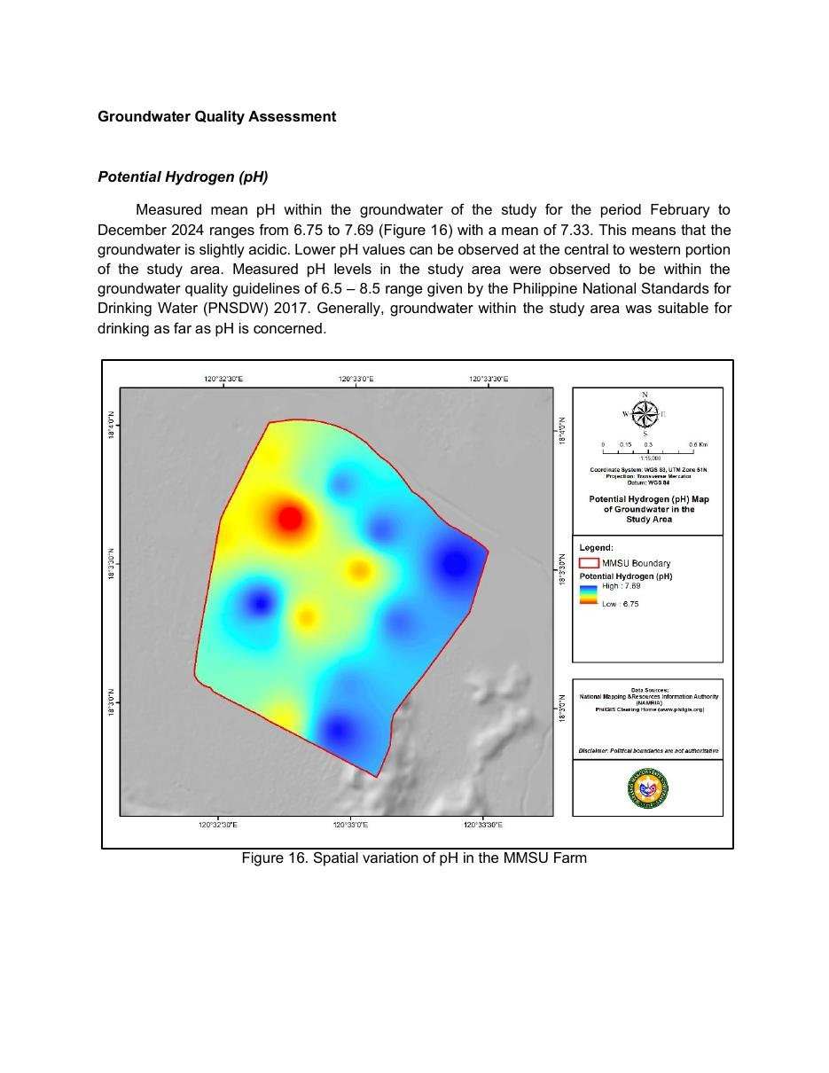
Document: MMSU Water Policy, control, conservation and protection of waters (Policies 2.6–2.9), Sirmata 2040 LUDIP. |  | Document: Groundwater Quality Assessment of the MMSU Farm, spatial variation of pH (monitoring February 2024 – June 2025).
MMSU’s Water Policy under Sirmata 2040, based on the Water Code of the Philippines and its 2005 implementing rules, requires that “all water and related resources of the university, ground and surface, shall be shielded from any kind of pollution” (Policy 2.9) and that the rehabilitation of polluted resources be immediate, giving importance to water impoundments, catch basins and water treatment facilities (Policy 2.8). The university’s Integrated Pollution and Waste Management Program also provides for registration as a hazardous waste generator for wastewater discharge from agro-industrial facilities such as the piggery, in compliance with Republic Act 9275, the Philippine Clean Water Act.
MMSU monitors the groundwater under its farm. From February 2024 to June 2025, 17 groundwater monitoring wells on the MMSU Farm were measured monthly for pH, total dissolved solids, electrical conductivity, chloride and nitrate-nitrogen, and the results were compared with the Philippine National Standards for Drinking Water (2017). Mean pH from February to December 2024 ranged from 6.75 to 7.69, within the 6.5–8.5 guideline, while wells with persistently high dissolved solids were flagged for continued monitoring to guide water resource management. Small campus reservoirs also collect rainwater, reduce flooding and recharge groundwater.
Source
- MMSU, Land Use, Zoning, Water and Energy Policies (Sirmata 2040 LUDIP, 2021) https://www.mmsu.edu.ph/resources/19uycXrgcO_iXPdPpMQwdCRxmoD1U5i60/view
- MMSU, Revised Integrated Pollution and Waste Management Program https://www.mmsu.edu.ph/resources/1fNUCZwyOozOKO27L2Bm6pNN-P_cJNpLd/view
- MMSU, Groundwater Quality Assessment of the MMSU Farm (monitoring February 2024 – June 2025) https://www.mmsu.edu.ph/resources/15g9Xtys7q3Rujd0-CZvPH4OHTdJ1__Z8/data
- MMSU, Water Discharge Management (SDG 15 evidence page) https://www.mmsu.edu.ph/resources/1l8foDfenNc7xpKp8wM8XShfZT58YyjSH/data

SDG 15.4.2 · Policy on plastic waste reduction
MMSU’s Commitment
Take an active role in protecting and promoting sustainable use of terrestrial ecosystems, responsible land use, and biodiversity conservation.

SDG 15.4.2 · Policy on plastic waste reduction
Have a policy on reducing plastic waste on campus.
Evidence year: 2025 (calendar year)

MMSU Policies Eliminate Styrofoam and Reduce Plastic Waste on Campus
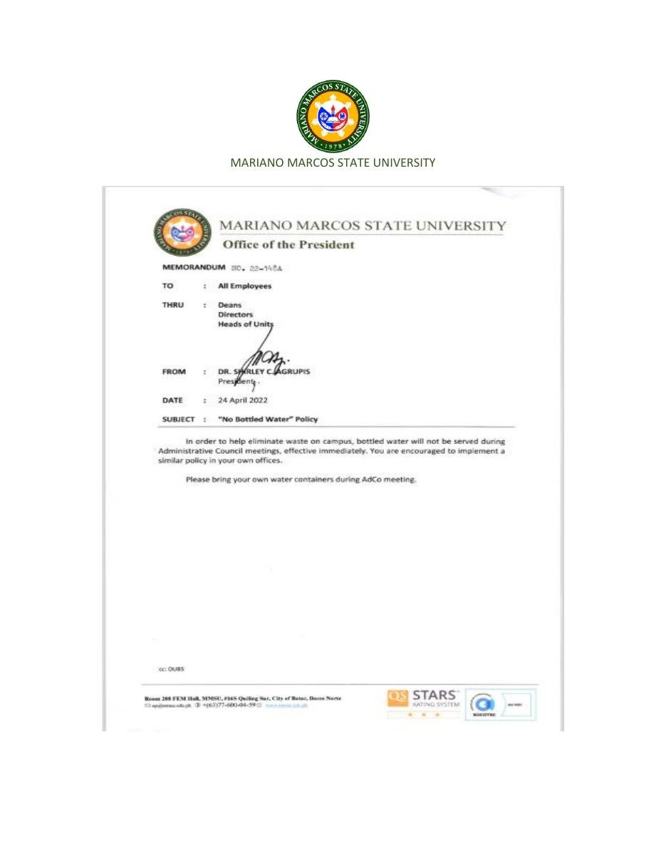 |  | 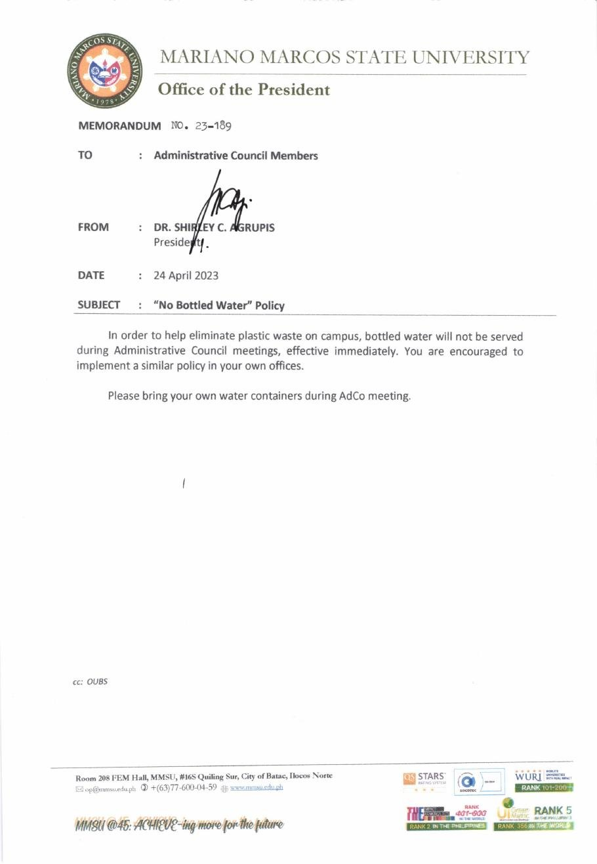
Document: Office of the President Memorandum No. 22-148A, “No Bottled Water” Policy, 24 April 2022. |  | Document: Office of the President Memorandum No. 23-189, “No Bottled Water” Policy, 24 April 2023.
MMSU reduces plastic waste under its Integrated Waste Management Program, approved by the Board of Regents in 2009 and amended in 2015, and its revised Integrated Pollution and Waste Management Program. The program prohibits Styrofoam for serving or packing food in the university Food Service Unit and limits the use of plastics, and a policy promulgated on February 11, 2016 eliminates Styrofoam and plastic as secondary packaging materials in favour of paper bags, cartons, eco-bags and reusable containers. The University Waste Management Committee develops, reviews and monitors these rules, and the food service unit requires customers dining out to bring their own food containers.
The Office of the President reissues the “No Bottled Water” Policy each year: Memorandum No. 22-148A of April 24, 2022 and Memorandum No. 23-189 of April 24, 2023 stop the serving of bottled water at Administrative Council meetings, ask members to bring their own water containers, and encourage all offices to adopt the same policy. In October 2024 the College of Agriculture, Food and Sustainable Development banned plastic bottled water in its auxiliary buildings, and on July 1, 2025 MMSU signed a memorandum of commitment with DENR-EMB Region I for the Regional Ecology Center to support solid waste management under Republic Act 9003 and the Extended Producer Responsibility Act (Republic Act 11898).
Source
- MMSU, Plastic Waste Management (SDG 15 evidence page) https://www.mmsu.edu.ph/resources/1NU-Qda9KG0J-PIOgKZwPKC4h_TU05zcm/data
- MMSU, Revised Integrated Pollution and Waste Management Program https://www.mmsu.edu.ph/resources/1fNUCZwyOozOKO27L2Bm6pNN-P_cJNpLd/view
- MMSU Office of the President, “No Bottled Water” Policy, Memorandum No. 22-148A (2022) and No. 23-189 (2023) https://www.mmsu.edu.ph/resources/1LbnK8yYkg-47ChbXyT0r8VQ9eBGuMxRx/data
- MMSU News, “MMSU CAFSD rolls out waste and pollution management program,” 15 October 2024 https://www.mmsu.edu.ph/news/mmsu-cafsd-rolls-out-waste-and-pollution-management-program
- MMSU News, “MMSU commits to ecological solid waste management in Region I,” 2 July 2025 https://www.mmsu.edu.ph/news/mmsu-commits-to-ecological-solid-waste-management-in-region-i

SDG 15.4.3 · Policy on hazardous waste disposal
MMSU’s Commitment
Take an active role in protecting and promoting sustainable use of terrestrial ecosystems, responsible land use, and biodiversity conservation.

SDG 15.4.3 · Policy on hazardous waste disposal
Have a policy, process or practice on waste disposal covering hazardous materials.
Evidence year: 2025 (calendar year)

Hazardous Waste Disposal under MMSU’s Integrated Pollution and Waste Management Program
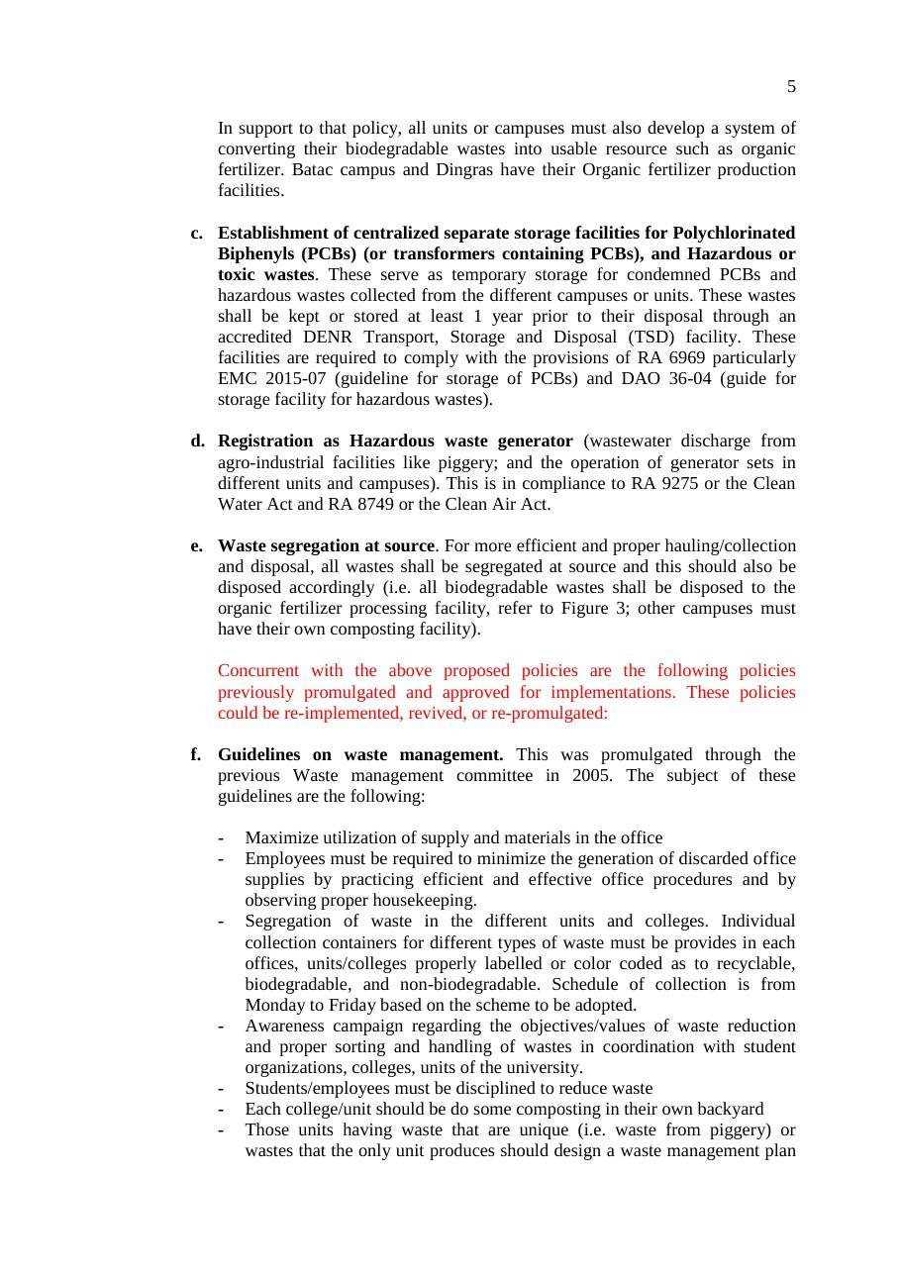
Document: Revised Integrated Pollution and Waste Management Program of MMSU, provisions on PCB and hazardous waste storage and registration.
MMSU’s Integrated Waste Management Program was revised in 2020 into the Integrated Pollution and Waste Management Program (IPWMP), implemented by the Pollution Control Unit and the General Services directorate, to cover hazardous materials. The IPWMP assigns focal persons for hazardous wastes (chemical and related wastes), air and water pollution, solid wastes, and PCBs and related industrial wastes, and requires the waste coordinators of every unit to store and label generated hazardous wastes properly before collection.
The program establishes centralized, separate storage facilities for polychlorinated biphenyls (PCBs) and other hazardous or toxic wastes collected from the campuses, where the wastes are kept for up to one year before disposal through a DENR-accredited transport, storage and disposal facility, in compliance with Republic Act 6969 and its storage guidelines. Units that generate hazardous waste are registered as hazardous waste generators, and the university coordinates with the Environmental Management Bureau of DENR for final collection and disposal.
Source
- MMSU, Hazardous Waste Disposal (SDG 15 evidence page) https://www.mmsu.edu.ph/resources/1jo6-3cVqxRAIllIxEhnSCgyT5ef5LGOW/data
- MMSU, Revised Integrated Pollution and Waste Management Program https://www.mmsu.edu.ph/resources/1fNUCZwyOozOKO27L2Bm6pNN-P_cJNpLd/view

Indicators still without public evidence
The following SDG 15 questions still have no MMSU evidence online. Peer universities answer them with dated policies or programmes; MMSU should retrieve or issue the equivalent documents. MMSU’s SDG 15 page also lists “Number of Seedlings Planted from 2018 to 2024,” “Summary of Tree Inventory for Payao and Dingras, October–December 2023” and “Sustainable Use of Land,” but no file is attached to those links; adding them would strengthen 15.2.3, 15.3.1 and 15.3.2.
Indicator | What peers submit | What MMSU should produce
15.2.2 Sustainably farmed food on campus | Campus farm statement or food sourcing policy (CarSU Ka-Agri Farm) | Policy or memorandum on sourcing campus food from MMSU farms (CARES, CAFSD) and local sustainable growers
15.2.6 Tourism land-management outreach | Training for tourism operators or eco-park stewards | Community programme linked to the Biodiversity Conservation Learning Center or campus eco-sites
15.3.2 IUCN and national-list species policy | Species monitoring policy with a species register | Policy plus a register for the forest reserves, using the 2023 Payao and Dingras tree inventory listed on MMSU’s SDG 15 page
15.3.4 Alien species policy | Alien species policy | Native-species planting and invasive-species control policy

To complete before submission
- Free access: state that the 2025 mangrove seminar, alukon training, Pinili bamboo training and School-on-the-Air were free of charge, if true. THE gives full credit only to free programmes (15.2.4, 15.2.5).
- Policies: attach the Board of Regents resolution or approval page for Sirmata 2040 and for the revised Integrated Pollution and Waste Management Program, so 15.3.1, 15.3.3, 15.4.2 and 15.4.3 show a visible approval date within 2020–2025.
- Pasuquin agreement: exact signing date and a copy of the signed tripartite memorandum of agreement; replace the news capture with MMSU’s own photo if available.
- MMSU–DENR Region 1 memorandum of understanding (October 2024) and the 2025 ILAARRDEC dialogue date; Biodiversity Day photo contest announcement link.
- Confirm the 2027 data year with THE before upload, and upload one file per indicator rather than this compendium. THE rejects evidence that is mainly a list of links.

