CIFAR 10

BUDGET 0.1

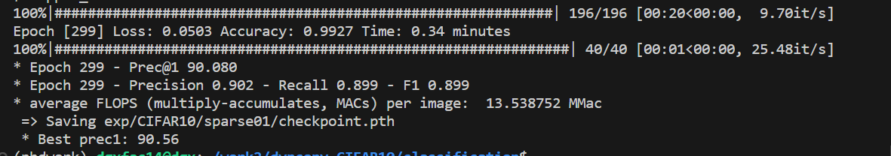

BUDGET 0.2

BUDGET 0.3

BUDGET 0.4

BUDGET 0.5

BUDGET 0.6

BUDGET 0.7

BUDGET 0.8

BUDGET 0.9

