RESNET50 MODEL – PYTORCH

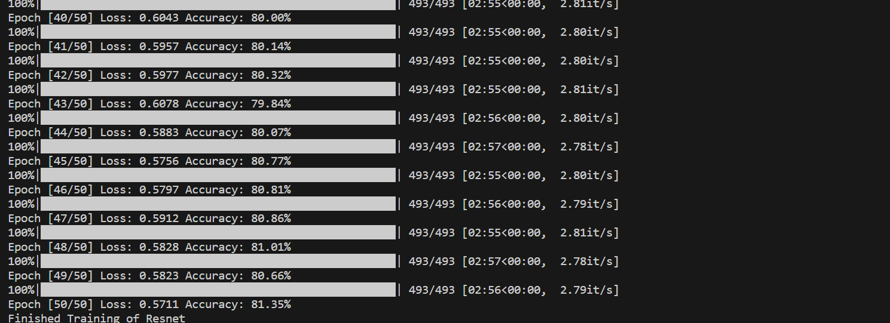

Run Command – python Resnet.py

Number of epochs - 50

Accuracy after 50th epoch – 81.35%

Best accuracy – 81.35%

Total FLOPs – 5396.53M

Total Params – 23.54 Params(M)

Testing accuracy – 79%

GoogleNet

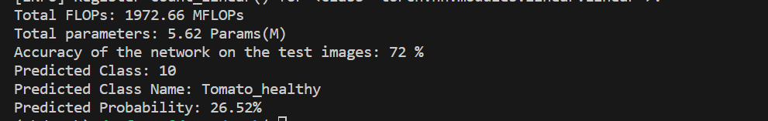

Run Command – python Googlenet.py

Number of epochs - 50

Accuracy after 50th epoch – 73.69%

Best accuracy – 73.77%

Total FLOPs – 1972.66M

Total Params – 5.62 Params(M)

Testing accuracy – 72%

VGG16

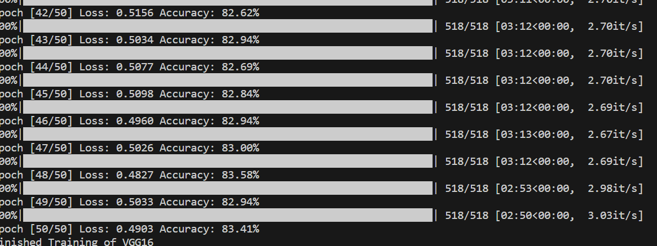

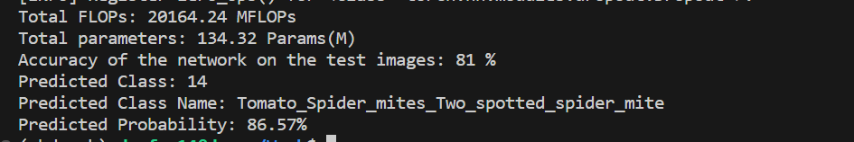

Run Command – python vgg16.py

Number of epochs - 50

Accuracy after 50th epoch – 83.41%

Best accuracy – 83.58%

Total FLOPs – 20164.24M

Total Params – 134.32 Params(M)

Testing accuracy – 81%

DENSENET 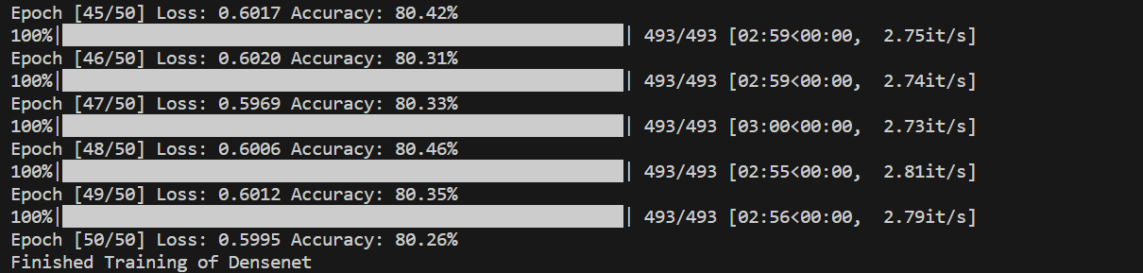

Run Command – python Densenet.py

Number of epochs - 50

Accuracy after 50th epoch – 80.26%

Best accuracy – 80.46%

Total FLOPs – 3782.52M

Total Params – 6.97 Params(M)

Testing accuracy – 79%