ALEXNET MODEL - PYTORCH

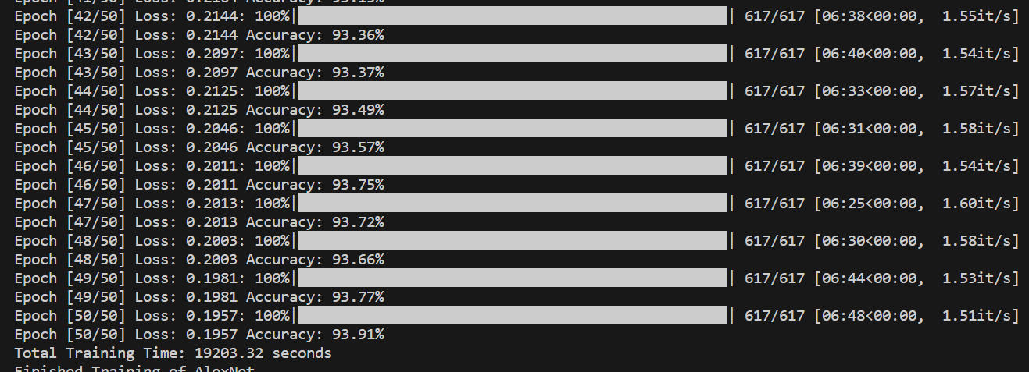

Run Command – python Alexnet.py

Number of epochs - 50

Accuracy after 50th epoch – 93.91%

Best accuracy – 93.91%s

Total training time – 320.06mins

Total FLOPs – 927.79M

Total Parameters – 61.74 Params(M)

Testing accuracy – 93%

Total testing time – 1.53mins

DENSENET MODEL – PYTORCH

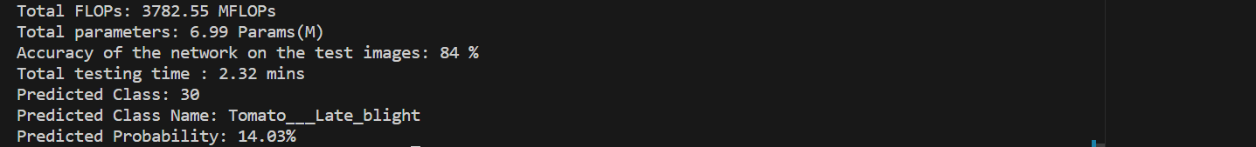

Run Command – python Densenet.py

Number of epochs - 50

Accuracy after 50th epoch – 84.82%

Best accuracy – 84.82%

Training time – 357.13mins

Total FLOPs – 3782.55M

Total Parameters – 6.99 Params(M)

Testing accuracy – 84%

Testing time – 2.32 mins

Vgg16 MODEL – PYTORCH

Run Command – python vgg16.py

Number of epochs - 50

Accuracy after 50th epoch – 86.55%

Best accuracy – 86.55%

Total Training Time – 411.71 mins

Total FLOPs – 20164.33M

Total Parameters – 61.74 Params(M)

Testing accuracy – 86%

Testing time total – 1.70mins

GOOGLENET MODEL PYTORCH

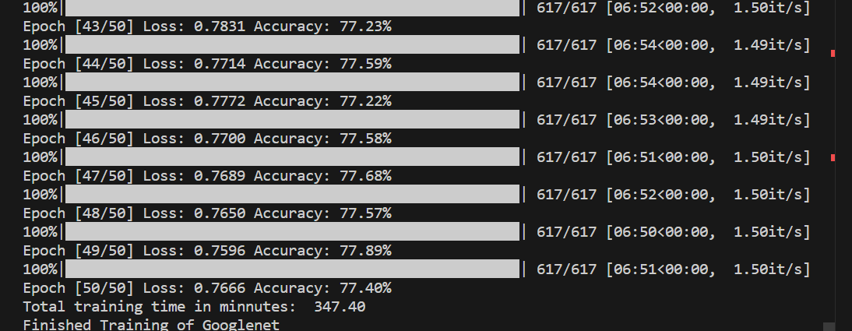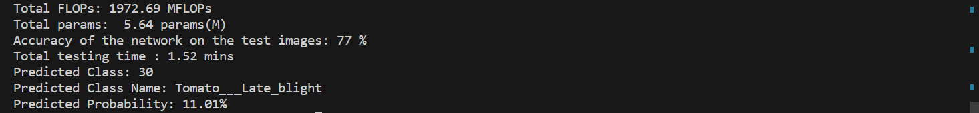

Run Command – python Googlene.py

Number of epochs - 50

Accuracy after 50th epoch – 77.40%

Best accuracy – 77.89%

Total training time – 347.40 mins

Total FLOPs – 1972.69 M Flops

Total Parameters – 5.64 Params(M)

Testing accuracy – 77%

Total testing time – 1.52 mins

RESNET MODEL PYTORCH

Run Command – python Resnet50.py

Number of epochs - 50

Accuracy after 50th epoch – 86.08%

Best accuracy – 86.18%

Total training time – 396.94mins

Total FLOPs – 5396.58 M Flops

Total Parameters – 23.59 Params(M)

Testing accuracy – 85%

Total testing time – 1.88 mins