TRAIN_BASE FILE

CIFAR 10

python train_base.py train cifar10_resnet_38

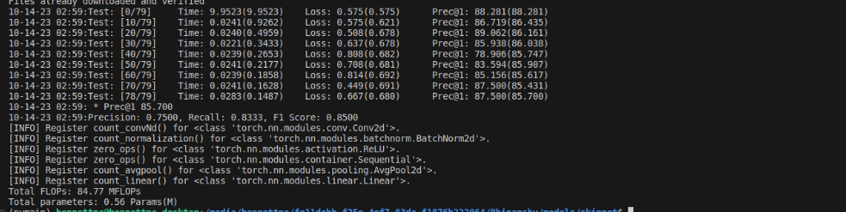

python train_base.py train cifar10_resnet_74

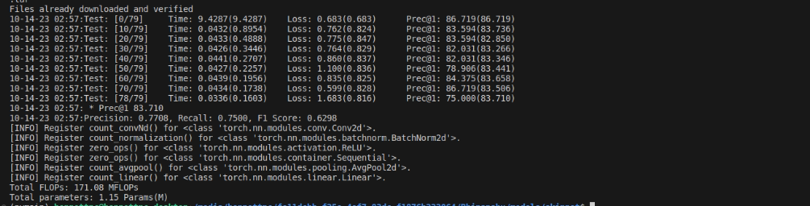

python train_base.py train cifar10_resnet_110

CIFAR100

python train_base.py train cifar100_resnet_38 -d cifar100

python train_base.py train cifar100_resnet_74 -d cifar100

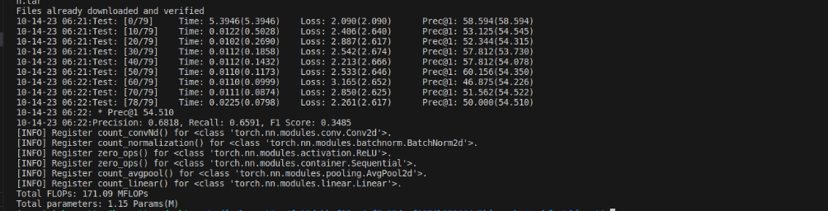

python train_base.py train cifar100_resnet_110 -d cifar100

