CIFAR10 -  
  
FEEDFORWARD

python train_sp.py test cifar10_feedforward_38  
  
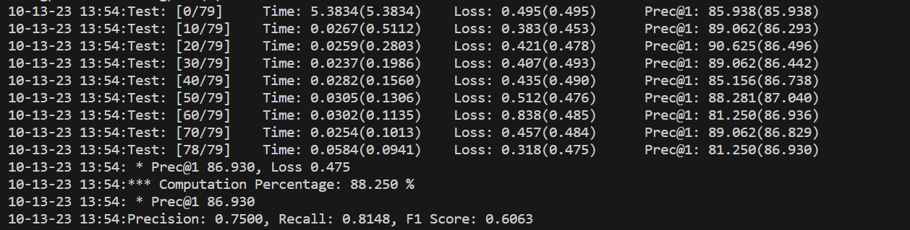  
  
python train_sp test cifar10_feedforward_74

python train_sp test cifar10_feedforward_110

CIFAR 100

Feedforward

python train_sp.py train cifar100_feedforward_38 -d cifar100

python train_sp.py train cifar100_feedforward_74 -d cifar100

python train_sp.py train cifar100_feedforward_110 -d cifar100

CIFAR10

RNN  
  
python train_sp.py train cifar10_rnn_gate_38  
  
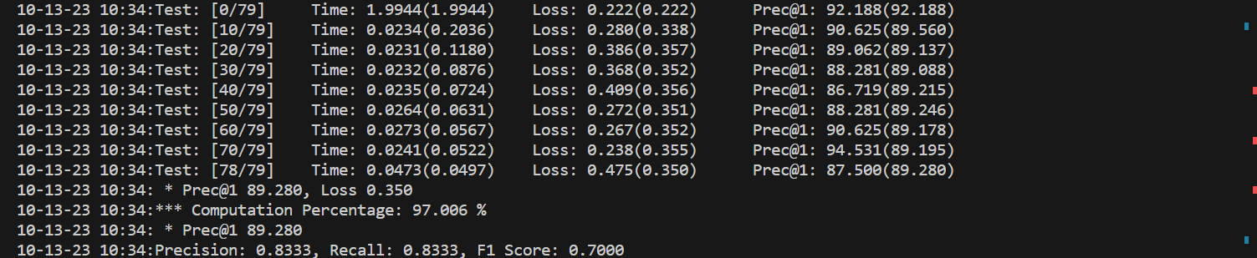

python train_sp.py train cifar10_rnn_gate_74

python train_sp.py train cifar10_rnn_gate_110