Practical - 1

Aim : Understanding of language processing activities through sample C code which does following operations:
- Preprocessed code
- Assembly Code
- Object Code
- Executable Code

Program:

Filename : Prac1.c

#include<stdio.h>
#define sq(x) x*x
#define cube(x) sq(x)*x

int main(){
int x = 10;
printf("%d",cube(x));
return 0;
}

To Generate preprocessed code: cpp prac1.c > prac1.i
Output of Preprocessor:
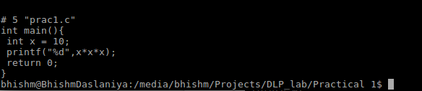
To generate assembly code: gcc -S prac1.i
Output of compiler:
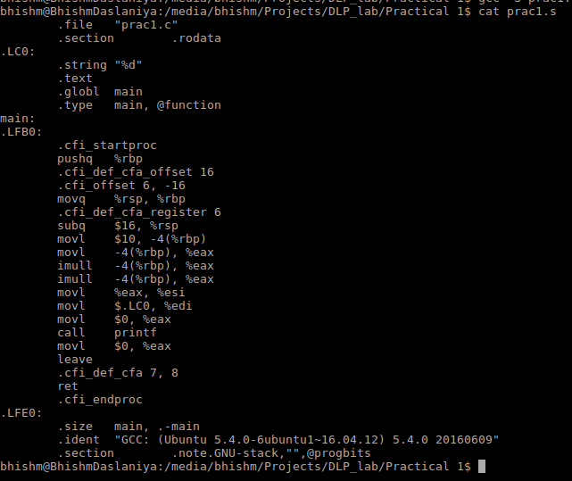
To generate object code: as -o prac1.o prac1.s
Output of assembler:
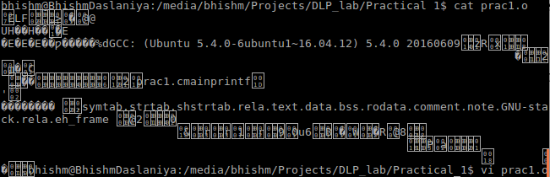
To generate executable code: gcc prac1.o -o prac1.exe
Output of executable file:
Conclusion: From this practical I have learnt about internal processing of language processor and also learnt about different stages of generating the output of code.

