Practical - 2

Aim : Understanding of macro facilities which will demonstrate the use of following preprocessor directive of C.

1. #define : A macro is a segment of code which is replaced by the value of macro. Macro is defined by #define directive.
There are two types of macros:
- Object-like Macros: #define PI 3.1415
- Function-like Macros: #define MIN(a,b) ((a)<(b)?(a):(b))

Code:
#include<stdio.h>
#define SQRT(x) x*x
#define CUBE(x) SQRT(x)*x
#define MIN(a,b) ((a)<(b)?(a):(b))

int main(){
printf("Cube of 10 : %d\n",CUBE(10));
printf("Minimum of 10 and 20 is : %d\n",MIN(10,20) );
}
Output:
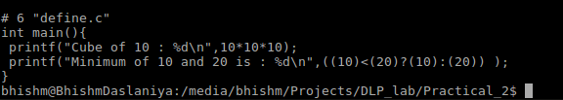

2. #include: The #include preprocessor directive is used to paste code of given file into current file.

Code:
User_cube.h:
#define SQRT(x) x*x
#define CUBE(x) SQRT(x)*x

include.c:
#include<stdio.h>
#include<math.h>
#include "User_cube.h"
int main(){
printf("Ex. of include macro, Cube from User_cube.h:%d\n",CUBE(10));
}

Output:
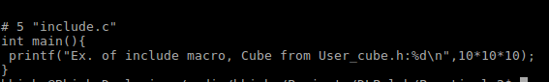

3. #undef: It is useful for undefine a macro means to cancel its defination.

Code:
#include <stdio.h>
#define PI 3.1415
#undef PI

int main() {
printf("%f",PI);
}
Output:
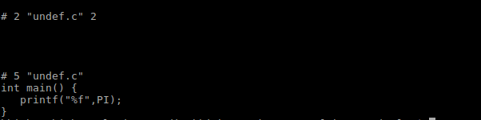
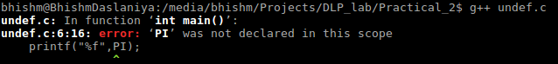
4. #ifdef: The #ifdef preprocessor directive checks if macro is defined by #define. If yes, it executes the code.

Code:
#include <stdio.h>
#define PI 3.1415
int main() {
#ifdef PI
printf("%f",PI);
#endif
}
Output:
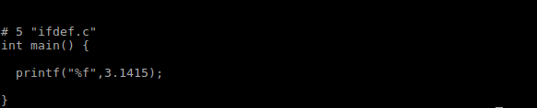
5. #ifndef: The #ifndef preprocessor directive checks if macro is not defined by #define. If yes, it executes the code.

Code:
#include <stdio.h>
#define PI 3.1415
#undef PI

int main() {
#ifndef PI
printf("PI is not defined\n");
#endif
}
Output:
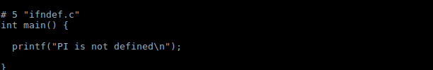
6. #if:The #if preprocessor directive evaluates the expression or condition. If condition is true, it executes the code.

Code:
#include<stdio.h>
#define a 10
int main(){
#if a==10
printf("a is equal to %d \n",a);
#endif
}

Output:
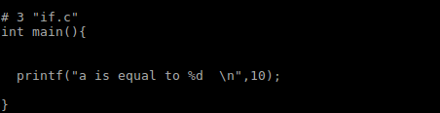

7. #else: The #else preprocessor directive evaluates the expression or condition if condition of #if is false. It can be used with #if, #elif, #ifdef and #ifndef directives.

Code:
#include<stdio.h>
#define a 11
int main(){
#if a==10
printf("a is equal to %d \n",a);
#else
printf("a is not equal to 10\n");
#endif
}
Output:
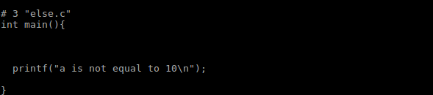
8. #elif: It is useful for if-else ladder kind of statements.

Code:
#include<stdio.h>
#define a 11
int main(){
#if a==10
printf("a is equal to %d \n",a);
#elif a > 10
printf("a is greater than 10\n");
#else
printf("a is less than 10\n");
#endif
}
Output:
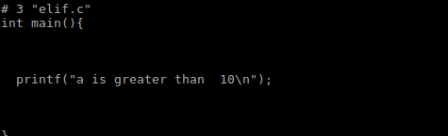

9. #endif: It is useful for complete the #if preprocessor directive means complete the if block.

Code:
#include<stdio.h>
#define a 10
int main(){
#if a==10
printf("a is equal to %d \n",a);
#endif
}
Output:

10.#error: The #error preprocessor directive indicates error. The compiler gives fatal error if #error directive is found and skips further compilation process.

Code:
#include<stdio.h>
#ifndef __MATH_H
#error First include then compile
#else
void main(){
float a;
a=sqrt(7);
printf("%f",a);
}
#endif
Output:
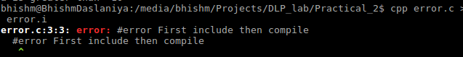

Conclusion: From this practical I have learnt about differnt types of preprocessor directives and how all are works.

