Hospital Operations Efficiency & Resource Utilization — Insights Summary
Date: 2025-11-01
Executive Summary
This report summarizes key operational, clinical, and financial insights derived from exploratory data analysis on the hospital operations dataset. The analysis covers admissions, bed and equipment utilization, staff efficiency, surgical outcomes, readmission patterns, and financial performance. Visual placeholders are included for insertion of charts from the Power BI report or the EDA notebook.
1. Network & Capacity Overview
- Total hospitals: 10
- Total beds (network): 5677
- Average beds per hospital: 567.70
- Geographic concentration: South region shows the highest capacity and admissions.
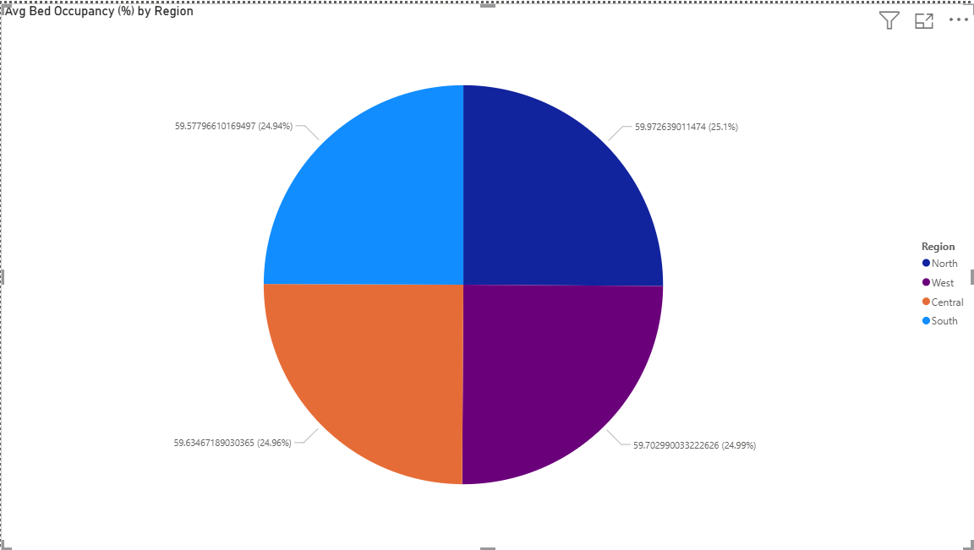
Figure 1: _Average Bed Occupancy by Region.
2. Operational Performance
- Average Length of Stay (LOS): ~5 days.
- Readmission Rate: ~8.0%.
- ER Wait Time (avg): ~29 minutes.
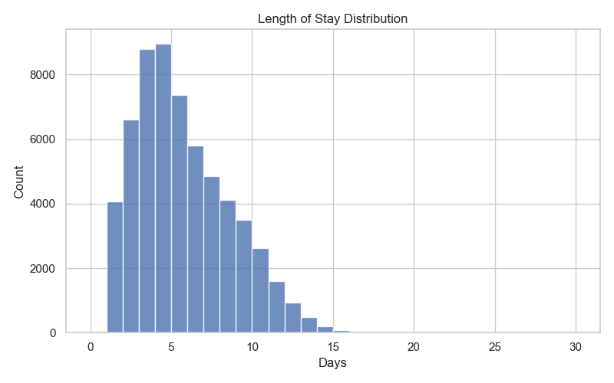
Figure 2: _Length of Stay Distribution
3. Staff & Workforce Insights
- Staff composition: Nurses are the largest group (~50% of staff), followed by technicians and doctors.
- Average staff utilization: ~63% (snapshot average).
- Salary & experience: Reasonable alignment of salary with experience across roles.
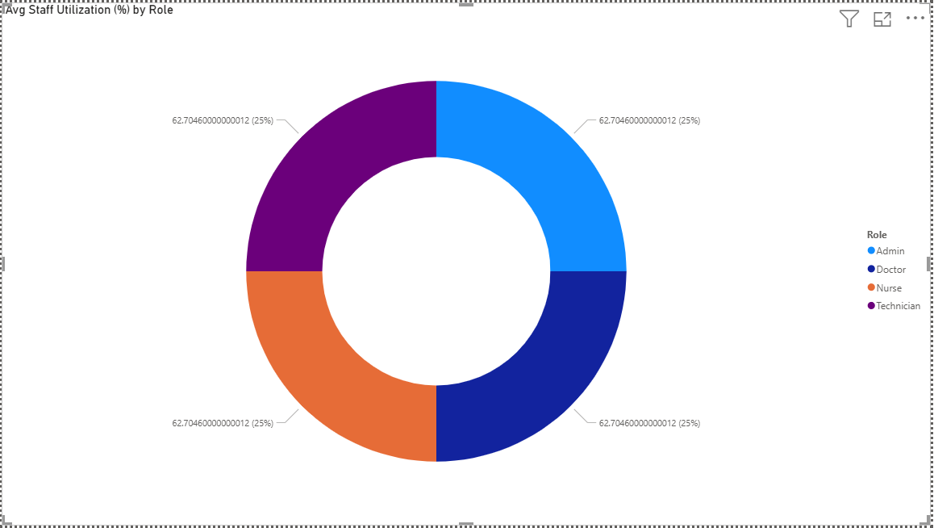
Figure 3: _Staff Utilization and Role Distribution
4. Clinical Outcomes & Surgery Performance
- Surgery complication rate: ~6% (overall).
- Most surgeries show standard durations; variance exists across specialty types.
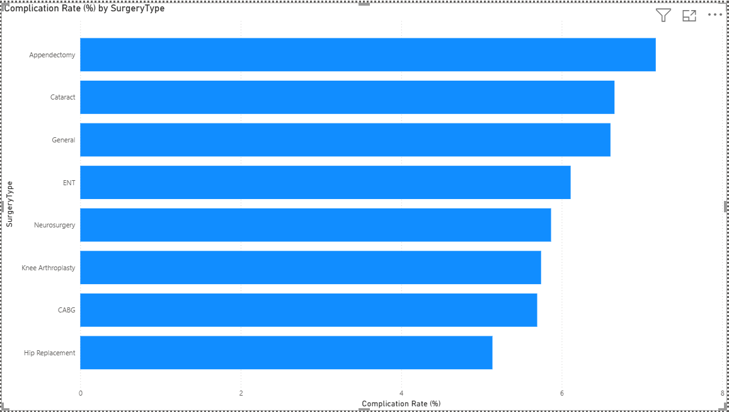
Figure 4: _Complication Rate by Surgery Type
5. Financial Summary
- Average insurance coverage: ~57% of billed amounts.
- Average profit margin (department-level): ~15%.
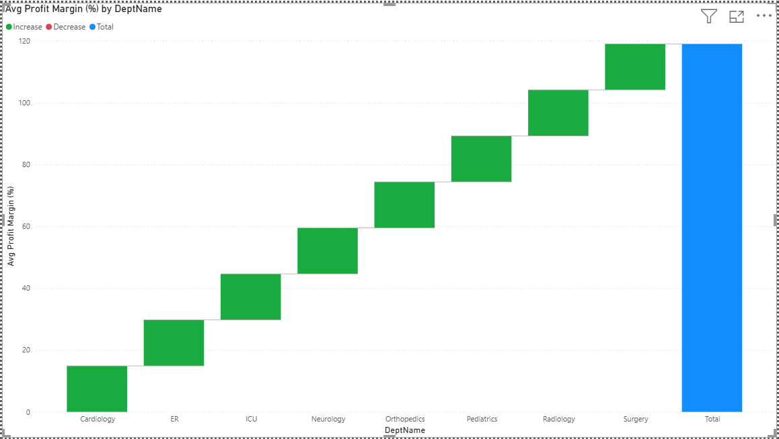
Figure 5: _Profit Margin by Department
6. Recommendations (Top Priorities)
1. Operational: Target bed occupancy to 75% through demand smoothing and referral management.
2. Workforce: Implement shift-optimization algorithms and cross-training programs.
3. Clinical: Establish surgeon scorecards and post-op care bundles for high-complication procedures.
4. Financial: Review billing and payer negotiation strategies; prioritize high-margin services.
Appendix — Key KPIs
- Total Admissions: 60,000
- Total Surgeries: 12,000
- Avg Bed Occupancy (%): 59.72%
- Avg Staff Utilization (%): 62.70%
- Avg Profit Margin (%): 14.87%

