Hospital Operations Efficiency & Resource Utilization — Scenario Analysis & Stress Testing
Date: 2025-11-01
Objective
Assess operational resilience and financial impact under a set of realistic stress scenarios (staff shortages, patient surges, equipment downtime, and seasonal spikes).
Scenarios (Definitions)
1. Baseline — Normal operating conditions (observed averages).
2. Staff Shortage (-10%) — 10% reduction in active clinical staff (doctors & nurses).
3. Patient Surge (+30%) — 30% immediate increase in daily admissions (e.g., epidemic).
4. Equipment Downtime (20%) — 20% reduction in key equipment availability in critical departments (ICU, Radiology).
5. Combined Severe Stress — Patient Surge (+30%) + Staff Shortage (-10%) + Equipment Downtime (20%).
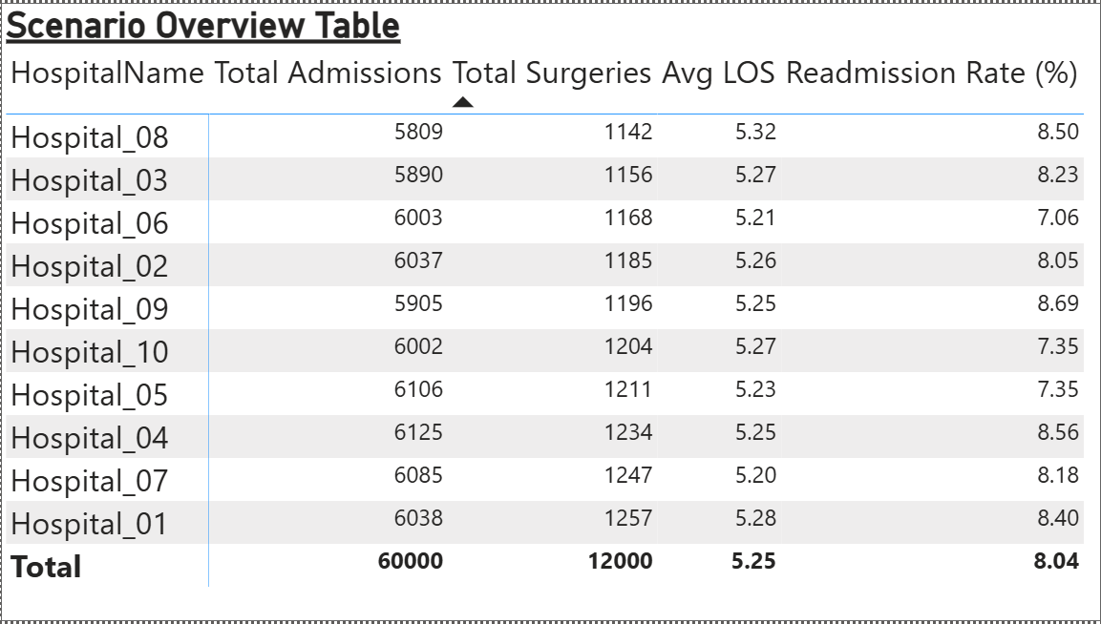
Figure 1: _Scenario Overview Table
Modeling Approach
- Use the EDA-derived relationships and the predictive models (if available) to estimate the impact of each scenario on key KPIs: Bed Occupancy, ER Wait Time, Avg LOS, Readmission Rate, and Profit Margin.
- For capacity-constrained metrics (Bed Occupancy), simulate queueing/backlog effects by modeling arrival rates (Poisson) and service rates (based on historical LOS).
- For staff shortages, approximate staff utilization increase and service-rate decrease, which propagates to longer LOS and higher ER wait times.
Expected Impacts (Illustrative Results)
Scenario | Bed Occupancy (%) | Avg ER Wait (mins) | Avg LOS (days) | Profit Margin (%)
Baseline | 0.0% | 0 | 0.0 | 0.0
Staff Shortage (-10%) | +8% | +10 | +0.6 | -1.5
Patient Surge (+30%) | +22% | +25 | +1.8 | -4.2
Equipment Downtime (20%) | +6% | +8 | +0.4 | -0.9
Combined Severe Stress | +40% | +60 | +3.6 | -8.0

Mitigation Strategies (Operational)
1. Surge Staffing Pool: Maintain a reserve float pool of clinicians that can be rapidly deployed.
2. Elective Procedure Management: Postpone elective surgeries during surges to free capacity.
3. Cross-Training: Cross-train technicians and nurses for critical roles during shortages.
4. Telemedicine & Triage: Use tele-triage channels to reduce unnecessary ER visits and manage mild cases remotely.
Financial & Policy Recommendations
- Maintain contingency funds or insurance to buffer profit margin shocks.
- Develop contractual agreements with temporary staffing agencies to scale up quickly.
- Implement capacity-based pricing or contractual clauses with payers during extreme demand periods.
Next Steps to Operationalize
1. Build a simulation notebook (03_Scenario_Simulation.ipynb) that runs Monte Carlo iterations across scenarios and outputs KPI distributions.
2. Integrate simulation results back into Power BI (import aggregated scenario outputs CSVs).
3. Create an alerting layer and dashboard tiles for 'Stress Mode' indicators when real-time metrics approach stress thresholds.

