**Human Resource Management System**

**INTRODUCTION TO THE SYSTEM**

The human resource management system can be used to manage the human resource of a company. The system helps the company to add new employee, add new department, make notice for a particular department, employee can apply for a leave, manage the salary and attendances of the employees.

It keeps the admin updated with the progress of employee and to know which employee works for which department and which employee wants to take leave on which day.

**FEATURES OF THE PROPOSED SYSTEM**

**Features of the Admin**

* **Profile:** In this module the Employee can view his profile details.
* **Add Admin:** The Admin can add one more person as the admin of the system.
* **Add Employee:** The Admin can add the new employees joined in the company.
* **View Employees:** This module consists of all the records of the employee. It also allows insertion and deletion of employee records. If the admin wants to find out which employees are working in a particular department than he can search for the department and afterwards the records will be displayed in the table according to the department.
* **Add Department:** In this module the admin can add Department.
* **View Departments:** This module consists of all the records of the Departments. It also allows insertion and deletion of Departments records. The existing Departments can also be updated.
* **Leave Status:** In this module the admin can Approve or Reject the leave form send by the employee.
* **Payroll:** In this module the admin manages the salary of the employees.
* **Notice:** In this Module the Admin can send notice to a particular Department or to all Departments if some events or training is to be held.
* **Attendance:** in this module the admin manages the attendance of the employees.

**Features of the Employee**

* **Profile:** In this module the Employee can view his profile details.
* **Take Leave:** In this module the Employee can take leave.
* **View:** In this module the Employee would be able to see the notices send by the employee.
* **Net pay:** in this module the employee can view the net salary payable to him.

**ENTITY RELATIONSHIP DIAGRAM**

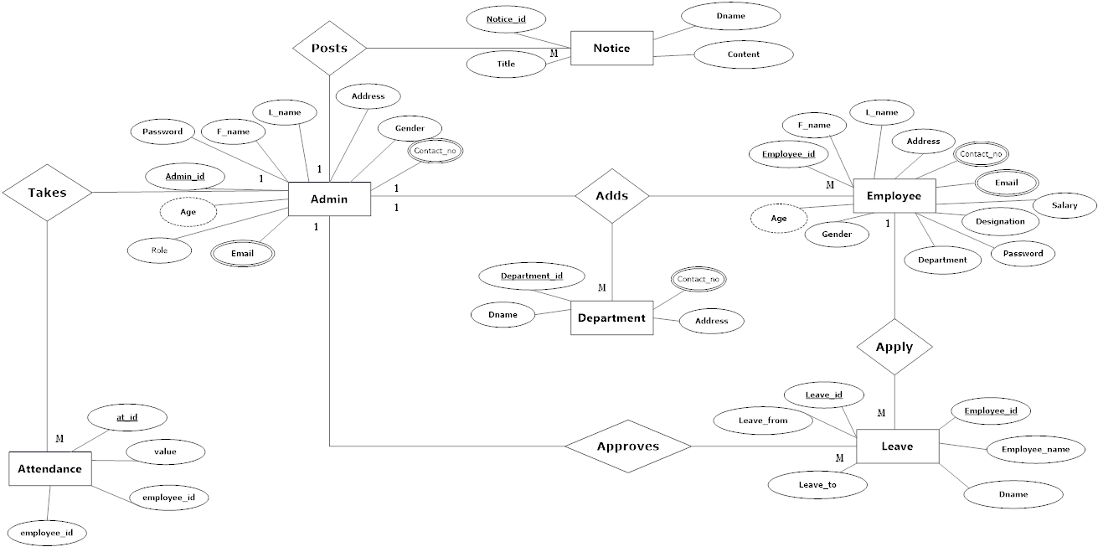

**USE CASE DIAGRAM**

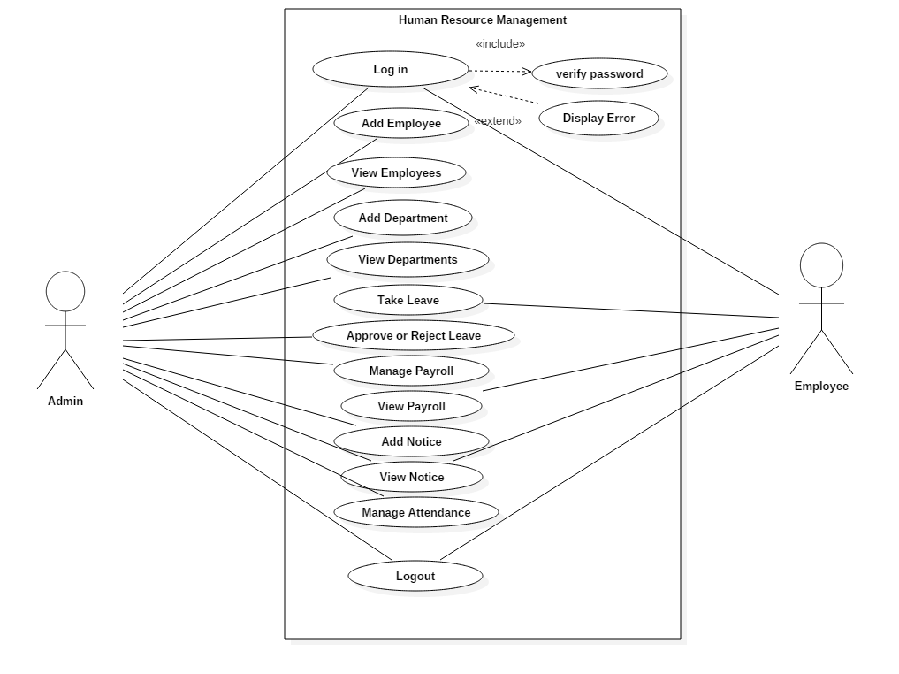

**DATABASE DESIGN**

Table Name: employee

Description: To store Employee details.

Primary Key: Employee_id

|  |  |  |  |  |
| --- | --- | --- | --- | --- |
| Sr. No | Field Name | Description | Data Type | Constraints |
| 1 | Employee_id | Stores the id | Int(11) | Primary Key |
| 2 | F_name | Stores the Employee First name | Varchar(40) |  |
| 3 | L_name | Stores the Employee Last name | Varchar(40) |  |
| 4 | Address | Stores the Address | Varchar(40) |  |
| 5 | Contact_No | Stores the contact no | Varchar(40) |  |
| 6 | Age | Stores the age | Int(40) |  |
| 7 | Gender | Stores the Employee’s Gender | Varchar(40) |  |
| 8 | Department | Stores the Employee’s Department | Varchar(40) |  |
| 9 | Designation | Stores the Employee’s Designation | Varchar(40) |  |
| 10 | Email | Stores the email | Varchar(40) |  |
| 11 | Salary | Stores the Salary | Int(25) |  |
| 12 | Password | Stores the Employee’s Password | Varchar(90) |  |
| 13 | Deduction | Stores the amount deducted | Int(10) |  |
| 14 | Advance | Stores the advance amount taken | Int(10) |  |
| 15 | Overtime | Stores the Overtime amount | Int(10) |  |
| 16 | Bonus | Stores the Bonus amount | Int(10) |  |
| 17 | Employee_image | Stores the Employee’s Profile | Varchar(60) |  |
| 18 | Employee_cover | Stores the Employee’s cover photo | Varchar(60) |  |
| 19 | Data_time_Created | Stores the date | DATETIME |  |

Table Name: admin

Description: To store admin details.

Primary Key: Admin_id

|  |  |  |  |  |
| --- | --- | --- | --- | --- |
| Sr. No | Field Name | Description | Data Type | Constraints |
| 1 | Admin_id | Stores the id | Int(11) | Primary Key |
| 2 | F_name | Stores the Employee First name | Varchar(40) |  |
| 3 | L_name | Stores the Employee Last name | Varchar(40) |  |
| 4 | Address | Stores the Address | Varchar(40) |  |
| 5 | Gender | Stores the Admin’s Gender | Varchar(40) |  |
| 6 | Contact_No | Stores the contact no | Varchar(255) |  |
| 7 | Age | Stores the age | Int(15) |  |
| 8 | Role | Stores the Admin’s Role | Varchar(40) |  |
| 9 | Email | Stores the email | Varchar(40) |  |
| 10 | Password | Stores the Admin’s Password | Varchar(255) |  |
| 11 | Admin_image | Stores the Admin’s Profile | Varchar(40) |  |
| 12 | Admin_cover | Stores the Admin’s cover photo | Varchar(40) |  |
| 13 | Data_time_Created | Stores the date | DATETIME |  |

Table Name: department

Description: To store department details.

Primary Key: Department_id

|  |  |  |  |  |
| --- | --- | --- | --- | --- |
| Sr. No | Field Name | Description | Data Type | Constraints |
| 1 | Department_id | Stores the id | Int(11) | Primary Key |
| 2 | Dname | Stores the Department name | Varchar(40) |  |
| 3 | Contact_No | Stores the contact no | Varchar(40) |  |
| 4 | Address | Stores the Address | Varchar(40) |  |
| 5 | Data_time_Created | Stores the date | DATETIME |  |
| 6 | Is_deleted | Used for deleting the record | Tinyint(4) |  |

Table Name: leaves

Description: To store leave details.

Primary Key: Leave_id

|  |  |  |  |  |
| --- | --- | --- | --- | --- |
| Sr. No | Field Name | Description | Data Type | Constraints |
| 1 | Leave_id | Stores the id | Int(11) | Primary Key |
| 2 | Employee_id | Stores the Employee id | Int(11) |  |
| 3 | Employee_name | Stores the Employee | Varchar(40) |  |
| 4 | Leave_type | Stores the Leave type | Varchar(40) |  |
| 5 | Dname | Stores the Department name | Varchar(40) |  |
| 6 | Leave_from | Stores the date | DATETIME |  |
| 7 | Leave_to | Stores the date | DATETIME |  |
| 8 | Description | Stores the leave descripion | Varchar(255) |  |
| 9 | Status | Stores the status | Varchar(255) |  |

Table Name: leave_type

Description: To store leave details.

Primary Key: Leave_id

|  |  |  |  |  |
| --- | --- | --- | --- | --- |
| Sr. No | Field Name | Description | Data Type | Constraints |
| 1 | id | Stores the id | Int(11) | Primary Key |
| 2 | Leave_type | Stores the Leave_type | varchar(40) |  |

Table Name: notice

Description: To store notice details.

Primary Key: Notice_id

|  |  |  |  |  |
| --- | --- | --- | --- | --- |
| Sr. No | Field Name | Description | Data Type | Constraints |
| 1 | id | Stores the id | Int(11) | Primary Key |
| 2 | Title | Stores the Title | varchar(255) |  |
| 3 | Dname | Stores the Department name | varchar(255) |  |
| 4 | Content | Stores the Content | text |  |

Table Name: overtime

Description: To store overtime details.

Primary Key: ot_id

|  |  |  |  |  |
| --- | --- | --- | --- | --- |
| Sr. No | Field Name | Description | Data Type | Constraints |
| 1 | ot_id | Stores the id | Int(11) | Primary Key |
| 2 | rate | Stores the rate | Int(11) |  |
| 3 | none | Stores the Details | Int(11) |  |

Table Name: attendance

Description: To store attendance details.

Primary Key: at_id

|  |  |  |  |  |
| --- | --- | --- | --- | --- |
| Sr. No | Field Name | Description | Data Type | Constraints |
| 1 | ot_id | Stores the id | Int(11) | Primary Key |
| 2 | value | Stores the value Present or Absent | Varchar(255) |  |
| 3 | employee_id | Stores the Employee id | Int(11) | Foreign Key |
| 4 | date | Stores the date | Varcha(255) |  |

**SYSTEM CONFIGURATION**

**Software Requirement**

* **FRONTEND SOFTWARE TOOLS**

HTML5

CSS3

JQUERY

JAVASCRIPT

BOOTSTRAP

AJAX

PHP

* **BACKEND SOFTWARE TOOLS**

MySQL

**Following Screenshot Shows the Homepage of the Application**

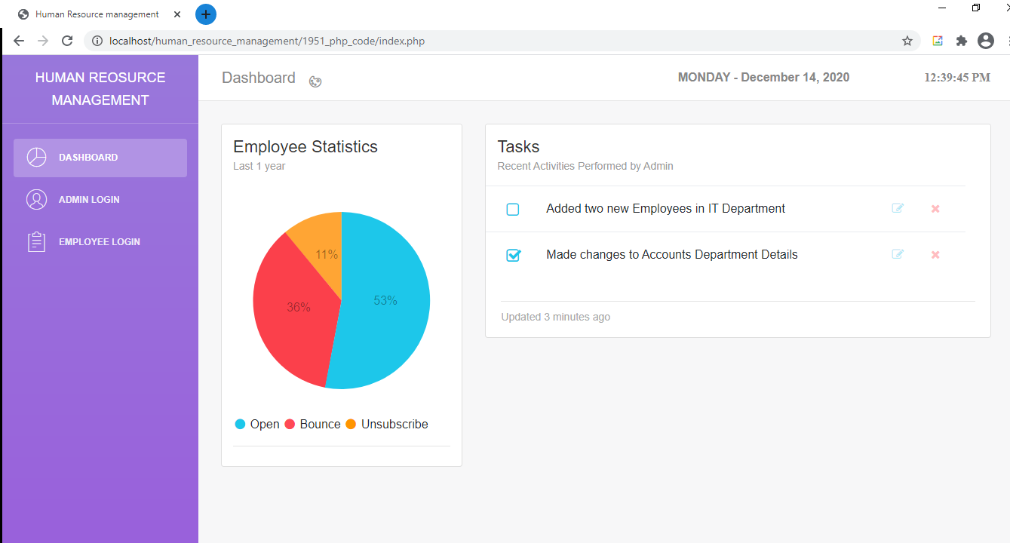

**Following Screenshot Shows the Login Page of the Admin**

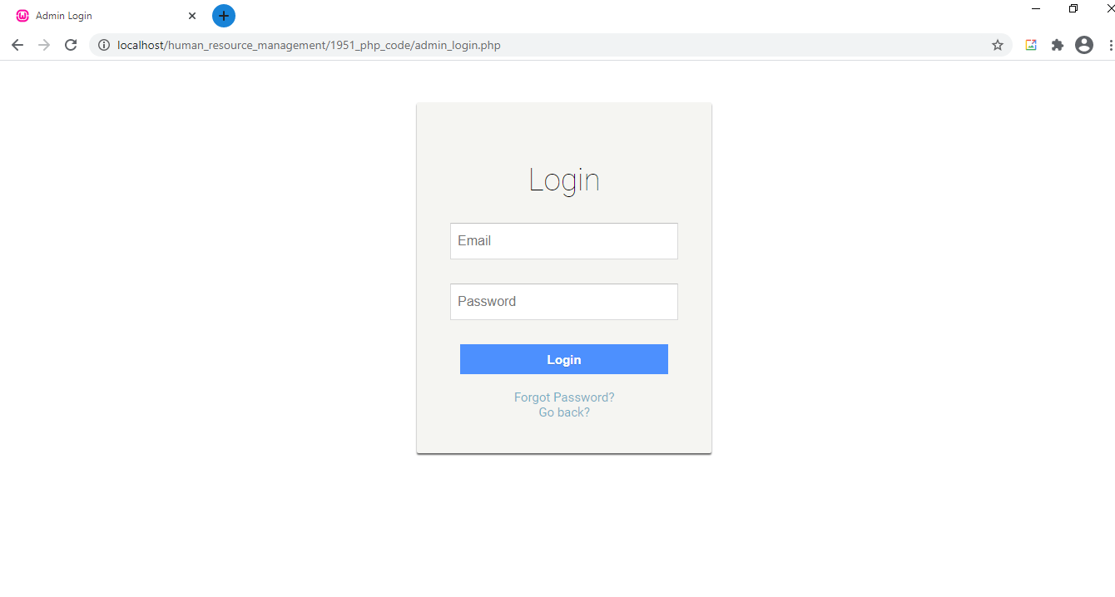

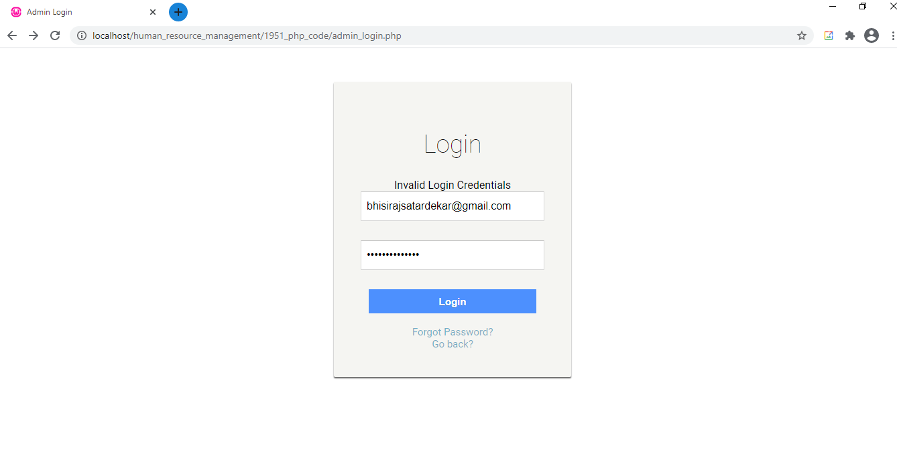

**Following Screenshot Shows the Forgot password Page of the Admin**

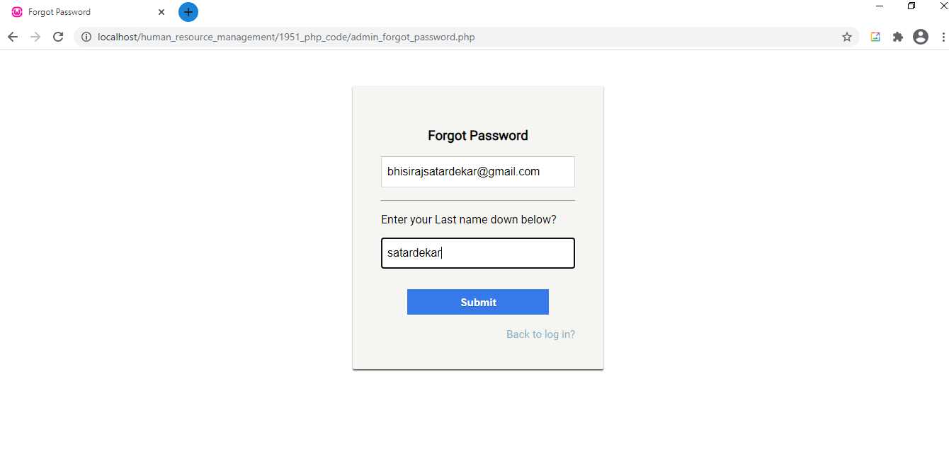

**Following Screenshot Shows the Change password Page of the Admin**

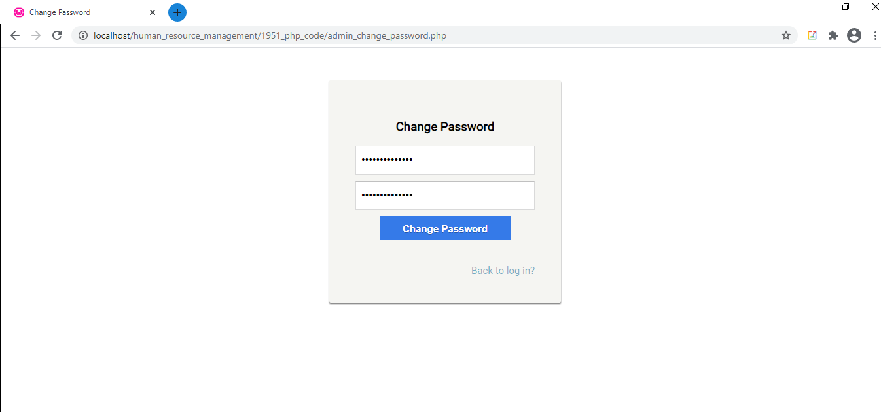

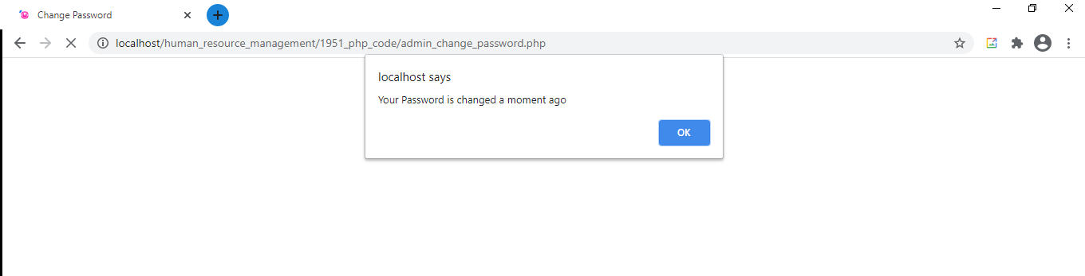

**Following Screenshot Shows the Homepage of the Admin**

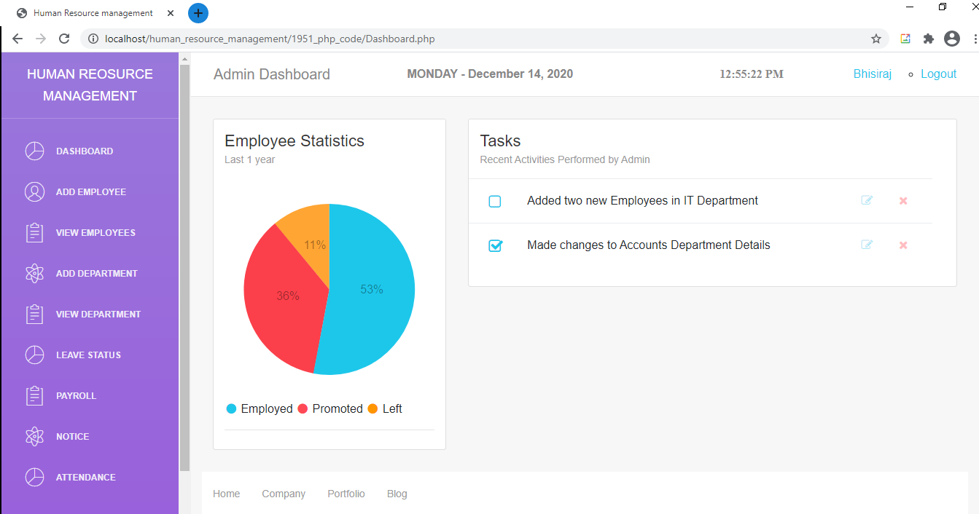

**Following Screenshot Shows the Profile page of the Admin**

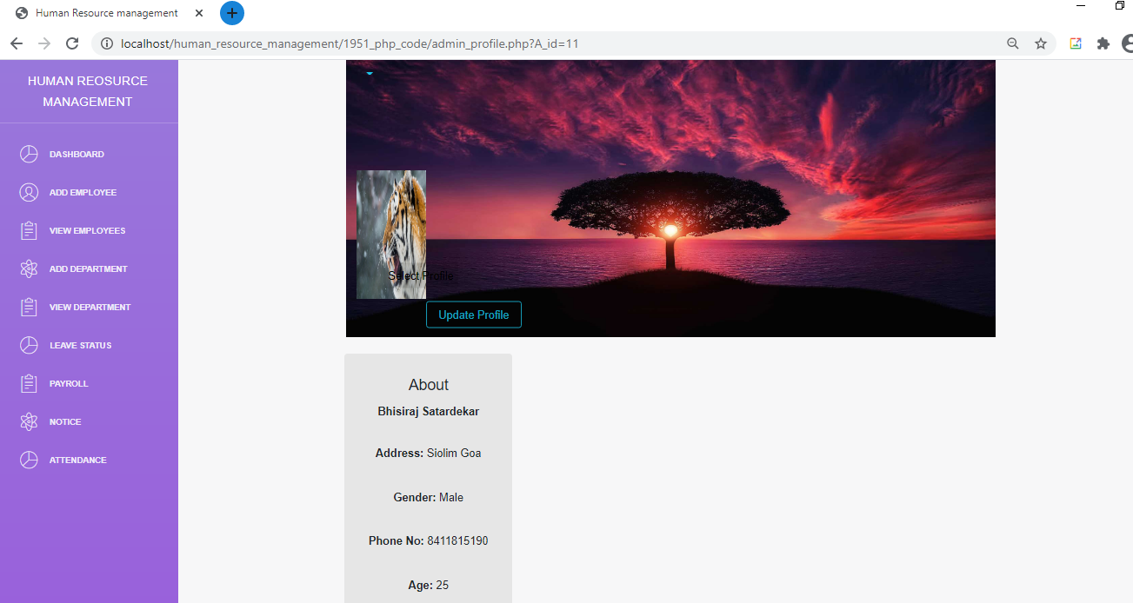

**Following Screenshot Shows the Edit Profile page of the Admin**

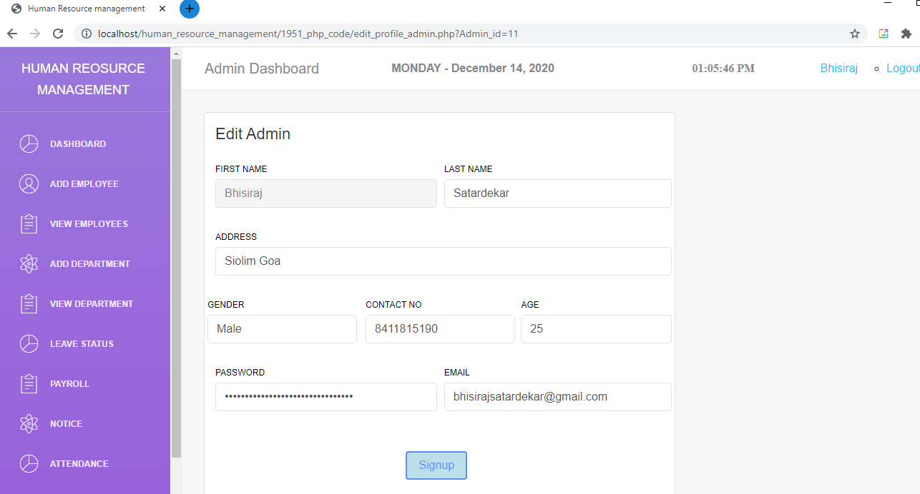

**Following Screenshot Shows the Add Employee page**

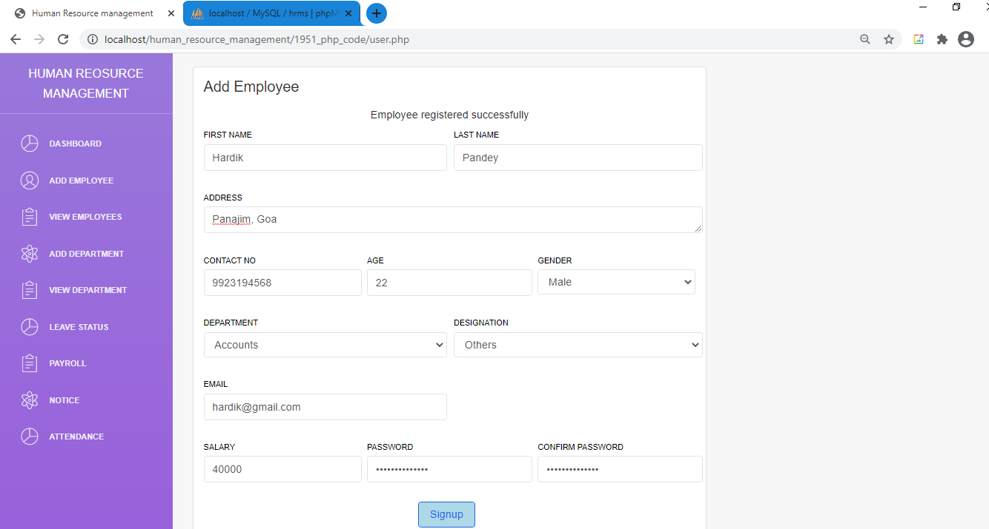

**Following Screenshot Shows the view Employee page, Employees can be searched by they departments.**

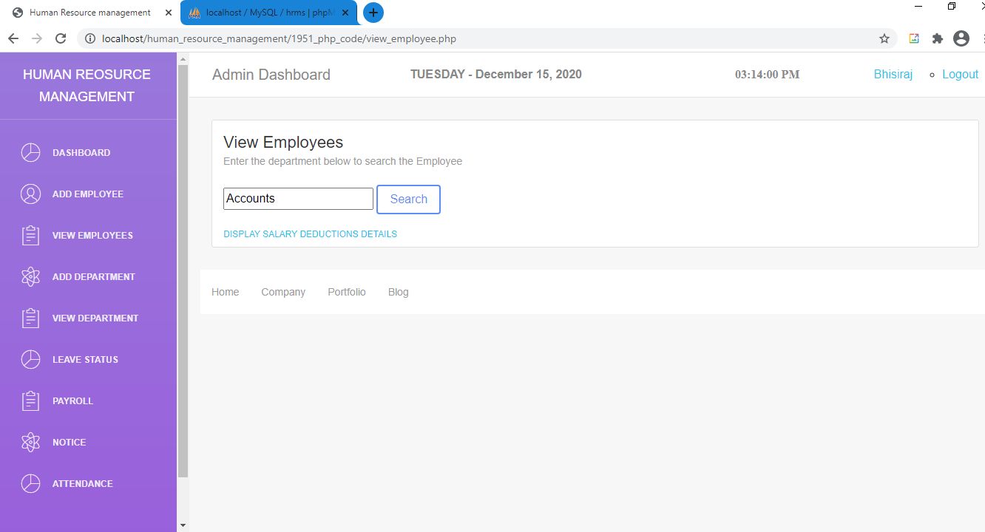

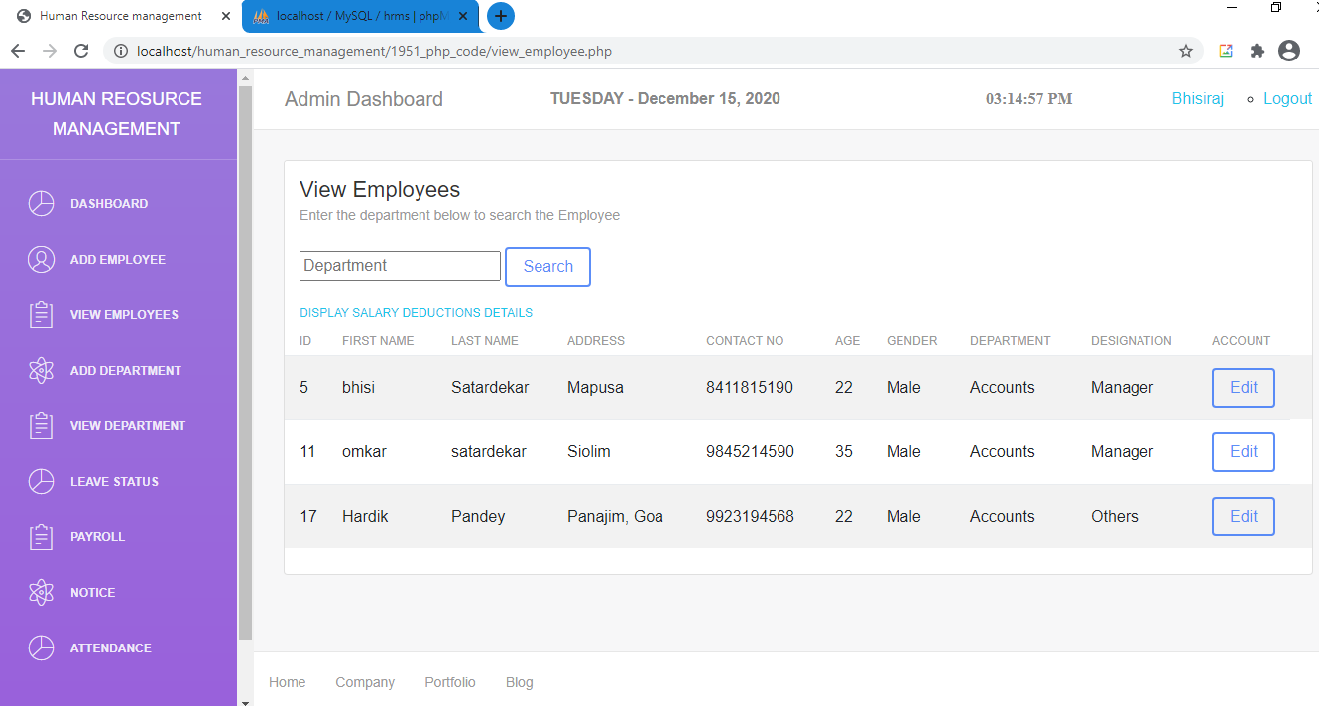

**Following Screenshot shows that the Admin manages the employee basic salary details.**

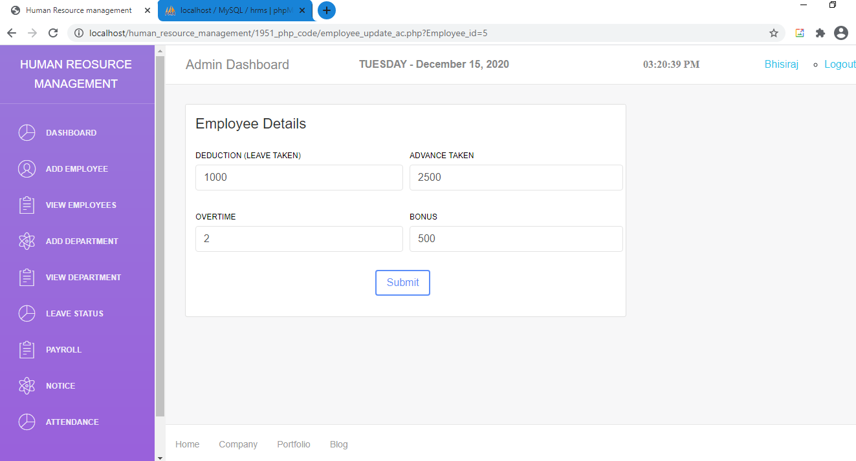

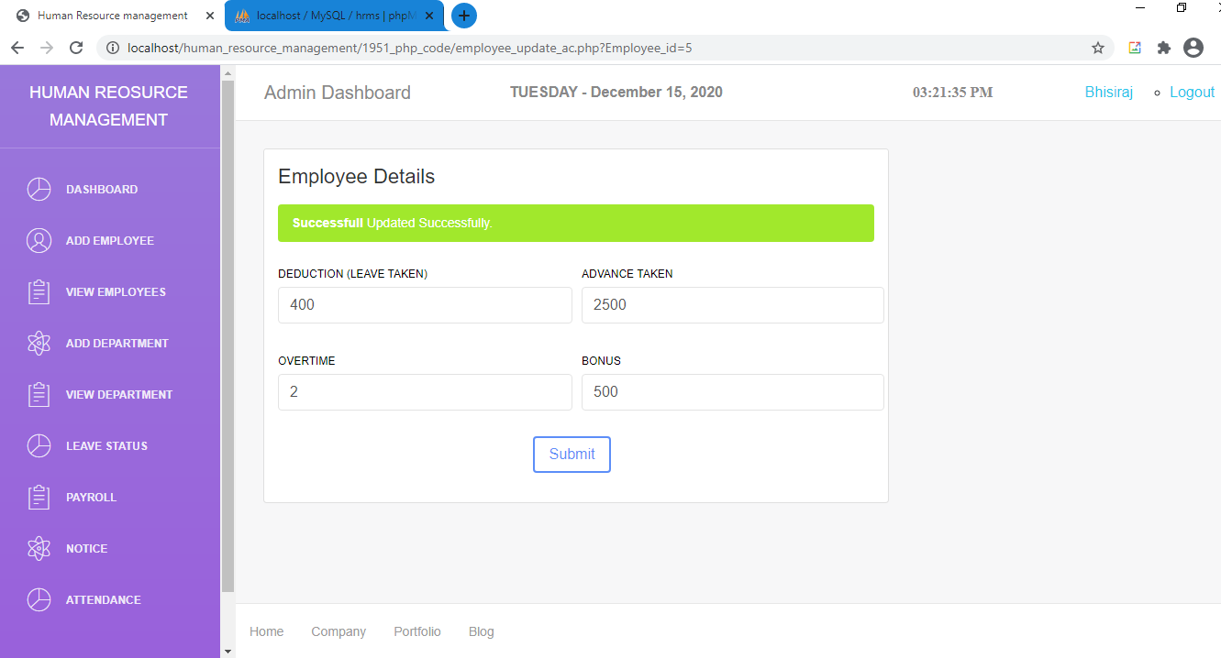

**Following Screenshot shows the leave amount deduction per day of employee.**

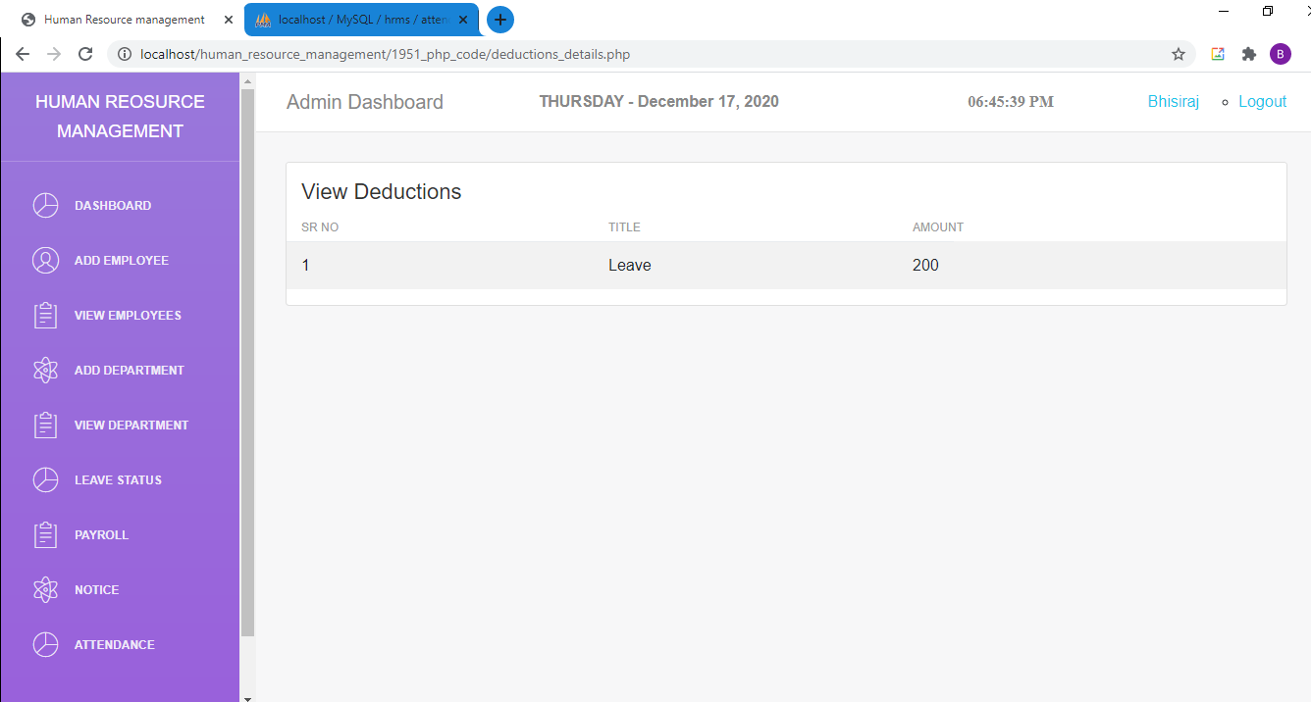

**Following Screenshot Shows the Add Department page**

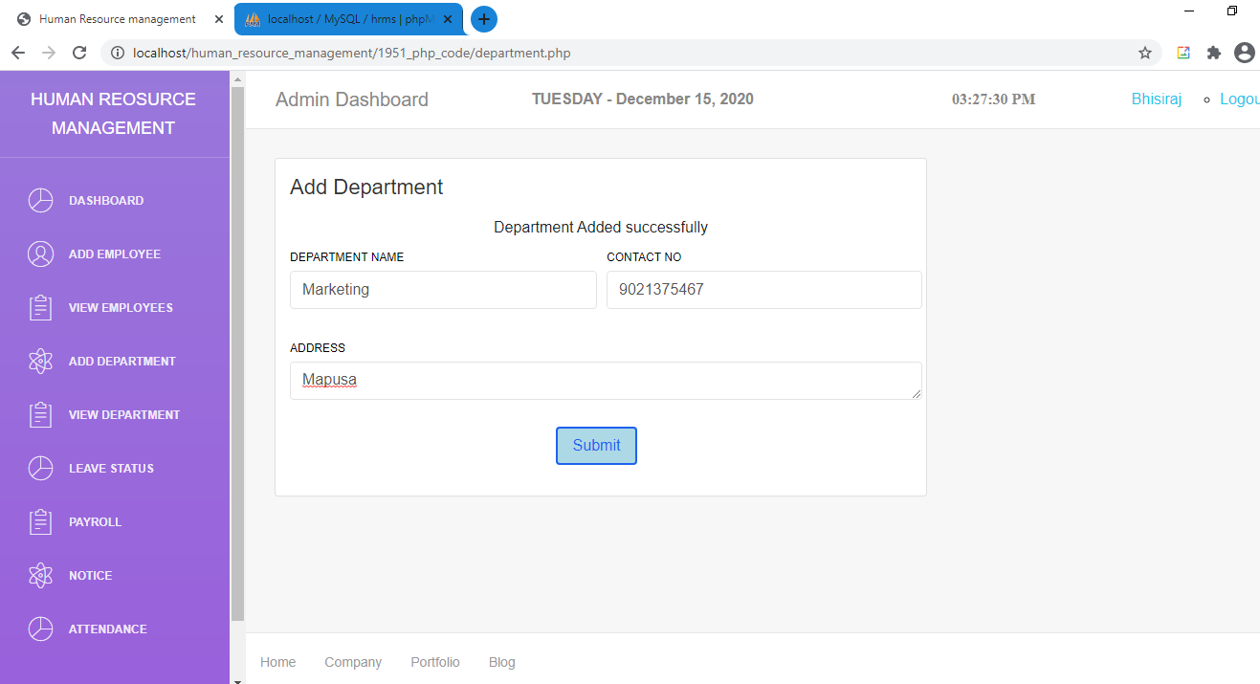

**Following Screenshot Shows the View Departments page**

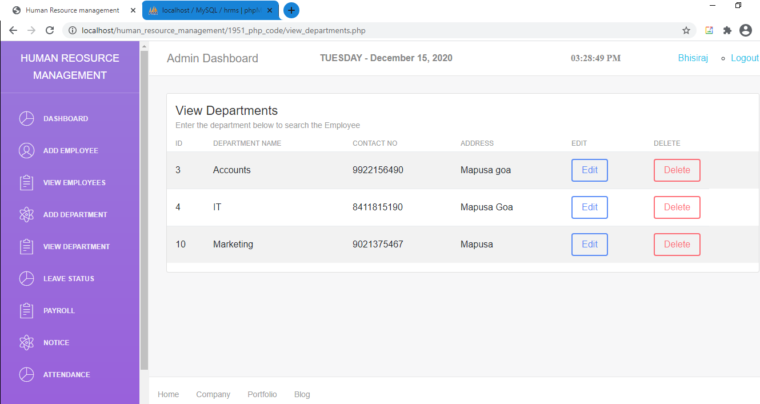

**Following Screenshot Shows the Edit Departments page**

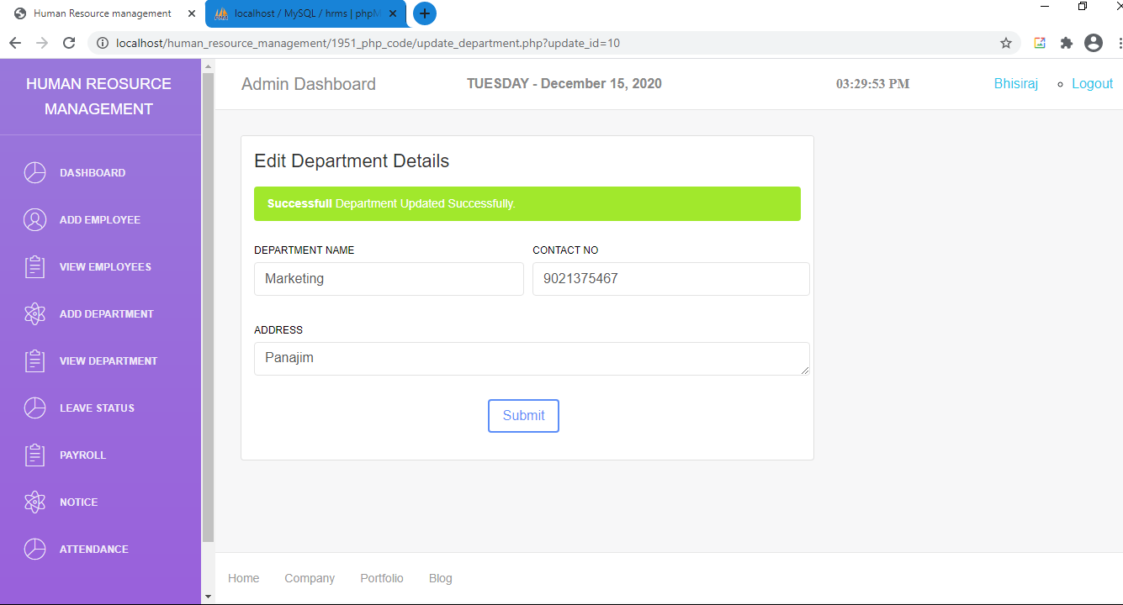

**Following Screenshot Shows the delete Department**

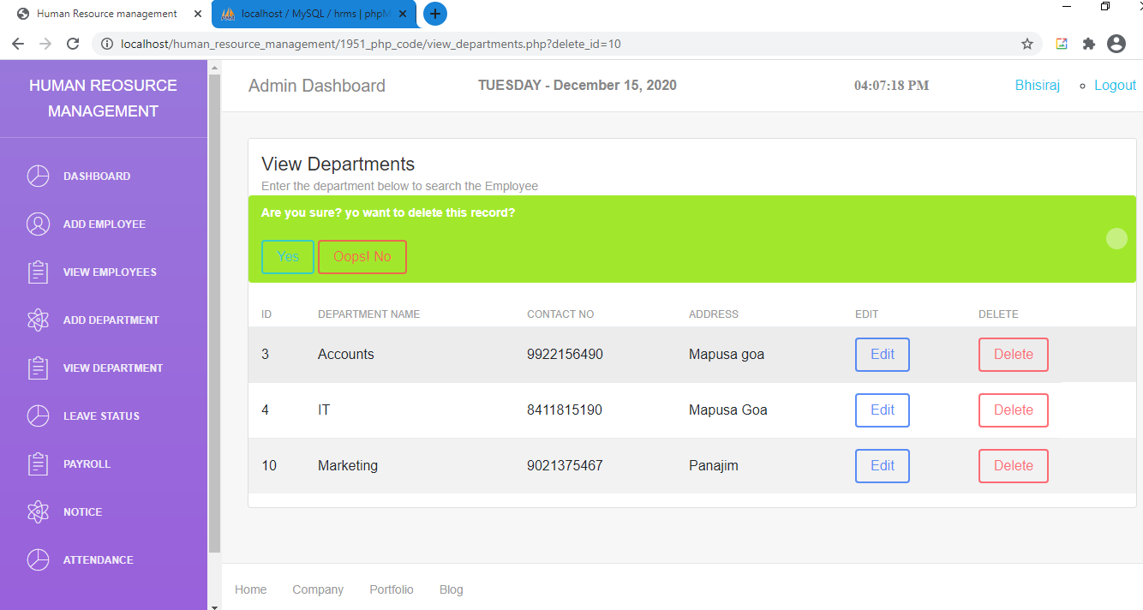

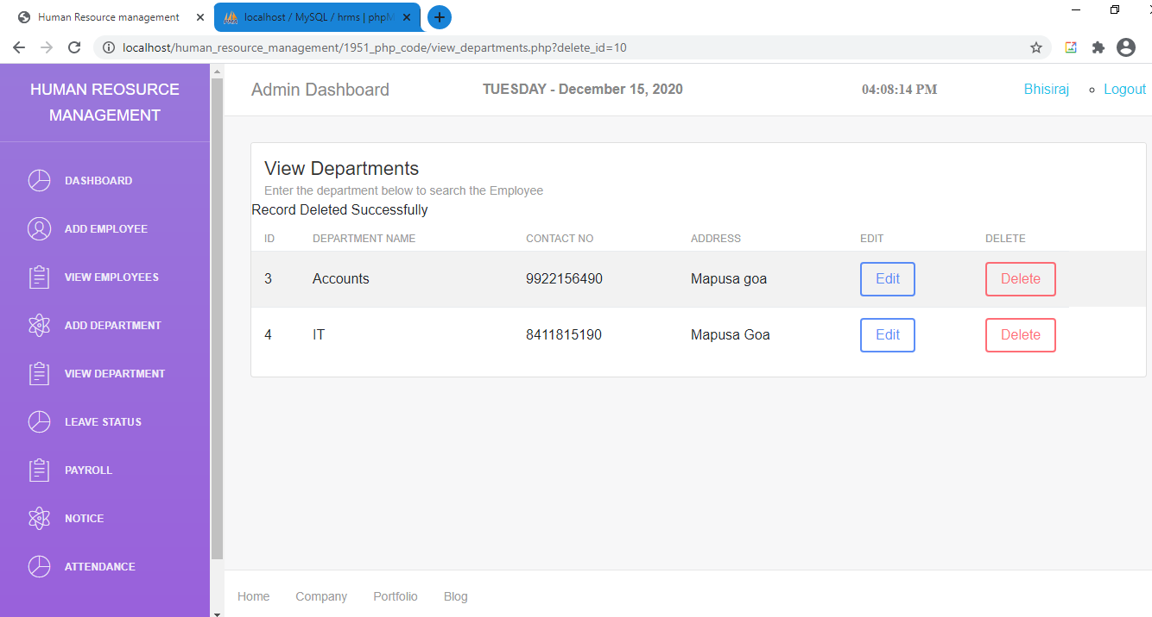

**Following Screenshot Shows how Admin approves the leave of employees**

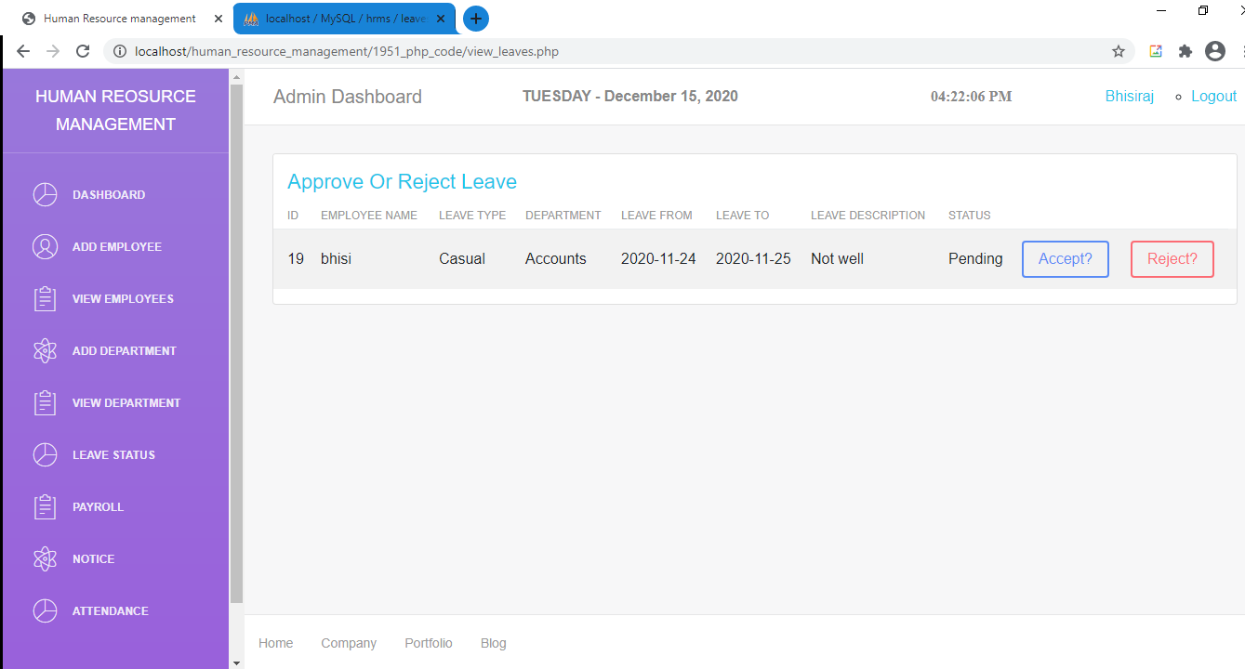

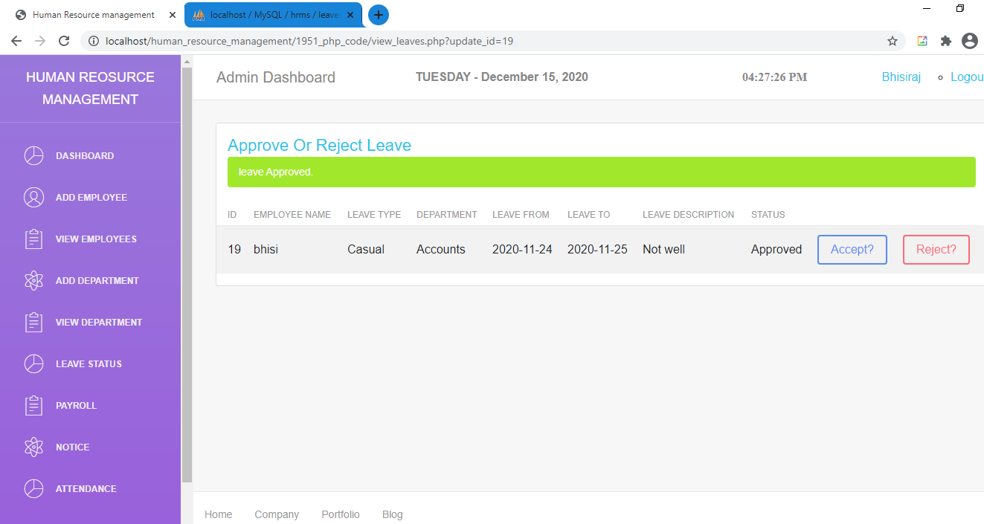

**Following Screenshot displays the payroll details of all Employees**

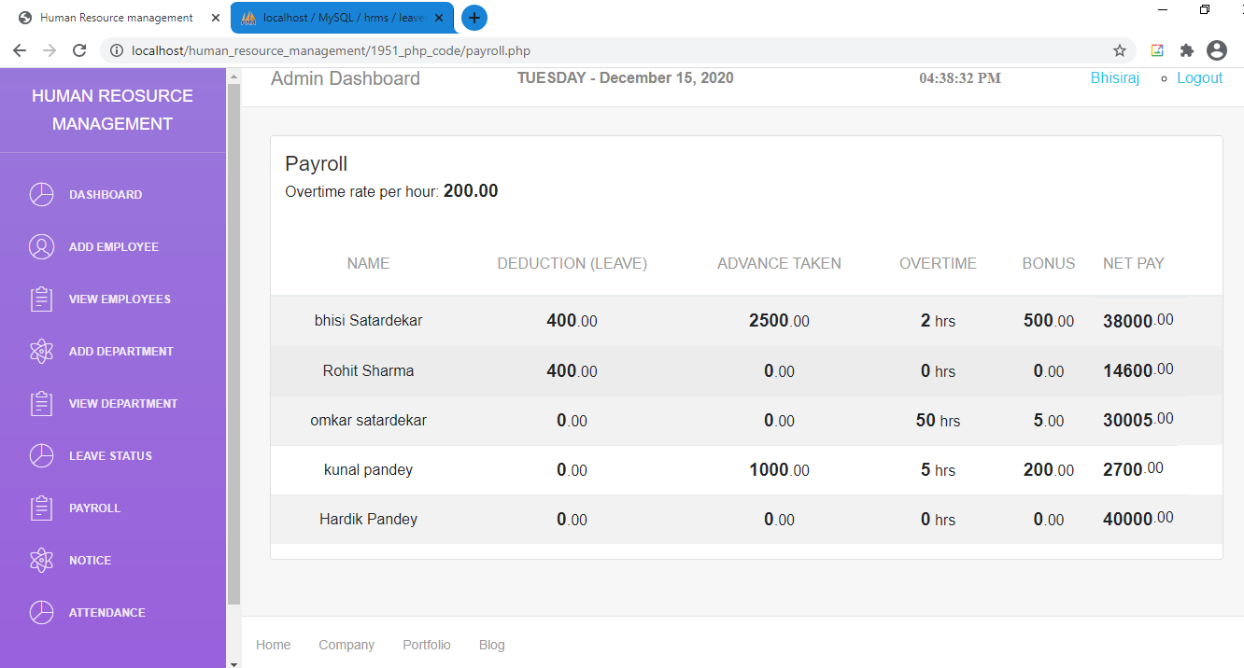

**Following Screenshot displays all the Notices Added by the Admin**

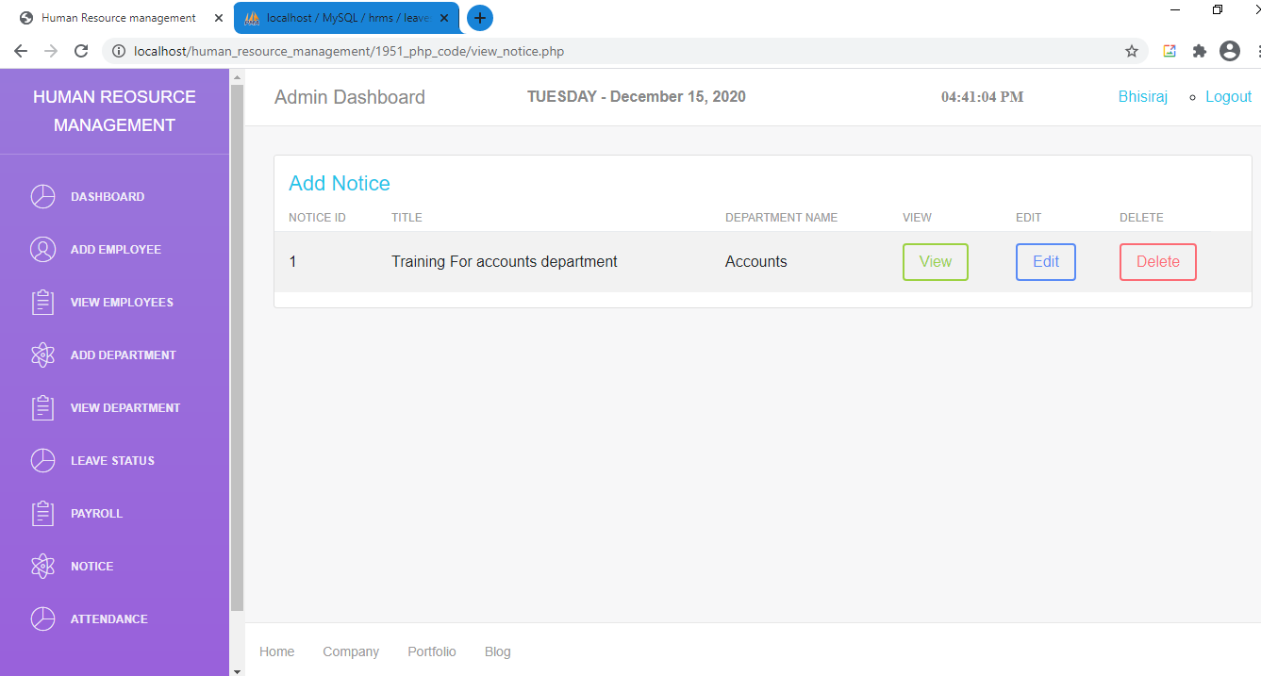

**Following Screenshot shows how to add new Notices**

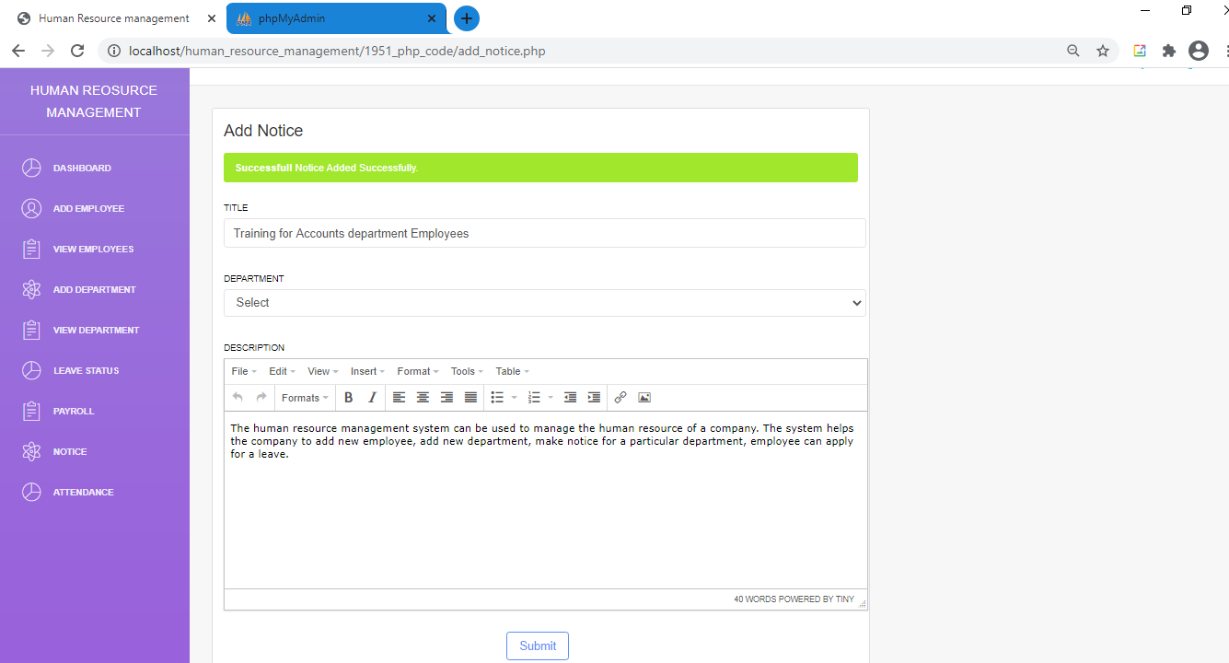

**Following Screenshot displays all the Notices Added by the Admin**

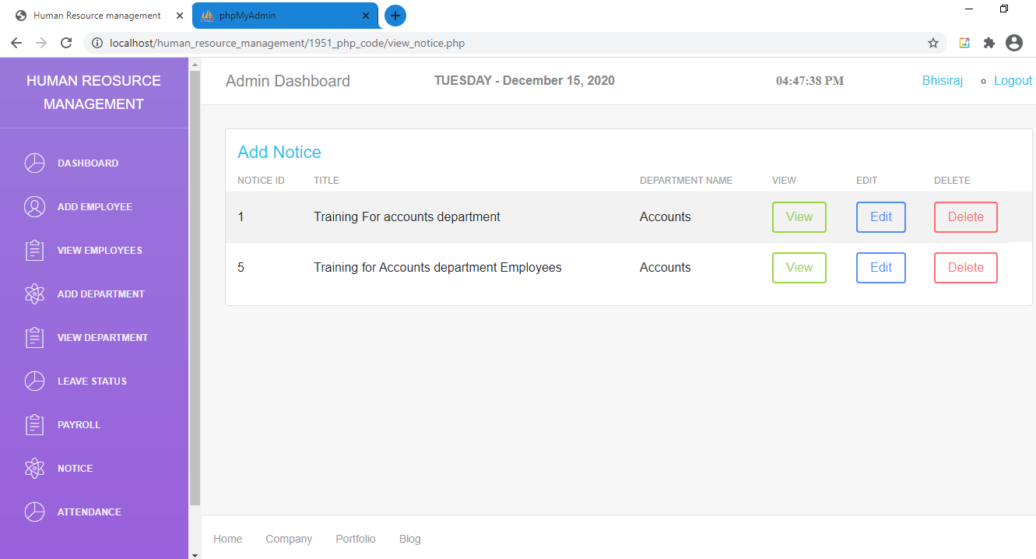

**Following Screenshot displays the Notice Viewed by the Admin**

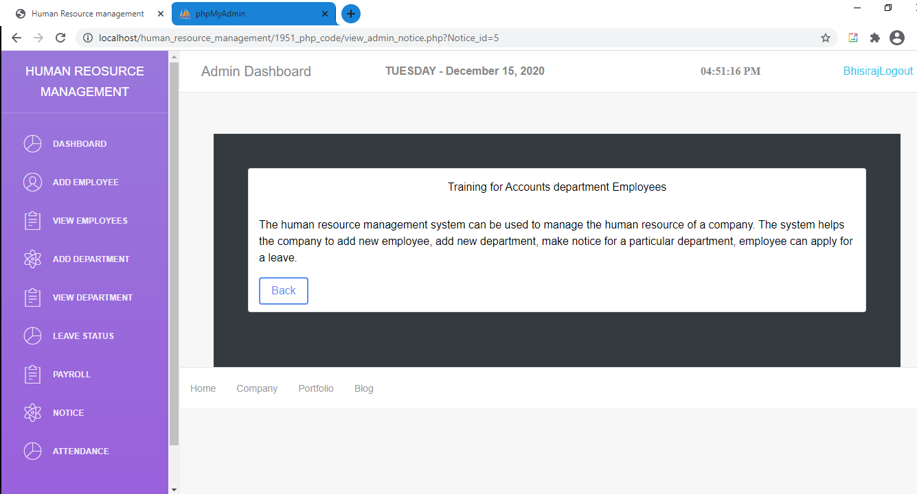

**Following Screenshot displays the Notice Edited by the Admin**

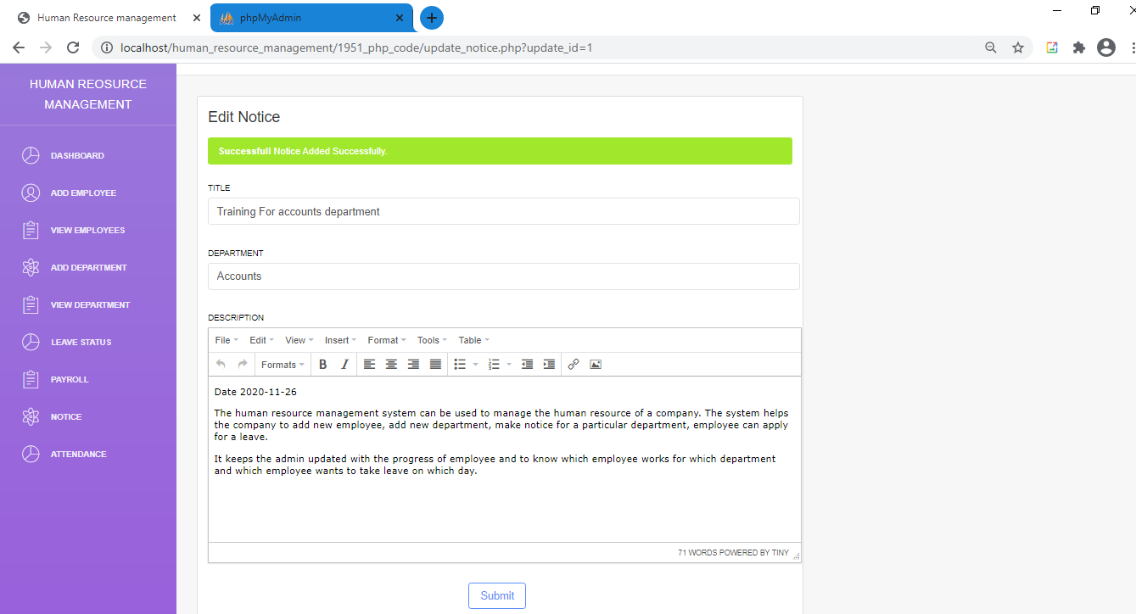

**Following Screenshot displays the Notice Removed by the Admin**

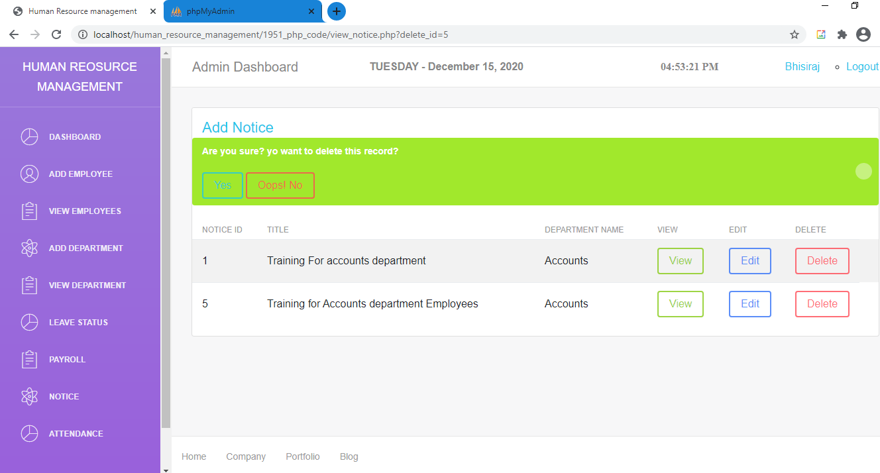

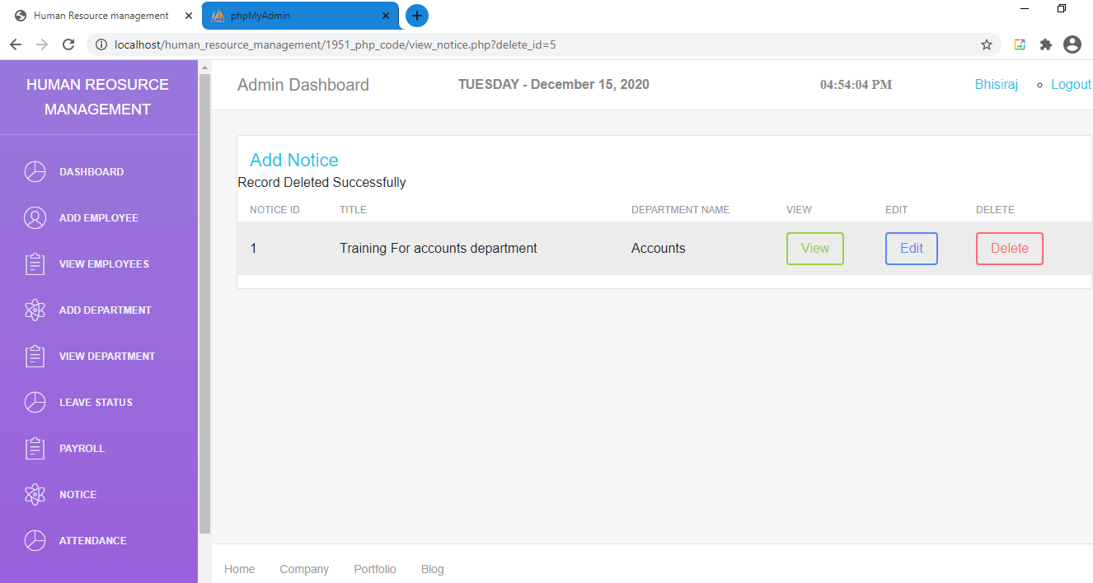

**Following Screenshot displays the Attendance page.**

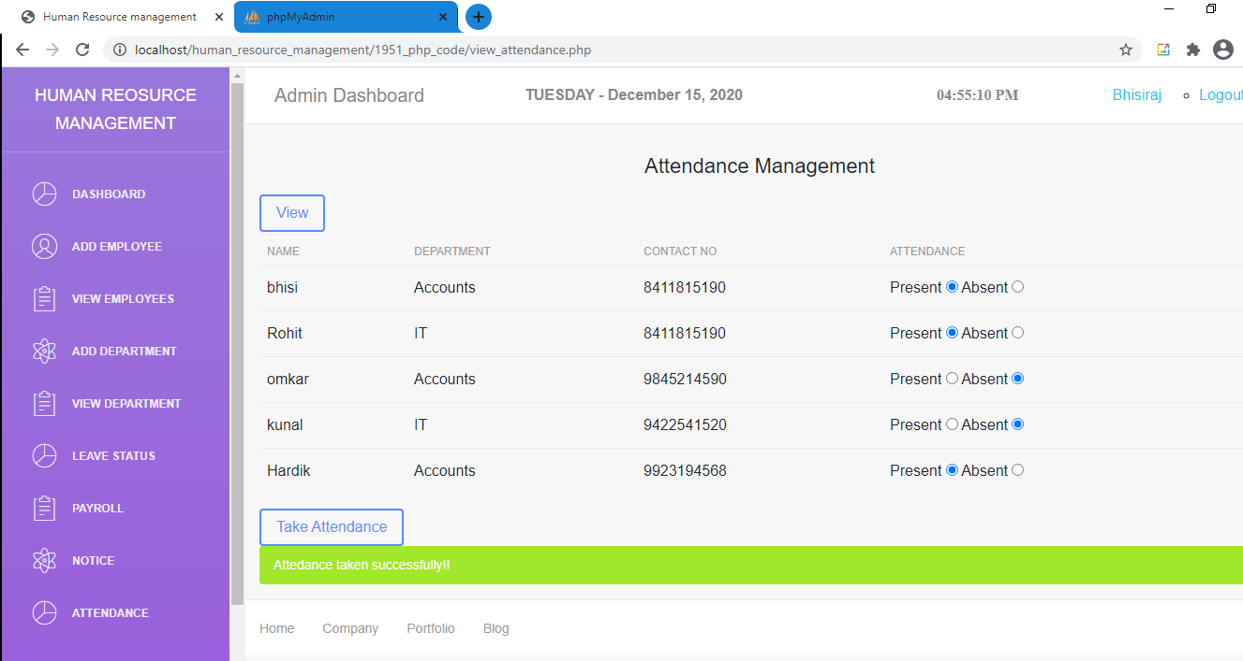

**Following Screenshot displays the View Attendance page according to date.**

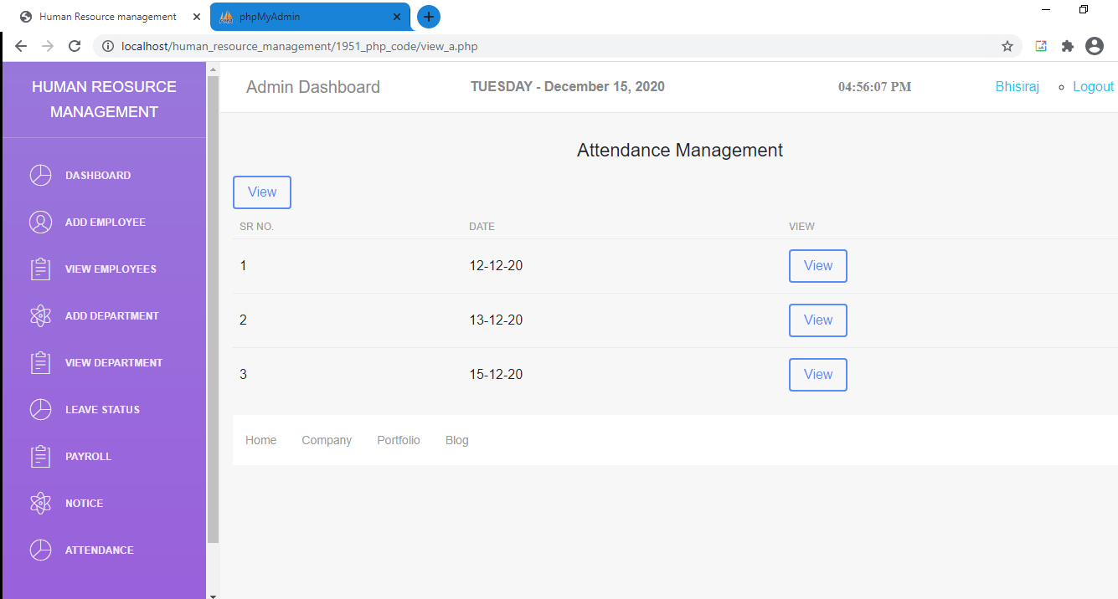

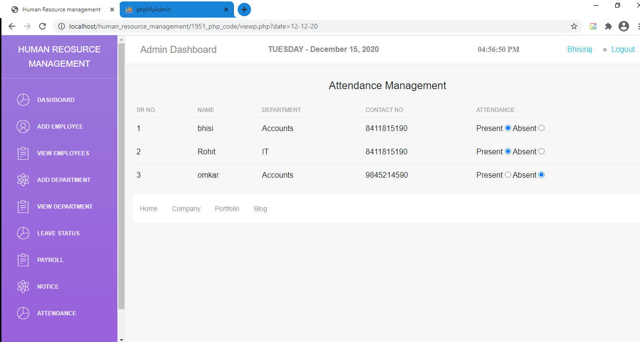

**Following Screenshot Shows the Login Page of the Employee**

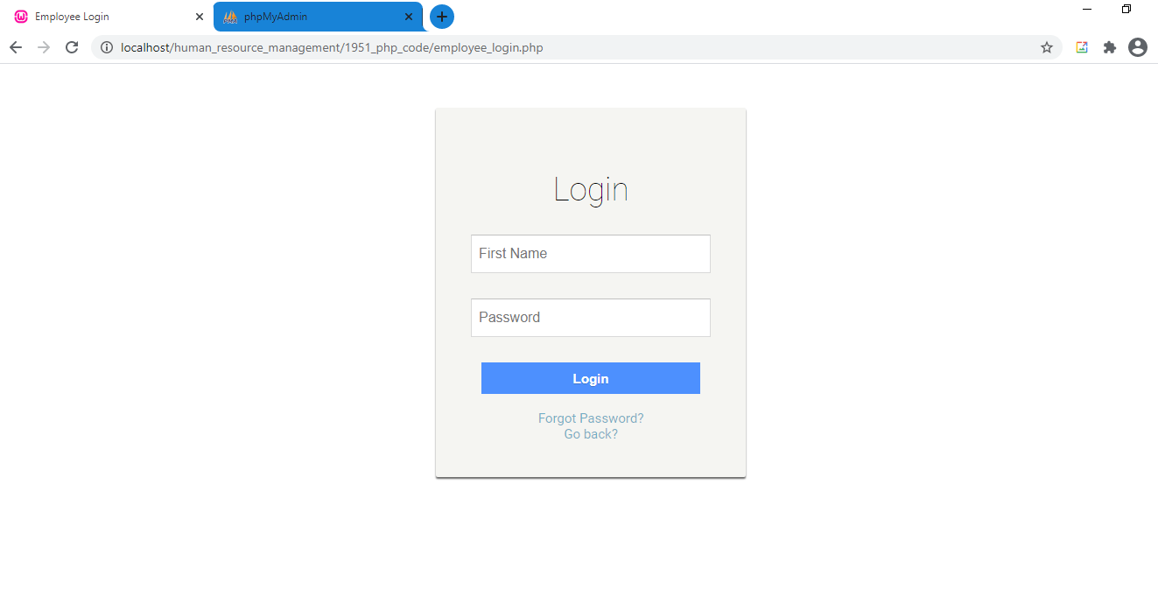

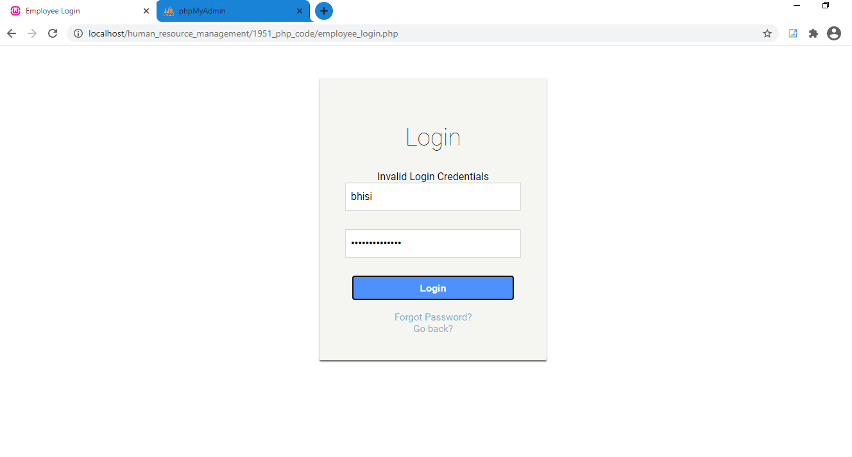

**Following Screenshot Shows the Forgot password Page of the Employee**

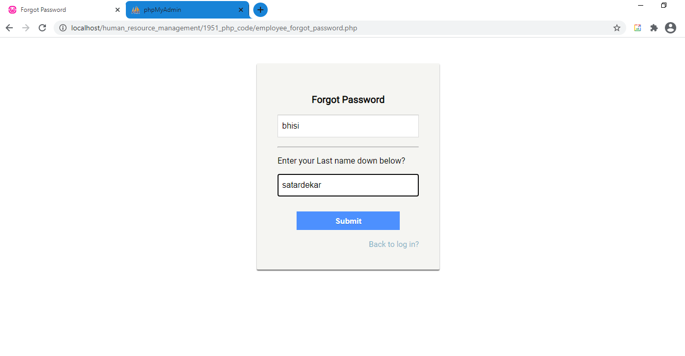**Following Screenshot Shows the Change password Page of the Employee**

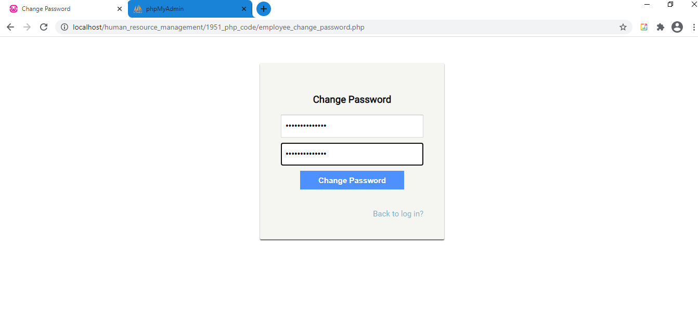

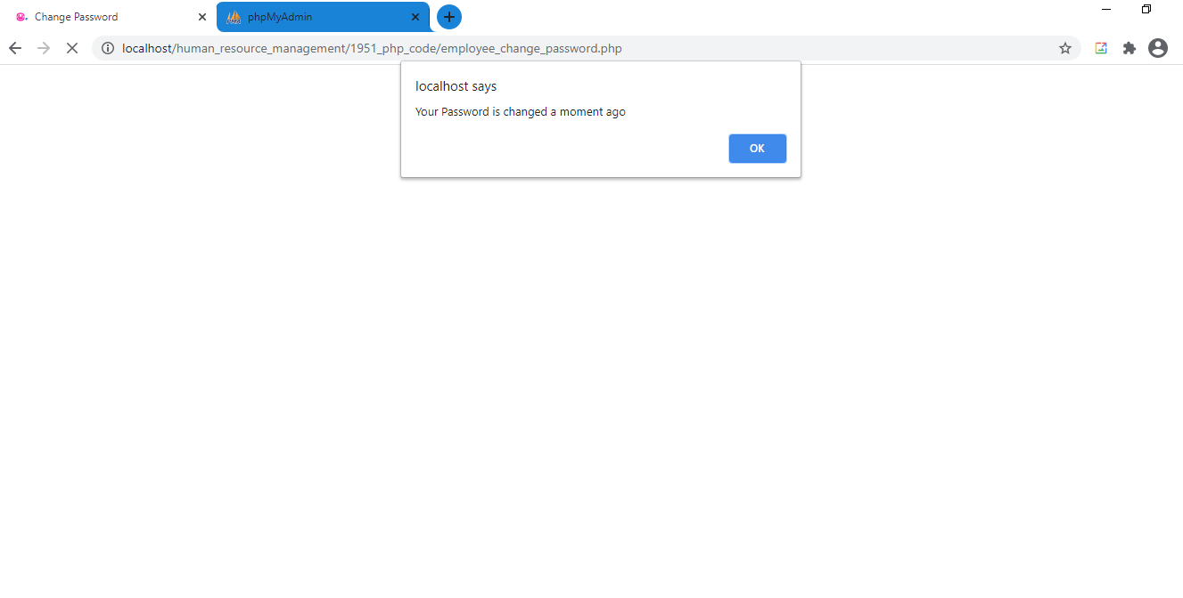

**Following Screenshot Shows the Homepage of Employee**

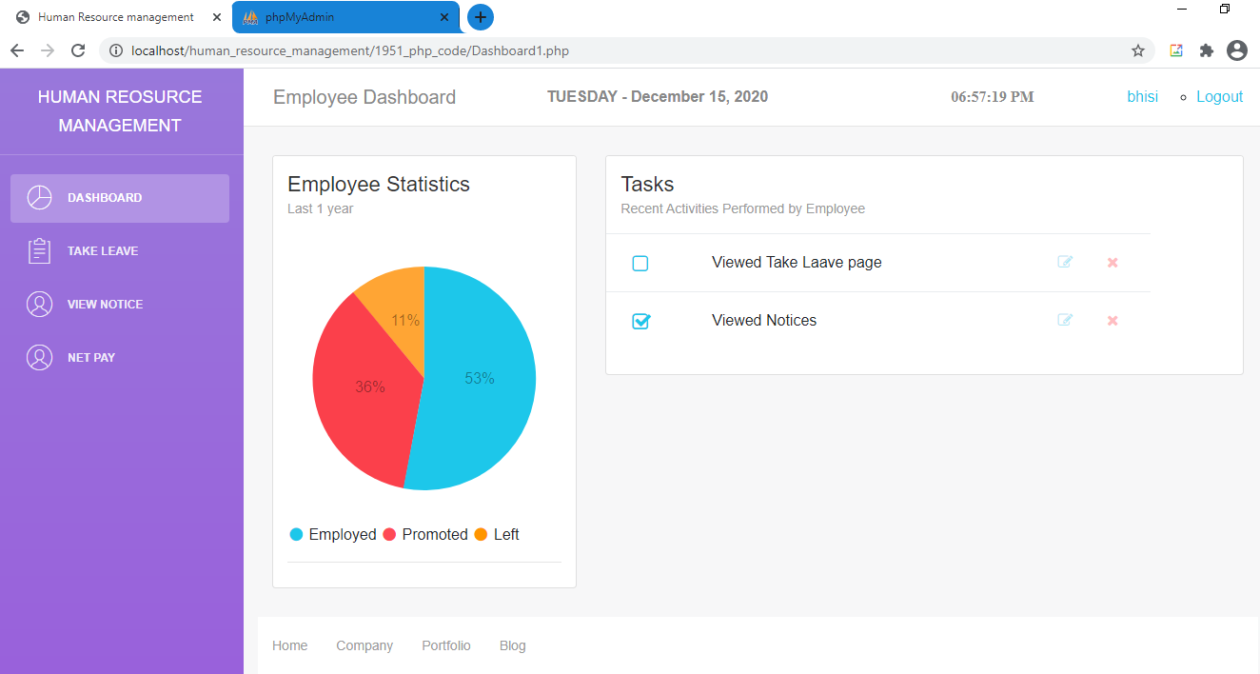

**Following Screenshot Shows the Profile page of Employee**

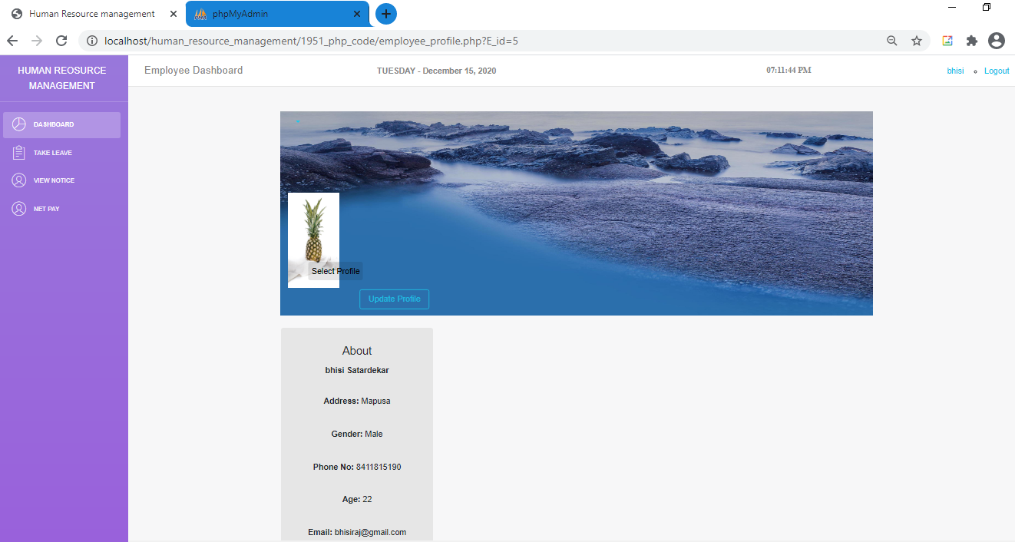

**Following Screenshot Shows the Edit Profile page of Employee**

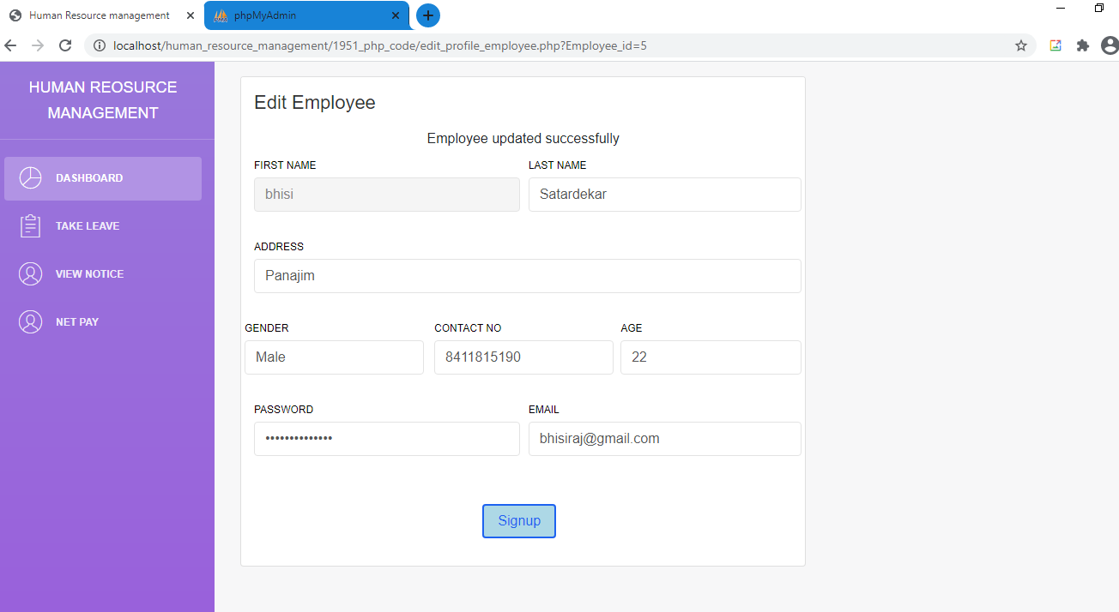

**Following Screenshot Shows the Add Leave page of Employee**

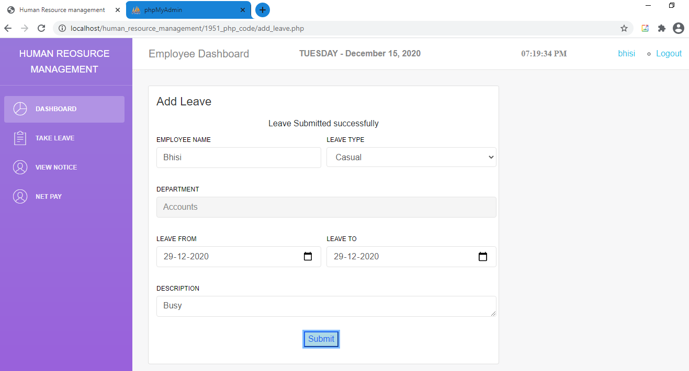

**Following Screenshot shows all the Leave applied by the Employee**

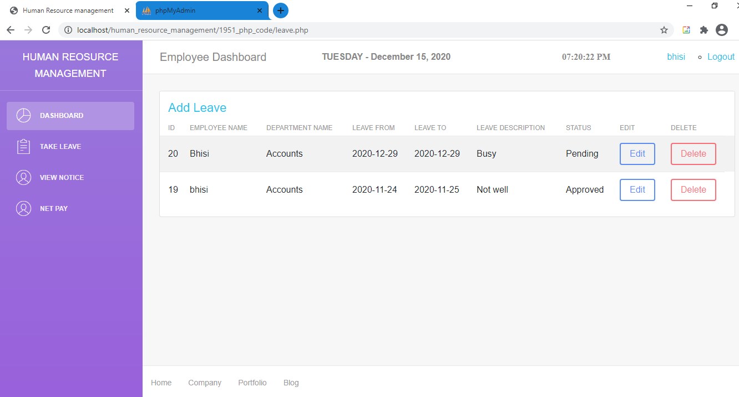

**In the following Screenshot the employee can edit the leave details of only those leaves whose status is pending.**

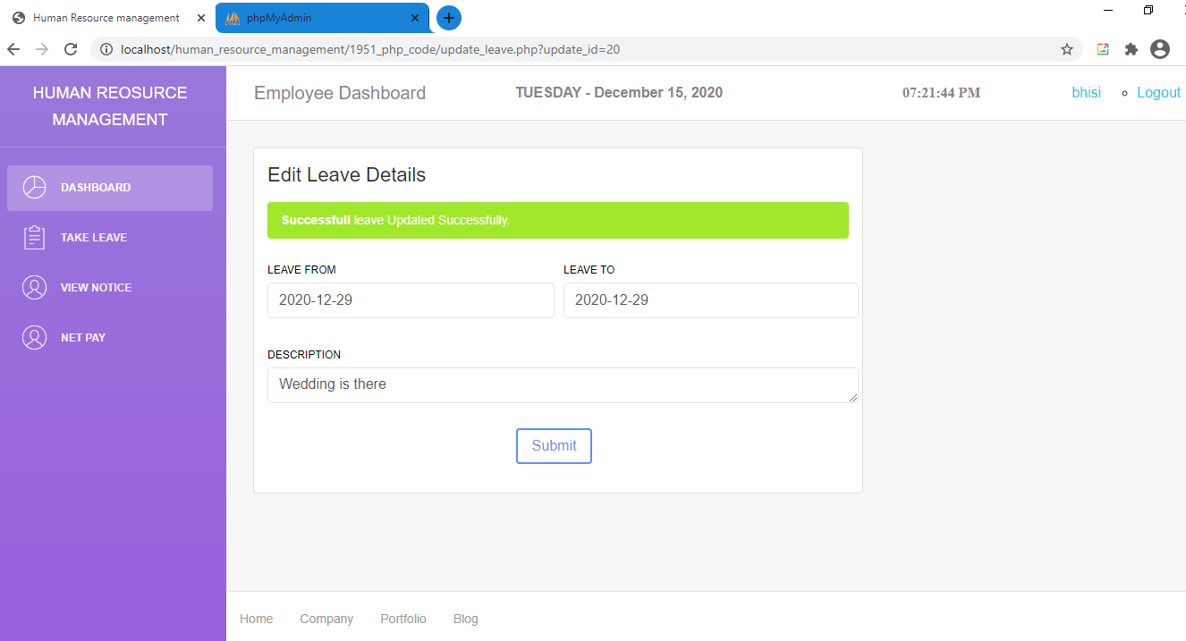

**In the following Screenshot the employee can delete the leave details of only those leaves whose status is pending.**

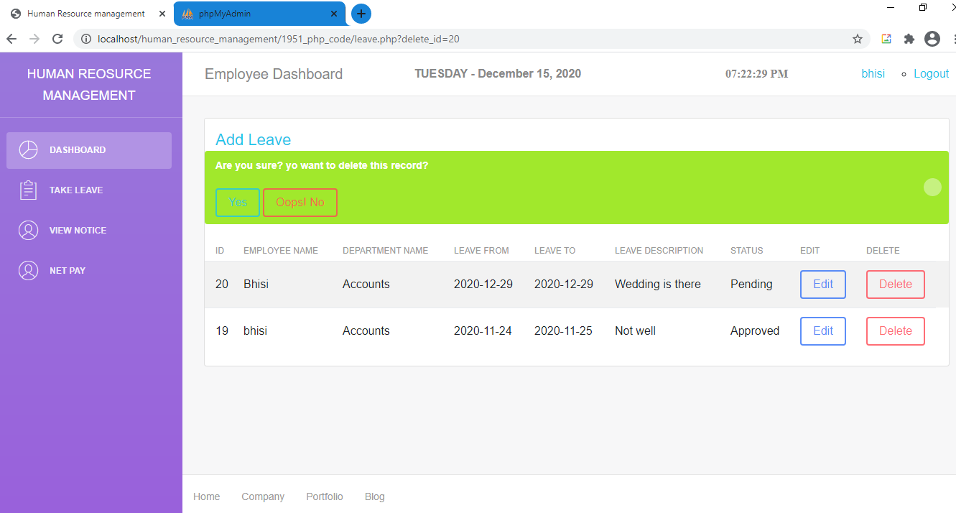

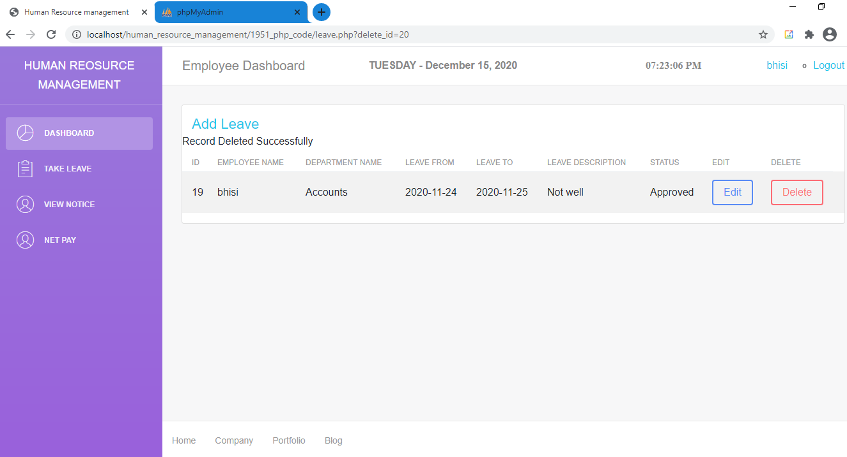

**Following Screenshot displays all the Notices send by the admin**

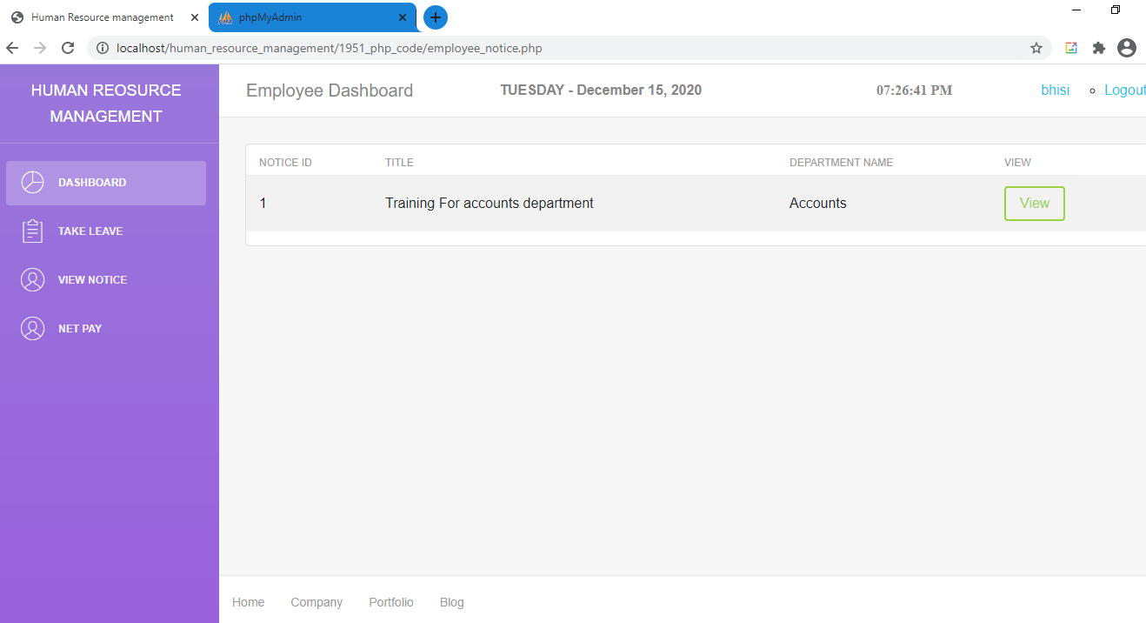

**Following Screenshot displays the Notice viewed by the employee**

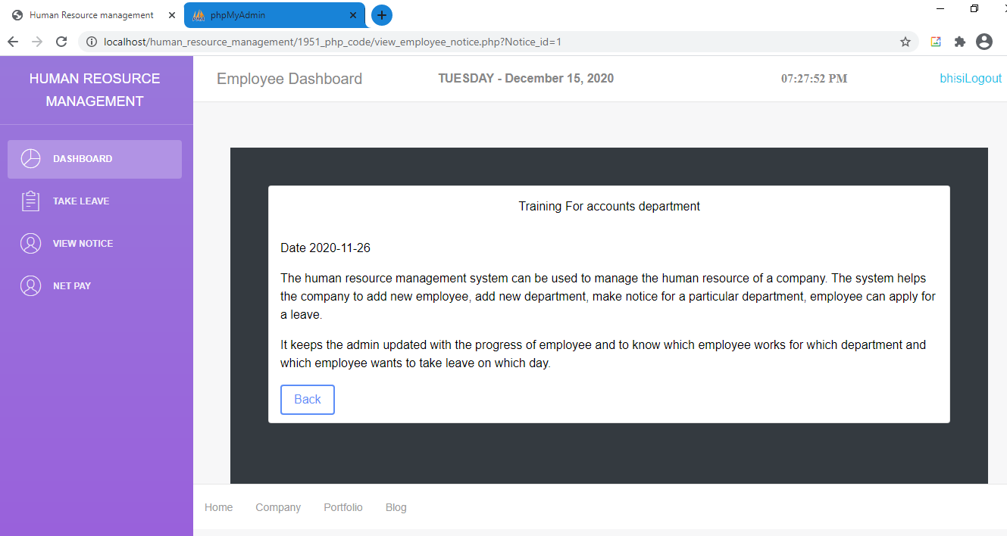

**Following Screenshot displays the Payroll details of the employee**

