Branden Hitt

Assignment #2

Task 1: C++. Store the 8000 numbers using a stack dynamic array.

Task 2: C++. Store the 8000 numbers using a heap dynamic array.

Task 3: Java. Store the 8000 numbers into 8 arrays, each of fixed size 1000.

Task 4: Java. Store the 8000 numbers into one arraylist.

1. When comparing Task 1 and Task 2, Task 1 was much faster. Given 10 trials each with n=8000, the average time to compute Task 1 was 37300 nanoseconds. Task 2 was much slower with an average time to compute equal to 51900 nanoseconds. This makes sense as the memory allocation and deallocation involved with the stack is very simple, whereas doing the same with the heap has extra steps. Each bite in the stack is also reused frequently so it is more likely to be mapped to the processor’s cache which would also improve speed.
2. When comparing Task 3 and Task 4, Task 3 was much faster. Given 10 trials each with n=8000, the average time to compute Task 3 was 1019030 nanoseconds. Task 4 was slower with an average compute time of 2249320 nanoseconds. The speed difference is due to fixed heap dynamic vs heap dynamic. A fixed size array is stored on the heap but the size of the array does not change so it does not have any added time. Conversely, an arrayList object is required to copy its elements into a new arrayList object whenever it is resized. This added step adds some time to the overall allocation of a heap dynamic arrayList.

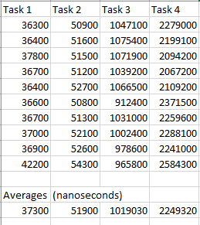

1. Compare and Contrast of set intersection and difference (python and java): After writing the same program in Java and Python, I found set operations and implementations to be much quicker and more readable in Python. Since Python already supports a set class, you simply created the set and called the operations on them. It took only a couple of lines of code and was clear what was happening. Java was instead more clunky. It required you to decide what type of set to use and took up many more lines of code to get the same results. Overall, it was much easier to read and write the code in python in this case.

**Program Code on following pages…**

**Program Code – Task 1 & 2 C++**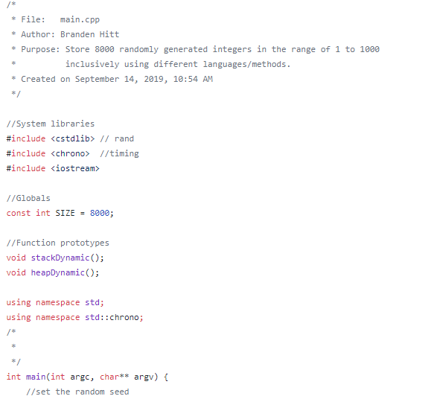

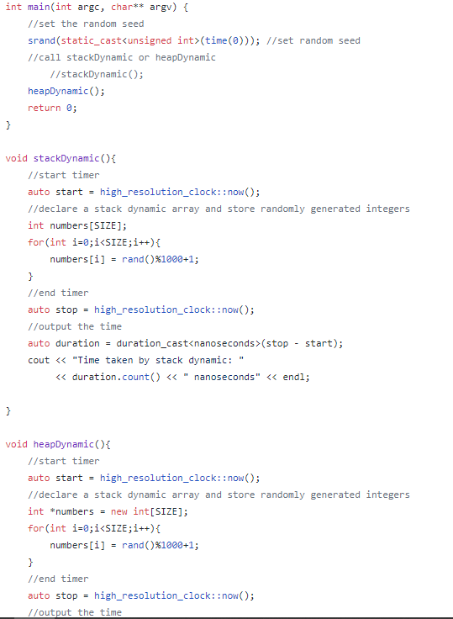

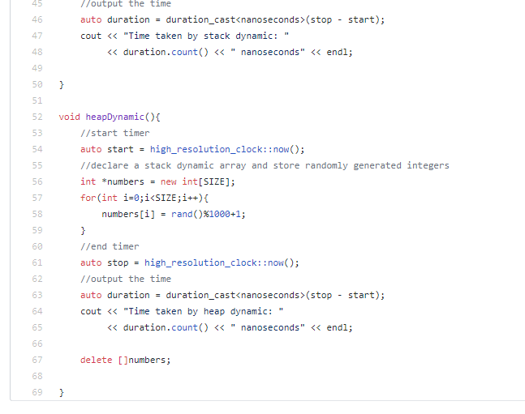

**Program Code – Task 3 & 4 Java**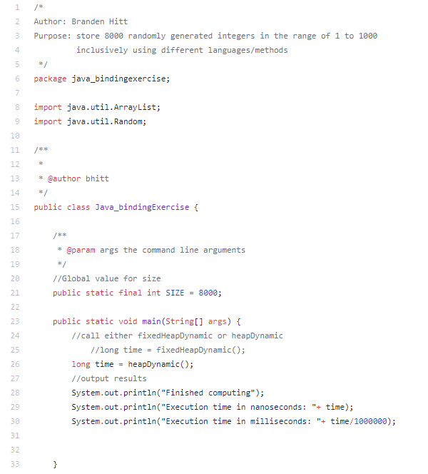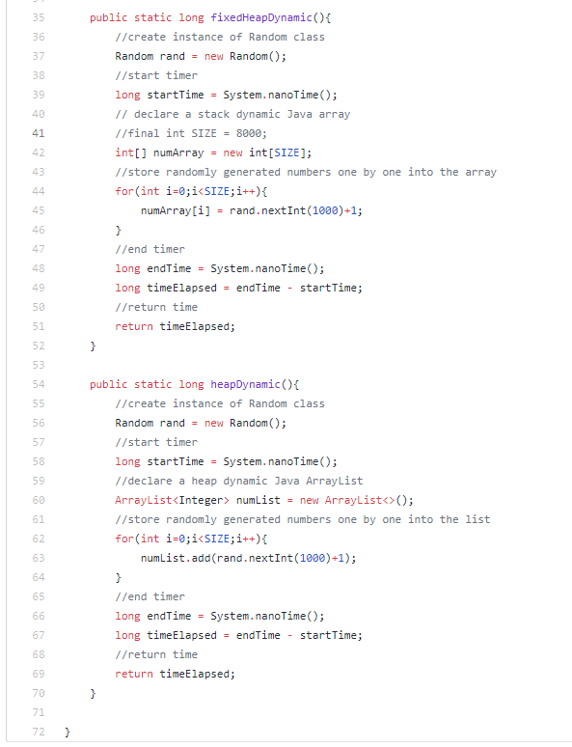

**Program Code: Java Set Intersection/Difference**

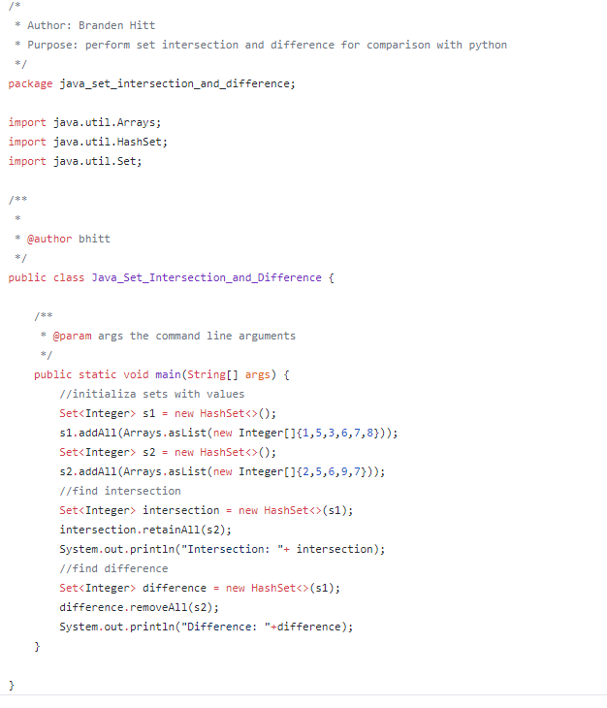

**Execution (Java)** 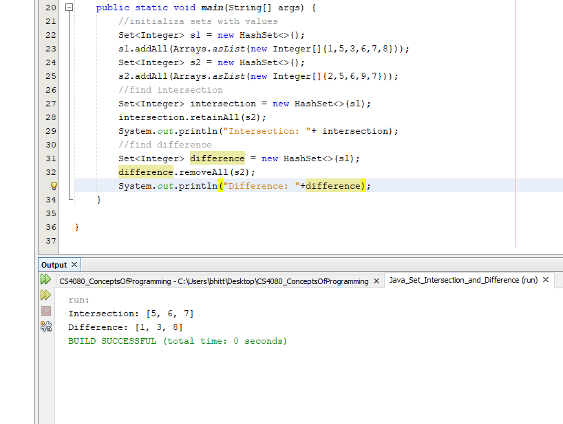

**Program Code: Python Set Intersection/Difference**

