**A CRM APPLICATION FOR WHOLESALE RICE MILL**

**Introduction to Salesforce:**

Salesforce is your customer success platform, designed to help you sell, service, market, analyze, and connect with your customers.

Salesforce has everything you need to run your business from anywhere. Using standard products and features, you can manage relationships with prospects and customers, collaborate and engage with employees and partners, and store your data securely in the cloud.

**1.Creating Developer Account and Account Activation:**

* Go to <https://developer.salesforce.com/signup>
* Fill in the following details:

First Name,Last Name,Email,Role,Company,Country,Postal Code,Username

* Click on **Sign Me Up**
* Go to the inbox of the email you used during sign-up
* Open the email and click on **Verify Account** (may take 5-10 minutes)
* Set your **Password** and answer the **Security Question**
* Click on **Change Password**
* You will be redirected to your Salesforce setup page

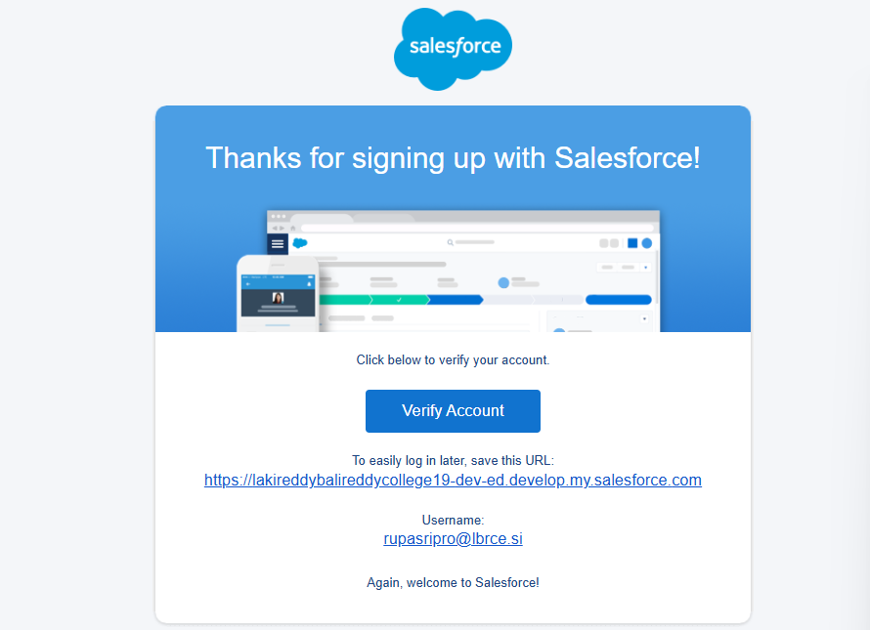

**2. Objects Creation:**

Setup Page > Object Manager > Create > Custom Object.

➤ supplier

➤ rice mill

➤ consumer

➤ rice details

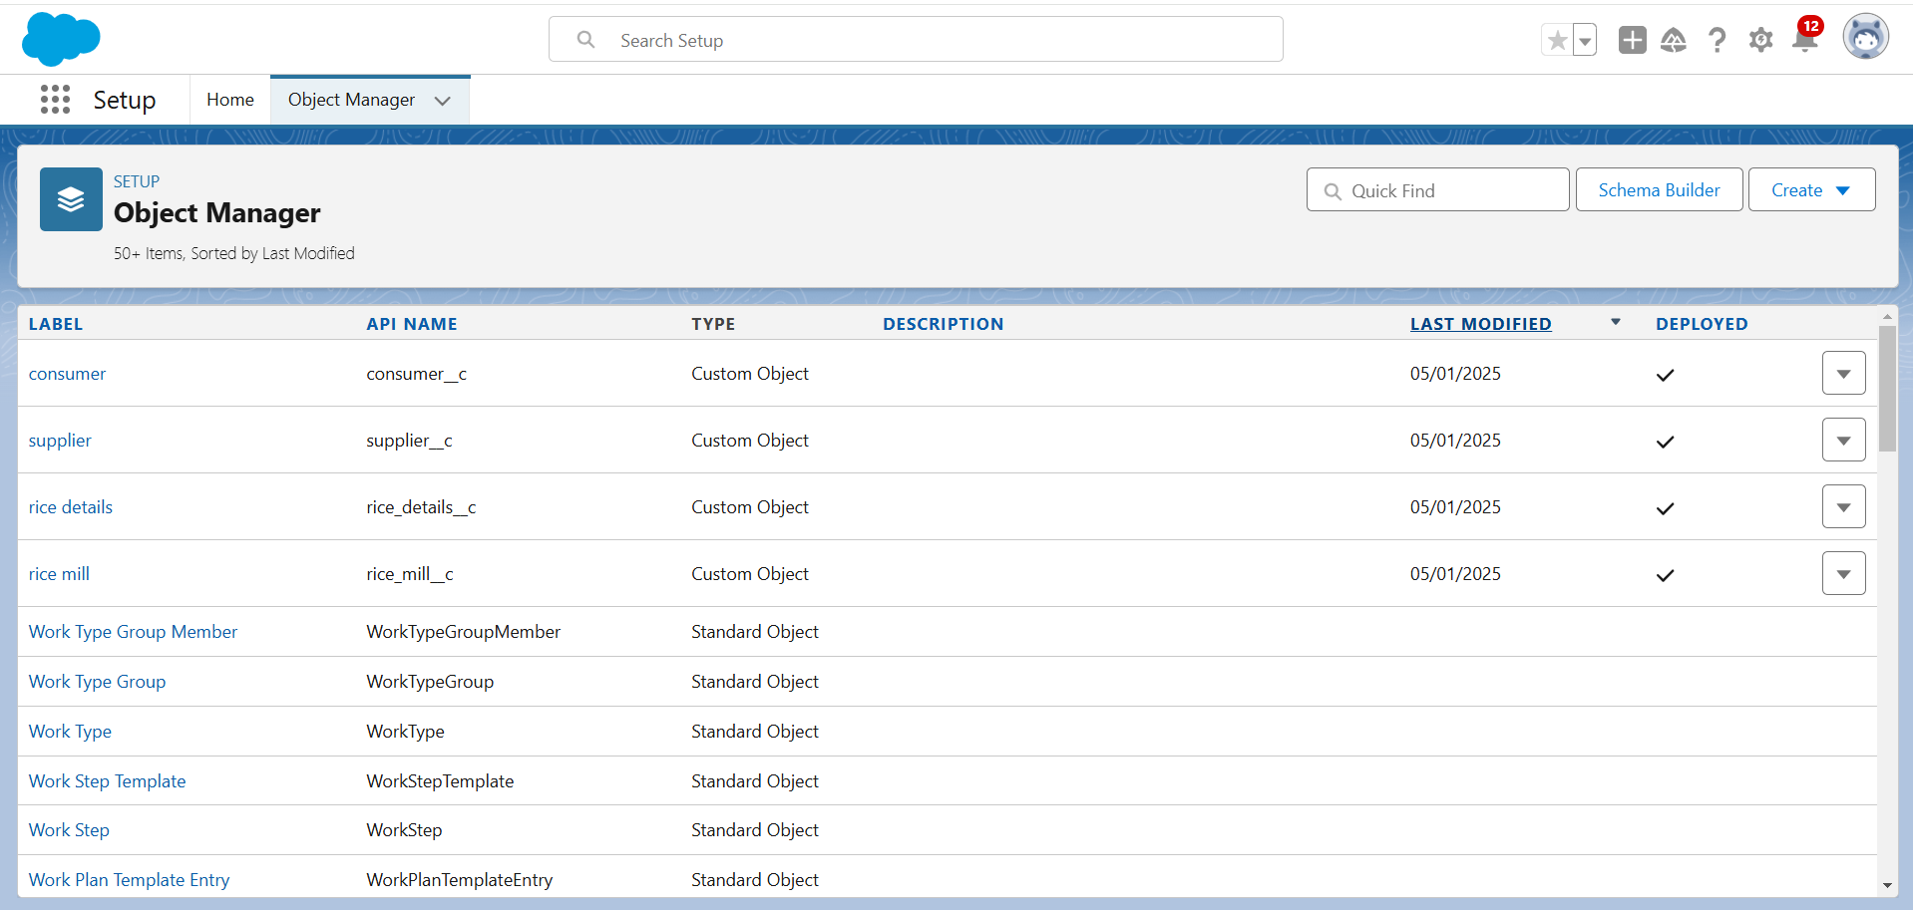

**3.Creating a Custom Tab:**

* Setup Page > Quick Find > **Tabs**
* Click on **New** (Custom Object Tab)
* Select **Object**: supplier
* Choose **Tab Style**
* Click on **Next**
* In **Profiles**: Select **Default**
* Click on **Next**
* In **Custom App**: Uncheck **"Include Tab"**
* Check **"Append Tab to Users' Existing Personal Customizations"**
* Click on **Save**

Repeat for: **rice mill, consumer, rice details**

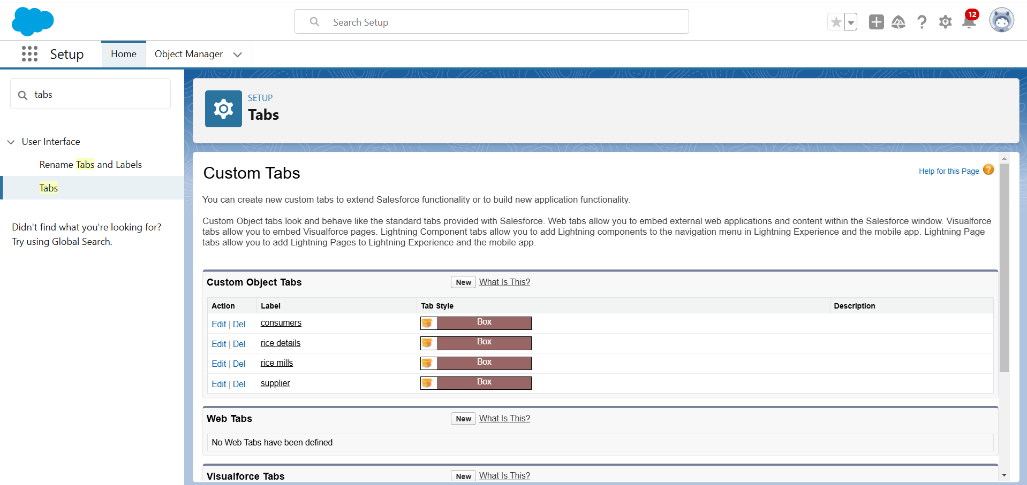

**4.Creating a Lightning App:**

**MY RICE**

1. Setup Page > Quick Find > **App Manager**
2. Click on **New Lightning App**
3. **App Name**: MY RICE
4. Click on **Next**
5. In **App Options**: Select **Default**
6. Click on **Next**
7. In **Utility Items**: Select **Default**
8. Click on **Next**
9. **Upload Photo**
10. In **Add Navigation Items**: Select **supplier, rice mill, consumer, rice details**
11. Click on **Next**
12. In **Add User Profiles**: Select **System Administrator**
13. Click on **Save & Finish**

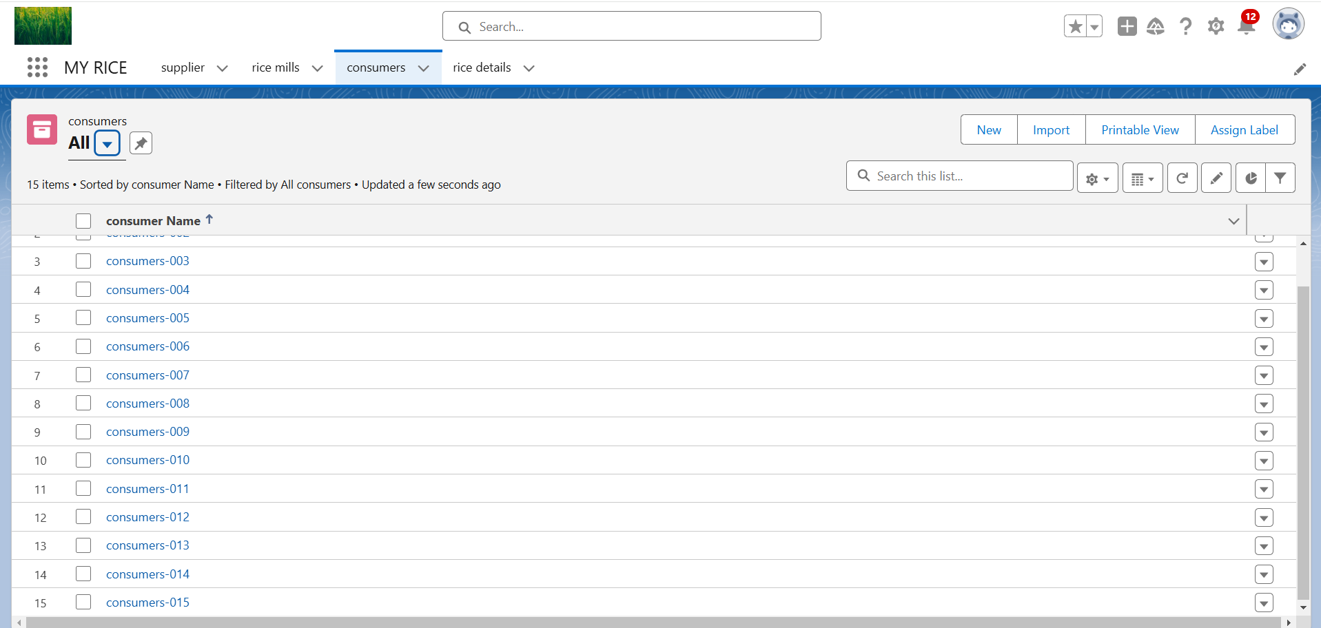

**5. Fields Creation:**

**Fields for consumer object:**

* Setup Page > Object Manager > **Consumer**
* Click on **Validation Rules->**Click on **New**
* **Rule Name**: Phonenumberoremailblankrule
* **Description**: Phone number and email should not be blank
* **Formula**: OR(ISBLANK(phone_number__c), ISBLANK(email__c))
* **Error Message**: Please fill in your phone number
* **Error Location**: Top of Page
* Click on **Save**

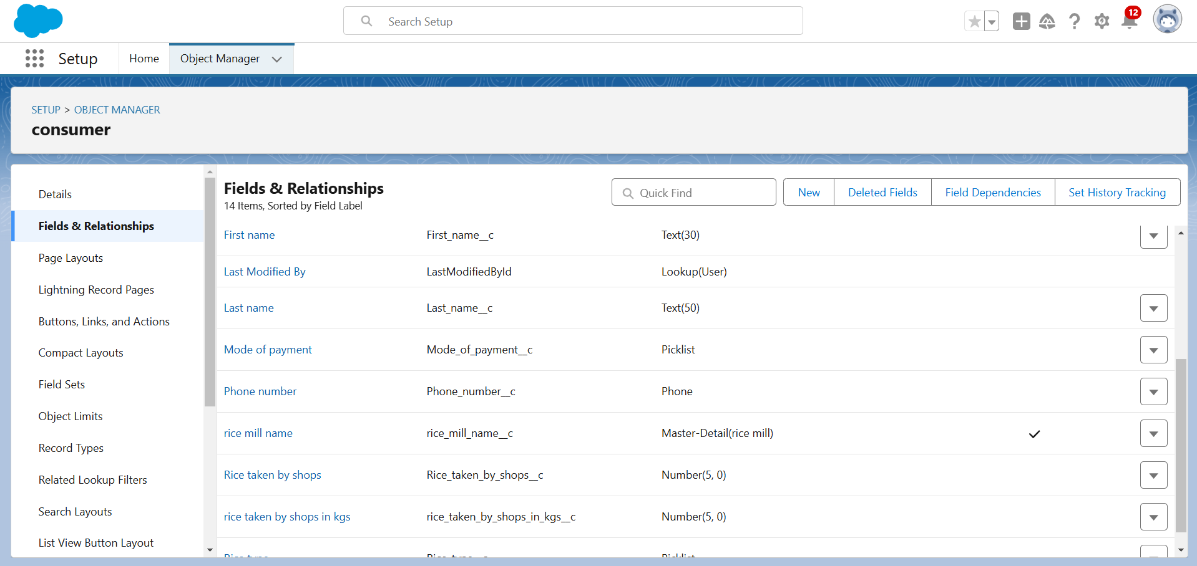

**Fields for supplier object:**

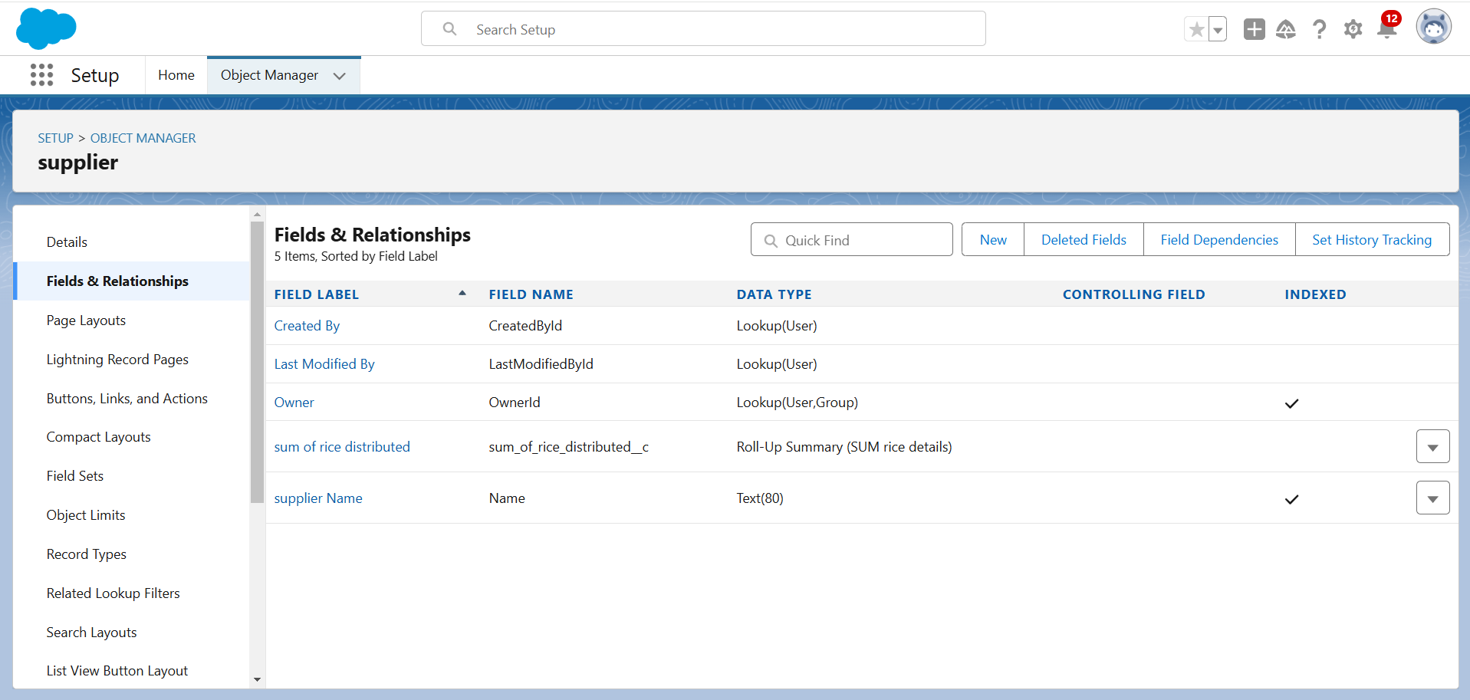

**Fields for rice details object:**

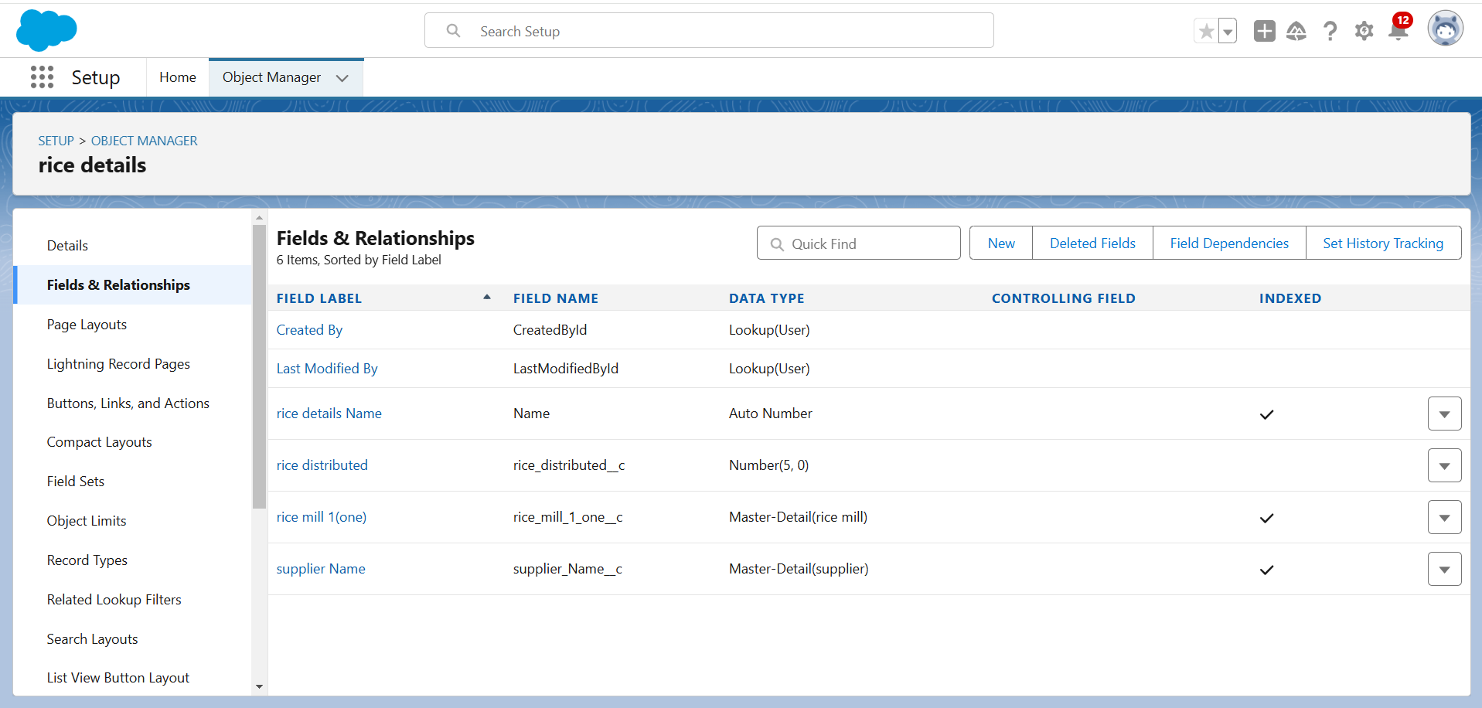

**Fields for ricce mill object:**

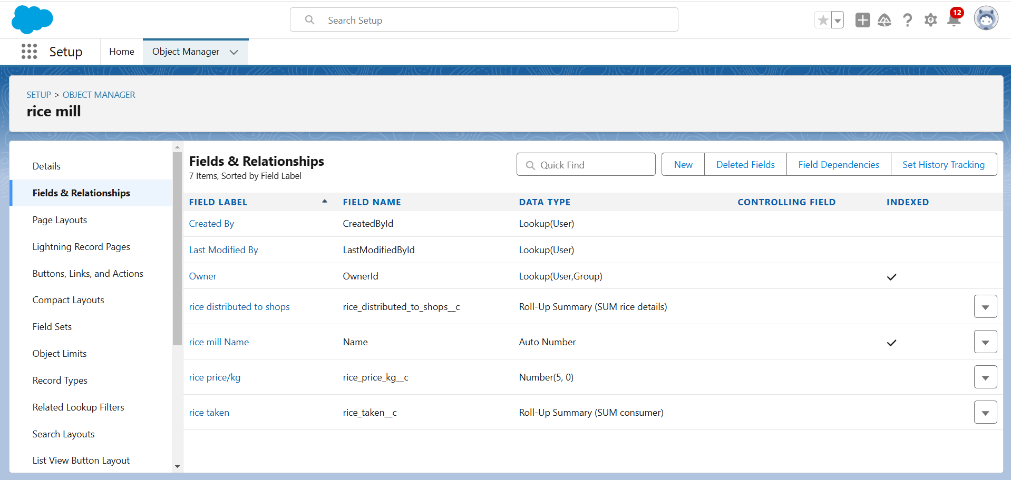

**6.Creating the page layout:**

* Setup > Object Manager > **Consumer**
* Click on **Page Layout**
* Click on **New**
* Select **Existing Layout**
* **Name**: consumer layout
* Add Sections:
  + **Personal Details**: Fields - First Name, Last Name, Consumer Name, Phone Number, Email, Rice Mill Name
  + **Rice Details**: Fields - Rice Taken by Shop, Rice Type
  + **Receipt Details**: Fields - Mode of Payment, Amount Paid
* Click on **Save**

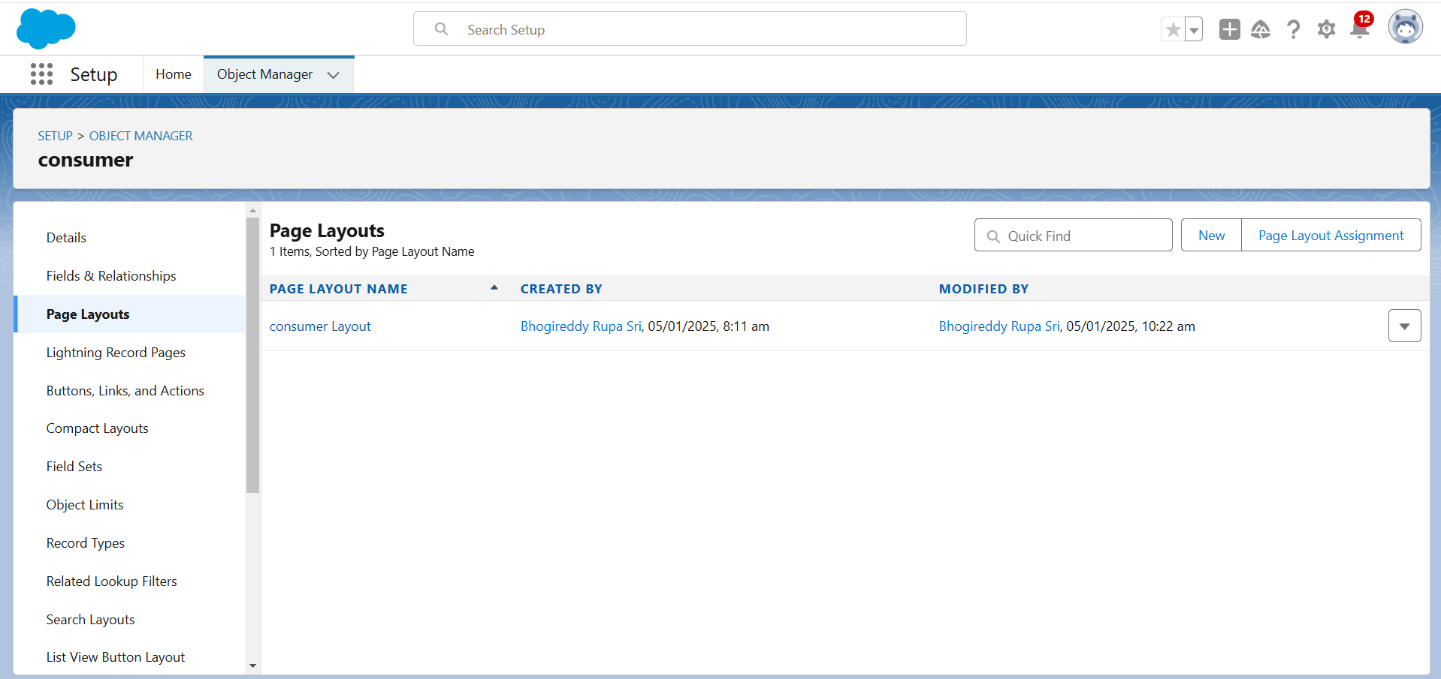

**7.Profiles creation:**

* Owner Profile
* Employer Profile
* Worker Profile

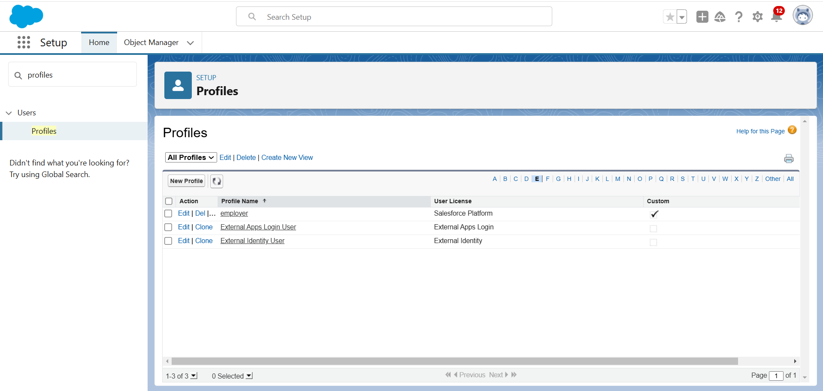

**Employer profile:**

* Setup > Quick Find > **Profiles**
* Clone **Standard Platform User**
* **Profile Name**: employer
* Click on **Save**
* Click on **Edit**
* **Default Custom App**: Select **Rice Mill**
* In **Custom Object Permissions**, give access to **consumers, rice details, rice mill, and suppliers**
* Click on **Save**

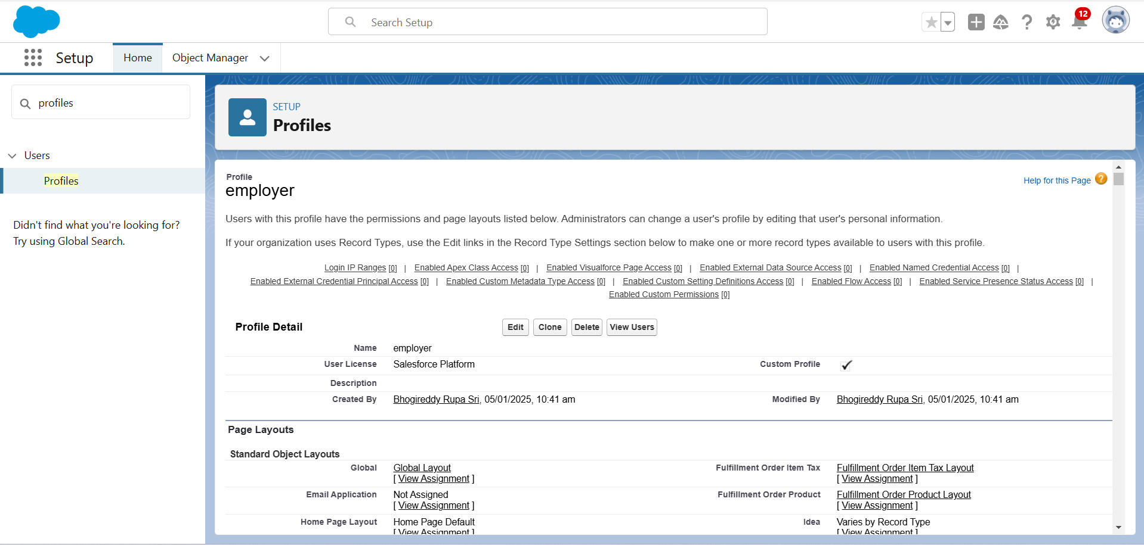

**Owner profile:**

* Setup > Quick Find > **Profiles**
* Clone **Standard User**
* **Profile Name**: owner
* Click on **Save**
* In **Custom Object Permissions**, give access to **consumers, rice details, rice mill, and suppliers**
* Click on **Save**

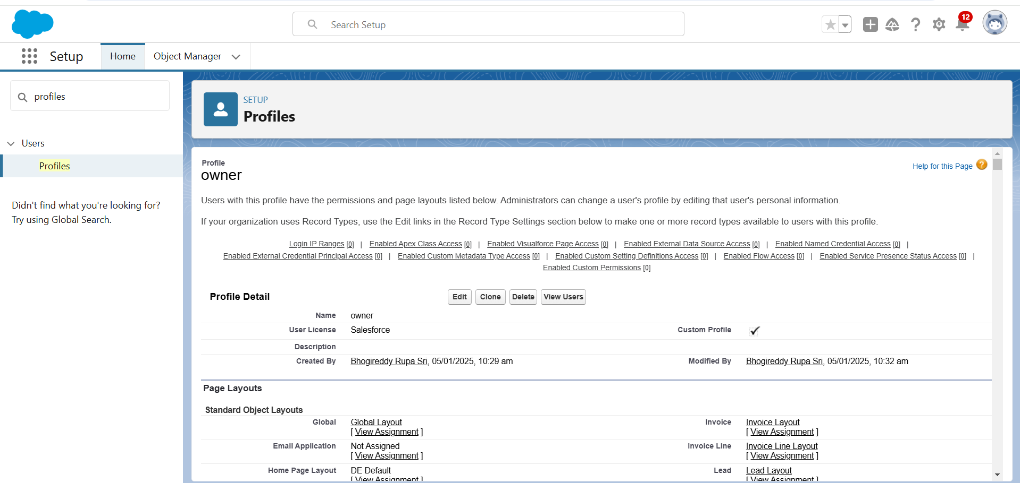

**Worker profile:**

* Setup > Quick Find > **Profiles**
* Clone **Standard Platform User**
* **Profile Name**: worker
* Click on **Save**
* Click on **Edit**
* **Default Custom App**: Select **Rice Mill**
* In **Custom Object Permissions**, give access to **consumers, rice details, rice mill, and suppliers**
* Click on **Save**

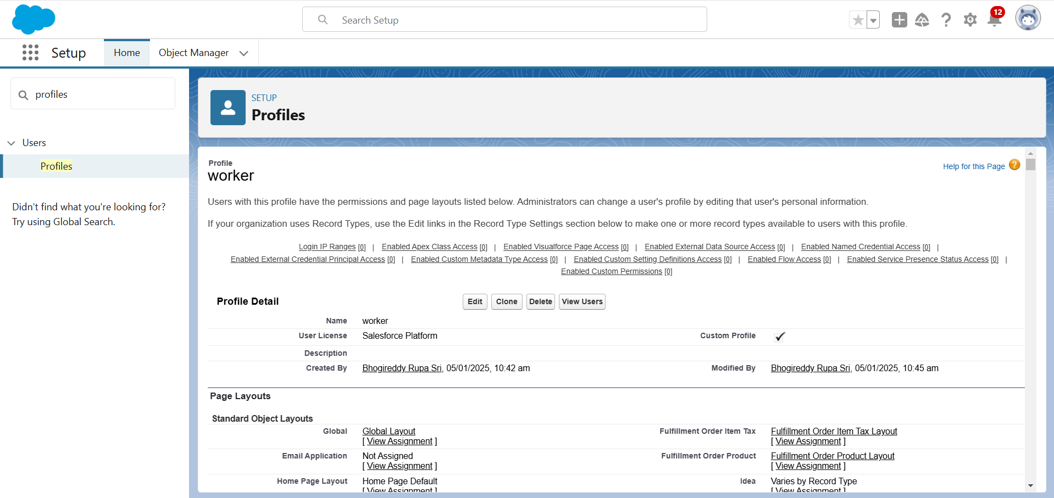

**8.Role & Role Hierarchy:**

1. **Creating Owner Role**
   * Quick Find > **Roles** > Setup Roles > Expand All
   * Add Role under **Owner**
   * **Label**: owner
   * Click on **Save**
2. **Creating Employer Role**
   * Quick Find > **Roles** > Setup Roles
   * Add Role under **Owner**
   * **Label**: employer
   * Click on **Save**
3. **Creating Worker Role**
   * Quick Find > **Roles** > Setup Roles
   * Add Role under **Employer**
   * **Label**: worker
   * Click on **Save**

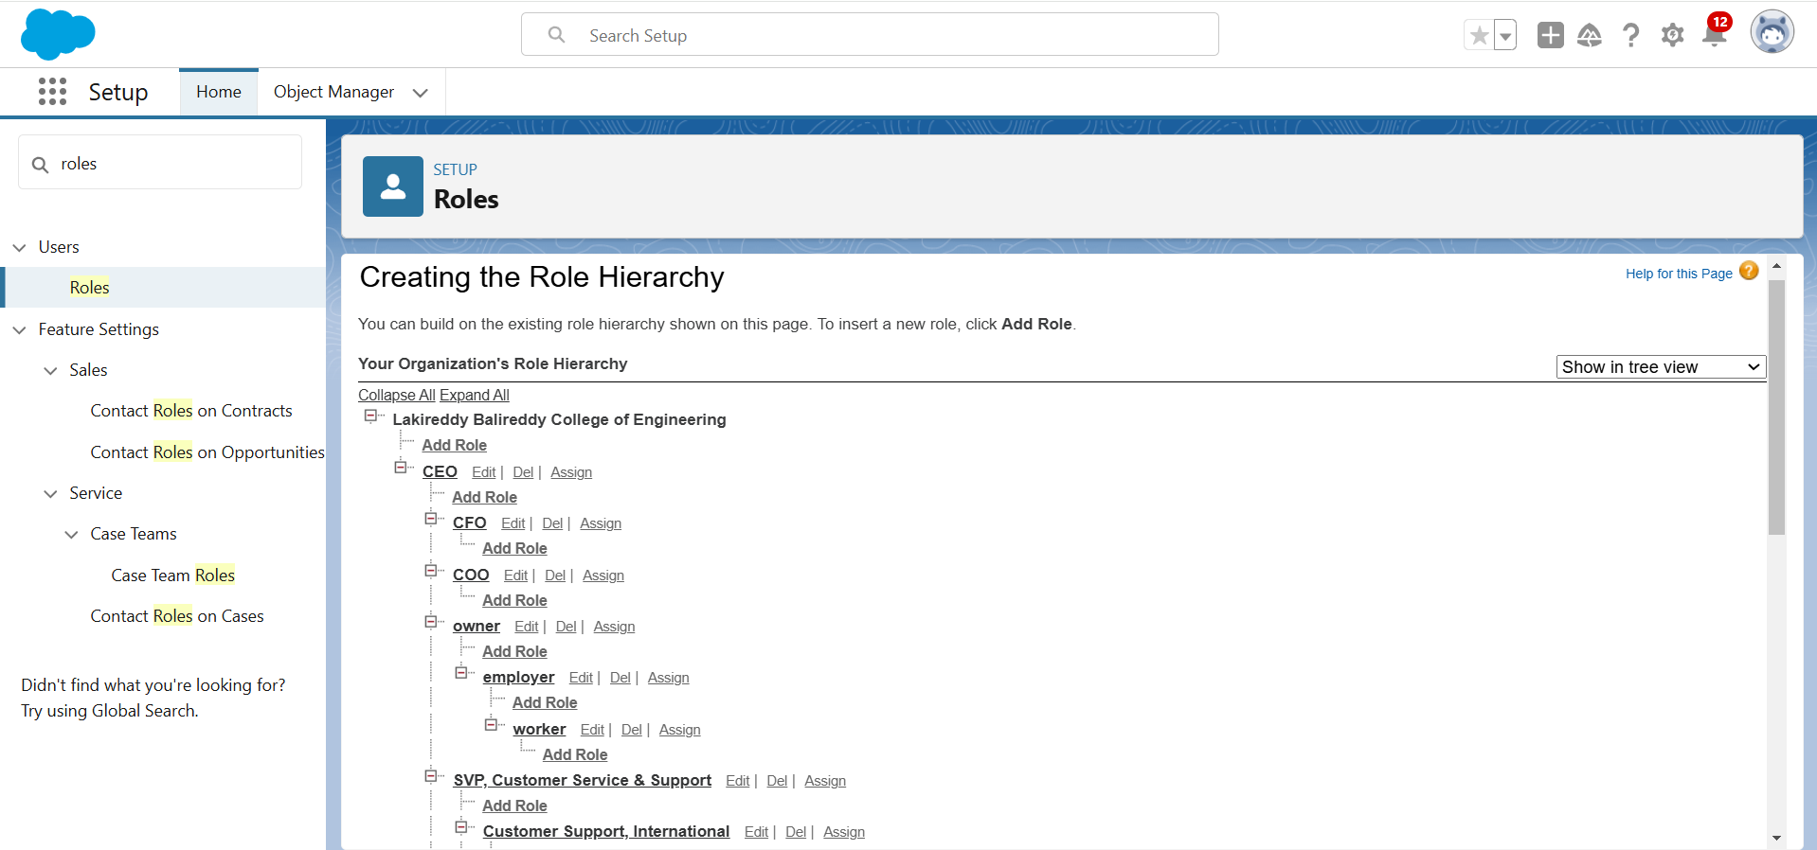

**9.Creating Users:**

1. **Create User (Owner)**
   * Setup > Quick Find > **Users** > New User
   * **First Name**: Vicky
   * **Last Name**: Y
   * **Alias**: Enter Alias
   * **Email**: Personal Email
   * **Username**: text@text.text
   * **Nickname**: Enter Nickname
   * **Role**: Owner
   * **User License**: Salesforce
   * **Profile**: Owner
   * Click on **Save**

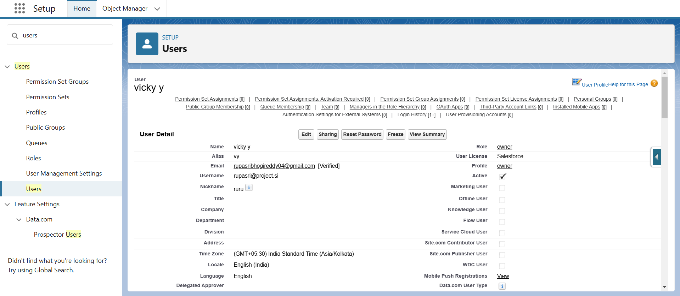

1. **Create User (Employer)**
   * Setup > Quick Find > **Users** > New User
   * **First Name**: Ram
   * **Last Name**: Ram
   * **Alias**: Enter Alias
   * **Email**: Personal Email
   * **Username**: text@text.text
   * **Nickname**: Enter Nickname
   * **Role**: Employer
   * **User License**: Salesforce Platform
   * **Profile**: Standard Platform User
   * Click on **Save**

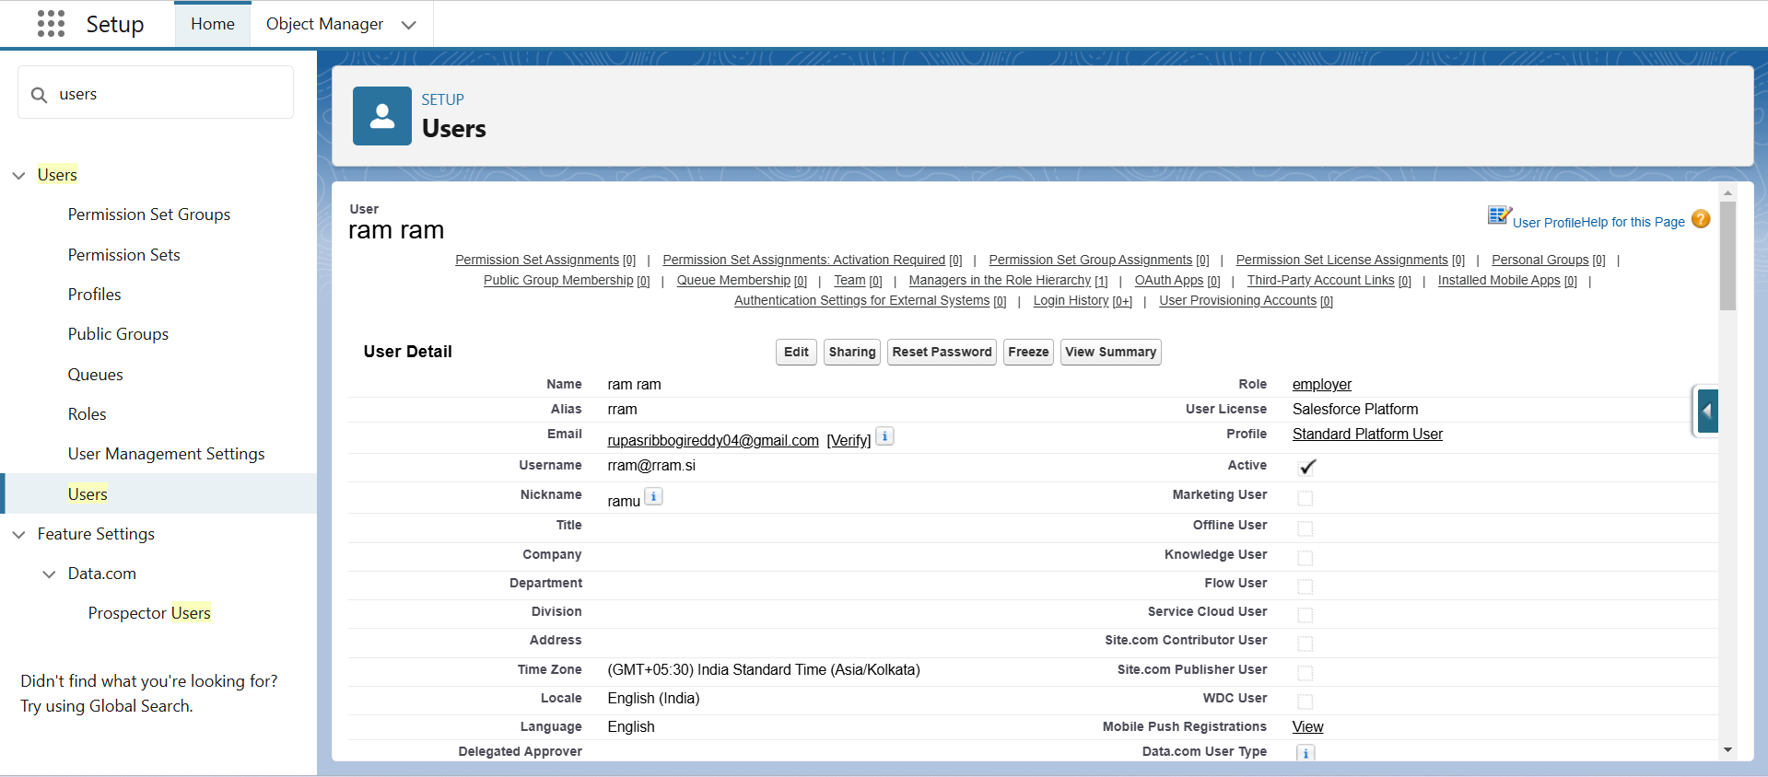

1. **Create User (Worker)**
   * Setup > Quick Find > **Users** > New User
   * **First Name**: Ragu
   * **Last Name**: Raj
   * **Alias**: Enter Alias
   * **Email**: Personal Email
   * **Username**: text@text.text
   * **Nickname**: Enter Nickname
   * **Role**: Worker
   * **User License**: Salesforce Platform
   * **Profile**: Standard Platform User
   * Click on **Save**

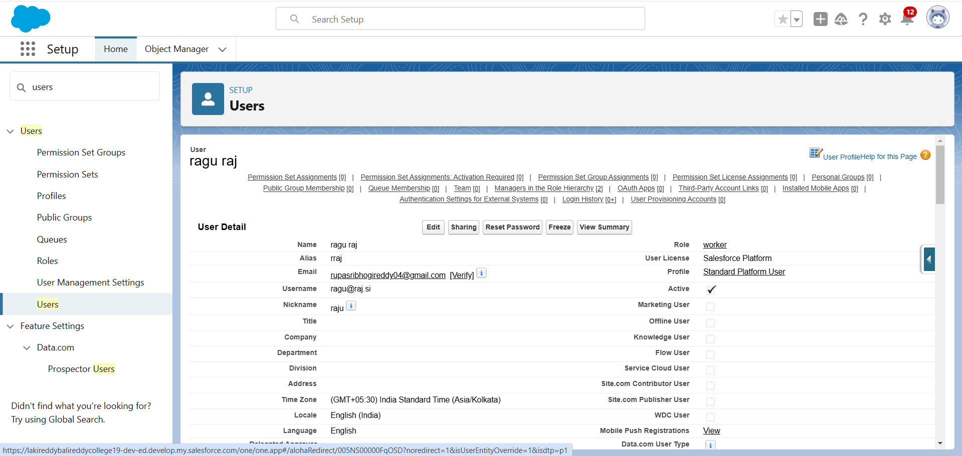

Users Page:

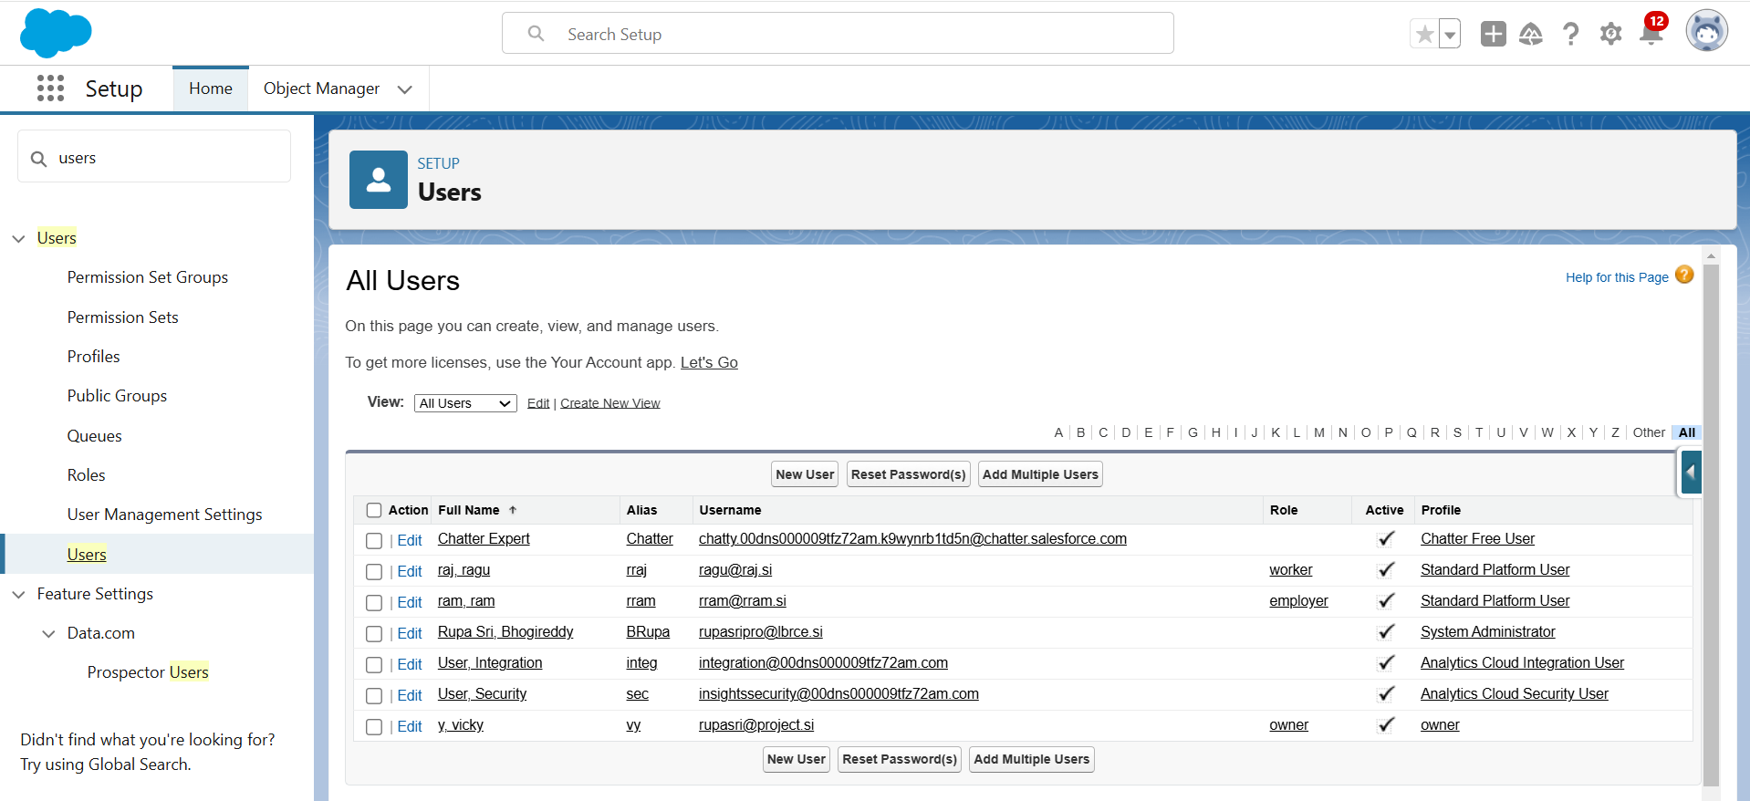

**10.Permission sets:**

**Updating Sharing Settings**

1. Setup > Quick Find > **Sharing Settings**
2. Click on **Edit**
3. Scroll down to **Rice Mill** and **Supplier** objects
4. Change **Default Internal Access** to **Public Read-Only**
5. Click on **Save**

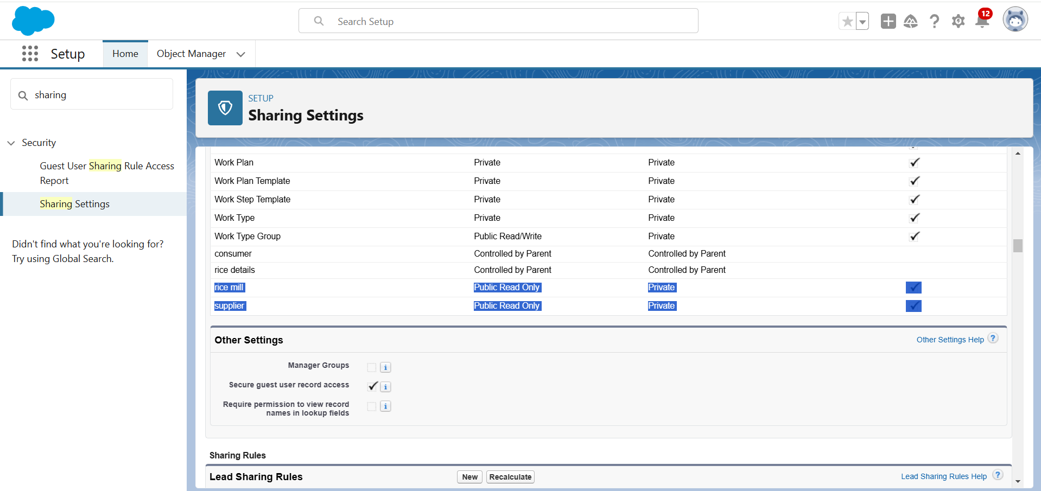

**11.Create Report:**

**Creating and Managing Reports**

1. **Create Report**
   * Go to **App** > **Reports Tab** > **New Report**
   * Select **Report Type**: "Rice Mill with Consumers"
   * Click **Start Report**
   * Add fields: **Consumer Name, Rice Type, Rice Price/kg, Mode of Payments, Amount Paid** to the column section
   * Remove unnecessary fields
   * Add **Rice Taken by Shops** in **Group Rows**
   * Click **Save and Run**
   * Save as **"Range of Amount Per Day"**
2. **Share Report with Owner**
   * Open the report and click **Edit**
   * Select **Subscribe**
   * Choose to run the report as **"Another Person"** and select the owner's email
   * Click **Save**
3. **Create Report Folder**
   * Go to **App Launcher** > Search for **Reports** > Open **Reports Tab**
   * Click **New Folder**
   * Enter **Folder Label**: "Estimated Rice Per Day"
   * Click **Save**
4. **Move Report to Folder**
   * Go to **Reports** > **All Reports**
   * Click the dropdown on **"Range of Amount Per Day"**
   * Click **Move**
   * Select **"Estimated Rice Per Day"** folder
   * Click **Save**

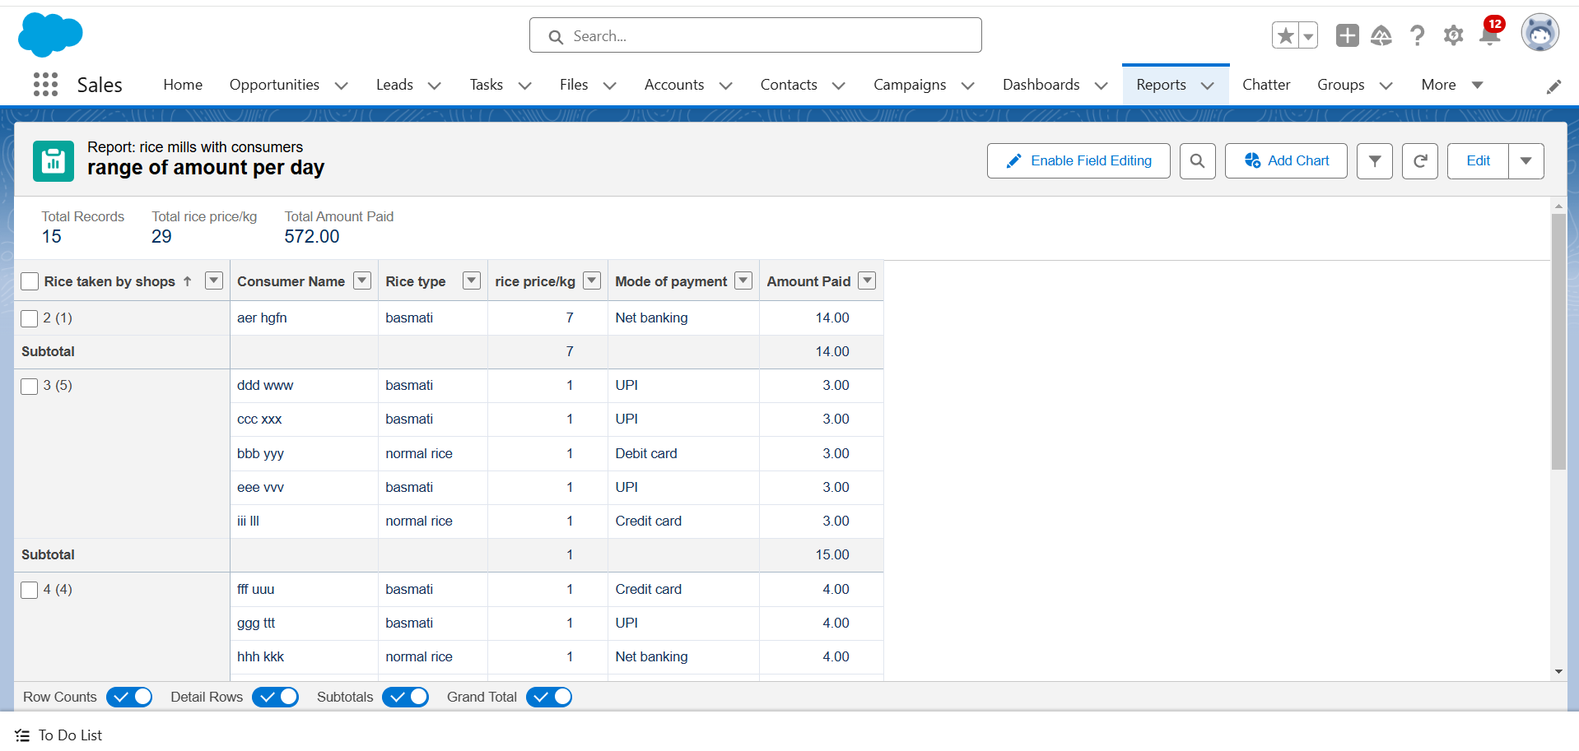

**12.Create Dashboard Folder:**

1. **Create Dashboard Folder**
   * Click on **App Launcher** > Search for **Dashboard** > Open **Dashboard Tab**
   * Click **New Folder**
   * Enter **Folder Label**: "Amount Data Dashboard"
   * Click **Save**
2. **Create Dashboard**
   * Go to **App** > Click on **Dashboards Tab**
   * Enter a **Name** and select the folder created
   * Click on **Create**
   * Click **Add Component**
3. **Select Report and Add Component**
   * Select a **Report** > Click **Select**
   * **Display As**: Vertical Bar Chart
   * **X-axis**: Rice Taken by Shops
   * **Y-axis**: Sum of Amount
   * **Y-axis Range**: Automatic
   * **Sort By**: Rice Taken by Shops
   * **Component Theme**: Dark
   * Click **Add Component**
4. **Add Another Component**
   * Click **Add Component**
   * **Display As**: Donut Chart
   * **Sort By**: Sum of Amount
   * **Title**: Range of Amount Per Day
   * **Component Theme**: Dark
   * Click **Add**
5. **Save Dashboard**

Click **Save and Done**

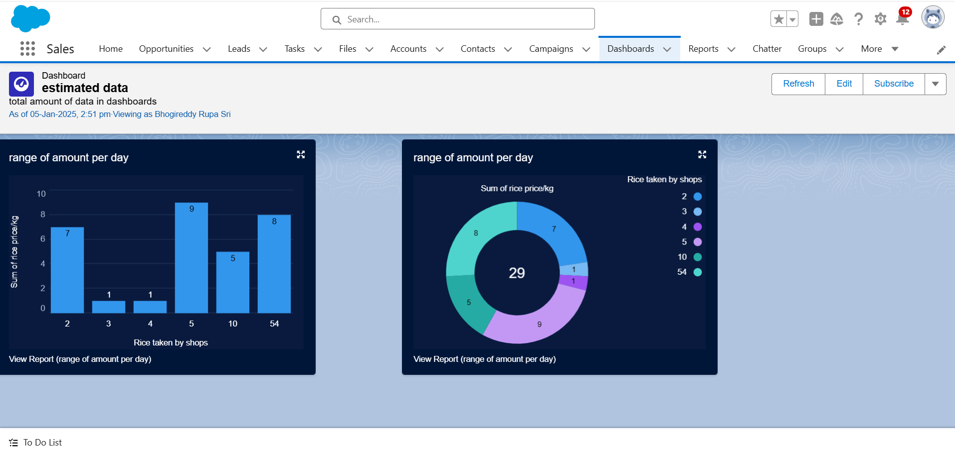

**13.Creating an Apex Class(ConsumerRecord):**

1. **Login to Salesforce**
2. Click on the **gear icon** (Setup)
3. Select **Developer Console**
4. In Developer Console:
   * Go to **File** > **New** > **Apex Class**
   * Enter the name: **ConsumerRecord**
   * Click **OK**
5. Paste the required **Apex code** into the editor
6. Click **File** > **Save**

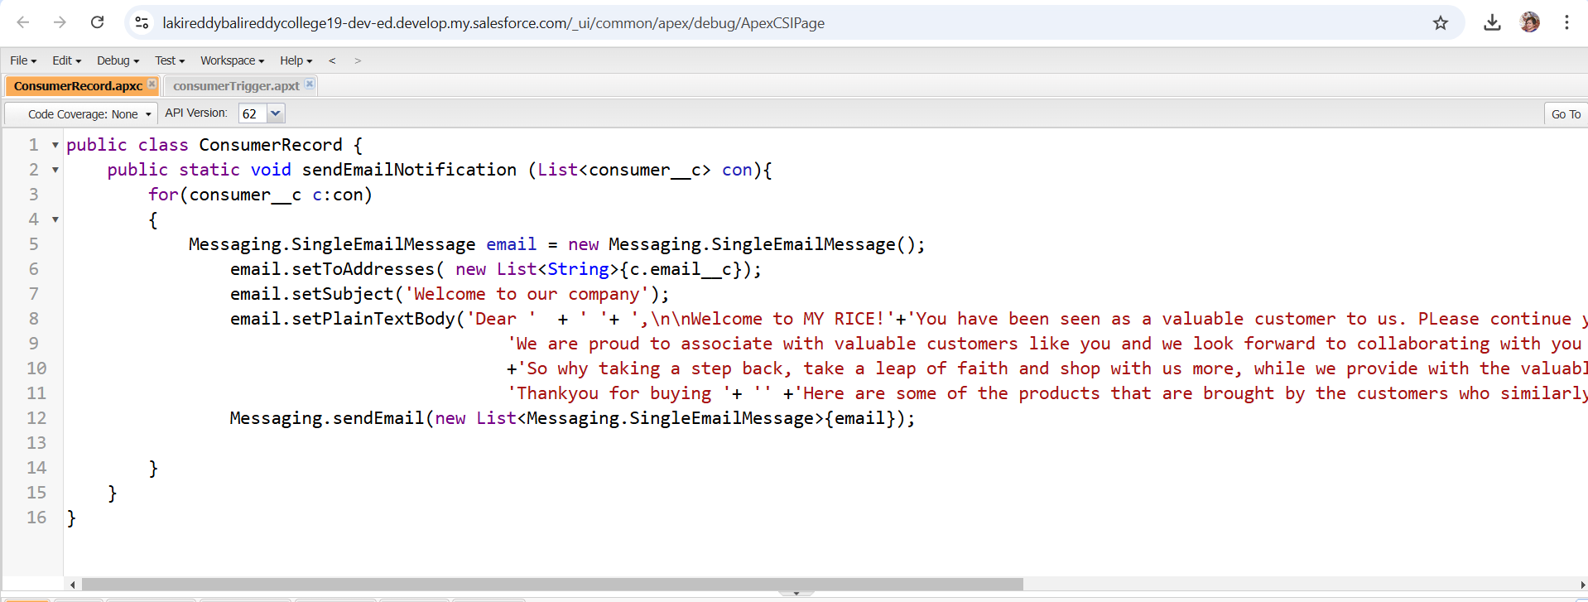

**Creating an Apex Trigger**

1. **Login to Salesforce**
2. Click on the **gear icon** (Setup)
3. Select **Developer Console**
4. In Developer Console:
   * Go to **File** > **New** > **Trigger**
   * Enter the **trigger name** and select the **object**
   * Click **OK**
5. Paste the required **trigger code** into the editor
6. Click **File** > **Save**

