Part-II

1. Build Docker File :
   1. docker build -t eeg_brainwave .

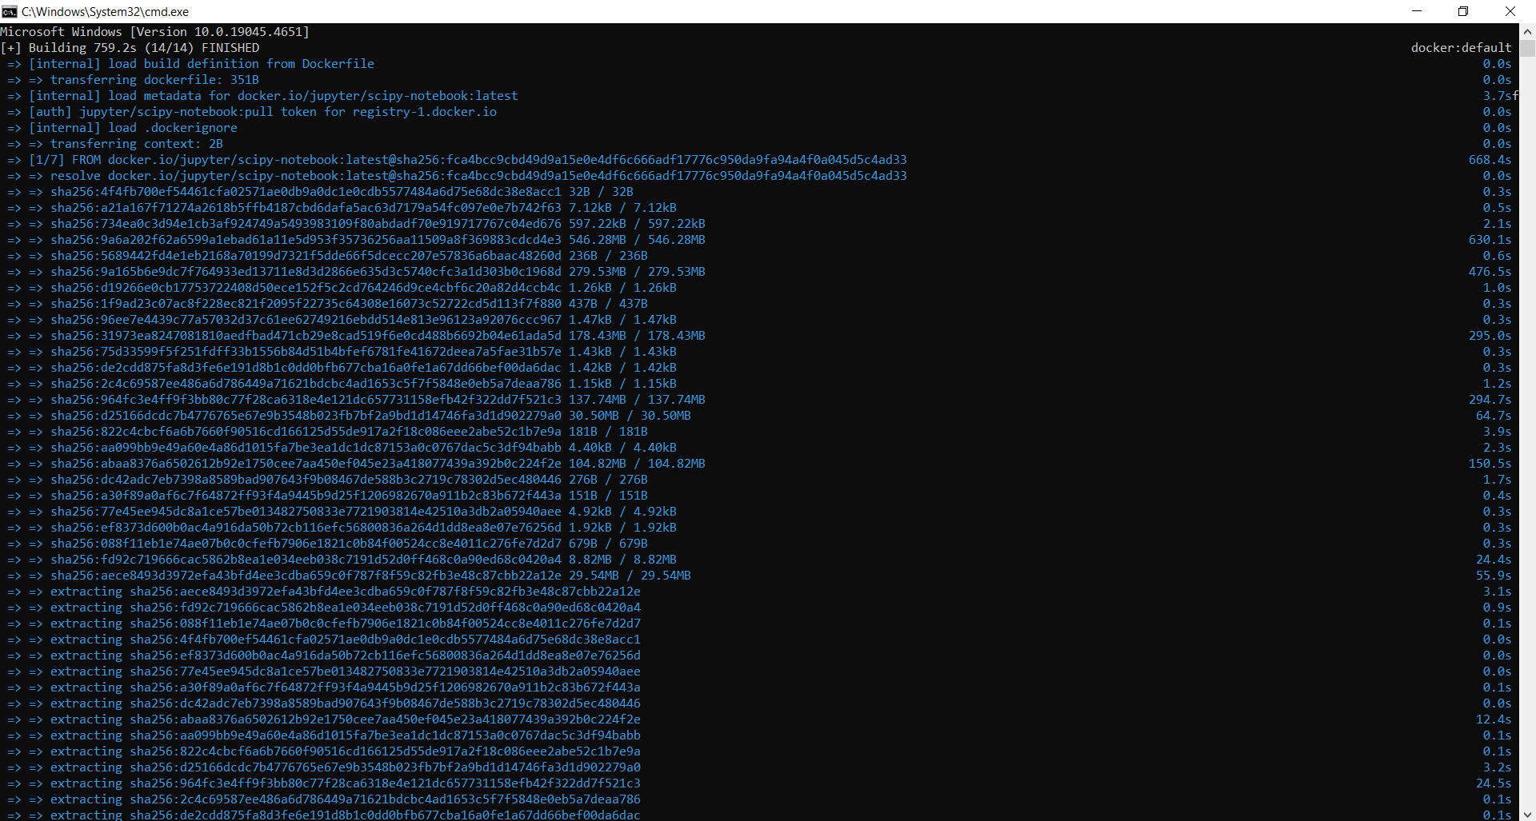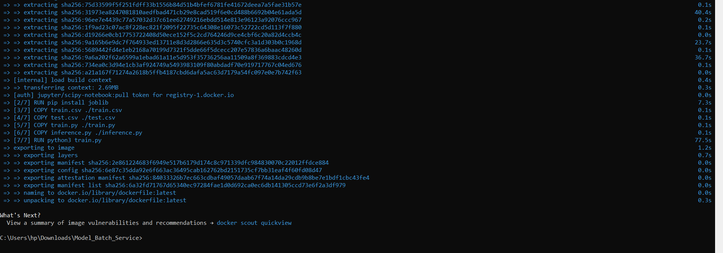

1. Run Docker Container
   1. docker run --name eeg_brainwave_cont -d eeg_brainwave



1. Get Docker Logs
   1. docker logs eeg_brainwave_cont

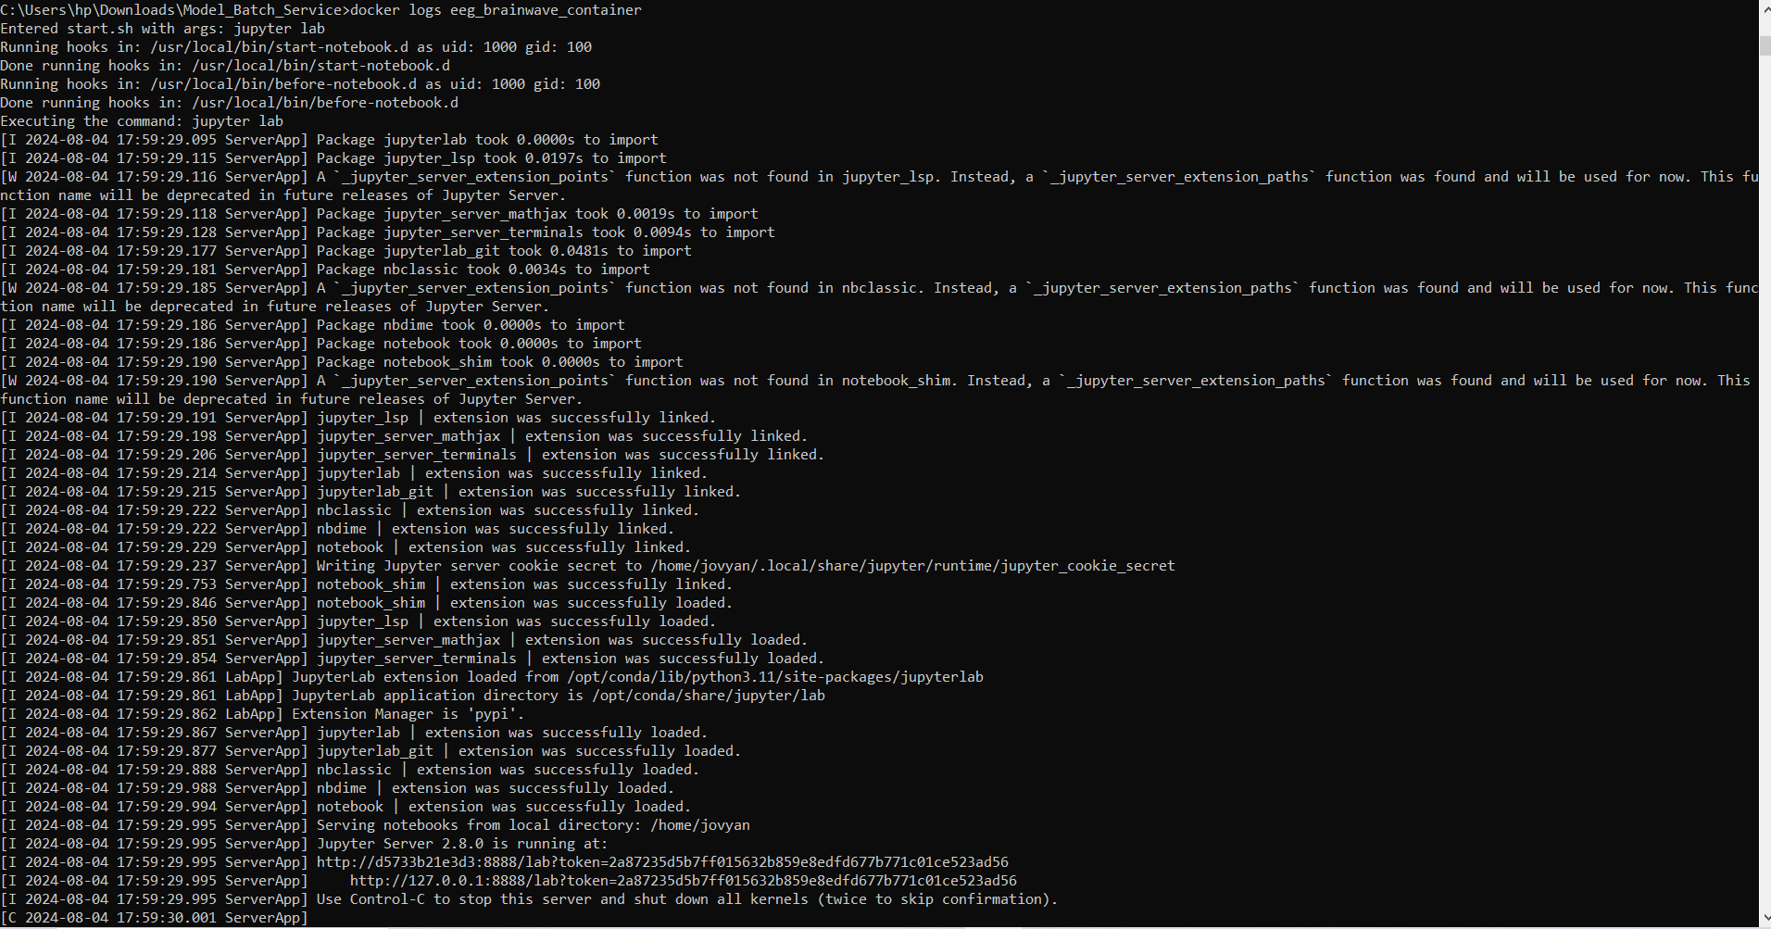

1. Run Container and inference.py to get output
   1. docker exec -it eeg_brainwave_cont /bin/bash
   2. python inference.py

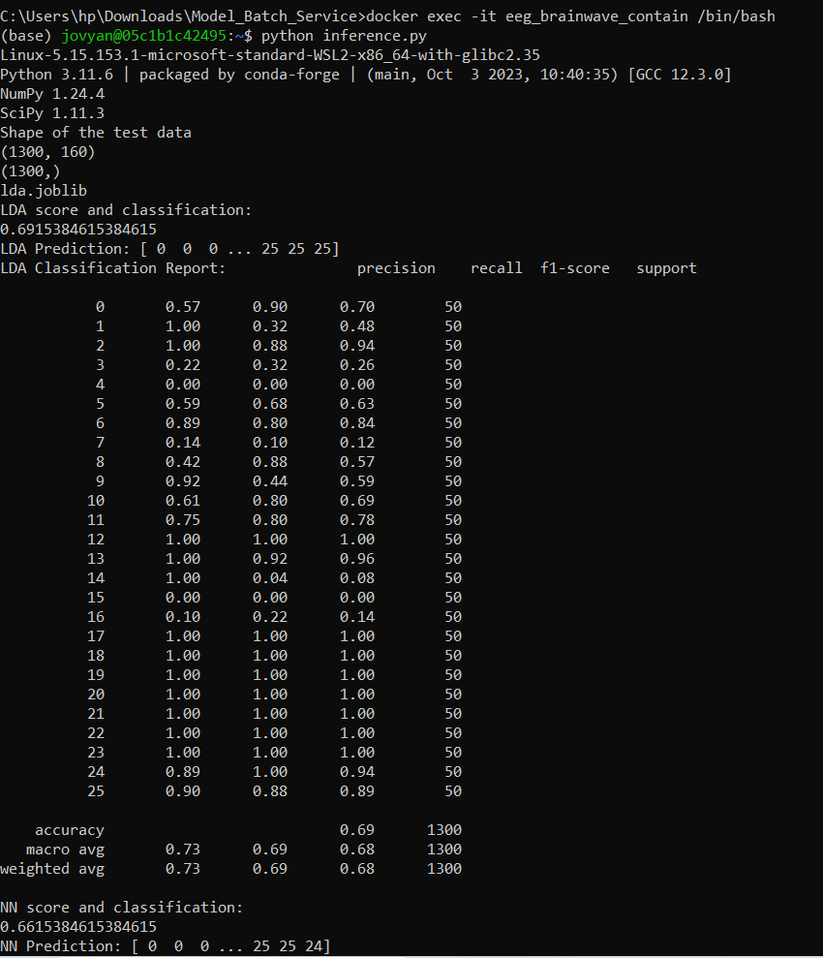

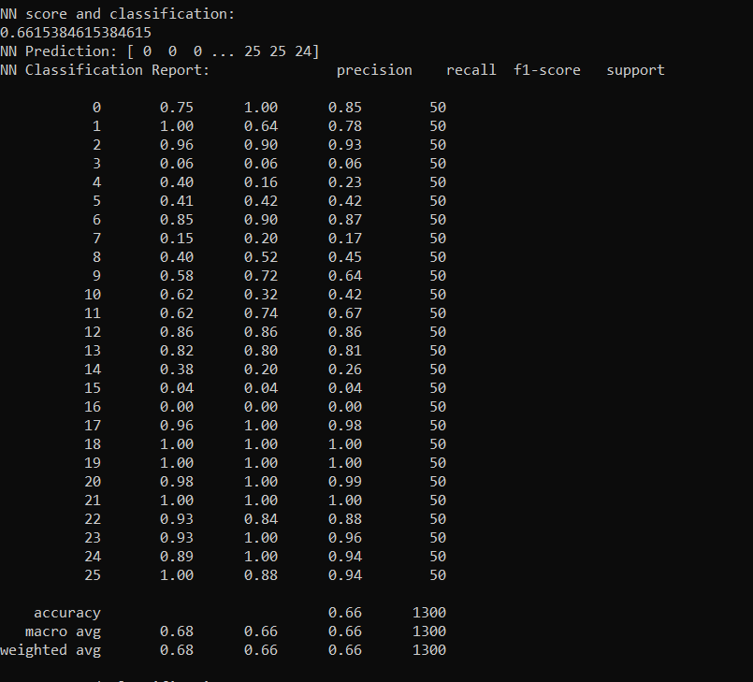

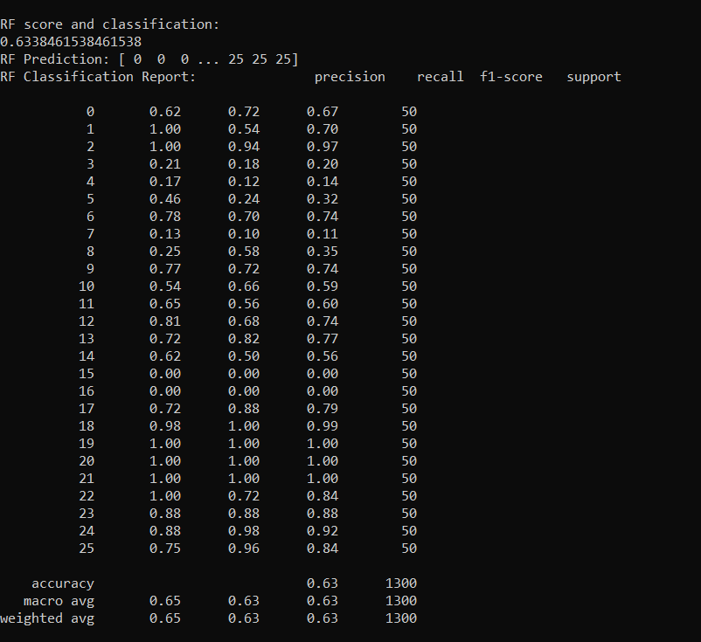

1. Models saved inside container:

