**What is Recursion?**

The process in which a function calls itself directly or indirectly is called recursion and the corresponding function is called as recursive function. Using recursive algorithm, certain problems can be solved quite easily. Examples of such problems are [Towers of Hanoi (TOH)](http://quiz.geeksforgeeks.org/c-program-for-tower-of-hanoi/), [Inorder/Preorder/Postorder Tree Traversals](https://www.cdn.geeksforgeeks.org/tree-traversals-inorder-preorder-and-postorder/), [DFS of Graph](https://www.cdn.geeksforgeeks.org/depth-first-traversal-for-a-graph/), etc.  
  
 **What is base condition in recursion?**

In recursive program, the solution to base case is provided and solution of bigger problem is expressed in terms of smaller problems.

int fact(int n)  
{  
 if (n < = 1) // base case  
 return 1;  
 else   
 return n*fact(n-1);   
}

In the above example, base case for n < = 1 is defined and larger value of number can be solved by converting to smaller one till base case is reached.

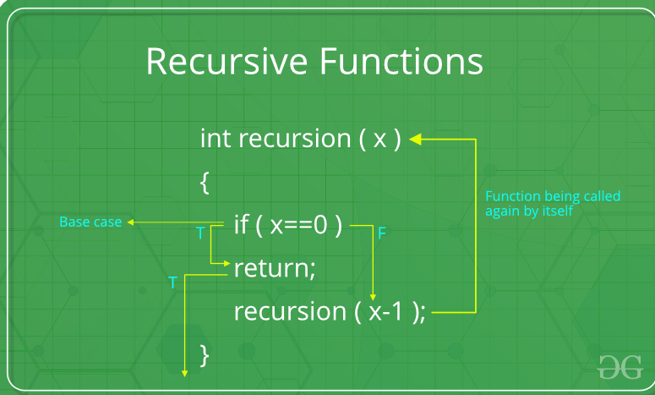  
 **How a particular problem is solved using recursion?**

The idea is represent a problem in terms of one or more smaller problems, and add one or more base conditions that stop recursion. For example, we compute factorial n if we know factorial of (n-1). Base case for factorial would be n = 0. We return 1 when n = 0.   
  
 **Why Stack Overflow error occurs in recursion?**

If base case is not reached or not defined, then stack overflow problem may arise. Let us take an example to understand this.

int fact(int n)  
{  
 // wrong base case (it may cause  
 // stack overflow).  
 if (n == 100)   
 return 1;  
  
 else  
 return n*fact(n-1);  
}

If fact(10) is called, it will call fact(9), fact(8), fact(7) and so on but number will never reach 100. So, the base case is not reached. If the memory is exhausted by these functions on stack, it will cause stack overflow error.   
  
 **How memory is allocated to different function calls in recursion?**

When any function is called from main(), the memory is allocated to it on stack. A recursive function calls itself, the memory for called function is allocated on top of memory allocated to calling function and different copy of local variables is created for each function call. When the base case is reached, the function returns its value to the function by whom it is called and memory is de-allocated and the process continues.  
  
Let us take the example how recursion works by taking a simple function:

void printFun(int test)  
{  
 if (test < 1)  
 return;  
 else  
 {  
 print test;  
 printFun(test-1); // statement 2  
 print test;  
 return;  
 }  
}  
  
// Calling function printFun()  
int test = 3;  
printFun(test);

**Output** : 

3 2 1 1 2 3

When **printFun(3)** is called from main(), memory is allocated to **printFun(3)** and a local variable test is initialized to 3 and statement 1 to 4 are pushed on the stack as shown in below diagram. It first prints ‘3’. In statement 2, **printFun(2)** is called and memory is allocated to **printFun(2)** and a local variable test is initialized to 2 and statement 1 to 4 are pushed in the stack. Similarly, **printFun(2)** calls **printFun(1)** and **printFun(1)** calls **printFun(0)**. **printFun(0)** goes to if statement and it return to **printFun(1)**. Remaining statements of **printFun(1)**are executed and it returns to **printFun(2)** and so on. In the output, value from 3 to 1 are printed and then 1 to 3 are printed. The memory stack has been shown in below diagram.  
  
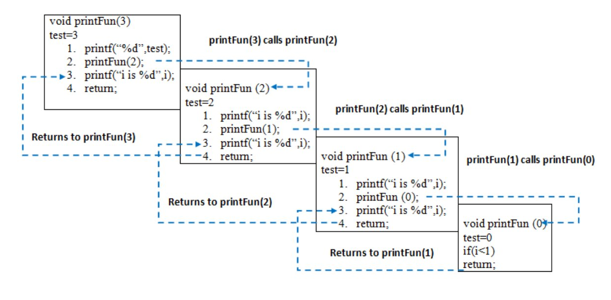**Disadvantage of Recursion**: Note that both recursive and iterative programs have same problem solving powers, i.e., every recursive program can be written iteratively and vice versa is also true. Recursive program has greater space requirements than iterative program as all functions will remain in stack until base case is reached. It also has greater time requirements because of function calls and return overhead.  
  
**Advantages of Recursion**: Recursion provides a clean and simple way to write code. Some problems are inherently recursive like tree traversals, Tower of Hanoi, etc. For such problems it is preferred to write recursive code. We can write such codes also iteratively with the help of stack data structure.

**Tail recursion is important because it can be implemented more efficiently than general recursion. When we make a normal recursive call, we have to push the return address onto the call stack then jump to the called function. This means that we need a call stack whose size is linear in the depth of the recursive calls. When we have tail recursion we know that as soon as we return from the recursive call we're going to immediately return as well, so we can skip the entire chain of recursive functions returning and return straight to the original caller. That means we don't need a call stack at all for all of the recursive calls, and can implement the final call as a simple jump, which saves us space.**