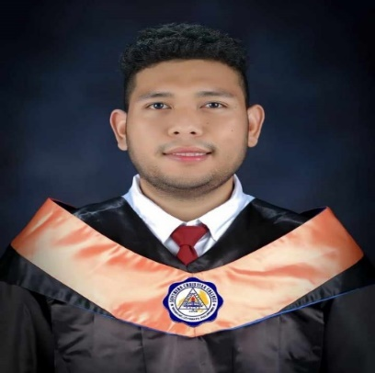

**JAMES GONZALES CABORNAY**

I am a fresh graduate of BS in Information Technology with good academic applying for position where I can use my knowledge and experience to ensure the delivery of all task and activities related to the job.

**Experience**

Feb 2023 – May 2023

**On the Job Training:**

**Assistant/Encoder**

HR Department**-Southern Christian College**

Pob.5, Midsayap, North Cotabato, 9410

**Seminars and Trainings**

**Job Basic Entry Skills Seminar**

Midsayap, Cotabato

**10th Philippine Society of Information Technology for Students Regional Convention 2020**

General Santos City

**11th Philippine Society of Information Technology for Students Regional Convention 2023**

General Santos City

**Reference**

**Please contact the following:**

**April Joy Estalilla**

Liquidation Clerk

09489225251

**Contact**

**Phone number:**

09500264092

**Email:**

[bonbongonzales16@gmail.com](mailto:bonbongonzales16@gmail.com)

**Address:**

Poblacion 8, Purok Orchids, Midsayap, North Cotabato

**Education**

2019-2023

**Bachelor of Science in Information Technology**

**Skills**

* Fast Learner
* Ability to Multitask
* Time Management
* Microsoft Office (Word, PowerPoint, Excel)
* Basic troubleshooting and networking
* Coding