Ex. No. : 03 Date: 23/02/2026
Register No.: 231701008 Name: BHOOBANRAJ KR

Wire framing and Prototyping with Figma

Aim
To design and develop low-fidelity wireframes and interactive prototypes using Figma, in order to visualize user interface structure, user flow, and overall application design before final development.

Procedure:
The app is a smart digital platform for eco-cultural tourism in Jharkhand, featuring a web app frontend with chatbot, AR/VR previews, AI assistance, and marketplace. Here's a short procedure outlining the core tourist UI flow based on the prototype description.​
Hobby App UI Flow
• Launch the app to explore different hobbies such as cycling, cooking, reading, etc., displayed with engaging visual cards and progress indicators.
• Select a hobby category from the home screen or navigation tabs to view detailed activity pages with descriptions, benefits, and visual previews.
• Track progress interactively using sliders and indicators that show efficiency, duration, and completion status for each hobby task.
• View personalized activity suggestions within each hobby, including recommended tasks, difficulty levels, and estimated time to complete.
• Update task status (e.g., completed, pending, in progress) to maintain a structured routine and monitor improvement over time.
• Analyze performance insights through visual progress bars and summaries that help users understand consistency and growth in each hobby.
• Switch between hobbies seamlessly using category tabs to maintain engagement across multiple interests in one platform.
• Receive motivation and guidance through structured content blocks that highlight benefits and encourage regular participation.

Output
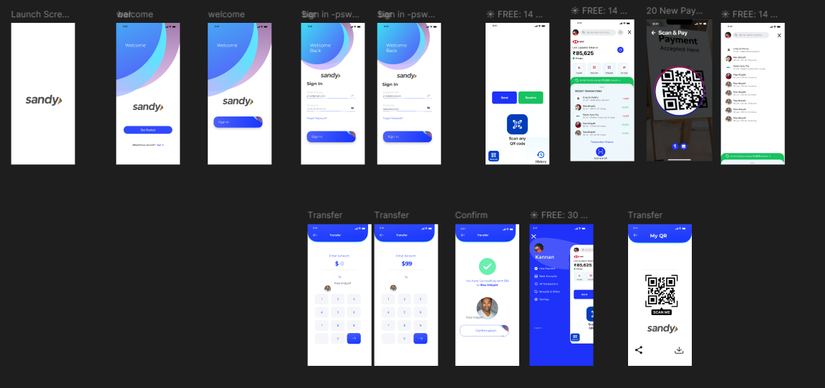

Result:
Hence the experiment is completed and the output is verified..

