**gamestore**

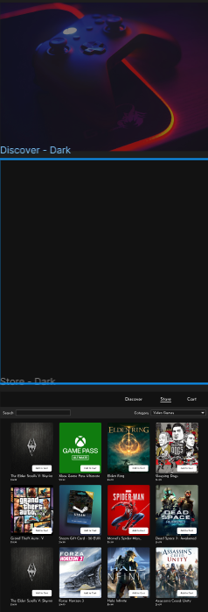

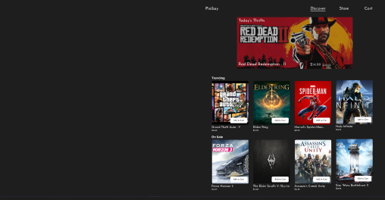



**Aim:**   
To create a simple game store app that allows users to browse, purchase, and download video games directly to their devices.

**Procedure:**

1. **Identify Key Features:**
   * Game browsing by genre, ratings, or popularity.
   * Game purchasing and downloading.
   * User accounts for tracking purchases.
   * Payment gateway integration.
   * Wishlist and recommendations based on user preferences.
2. **Design UI/UX:**
   * Create a clean, intuitive interface with easy navigation (e.g., Home, Categories, Cart, Profile).
   * Include visuals like game screenshots, trailers, and ratings.
3. **Choose Development Tools:**
   * For iOS: Use Swift and integrate with the App Store API.
   * For Android: Use Kotlin and Google Play Services for purchasing integration.
4. **Set Up Backend:**
   * Set up a backend server (e.g., using Firebase or AWS) to handle user accounts, game information, and purchase data.
5. **Develop the App:**
   * Implement game browsing, search functionality, and shopping cart.
   * Integrate secure payment methods (like Stripe or PayPal).
6. **Testing:**
   * Test for bugs, in-app purchases, and compatibility with different devices.
7. **Launch:**
   * Deploy the app on the app stores after final testing and optimization.

**Result:**   
A functional game store app that allows users to browse, purchase, and download games seamlessly, with secure payment processing and a personalized experience.

4o mini