Technology for Business Intelligent

(COMP11013) - 202122 T2

Coursework 2 – (B00733638)

By Bhoomi Sharma

Submitted on 22nd April 2022

1. **Screenshot Of data source Screen**

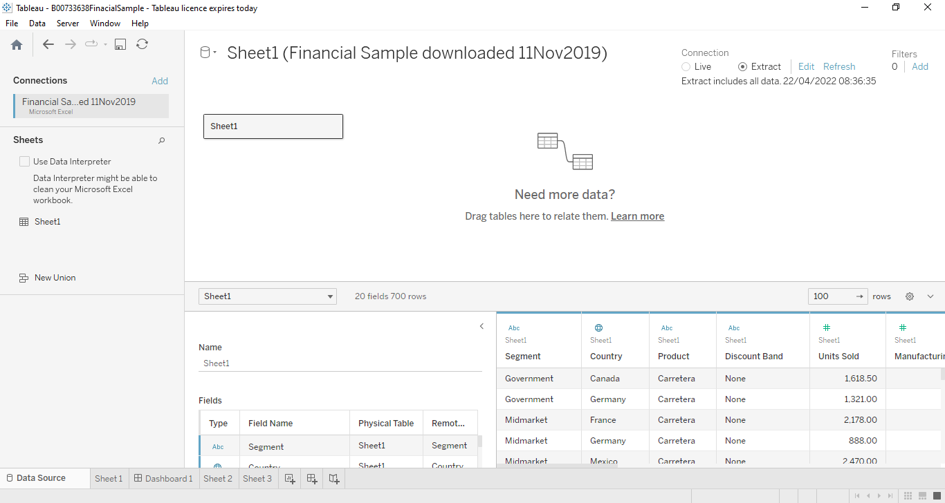

1. **The sheets in the Tableau workbook:**

|  |  |  |  |  |
| --- | --- | --- | --- | --- |
| **Sheet Name** | **Chart Type** | **Dimensions used** | **Measures looked at or used** | **What is being explored** |
| Product By Selection | Stacked bar chart | Product, Year | Then Product Also Contains (calculated field) | To show which product sold when the user selects the product by year wise |
| Sales per Month (Discount band) | Scatter plots | Month, Discount Band | Sales, cogs | The average of cogs ration is highest in the month of November |
| Country by date(segment) | Area Chart | Date, Segment | Country, Gross Sales | The average of Government segment sold highest in Canada and Gross Sales reached at 628,080. |

**Sheet 1:**

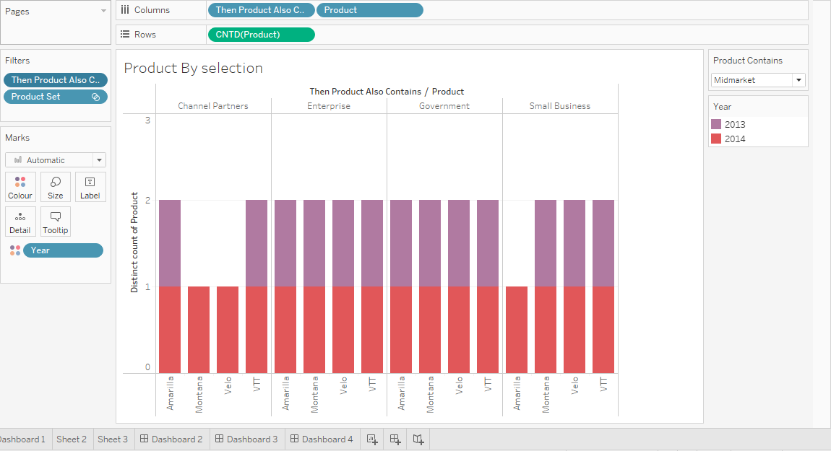

**Sheet 2:**

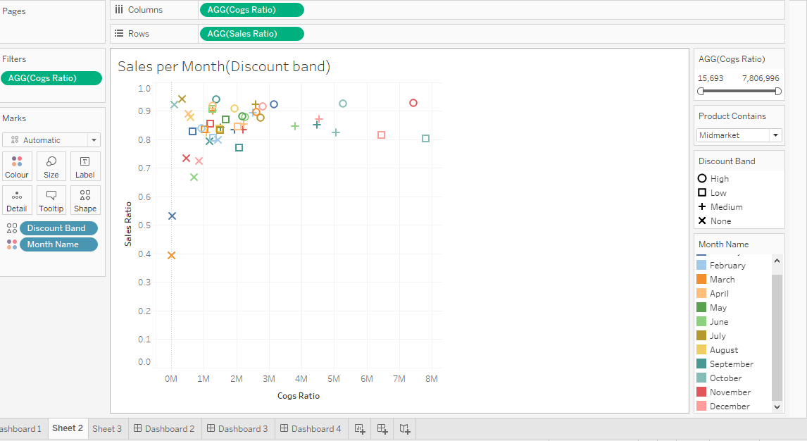

**Sheet 3:**

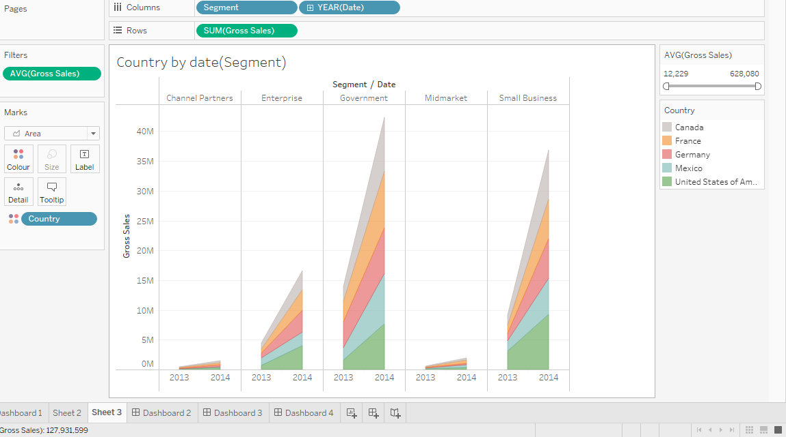

**Dashboards Screenshots including three sheets:**

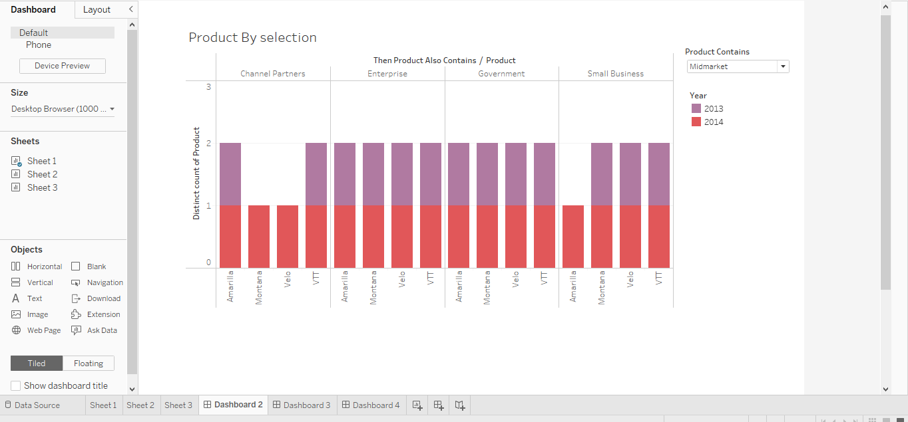

This Chart is belongs to product by selection and includes products and year. Additionally this chart has one calculation field in that I define which product is sold in a year when user can select any product. This is bar chart and using this bar chart analyse that which product sold in which year. Add to this, I also add colour filter in year section that it is easily recognise the year.

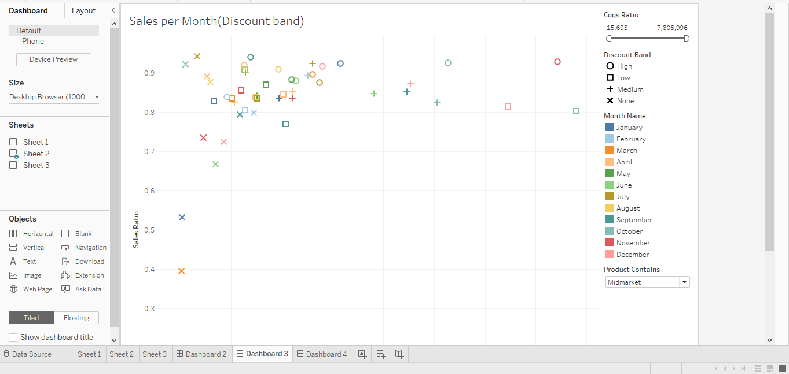

This chart belongs to sales per month (discount band) in which it’s define that average of sales and discount band per month. In this I used scatter plots chart to define this using colour specification. Initially, I add month in colour as it is easily identified that in which month average of sales and discount band at highest point and at lowest point.

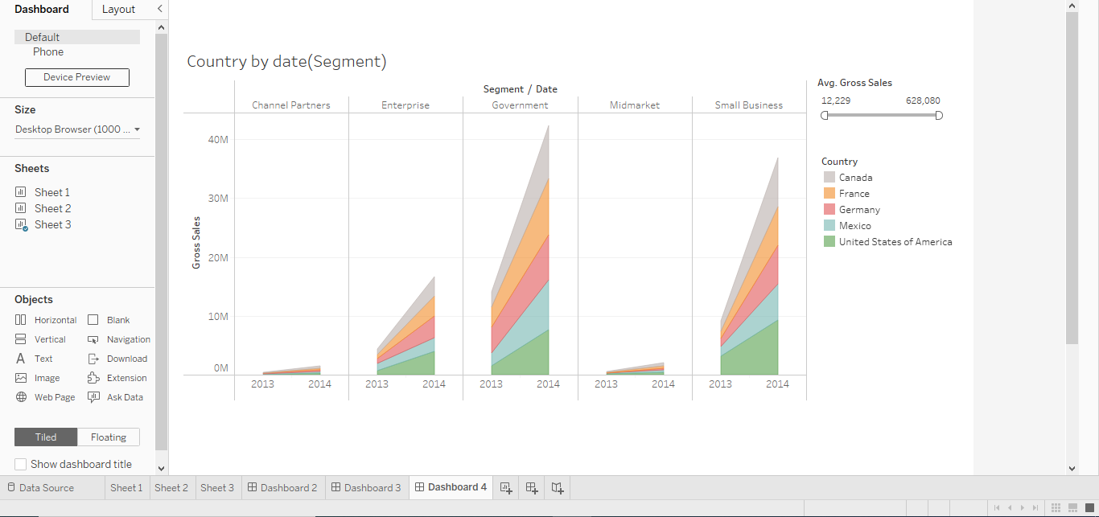

This is area-based chart and in that I take country, date and segment and also gross sales. It’s defining that in which country and which date the average of goss sales reached at high level. I add colour in a country and average gross sale is about 628,080.

1. **Datamining task using create parameter, calculation, and set field.**

First create parameter: Parameter name is Product Contains.

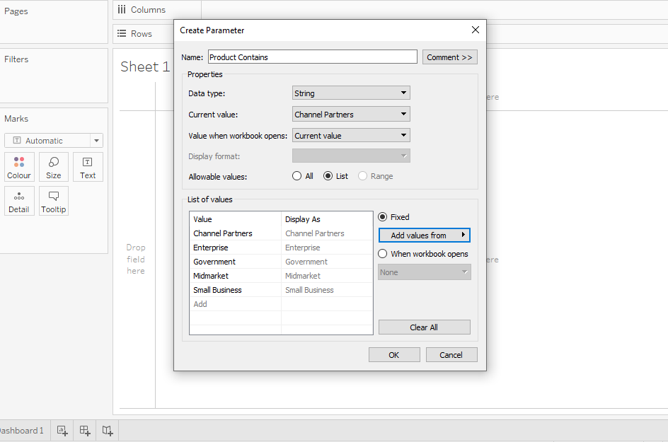

In this choose analysis and select create parameter and give name of parameter. After that set datatype and then select list. Then select segment sub category.

Second create Calculations filed

First calculated filed

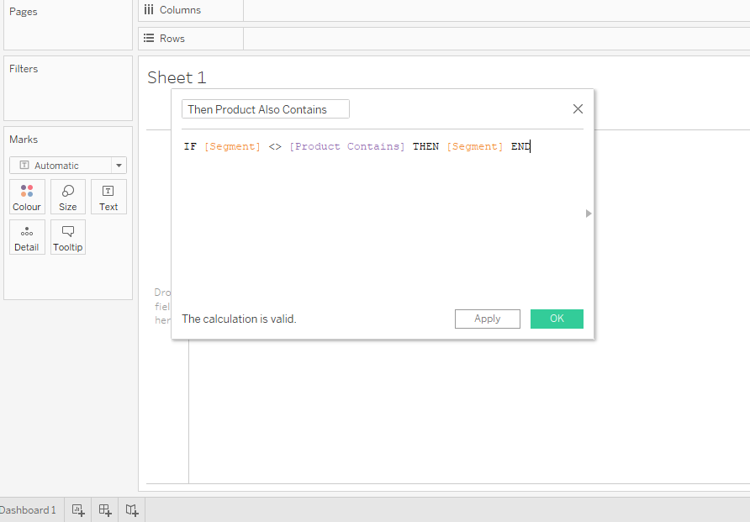

Second calculated field.

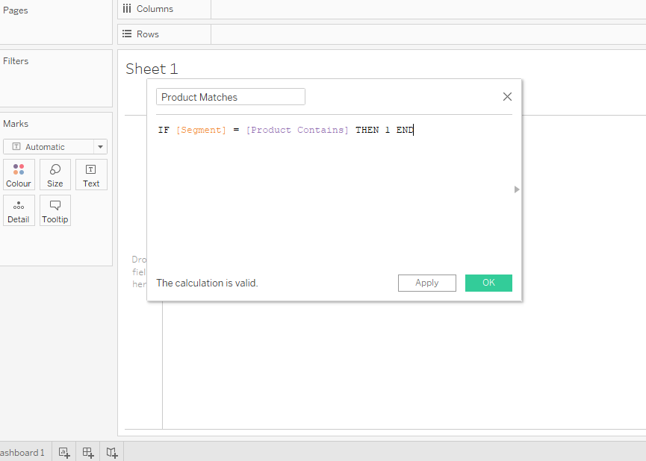

Third create set on Segment

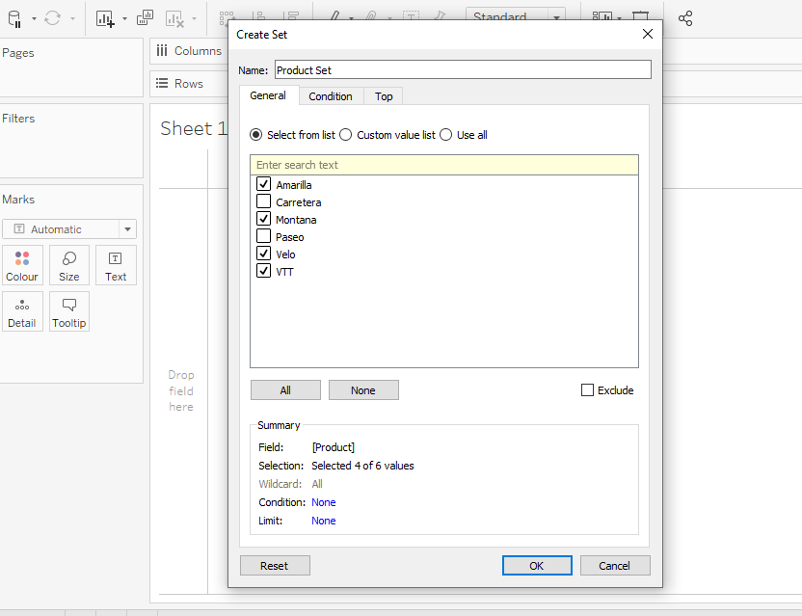

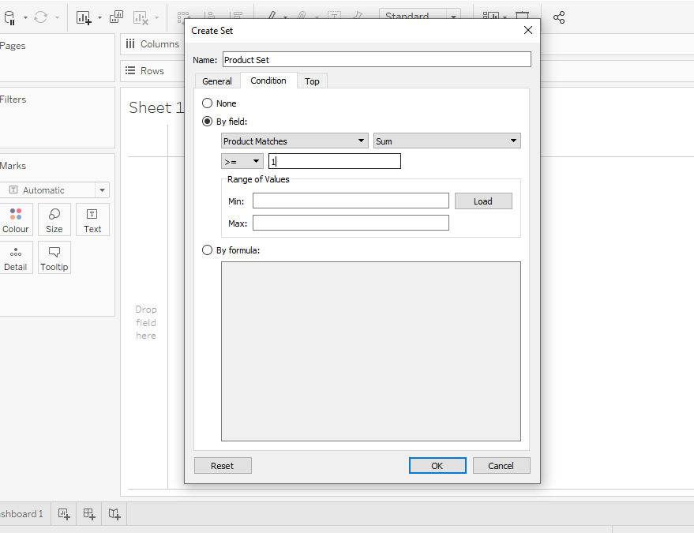

After lastly create the view:

Initially, first drag and drop calculated field is Then product Also Contains in the column and product also. After that add set field in filter section and generate bar chart.



It is very helpful to user as they can easily analyse which segment is sold in which year using datamining task anyone can easily analyse the chart. This chart shows segment and product by year. In this user can select segment and see tin which year product sold at highest level.

1. **Individual Appraisal:**

Technologies for Business Intelligent subject is the best subject to learn create and store data in database. Initially, from this subject I learnt create, insert, delete, update data in database using SQL server. Moreover, this subject learns data ware house, data mining as well as star and snowflakes schema.

BI subject is mostly based on business analytics and it is the key that unlock the value that can extract data. To create and cost-effective analytics strategy to get result. From this subject I learnt database management system to store data in a one database.

Furthermore, business intelligent is set of processes, architectures, and technologies that convert big data or raw data in to meaningful information. BI tools also learn how to create charts, maps, dashboard, graphs, reports, summaries to provide user with detailed information about the business. In this subject I also learnt how important this business intelligent, what types of tools are used as well as advantages and disadvantages of this subject.

However, this subject not as easy as that as there are more tools and business practice are include to create data mining, data ware housing and schemas. Additionally, in this I also learnt data models such as, structure of data, constraints on data, operations allowed to performed data. Data models includes data entity relationship and extend entity relationship. Owing to this it is easy to store data, files, records in database.

On the top of that, this subject is very fruitful when customize the view using tools. The specific thing is that BI is the one type of umbrella that covers the processes and methods of collecting, storing, and analyse data from business practice. Data mining is the way that store large into small through machine learning. A few things that business intelligent very useful in many companies.

* Identify to increase business profit
* Analyse user behaviour
* Track performance
* Optimise operation
* Predict success
* Spot market trends
* Discover issues and problems

Moreover, I learnt Tableau desktop software to store files and create charts to analyse data information. Using this desktop easily do data mining task like create parameter, calculations, sets etc. It is very useful when get some particular data like sums of price, discounts, number of products and orders and so on. Using Tableau desktop anyone can create different types of charts and get some meaningful information.

On the other hand, on the technical side, raw data is collected from the company or business. Data is processed and then stored in the data warehouse and generate schemas. Once the data is stored then users can access data, start the analysis to answer business questions. It can help organization to run smoothly and efficiently. Additionally, I learnt SQL queries that is very useful to mange database and tables and get some data from one table to another table.

There are bunch of SQL queries available to create, delete tables as well as generate star and snowflakes schemas. Using schemas user can learn how it works like it store more tables and connected one table to more table as extract data using join, cube, dicing, slicing queries. It’s including data warehousing and data mart. Because of these two many businesses reduce complexities associated with data. Data marts allow users to build and achieve for a specific group of users. Data mart is the way that anyone can create more tables and stored data in tables.

I also learnt OLAP queries to store data using data ware housing. OLAP is one type of tools that optimize the storing and querying of large volumes of multi-dimensional that is aggregated to various levels of detail to support analysis of data.