**DBMS - MINI PROJECT**

**BLOOD BANK MANAGEMENT SYSTEM**

**Submitted By:-Bhoomika**

**Name:-Bhoomika**

**SRN:-PES1UG20CS633**

**V Semester**

**Section K**

**ABSTRACT**

**Blood Bank Management System:-**

Blood Bank Management System (BBMS) is a browser based system that is designed to store, process, retrieve and analyze information concerned with the administrative and inventory management within a blood bank. This project aims at maintaining all the information pertaining to blood donors, different blood groups available in each blood bank and help them manage in a better way. The donors who are interested in donating blood has to register in the database. Details of the hospital who requests for the blood from particular blood bank is also stored.

**ER DIAGRAM**

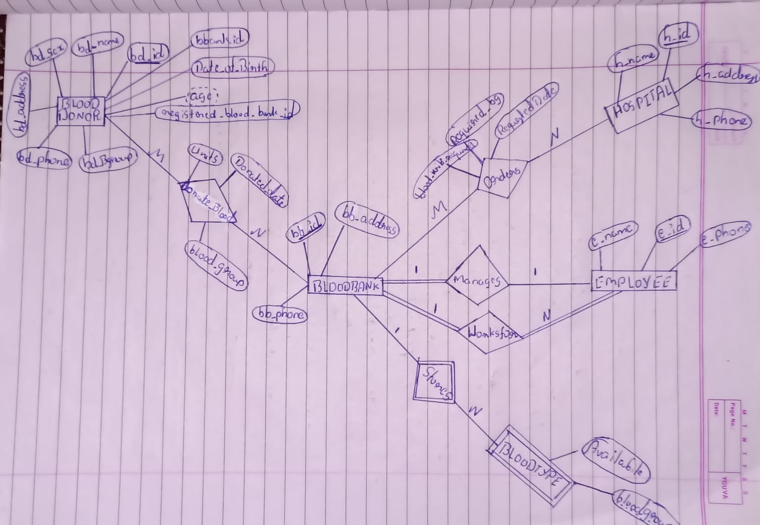

**RELATIONAL SCHEMA**

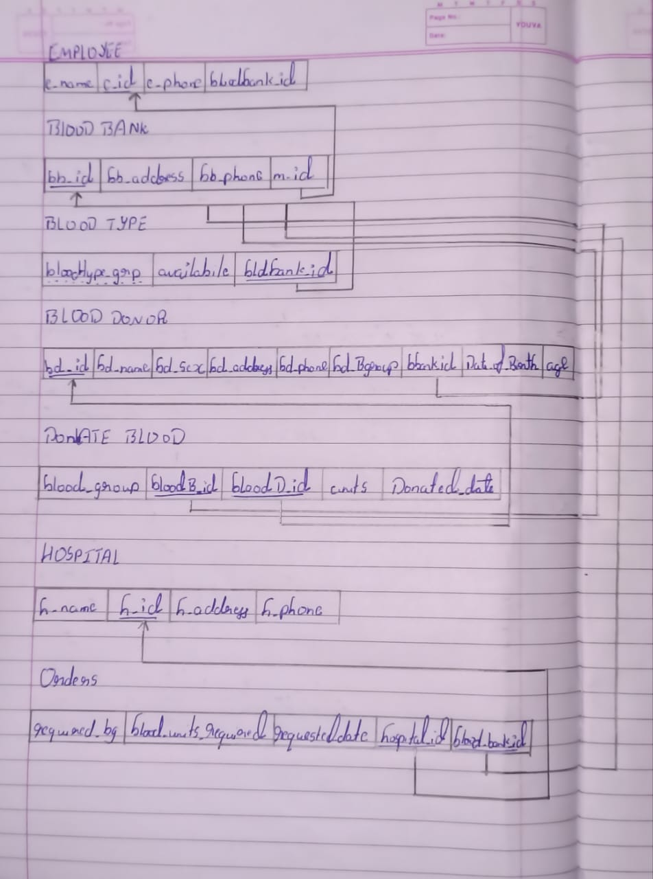

**DDL STATEMENTS – BUILDING THE DATABASE**

**EMPLOYEE:-**

create TABLE EMPLOYEE(e_name varchar(15) NOT NULL,e_id char(9) NOT NULL,e_phone char(15),bloodbank_id char(10) NOT NULL,

PRIMARY KEY(e_id));

**BLOOD BANK:-**

CREATE TABLE BLOOD_BANK(bb_id char(10) NOT NULL,bb_address varchar(20),bb_phone varchar(20),

m_id char(9) NOT NULL,PRIMARY KEY(bb_id));

ALTER TABLE BLOOD_BANK add constraint blood_bank FOREIGN KEY(m_id) REFERENCES EMPLOYEE(e_id) ON DELETE CASCADE;

**BLOOD TYPE:-**

CREATE TABLE BLOOD_TYPE(bloodtype_grp varchar(10) DEFAULT NULL,availabile varchar(10),bldbank_id char(10) NOT NULL,

PRIMARY KEY(bloodtype_grp,bldbank_id));

ALTER TABLE BLOOD_TYPE add constraint blood_type FOREIGN KEY(bldbank_id) REFERENCES BLOOD_BANK(bb_id) ON DELETE CASCADE;

**BLOOD DONOR:-**

CREATE TABLE BLOOD_DONOR(bd_id char(10) NOT NULL,bd_name varchar(15) NOT NULL,

bd_sex varchar(15) NOT NULL,bd_address varchar(20),bd_phone varchar(20),

bd_Bgroup varchar(10) NOT NULL,registered_blood_bank_id char(15),Date_of_birth date,age char(10) DEFAULT NULL,PRIMARY KEY(bd_id));

**DONATE BLOOD :-**

CREATE TABLE DONATE_BLOOD(blood_group varchar(10) NOT NULL,bloodB_id char(10) NOT NULL,

bloodD_id char(10) NOT NULL,units int,Donated_date date,PRIMARY KEY(bloodB_id,bloodD_id,Donated_date));

ALTER TABLE DONATE_BLOOD add constraint donate_bloodfk1 FOREIGN KEY(bloodB_id) REFERENCES BLOOD_BANK(bb_id) ON DELETE CASCADE;

ALTER TABLE DONATE_BLOOD add constraint donate_bloodfk2 FOREIGN KEY(bloodD_id) REFERENCES BLOOD_DONOR(bd_id) ON DELETE CASCADE;

**HOSPITAL:-**

CREATE TABLE HOSPITAL(h_name varchar(15) NOT NULL,h_id char(9) NOT NULL,h_address varchar(20),h_phone varchar(20),PRIMARY KEY(h_id));

**ORDERS:-**

CREATE TABLE ORDERS(required_bg varchar(10),blood_units_required int,requested_date date NOT NULL,hospital_id char(9) NOT NULL,

blood_bank_id char(10) NOT NULL,PRIMARY KEY(hospital_id,blood_bank_id,requested_date));

ALTER TABLE ORDERS add constraint ordersfk1 FOREIGN KEY(hospital_id) REFERENCES HOSPITAL(h_id) ON DELETE CASCADE;

ALTER TABLE ORDERS add constraint ordersfk2 FOREIGN KEY(blood_bank_id) REFERENCES BLOOD_BANK(bb_id) ON DELETE CASCADE;

**POPULATING THE DATABASE**

**EMPLOYEE:-**

INSERT into EMPLOYEE VALUES('john','100','9845671234','B01'),('james','101','9842221234','B01'),

('Ram','102','9845871224','B01'),('Roopa','103','6665671234','B01'),

('Shree','104','7845671234','B01'),('Sana','105','9845671234','B01'),

('Reena','200','9845551234','B02'),('Sheela','201','9888671234','B02'),

('Hima','202','9191677774','B02'),('Tom','203','8181677774','B02'),

('Lewis','204','9845672724','B02'),('Lara','205','9845667674','B02'),

('Droupadi','300','9977671234','B03'),('Rahul','301','9845674444','B03'),

('Anshu','302','9846666234','B03'),('Ans','303','9846661134','B03'),

('Rack','304','7161661134','B03'),('Jack','305','8886661134','B03'),

('David','306','7746661134','B03');

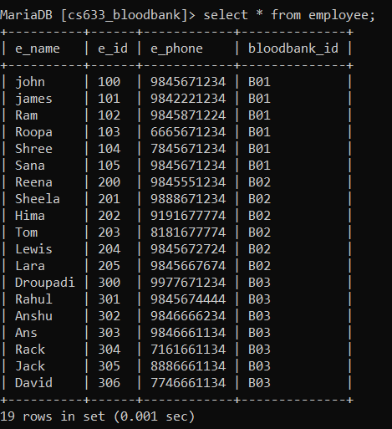

**BLOOD BANK:-**

INSERT into BLOOD_BANK VALUES('B01','Girinagar','9345671230','101'),

('B02','Jayanagar','9345675656','202'),('B03','RT Nagar','9131315230','300');

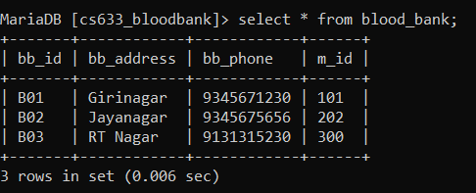

**BLOOD TYPE:-**

INSERT into BLOOD_TYPE VALUES('A+ve','yes','B01'),

('B+ve','yes','B01'),

('AB+ve','no','B01'),

('A-ve','no','B01'),

('B-ve','no','B01'),

('AB-ve','yes','B01'),

('O+ve','yes','B01'),

('O-ve','yes','B01'),

('A+ve','no','B02'),

('B+ve','yes','B02'),

('AB+ve','yes','B02'),

('A-ve','no','B02'),

('AB-ve','yes','B02'),

('O+ve','yes','B02'),

('O-ve','no','B02'),

('A+ve','no','B03'),

('B+ve','yes','B03'),

('AB+ve','no','B03'),

('A-ve','yes','B03'),

('AB-ve','yes','B03'),

('O+ve','no','B03'),

('O-ve','yes','B03');

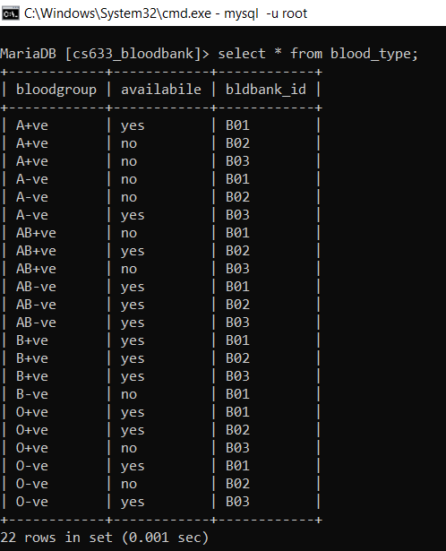

**BLOOD DONOR:-**

INSERT into BLOOD_DONOR VALUES('BD1','Robert','M','Jayanagar','9886712333','A+ve','B01','1989-04-14',NULL),

('BD2','David','M','JP Nagar','9886713333','AB+ve','B03','1989-03-12',NULL),

('BD3','John','M','Grinagar','9886712332','B+ve','B02','1980-04-14',NULL),

('BD4','Ajit Ullal','M','High Street','9896712333','B-ve','B01','2004-01-01',NULL),

('BD5','Suma S','F','Jp Nagar','9886712344','A-ve','B03','1970-02-14',NULL),

('BD6','Samanta','F','Girinagar','9886712367','B+ve','B02','1960-05-31',NULL),

('BD7','Ansh','F','JC Road','9990712333','O+ve','B03','1999-02-27',NULL),

('BD8','Roopa','F','M G Road','8886712333','O-ve','B01','1996-12-10',NULL),

('BD9','Virat','M','Pink Street','9886712322','AB-ve','B02','2002-01-01',NULL),

('BD10','Subbu','M','Jayanagar','9877712333','A+ve','B01','1990-09-20',NULL),

('BD11','Udupa','F','Anna Sali','9886712424','B+ve','B02','2000-11-07',NULL),

('BD12','Rish','M','KSR Road','6666712333','O+ve','B01','1991-05-15',NULL),

('BD13','Arun','M','Clone Colony','6565712333','AB+ve','B02','2002-12-10',NULL),

('BD14','Margaret','F','Mirza Road','9886111333','B+ve','B03','1979-08-15',NULL),

('BD15','Irani','F','T Nagar','9886712111','O+ve','B02','1997-01-31',NULL);

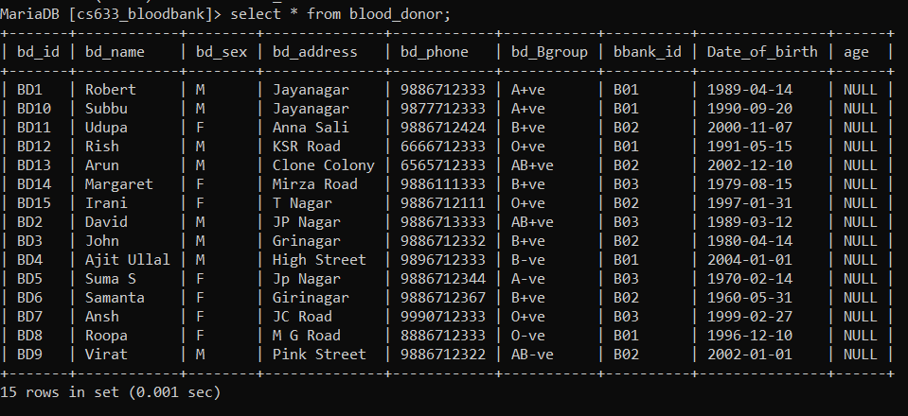

**DONATE BLOOD:-**

INSERT into DONATE_BLOOD VALUES('AB+ve','B03','BD2','10','2019-01-10'),

('B+ve','B02','BD3','15','2022-10-01'),

('AB-ve','B02','BD9','5','2022-10-01'),

('A+ve','B01','BD10','10','2019-01-10'),

('O+ve','B01','BD12','20','2022-12-22'),

('AB-ve','B02','BD9','10','2021-11-30'),

('O+ve','B02','BD15','10','2020-04-16'),

('A-ve','B03','BD5','15','2022-12-20'),

('O+ve','B03','BD7','12','2021-07-30'),

('AB-ve','B03','BD9','13','2021-11-16'),

('AB+ve','B03','BD2','15','2022-01-20'),

('O+ve','B01','BD12','10','2020-10-02'),

('B+ve','B01','BD3','10','2019-01-20');

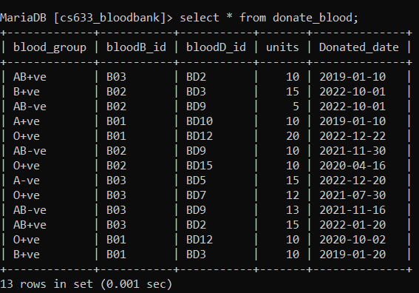

**HOSPITAL:-**

INSERT into HOSPITAL VALUES('Mayoclinic','H01','Jayanagar','9222333558'),

('Alexa','H02','JP Nagara','9333555777'),

('Siri','H03','Girinagar','93335557722'),

('ValueView','H04','Street Road','9311555777'),

('MothersPalace','H05','M G Road','9111555777'),

('UnityClinics','H06','RR Nagar','9333555444');

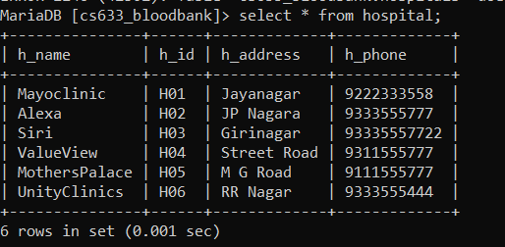

**ORDERS:-**

INSERT into ORDERS VALUES('A+ve','10','2019-01-10','H01','B02'),

('A+ve','10','2022-10-01','H01','B03'),

('AB+ve','5','2021-11-16','H02','B01'),

('B+ve','10','2020-10-02','H03','B02'),

('O+ve','10','2021-11-16','H05','B03');

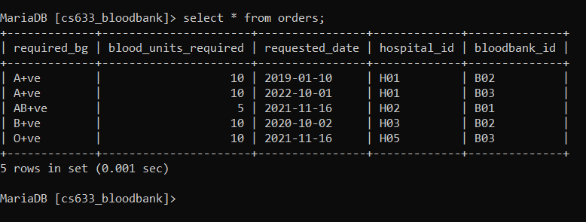

**TOOL USED:-**

**Streamlit**

**QUERIES**

**REGULAR JOIN**

**NATURAL JOIN**

**1. Retrive details if required blood by hospital is available in blood bank which it requested.**

select * from orders NATURAL JOIN BLOOD_TYPE where availabile='yes' and required_bg=bloodgroup and bloodbank_id=bldbank_id;

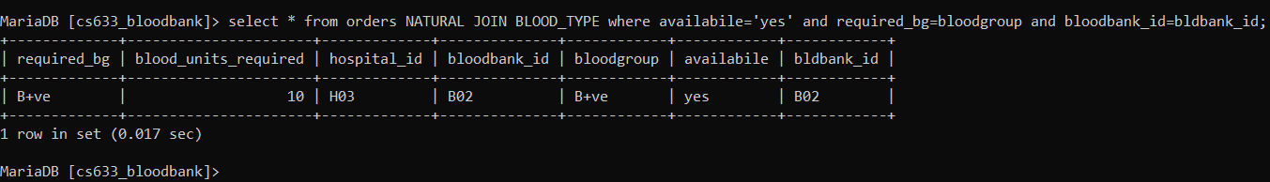

**INNER JOIN**

**1. Retrive details of all donor who donated bloodgroup O+ve.**

Select bd_name,bd_address,bd_id,bd_Bgroup,bloodB_id,Donated_date from BLOOD_DONOR JOIN DONATE_BLOOD ON BLOOD_DONOR.bd_id=DONATE_BLOOD.bloodD_id and DONATE_BLOOD.blood_group='O+ve';

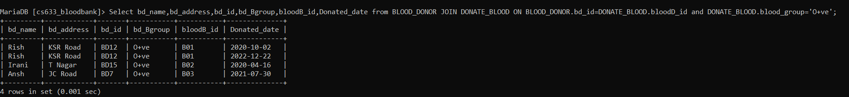

**2. Retrive details of the blood donor who donated on particular date(2022-01-20)**

select bd_name,bd_address,bd_id from BLOOD_DONOR JOIN DONATE_BLOOD ON BLOOD_DONOR.bd_id=DONATE_BLOOD.bloodD_id where DONATE_BLOOD.Donated_date='2022-01-20';

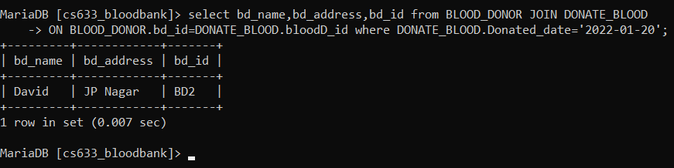

**CORRELATED QUERIES**

**1. Update age attribute in blood donor**

UPDATE blood_donor SET Age=DATE_FORMAT(FROM_DAYS(DATEDIFF(now(),Date_of_birth)),'%Y')+0;



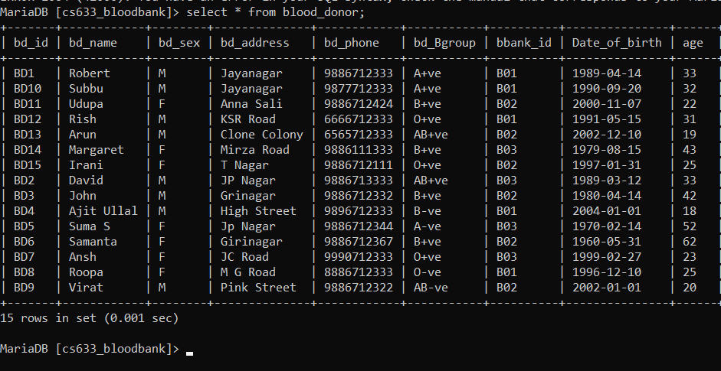

**2. Display the emplyoee id,name and blood bank id that he manages blood bank B02**

select e_id,e_name,bloodbank_id from employee as e where EXISTS( select m_id,bb_id from BLOOD_BANK as b where b.m_id=e.e_id and b.bb_id='B02'); 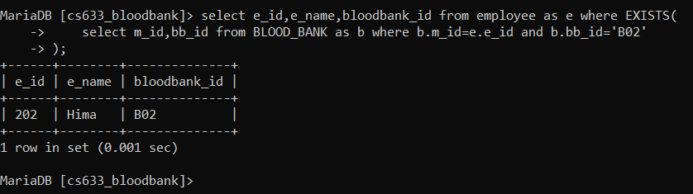

**3. Display the employee id,name and blood bank id of employees  working for bloodbank 'B03' and they are not having manager status.**

select e_id,e_name,bloodbank_id from employee as e where e.bloodbank_id='B03' and  NOT EXISTS( select m_id,bb_id from BLOOD_BANK as b where b.m_id=e.e_id and b.bb_id='B03');

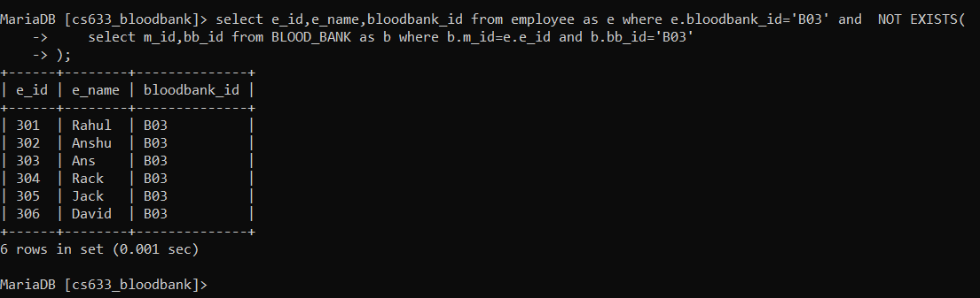

**NESTED QUERIES**

**1. Retrive details of hospital who had not requested the blood bank for blood group**

select h_id,h_name,h_phone from hospital

where h_id NOT IN(select h_id from

hospital JOIN orders ON hospital.h_id=orders.hospital_id);

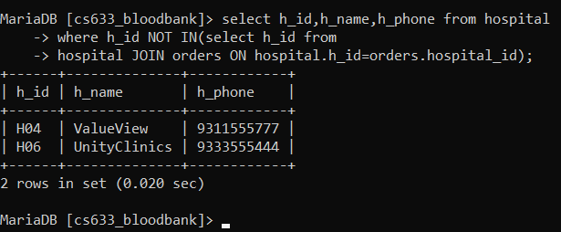

**2. Retrive details of all donor who had not donated blood**

select bd_id,bd_name,bd_phone,bd_Bgroup from BLOOD_DONOR where bd_id NOT IN

(select bd_id from BLOOD_DONOR JOIN DONATE_BLOOD on

BLOOD_DONOR.bd_id=DONATE_BLOOD.bloodD_id);

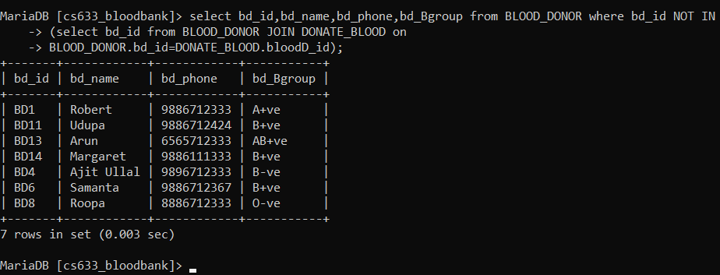

**AGGREGATE FUNCTION**

**1. Display the total units of blood donated by donor with bdid=BD10 to blood bank with bbid=BD01**

select bloodD_id,SUM(units) as Total_units_donated,bloodB_id

from DONATE_BLOOD where DONATE_BLOOD.bloodD_id='BD10' AND DONATE_BLOOD.bloodB_id='B01';

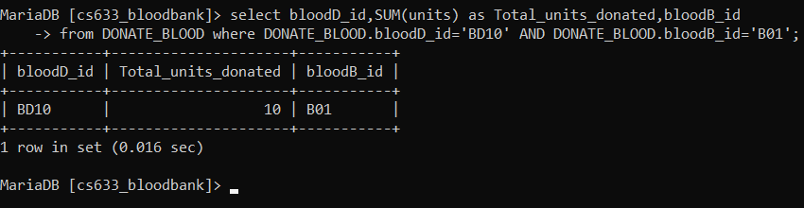

**2. Retrive the number of donors registered to each of the blood bank.**

select COUNT(bd_id),bbank_id from BLOOD_DONOR GROUP BY bbank_id;

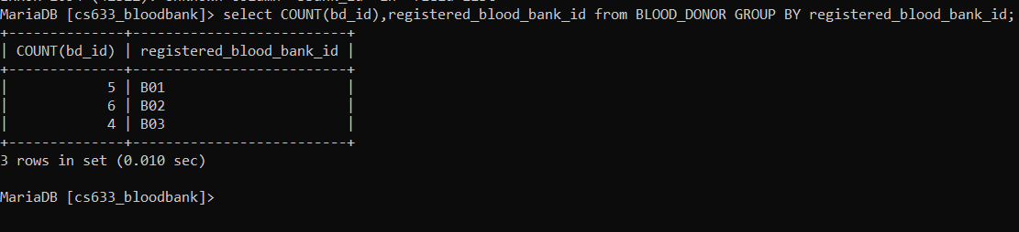

**SET OPERATIONS**

**1. Retrive the manager  of all the blood bank**

select m_id,bb_id from BLOOD_BANK INTERSECT select e_id,bloodbank_id from employee;

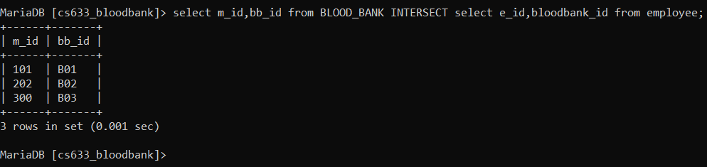

**2. Retrive the all the blood bank and hospital along with its address**

select bb_id,bb_address from BLOOD_BANK UNION select h_id,h_address from hospital;

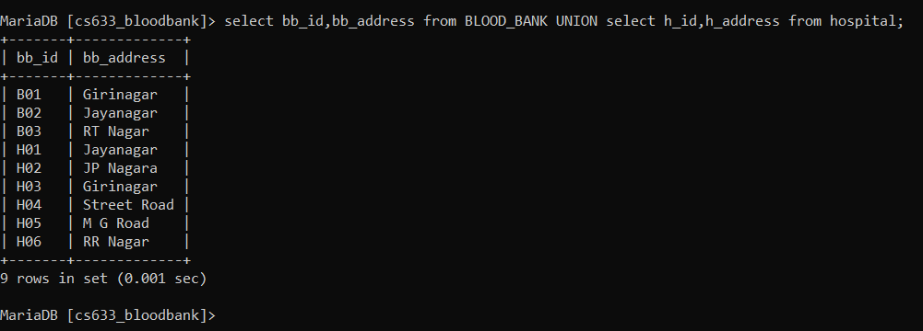

**PROCEDURE**

DELIMITER $$

CREATE procedure update_age ()

BEGIN

DECLARE cur date;

select sysdate() into cur;

update blood_donor

SET age=year(cur)-year(Date_of_birth);

END ; $$

DELIMITER ;

call update_age();

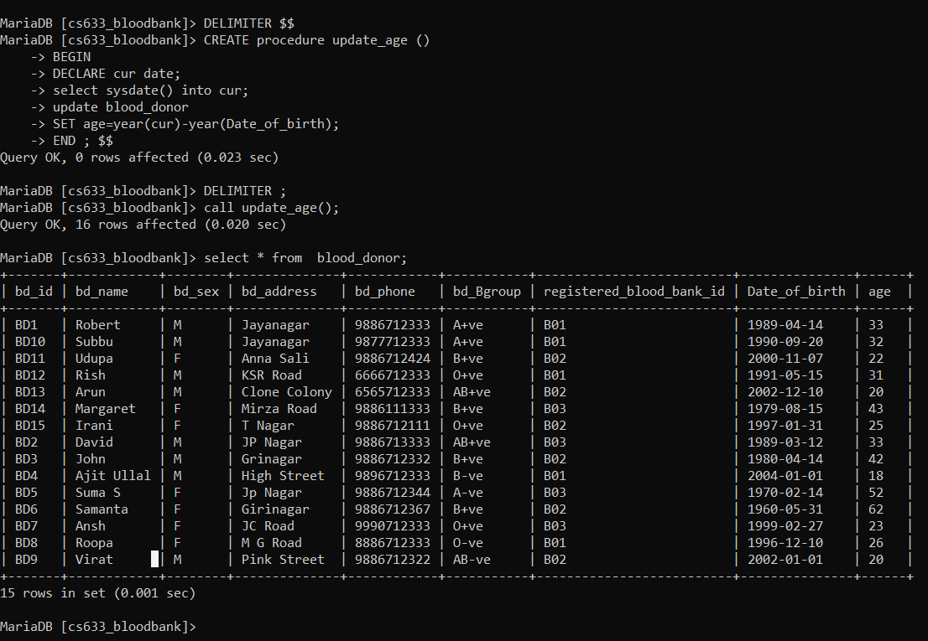

**VIEW**

**create view of blood donor as eligible donor  whose age is in between 18 and 60**

create VIEW eligible_donor as select bd_id,bd_name,bd_Bgroup,age from blood_donor where blood_donor.age>'18' and blood_donor.age<'60';



**Retrive details of blooddonor whose age is 33**

select bd_id,bd_name,bd_Bgroup,age from eligible_donor where age='33';

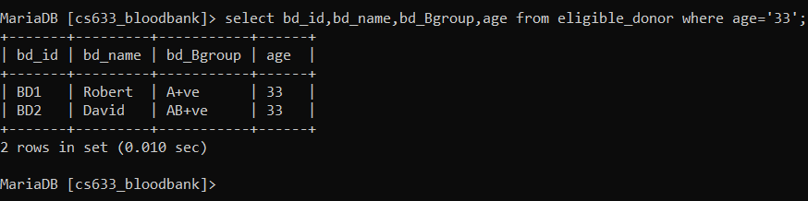

**TRIGGER:-**

DELIMITER $$

CREATE TRIGGER bldcoun

BEFORE insert

ON DONATE_BLOOD FOR EACH ROW

BEGIN

DECLARE error_msg VARCHAR(255);

SET error_msg = ('You have donated more than 20 units of blood....You have earned a donater badge');

IF (select SUM(units) as u from DONATE_BLOOD where DONATE_BLOOD.bloodD_id=new.bloodD_id) >20 THEN

SIGNAL SQLSTATE '45000'

SET MESSAGE_TEXT = error_msg;

END IF;

END $$

DELIMITER ;

INSERT into DONATE_BLOOD VALUES('O+ve','B02','BD15','20','2022-04-16');

