Marwadi Education Foundation’s Group of Institutions

Computer/Information Technology (IT)

Engineering Department



Subject: Software Engineering (**2160701)**

Project Report

**Acknowledgements**

* I express my cavernous sense of obligation and gratitude to my Guide Prof. NAVJYOTSINH JADEJA for her genuine guidance and constant Encouragement throughout this project work. I am highly obliged as my honorable guide for providing me such an opportunity to carry out research work under her continuous guidance.
* I extend my sincere thanks to Prof. Sunil Soni Head Of Department of Information Technology have devoted his valuable time and shared his expertise knowledge.
* I also wish to express my heartfelt appreciation to my friends, colleagues and many who have rendered their support for the successful works towards the completion of the research work, both explicitly and implicitly.
* We Choose This Topic Because We Realize Our Responsibility Towards the Society. So We discover that Many of people face problem with Municipal Corporation for City.
* In This System People can Complain about Government Services Like GEB, Transportation, Water Department ETC. And The Employee of that department have a notification about that Complain.

**Abstract**

* In our project, we are doing **‘Citizen Grievance System’**. In this project we are trying to construct a System in which there is high accuracy, save time and easily register their **Grievance**.
* The people need not go to the higher authorities always when they face problems. They can use the service of this software browser and can give their complaint and the complaint is taken up by the employee of specified department and he solves the problems.
* Our System is basically Helping to People of our City and This System is Help Government Employee to help People Because In General Employee doesn’t know Which Problem are Facing by People of City. So, Employee can find problems of People and they can Solve it.



**CERTIFICATE**

This is to certify that **Bhoomi Dangar(160973116001)** of B.E. Semester **VI(Information And Technology)** has completed his **Software Engineering I-A** work for the project entitled “**Citizen Grievance System**” satisfactorily in fulfillment for requirement of **Software Engineering** course, Gujarat Technical University, Ahmadabad, in the academic year **2017-2018.**

**Sign of Faculty Guide**

Prof. NAVJYOTSINH JADEJA



**CERTIFICATE**

This is to certify that **Hiren Nakum(160973116002)** of B.E. Semester **VI(Information And Technology)** has completed his **Software Engineering I-A** work for the project entitled “**Citizen Grievance System**” satisfactorily in fulfillment for requirement of **Software Engineering** course, Gujarat Technical University, Ahmadabad, in the academic year **2017-2018.**

**Sign of Faculty Guide**

**Prof.** NAVJYOTSINH JADEJA



**CERTIFICATE**

This is to certify that **Ravi Khant(160573116003)** of B.E. Semester **VI(Information And Technology)** has completed his **Software Engineering I-A** work for the project entitled “**Citizen Grievance System**” satisfactorily in fulfillment for requirement of **Software Engineering** course, Gujarat Technical University, Ahmadabad, in the academic year **2017-2018.**

**Sign of Faculty Guide**

Prof. NAVJYOTSINH JADEJA

**Index**

|  |  |  |
| --- | --- | --- |
| **Sr. No** | **Title** | **Pg.No** |
| A | Process Report |  |
|  | 1.Introduction | 1 |
| B | Acknowledgements | 2 |
| C | Abstract | 3 |
| D | Institute Certificate | 4-6 |
| E | Objective And Functionality | 8 |
| F | List of Figures | 9 |
|  | 1. Gantt Chart | 10 |
|  | 1. Tracebility Matrix | 11 |
|  | 1. Risk Managements | 12 |
| G | Reference | 13 |

**List of Figures**

|  |  |  |
| --- | --- | --- |
| **Sr. No** | **Title** | **Pg No** |
| 1 | Gantt Chart | 10 |
| 2 | Tracebility Matrix | 11 |
| 3 | Risk Managements | 12 |

**Objective And Functionality**

* New Suggestion / Complain
* My Suggestion / Complain
* My Completed Response
* My Suggestion / Complain Status
* My Pending Response
* My Suggestion / Complain Summery

**Project Management**

**1.Gannt Chart**

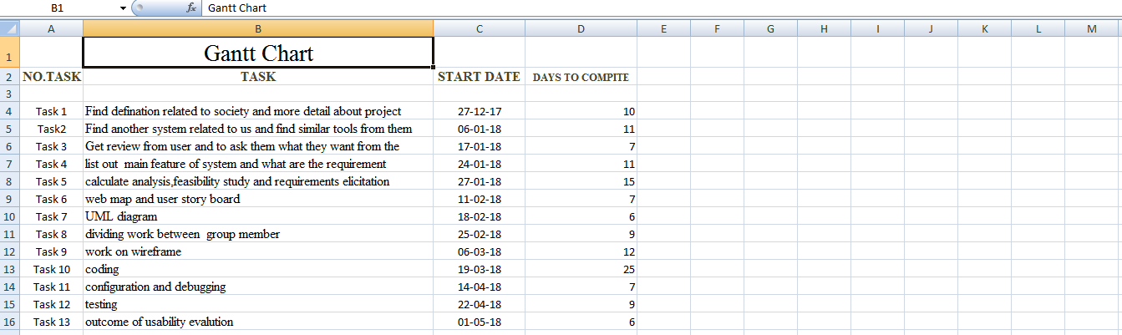

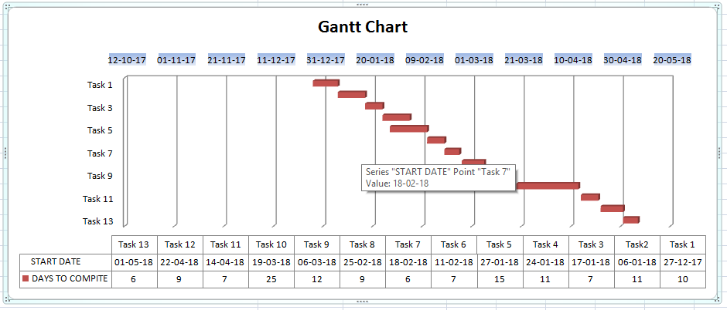

**Tracebility Matrix**

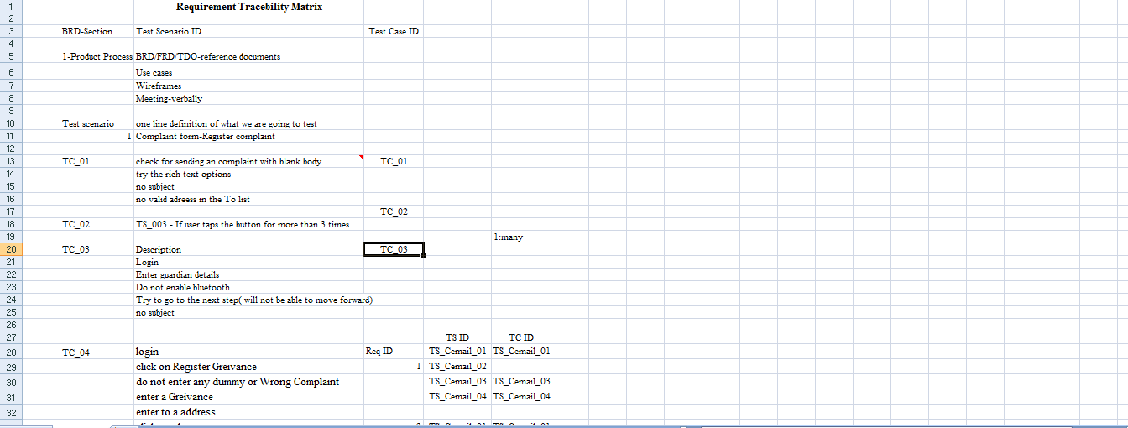

**Risk Managements**

**Risk Managements**

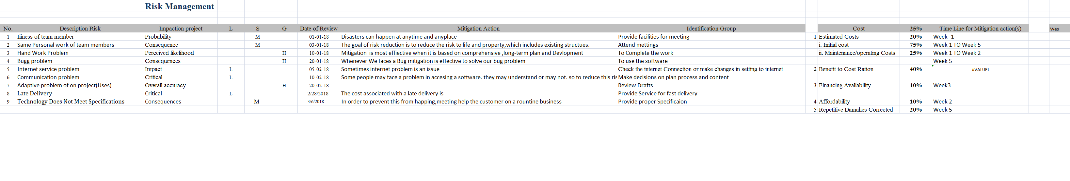

**Reference**

1.<http://vikaspedia.in/e-governance/online-citizen-services/government-to-citizen-services-g2c/grievance-redressal-1/raise-public-grievance-through-online>

2.<https://dpg.gov.in/>

3.<http://ieeexplore.ieee.org/document/7368461/?reload=true>

4.<https://grievances.maharashtra.gov.in/en>

5.<https://www.goa.gov.in/citizen/how-do-i/online-grievance/>

6.<http://delhi.gov.in/wps/wcm/connect/pgc1/public+grievances+commission/home>

7.<http://upneda.org.in/?q=help-desk>