**WEEK -02**

*select * from car

order by year asc;

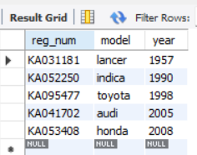

select count(report_num)

from car c , participated p

where c.reg_num=p.reg_num and c.model='lancer';

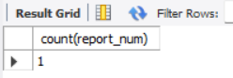

select count(driver_id)

from accident a,participated p

where a.report_num=p.report_num and a.accident_date like '__08%';

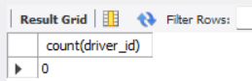

select name,damage_amount

from person a ,participated b

where a.driver_id =b.driver_id

order by damage_amount desc;

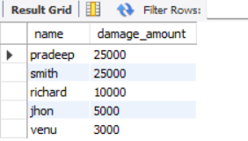

select avg(damage_amount) as 'average' from participated;

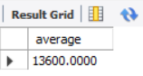

select name

from person a ,participated p

where a.driver_id=p.driver_id and p.damage_amount >(select avg(damage_amount) from participated);

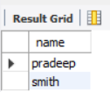

select max(damage_amount) from participated;

