WEEK -04

1. Retrieve all branches and their respective total assets

select branchname, assests

from branch;

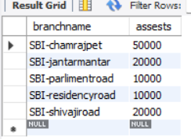

1. List all customers who live in a particular city

select customername

from bankcustomer

where city='banglore';

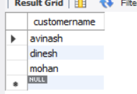

1. List all customers with their account numbers

select customername ,accno

from depositer ;

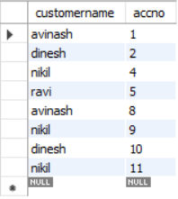

1. Find all the customers who have an account at all the branches located in a specific city (Ex. Delhi).

select c.customername

from bankcustomer c, depositer d, bankaccount a, branch b

where c.customername=d.customername and d.accno=a.accno and a.branchname=b.branchname and b.branchname=all(select b.branchname

from branch b

where b.branchcity='delhi');

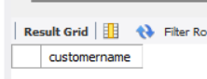

1. Find all customers who have accounts with a balance greater than a specified amount (5000)

select c.customername, b.balance

from bankcustomer c, bankaccount b, depositer d

where d.accno=b.accno and c.customername=d.customername and b.balance>5000;

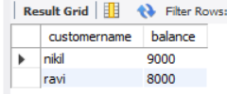

1. List all branch who have both a loan and an account

select distinct(b.branchname)

from branch b, bankaccount a, loan l

where b. branchname=a.branchname and b.branchname=l.branchname;

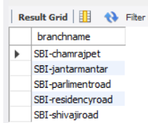

1. Get the number of accounts held at each branch

select branchname , count(\*)

from bankaccount

group by branchname;

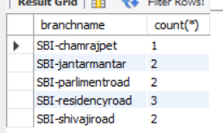

1. Find all branches that have no loans issued

select b.branchname

from branch b

where b.branchname not in(select branchname

from loan);

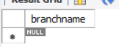

1. Retrieve the branch with the smallest total loan amount

select branchname ,min(amount)

from loan

group by branchname

order by min(amount)

limit 1;

