**(WEEK-06)**

1. List all employees along with their project details (if assigned)

select e.empname, p.*

from employee e , project p, assigned_to a

where e.empno=a.empno and p.pno=a.pno;

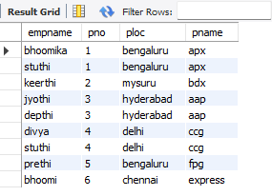

1. Find all employees who received incentives, along with the total incentive amount

select i.empno, e.empname, sum(i.incentive_amt) as total_incentive

from incentives i, employee e

where i.empno=e.empno

group by empno;

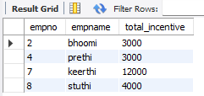

1. Retrieve the project names and locations of projects with employees assigned as 'Manager'

select p.pname, p.ploc

from project p

where pno in (select pno from assigned_to a where job_role='manager');

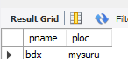

1. List departments along with the number of employees in each department

select d.dname, count(e.empno)

from dept d, employee e

where d.deptno =e. deptno

group by d.dname;

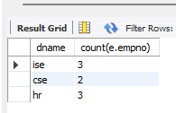

1. Find employees who have not been assigned to any project

select e.empno, e.empname

from employee e

where not exists (select 1 from assigned_to a where e.empno=a.empno);

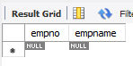

1. List all employees along with their department names and location

select e.empname , d.deptno, d.dloc

from employee e , dept d

where e.deptno=d.deptno;

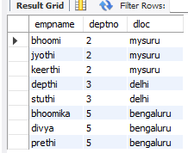

1. Retrieve the details of employees who work under a specific manager

select *

from employee e

where mgr_no=7;

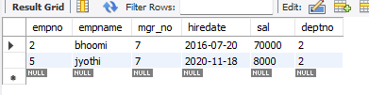

1. List all projects that have employees assigned and the number of employees on each project:

select p.pname, count(e.empno)

from project p, assigned_to e

where e.pno=p.pno

group by p.pname;

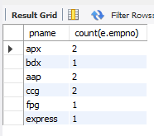

1. List the total number of incentives given to each employee and the sum of incentives for each

select empno, count(incentive_date) as number_of_times, sum(incentive_amt) as total_amt

from incentives

group by empno;

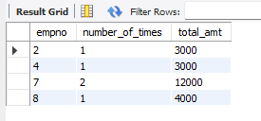

1. Retrieve all employees who have the role of 'Developer' on any project

select e.empno, e.empname

from employee e

where e.empno in (select empno from assigned_to where empno=e.empno and job_role='app developer');

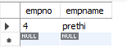

1. Display the department-wise average salary of employees:

select deptno , avg(sal) as average

from employee

group by deptno;

