**Question**

**(Week 1)**

**-** PERSON (driver_id: String, name: String, address: String)

**-** CAR (reg_num: String, model: String, year: int)

**-** ACCIDENT (report_num: int, accident_date: date, location: String)

**-** OWNS (driver_id: String, reg_num: String)

**-** PARTICIPATED (driver_id: String,reg_num: String, report_num: int, damage_amount: int)

**-** Create the above tables by properly specifying the primary keys and the foreign keys. **-** Enter at least five tuples for each relation

**-** Update the damage amount to 25000 for the car with a specific reg_num (example 'K A053408' ) for which the accident report number was 12.

**-** Add a new accident to the database.

**-** To Do

**-** Display Accident date and location

**-** Display driver id who did accident with damage amount greater than or equal to Rs.25000

**Schema Diagram**

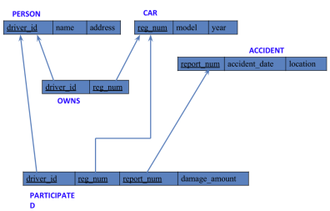

**Create database**

create database bhoomika_cs068;

use bhoomika_cs068;

**Create table**

create table person (

driver_id varchar(10),

name varchar(20),

address varchar(20),

primary key(driver_id)

);

create table car (

reg_num varchar(10),

model varchar(10),

year int,

primary key (reg_num)

);

create table accident(

report_num int,

accident_date date,

location varchar(20),

primary key (report_num)

);

create table owns(

driver_id varchar(10),

reg_num varchar(10),

primary key (driver_id , reg_num),

foreign key(driver_id) references person(driver_id),

foreign key(reg_num) references car(reg_num)

);

create table participated (

driver_id varchar(10),

reg_num varchar(10),

report_num int,

damage_amount int,

primary key (driver_id, reg_num, report_num),

foreign key (driver_id) references person(driver_id),

foreign key (reg_num) references car(reg_num),

foreign key (report_num) references accident(report_num)

);

**Structure of the table**

desc person;

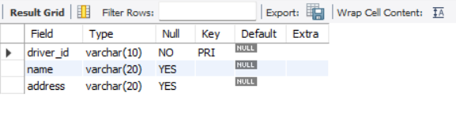

desc car;

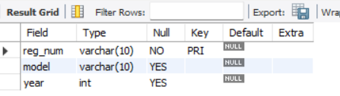

desc accident;

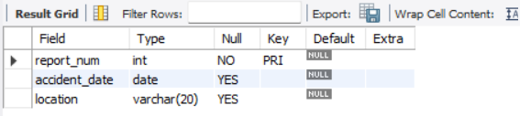

desc owns;

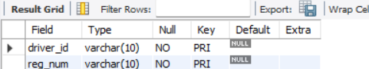

desc participated;

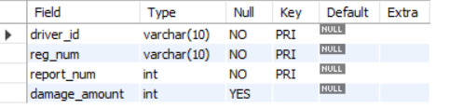

**Inserting Values to the table**

insert into person

values(‘a01’,’richard’,’srinivasnagar’),

(‘a02’,’pradeep’,’rajajinagar’),

(‘a03’,’smith’,’ ashoknagar’),

(‘a04’,’venu’,’NRcolony’),

(‘a05’,’jhon’,’hanumanthnagar’);

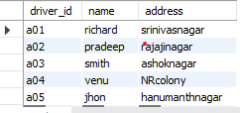

insert into car

values ('KA052250', 'indica',1990),

('KA031181','lancer',1957),

('KA095477','toyota',1998),

('KA053408','honda',2008),

('KA041702','audi',2005);

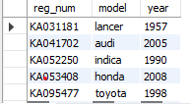

insert into accident

values(11,'2001-01-03','mysoreroad'),

(12,'2002-02-04','southendcircle'),

(13,'2021-01-03','bulltempleroad'),

(14,'2017-02-08','mysoreroad)'),

(15,'2004-03-05','kanakpuraroad');

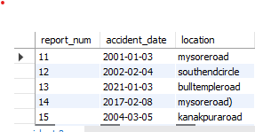

insert into owns

values('a01','KA052250'),

('a02','KA053408'),

('a03','KA031181'),

('a04','KA095477'),

('a05','KA041702');

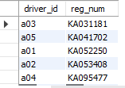

insert into participated

values('a01','KA052250',11,10000),

('a02','KA053408',12,50000),

('a03','KA031181',13,25000),

('a04','KA095477',14,3000),

('a05','KA041702',15,5000);

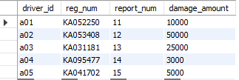

**Queries**

* Update the damage amount to 25000 for the car with a specific reg-num (example 'KA053408' ) for which the accident report number was 12.

update participated set damage_amount=25000

where reg_num='KA053408' and report_num=12;

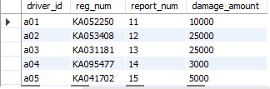

* Add a new accident to the database.

insert into accident

values (16,'2015-03-08','domlur');

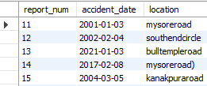

* Display Accident date and location

select accident_date ,location from accident;

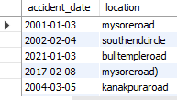

* Display driver id who did accident with damage amount greater than or equal to Rs.25000

select driver_id from participated

where damage_amount>=25000;

