**BANK ACCOUNT**

**QUESTION**

**(WEEK 3)**

* Create the above tables by properly specifying the primary keys and the foreign keys.
* Enter at least five tuples for each relation.
* Display the branch name and assets from all branches in lakhs of rupees and rename

The assets column to 'assets in lakhs'.

* Find all the customers who have at least two accounts at the same branch (ex.SBI_residencyroad).
* Create a view which gives each branch the sum of the amount of all the loans at the branch.

**SCHEMA DIAGRAM**

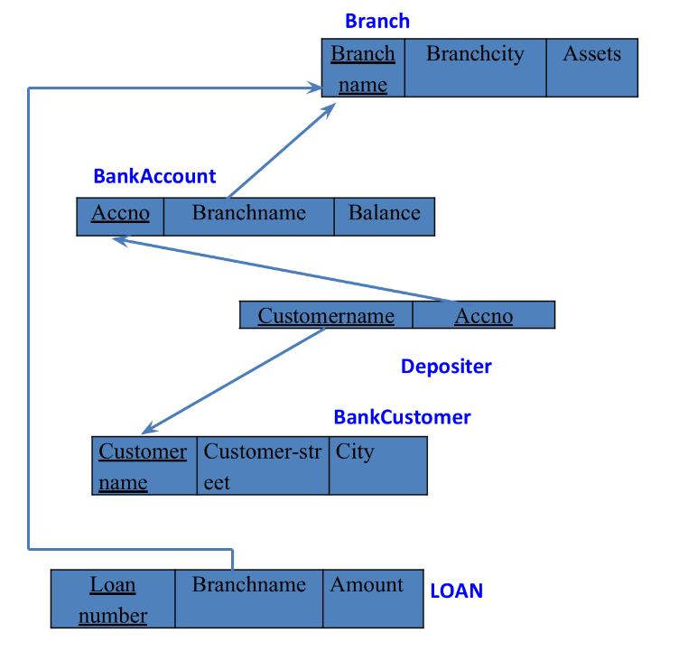

**CREATE DATABASE**

create database bhoomika_cs068;

use bhoomika_cs068;

**CREATE TABLES**

create table branch (

branchname varchar(50),

branchcity varchar(50),

assests int ,

primary key (branchname));

create table bankcustomer(

customername varchar(50),

customer_street varchar(50),

city varchar(50),

primary key(customername));

create table bankaccount (

accno int,

branchname varchar(50),

balance int,

primary key (accno),

foreign key (branchname) references branch (branchname));

create table depositer(

customername varchar(50),

accno int,

primary key (customername, accno),

foreign key (customername) references bankcustomer(customername),

foreign key (accno) references bankaccount(accno));

create table loan(

loannumber int,

branchname varchar(50),

amount int,

primary key (loannumber),

foreign key (branchname) references branch (branchname));

**STRUCTURE OF TABLE**

desc branch;

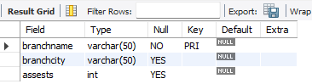

desc bankaccount;

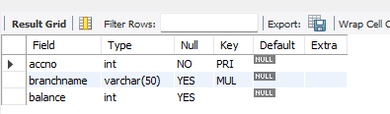

desc depositer;

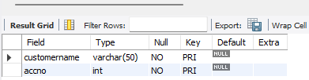

desc bankcustomer;

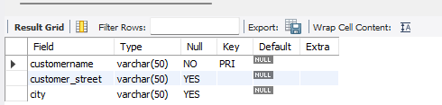

desc loan;

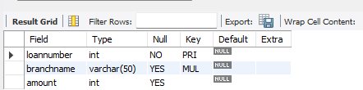

**INSERTING VALUES INTO THE TABLE**

insert into branch

values('SBI-chamrajpet','banglore', 50000),

('SBI-residencyroad','banglore',10000),

('SBI-shivajiroad','bombay',20000),

('SBI-parlimentroad','delhi',10000),

('SBI-jantarmantar','delhi',20000);

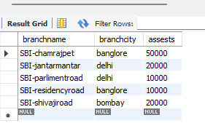

insert into bankcustomer

values('avinash','bull-temple-road','banglore'),

('dinesh','bannergatta-road','banglore'),

('mohan','nationalcollege-road','banglore'),

('nikil','akbar-road','delhi'),

('ravi','prithviraj-road','delhi');

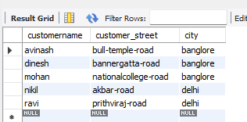

insert into bankaccount

values(1,'SBI-chamrajpet',2000),

(2,'SBI-residencyroad',5000),

(3,'SBI-shivajiroad',6000),

(4,'SBI-parlimentroad',9000),

(5,'SBI-jantarmantar',8000),

(6,'SBI-shivajiroad',4000),

(8,'SBI-residencyroad',4000),

(9,'SBI-parlimentroad',3000),

(10,'SBI-residencyroad',5000),

(11,'SBI-jantarmantar',2000);

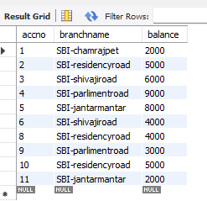

insert into depositer

values('avinash',1),

('dinesh',2),

('nikil',4),

('ravi',5),

('avinash',8),

('nikil',9),

('dinesh',10),

('nikil',11);

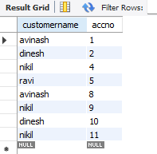

insert into loan

values(1,'SBI-chamrajpet',1000),

(2,'SBI-residencyroad',2000),

(3,'SBI-shivajiroad',3000),

(4,'SBI-parlimentroad',4000),

(5,'SBI-jantarmantar',5000);

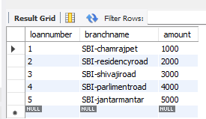

**QUERIES**

1. Display the branch name and assets from all branches in lakhs of rupees and rename the assets column to 'assets in lakhs'.

select branchname,assests as 'assets in lakhs'

from  branch;

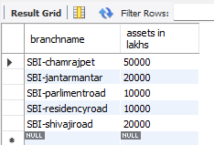

1. Find all the customers who have at least two accounts at the same branch (ex.SBI_ResidencyRoad).

select d.customername

from bankaccount b, depositer d

where b.accno=d.accno and branchname='SBI-residencyroad'

group by customername

having count(*)>=2;

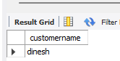

1. Create a view which gives each branch the sum of the amount of all the loans at the branch.

create view loan_info as

select b.branchname, sum(l.amount)

from branch b , loan l

where b.branchname=l.branchname

group by l.branchname;

select * from loan_info;

