**EMPLOYEE DATABASE**

**(WEEL -05)**

**QUESTION**

1. Using Scheme diagram, Create tables by properly specifying the primary keys and the foreign keys.

2. Enter greater than five tuples for each table.

3. Retrieve the employee numbers of all employees who work on project located in Bengaluru, Hyderabad, or Mysuru

4. Get Employee ID’s of those employees who didn’t receive incentives

5. Write a SQL query to find the employees name, number, dept, job_role, department location and project location who are working for a project location same as his/her department location.

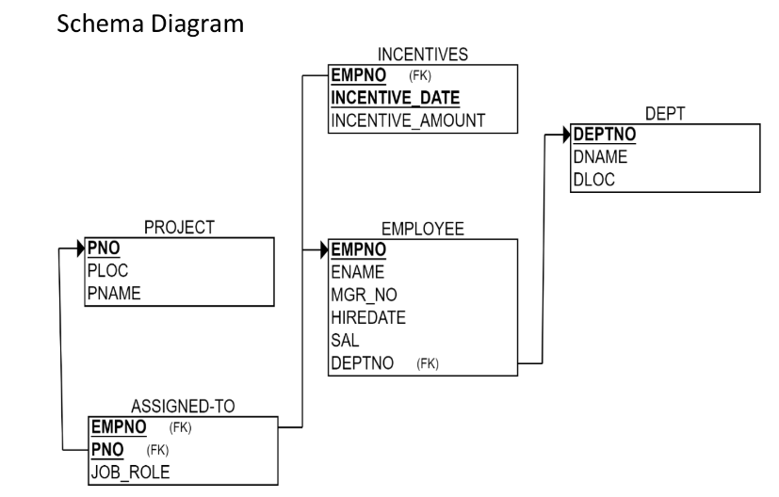

**CREATE DATABASE**

Create database Bhoomika_cs068;

Use database Bhoomika_cs068;

**CREATE TABLES**

create table project(

pno int,

ploc varchar(50),

pname varchar(50),

primary key (pno));

create table dept(

deptno int primary key,

dname varchar(50),

dloc varchar(50));

create table employee(

empno int primary key,

empname varchar(50),

mgr_no int,

hiredate date,

sal int,

deptno int,

foreign key (deptno) references dept (deptno));

create table incentives(

empno int ,

incentive_date date ,

incentive_amt int,

primary key(empno,incentive_date),

foreign key (empno) references employee (empno));

create table assigned_to(

empno int,

pno int,

job_role varchar (50),

primary key (empno, pno),

foreign key (empno) references employee(empno),

foreign key (pno) references project (pno));

**STRUCTURE OF TABLE**

Desc project;

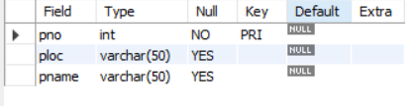

desc dept;

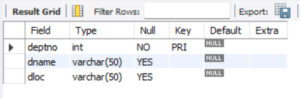

Desc employee;

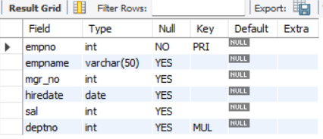

Desc incentives;

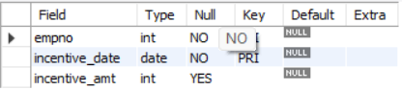

Desc assigned_to;

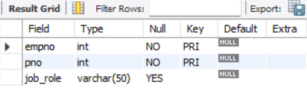

**INSERT TO TABLE**

insert into project

values(01,'bengaluru','apx'),

(02,'mysuru','bdx'),

(03,'hyderabad','aap'),

(04,'delhi','ccg'),

(05,'bengaluru','fpg'),

(06,'chennai','express');

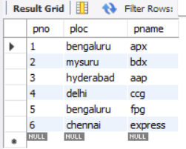

insert into dept

values(01,'cse','bengaluru'),

(02,'ise','mysuru'),

(03,'cse','delhi'),

(04,'ise','hyderabad'),

(05,'hr','bengaluru'),

(06,'managers','mysuru');

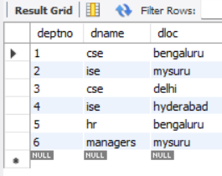

insert into employee

values (1,'bhoomika',3,'2015-04-19',15000,05),

(2,'bhoomi',7,'2016-07-20',70000,02),

(3,'divya',NULL,'2000-07-22',10000,05),

(4,'prethi',3,'2028-10-02',10000,05),

(5,'jyothi',7,'2020-11-18',8000,02),

(6,'depthi',8,'2024-07-03',7000,03),

(7,'keerthi',NULL,'1998-01-01',80000,02),

(8,'stuthi',NULL,'2010-10-10',50000,03);

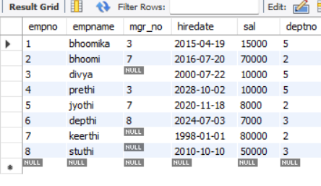

insert into incentives

values(4,'2020-11-12',3000),

(8,'2015-07-30',4000),

(7,'2010-10-14',5000),

(7,'2015-07-24',7000),

(2,'2020-11-30',3000);

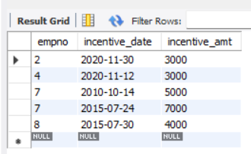

insert into assigned_to

values(7,02,'manager'),

(8,01,'data analyst'),

(3,04,'worker'),

(2, 06,'worker'),

(4,05,'app developer'),

(8,04,'worker'),

(1,01,'worker'),

(5,03,'worker'),

(6,03,'head');

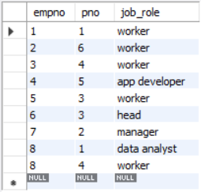

**QUERIES**

1. Retrieve the employee numbers of all employees who work on project located in Bengaluru, Hyderabad, or Mysuru

select e.empno

from employee e, assigned_to a

where e.empno=a.empno and a.pno in(select pno

from project

where ploc in ('bengaluru' ,' hyderabad',' mysuru'));

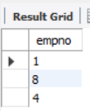

1. Get Employee ID’s of those employees who didn’t receive incentives

select empname

from employee

where not exists(select 1

from incentives

where empno=employee.empno);

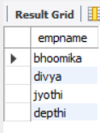

1. Write a SQL query to find the employees name, number, dept, job_role, department location and project location who are working for a project location same as his/her department location.

select e.empno, e.empname, d.deptno, a.job_role, d.dloc ,p.ploc

from employee e, project p, assigned_to a, dept d

where e.empno=a.empno and p.pno=a.pno and e.deptno=d.deptno and d.dloc=p.ploc;

