**SUPPLIERS DATABASE**

**(WEEK -07)**

**QUESTION**

1. Using Scheme diagram, Create tables by properly specifying the primary keys and the foreign keys.
2. Insert appropriate records in each table.

3. Find the pnames of parts for which there is some supplier.

1. Find the snames of suppliers who supply every part.
2. Find the snames of suppliers who supply every red part.
3. Find the pnames of parts supplied by Acme Widget Suppliers and by no one else
4. Find the sids of suppliers who charge more for some part than the average cost of that part (averaged over all the suppliers who supply that part)
5. For each part, find the sname of the supplier who charges the most for that part

### Schema Diagram:

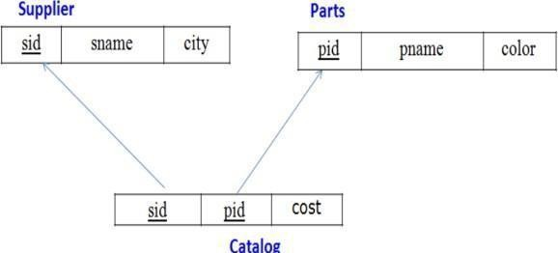

**Create Database:**

create database supp;

use supp;

### Create Tables:

create table Supplier(

s_id int primary key,

s_name varchar(30),

city varchar(20));

create table Parts( p_id int primary key, p_name varchar(30), color varchar(30));

create table Catalog( s_id int,

p_id int, cost float,

foreign key(s_id) references Supplier(s_id), foreign key(p_id) references Parts(p_id));

### Structure of the Table:

desc Supplier;

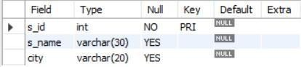

desc Parts;

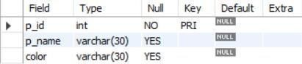

desc Catalog;

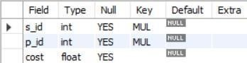

### Inserting Values to the tables:

insert into Supplier values

(10001, 'Acme_Widget', 'Bangalore'),

(10002, 'Johns', 'Kolkata'),

(10003, 'Vimal', 'Mumbai'),

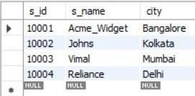(10004, 'Reliance', 'Delhi'); select * from Supplier;

insert into Parts values (20001, 'Book', 'Red'),

(20002, 'Pen', 'Red'),

(20003, 'Pencil', 'Green'),

(20004, 'Mobile', 'Green'),

(20005, 'Charger', 'Black');

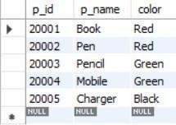

insert into Catalog values (10001, 20001, 10),

(10001, 20002, 10),

(10001, 20003, 30),

(10001, 20004, 10),

(10001, 20005, 10),

(10002, 20001, 10),

(10002, 20002, 20),

(10003, 20003, 30),

(10004, 20003, 40);

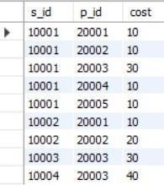

### Queries:

#### Find the pnames of parts for which there is some supplier.

select distinct p.p_name

from Supplier s, Catalog c, Parts p where s.s_id = c.s_id and

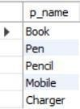p.p_id = c.p_id and c.s_id is not null;

#### Find the snames of suppliers who supply every part.

select distinct s_name

from Supplier s, Catalog c, Parts p where s.s_id = c.s_id

group by s.s_id, s.s_name

having count(distinct c.p_id)=(select count(*) from Parts p);

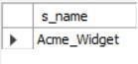

#### Find the snames of suppliers who supply every red part.

select distinct s_name

from Supplier s, Catalog c, Parts p where s.s_id = c.s_id and

c.p_id in (select p_id from Parts p where p.color = 'Red')

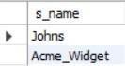

#### Find the pnames of parts supplied by Acme Widget Suppliers and by no one else

select distinct p_name from Supplier s, Parts p, Catalog c where p.p_id in (select c.p_id from Catalog c, Supplier s where

s.s_id = c.s_id and s.s_name = 'Acme_Widget') and

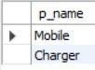p.p_id not in (select c.p_id from Catalog c, Supplier s where s.s_id = c.s_id and s.s_name != 'Acme_Widget');

#### Find the sids of suppliers who charge more for some part than the average cost of that part (averaged over all the suppliers who supply that part)

create view Average(p_id, Average_Product_Cost) as select c.p_id, avg(cost)

from Catalog c group by c.p_id;

select c.s_id from Catalog c, Average a where c.p_id = a.p_id and c.cost>(a.Average_Product_Cost)

group by c.p_id, c.s_id;

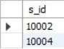

#### For each part, find the sname of the supplier who charges the most for that part

select distinct s.s_name, c.cost, c.p_id from Catalog c, Supplier s where s.s_id = c.s_id and

c.cost in (select max(cost) from Catalog c group by c.p_id);

