**NO SQL STUDENT DATABASE**

**(WEEK -08)**

**QUESTION**

* Perform the following DB operations using MongoDB.
* Create a database “Student” with the following attributes Rollno, Age, ContactNo, Email-Id.
* Insert appropriate values
* Write query to update Email-Id of a student with rollno 10.
* Replace the student name from “ABC” to “FEM” of rollno 11.

### Create Database:

db.createCollection("Student");



### Inserting Values to the tables:

db.Student.insert({RollNo:1,Age:21,Cont:9876,email:"[antara.de9@gmail.com](mailto:antara.de9@gmail.com)"});

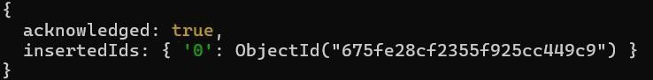

db.Student.insert({RollNo:2,Age:22,Cont:9976,email:"[anushka.de9@gmail.com](mailto:anushka.de9@gmail.com)"});

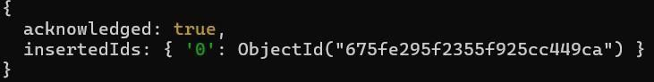

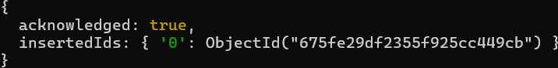db.Student.insert({RollNo:3,Age:21,Cont:5576,email:"[anubhav.de9@gmail.com](mailto:anubhav.de9@gmail.com)"});

db.Student.insert({RollNo:4,Age:20,Cont:4476,email:"[pani.de9@gmail.com](mailto:pani.de9@gmail.com)"});

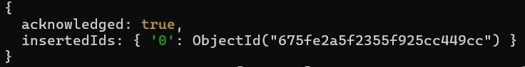

db.Student.insert({RollNo:10,Age:23,Cont:2276,email:"[rekha.de9@gmail.com](mailto:rekha.de9@gmail.com)"});

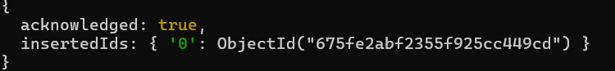

### Queries:

db.Student.find()

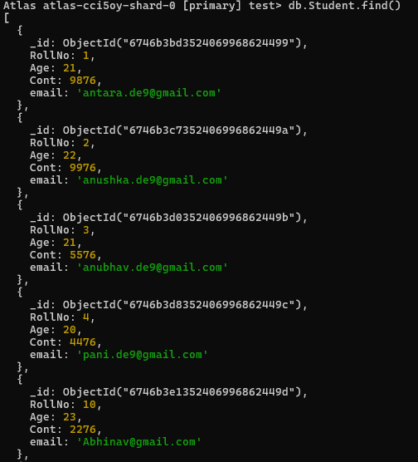

#### Write query to update Email-Id of a student with rollno 10.

db.Student.update({RollNo:10},{$set:{email:"[Abhinav@gmail.com](mailto:Abhinav@gmail.com)"}})

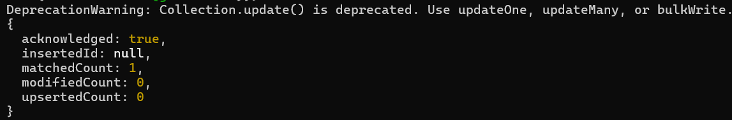

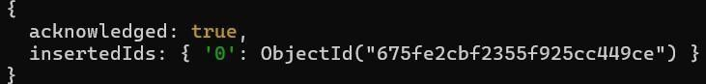**Replace the student name from “ABC” to “FEM” of rollno 11.** db.Student.insert({RollNo:11,Age:22,Name:"ABC",Cont:2276,email:"[rea.de9@gmail.](mailto:rea.de9@gmail.com) [c](mailto:rea.de9@gmail.com) [om](mailto:rea.de9@gmail.com)"});

db.Student.update({RollNo:11,Name:"ABC"},{$set:{Name:"FEM"}})

