# **NO SQL CUSTOMERS DATABASE**

**(WEEK -09)**

**QUESTION**

* + Create a collection by name Customers with the following attributes. Cust_id, Acc_Bal, Acc_Type
  + Insert at least 5 values into the table
  + Write a query to display those records whose total account balance is greater than 1200 of account type ‘Z’ for each customer_id.
  + Determine Minimum and Maximum account balance for each customer_id.
  + Export the created collection into local file system
  + Drop the table
  + Import a given csv dataset from local file system into mongodb collection.

### Create Database:

db.createCollection("Customer");



### Inserting Values to the tables:

db.Customer.insertMany([{custid: 1, acc_bal:10000, acc_type:"Saving"},

{custid: 1, acc_bal:20000, acc_type: "Checking"}, {custid: 3, acc_bal:50000, acc_type: "Checking"}, {custid: 4, acc_bal:10000, acc_type: "Saving"}, {custid: 5, acc_bal:2000, acc_type: "Checking"}]);

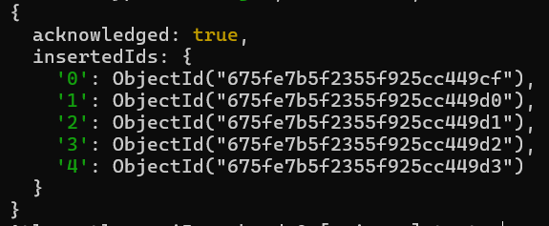

### Queries:

#### Write a query to display those records whose total account balance is greater than 1200 of account type ‘Z’ for each customer_id.

db.Customer.find({acc_bal: {$gt: 12000}, acc_type:"Checking"});

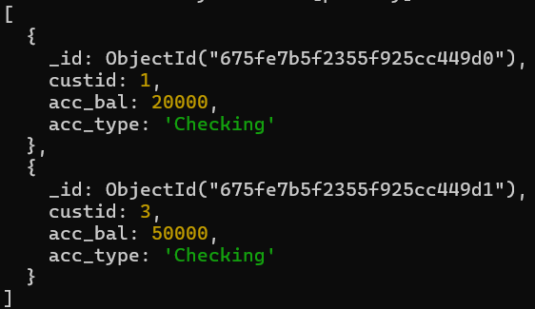

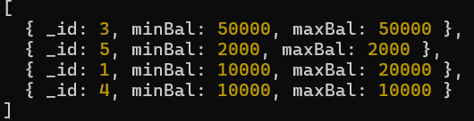**Determine Minimum and Maximum account balance for each customer_id.** db.Customer.aggregate([{$group:{_id:"$custid", minBal:{$min:"$acc_bal"}, maxBal:{$max:"$acc_bal"}}}]);

db.Customers.drop()



mongoexport mongodb+srv://dbms:@cluster0.xmdk9.mongodb.net/test

--collection=Student --out C:\Users\BMSCECSE\Desktop\st.json



mongoimport mongodb+srv://dbms:@cluster0.xmdk9.mongodb.net/test

--collection=New_Student --file C:\Users\BMSCECSE\Desktop\New_Student.json

