# **NO SQL RESTAURANTS DATABASE**

**(WEEK-10)**

**QUESTION**

* Write a MongoDB query to display all the documents in the collection restaurants.
* Write a MongoDB query to arrange the name of the restaurants in descending along with all the columns.
* Write a MongoDB query to find the restaurant Id, name, town and cuisine for those restaurants which achieved a score which is not more than 10.
* Write a MongoDB query to find the average score for each restaurant.
* Write a MongoDB query to find the name and address of the restaurants that have a zipcode that starts with '10'.

### Create Database:

db.createCollection("restaurants");



### Inserting Values to the tables:

db.restaurants.insertMany([{ name: "Meghna Foods", town: "Jayanagar", cuisine: "Indian", score: 8, address: { zipcode: "10001", street: "Jayanagar"}},{ name: "Empire", town: "MG Road", cuisine: "Indian", score: 7, address: { zipcode: "10100", street: "MG Road"}},{ name: "Chinese WOK", town: "Indiranagar", cuisine: "Chinese", score: 12, address: { zipcode: "20000", street: "Indiranagar" }},{ name: "Kyotos", town: "Majestic", cuisine: "Japanese", score: 9, address: { zipcode: "10300", street: "Majestic"

}},{ name: "WOW Momos", town: "Malleshwaram", cuisine: "Indian", score: 5, address: { zipcode: "10400", street: "Malleshwaram"}}])

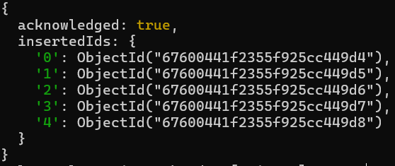

### Queries:

#### Write a MongoDB query to display all the documents in the collection restaurants.

db.restaurants.find({})

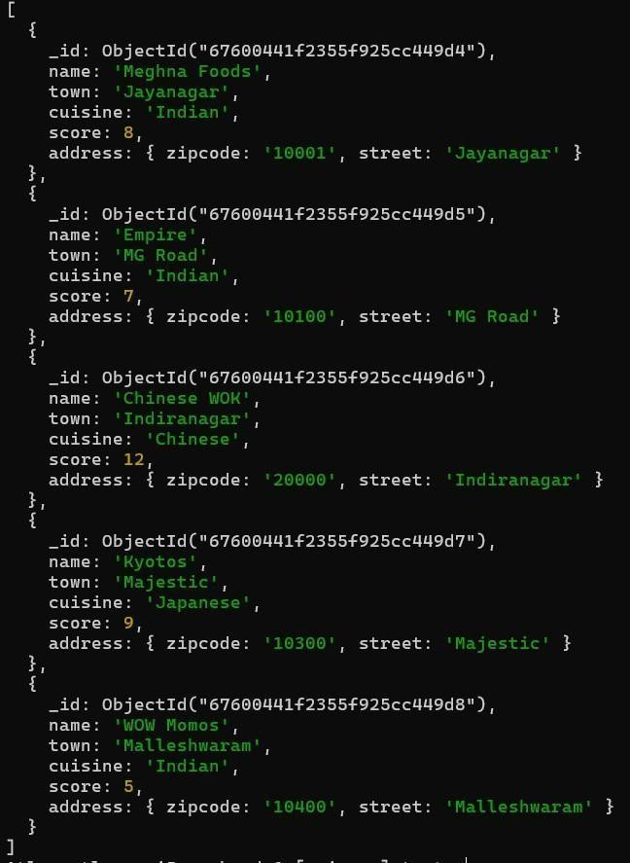

#### Write a MongoDB query to arrange the name of the restaurants in descending along with all the columns

db.restaurants.find({}).sort({ name: -1 })

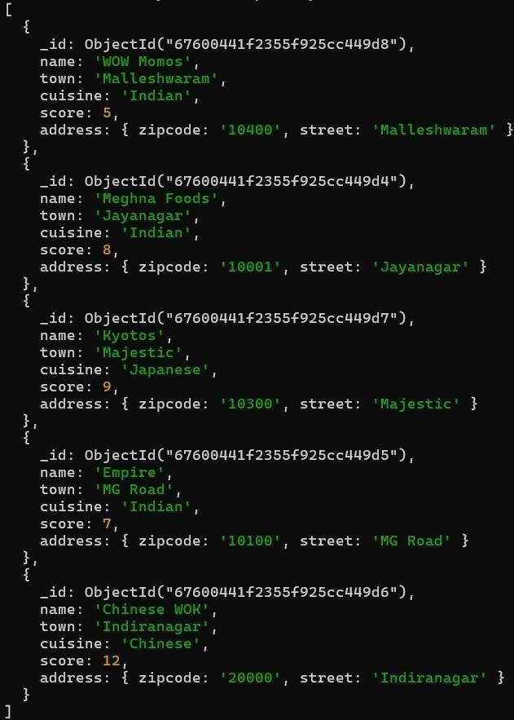

#### Write a MongoDB query to find the restaurant Id, name, town and cuisine for those restaurants which achieved a score which is not more than 10.

db.restaurants.find({ "score": { $lte: 10 } }, { _id: 1, name: 1, town: 1, cuisine: 1 })

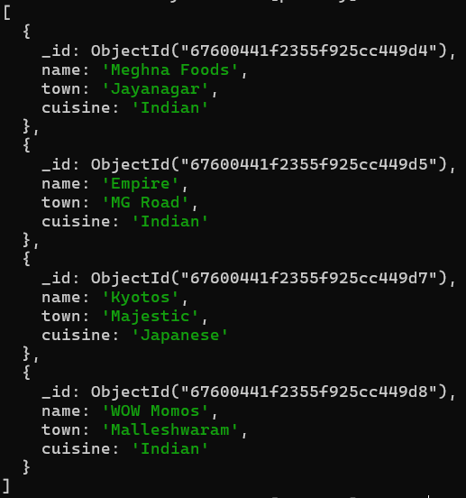

#### Write a MongoDB query to find the average score for each restaurant.

db.restaurants.aggregate([ { $group: { _id: "$name", average_score: {

$avg:"$score"}}}])

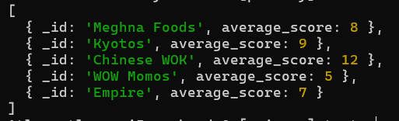

#### Write a MongoDB query to find the name and address of the restaurants that have a zipcode that starts with '10'.

db.restaurants.find({ "address.zipcode": /^10/ }, { name: 1, "address.street": 1, _id: 0 })

