LAB-07

1.Create a package CIE which has two classes- Student and Internals. The class Personalhas members like usn, name, sem. The class internals has an array that stores theinternal marks scored in five courses of the current semester of the student. Createanother package SEE which has the class External which is a derived class of Student.

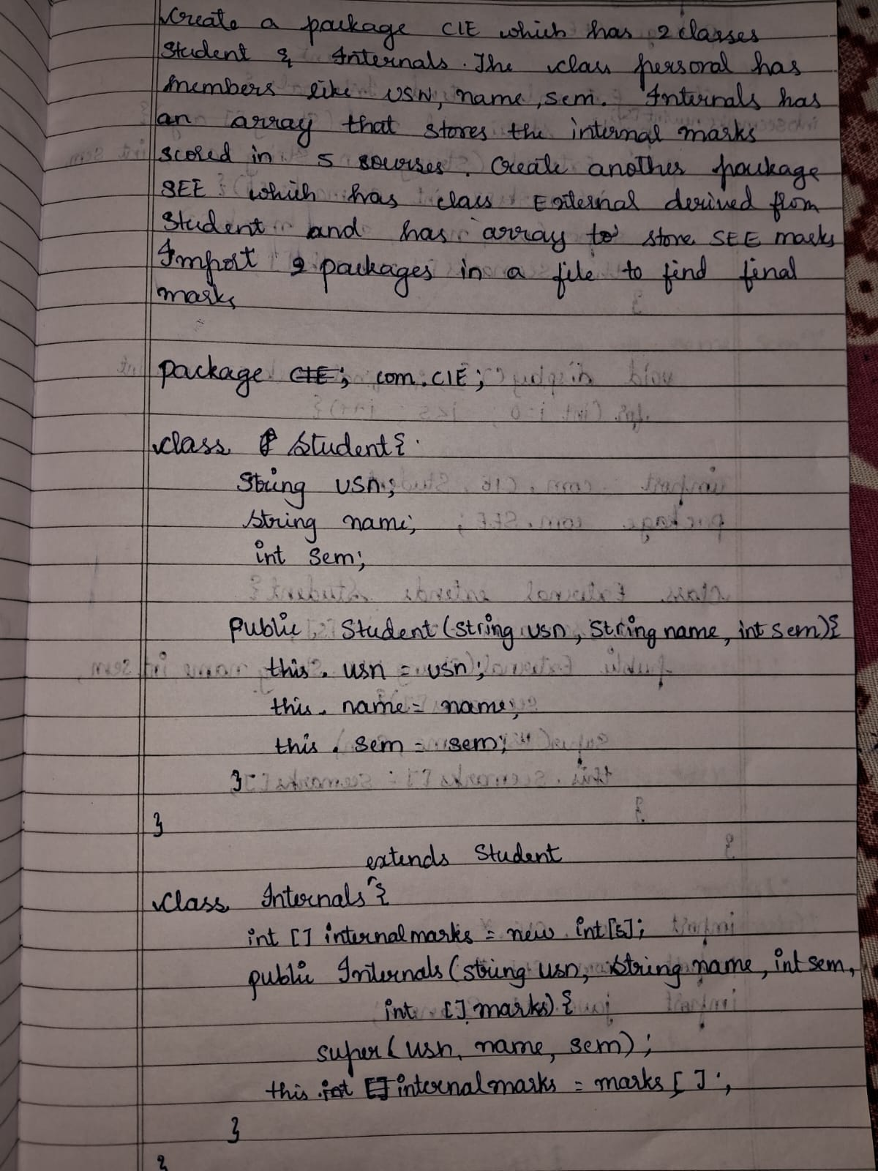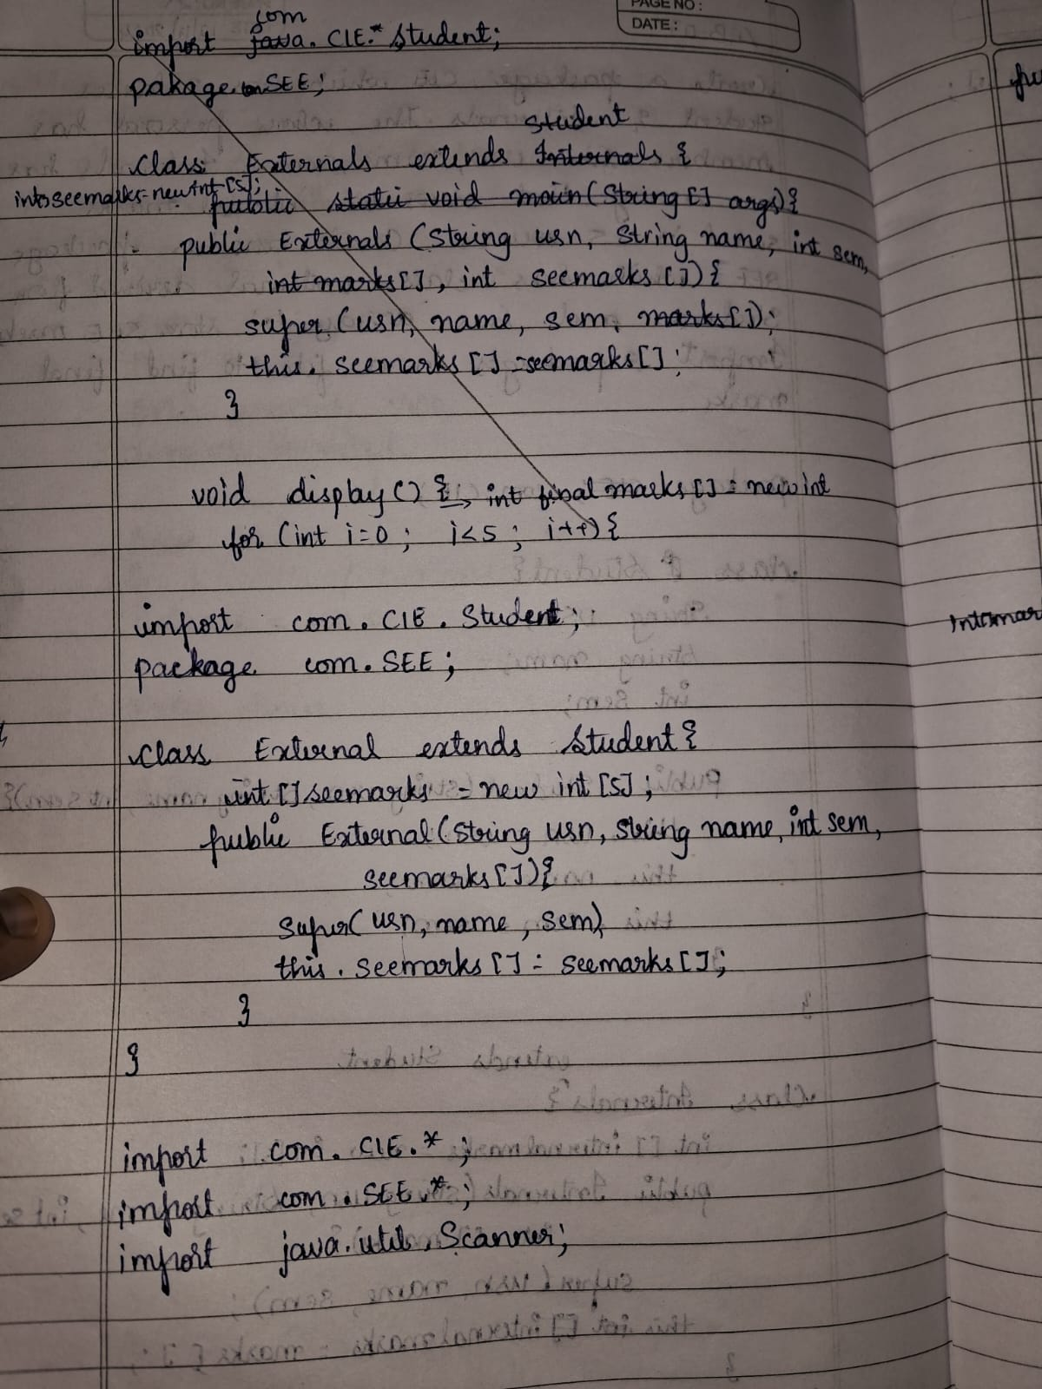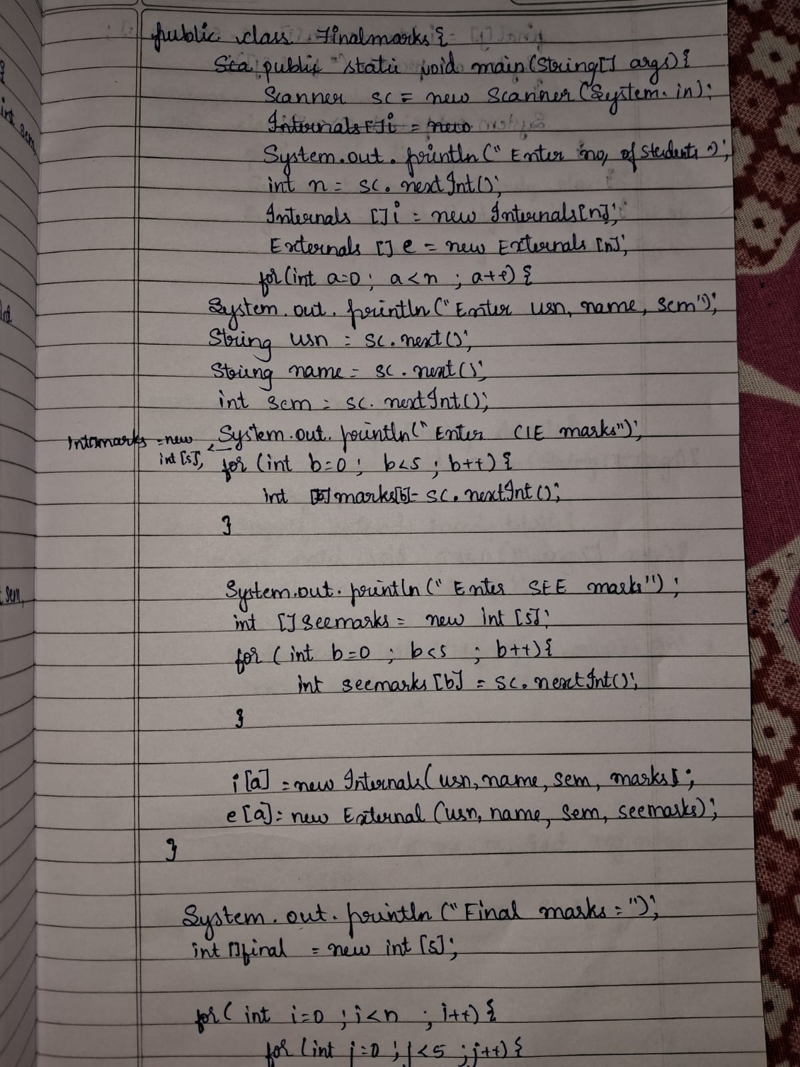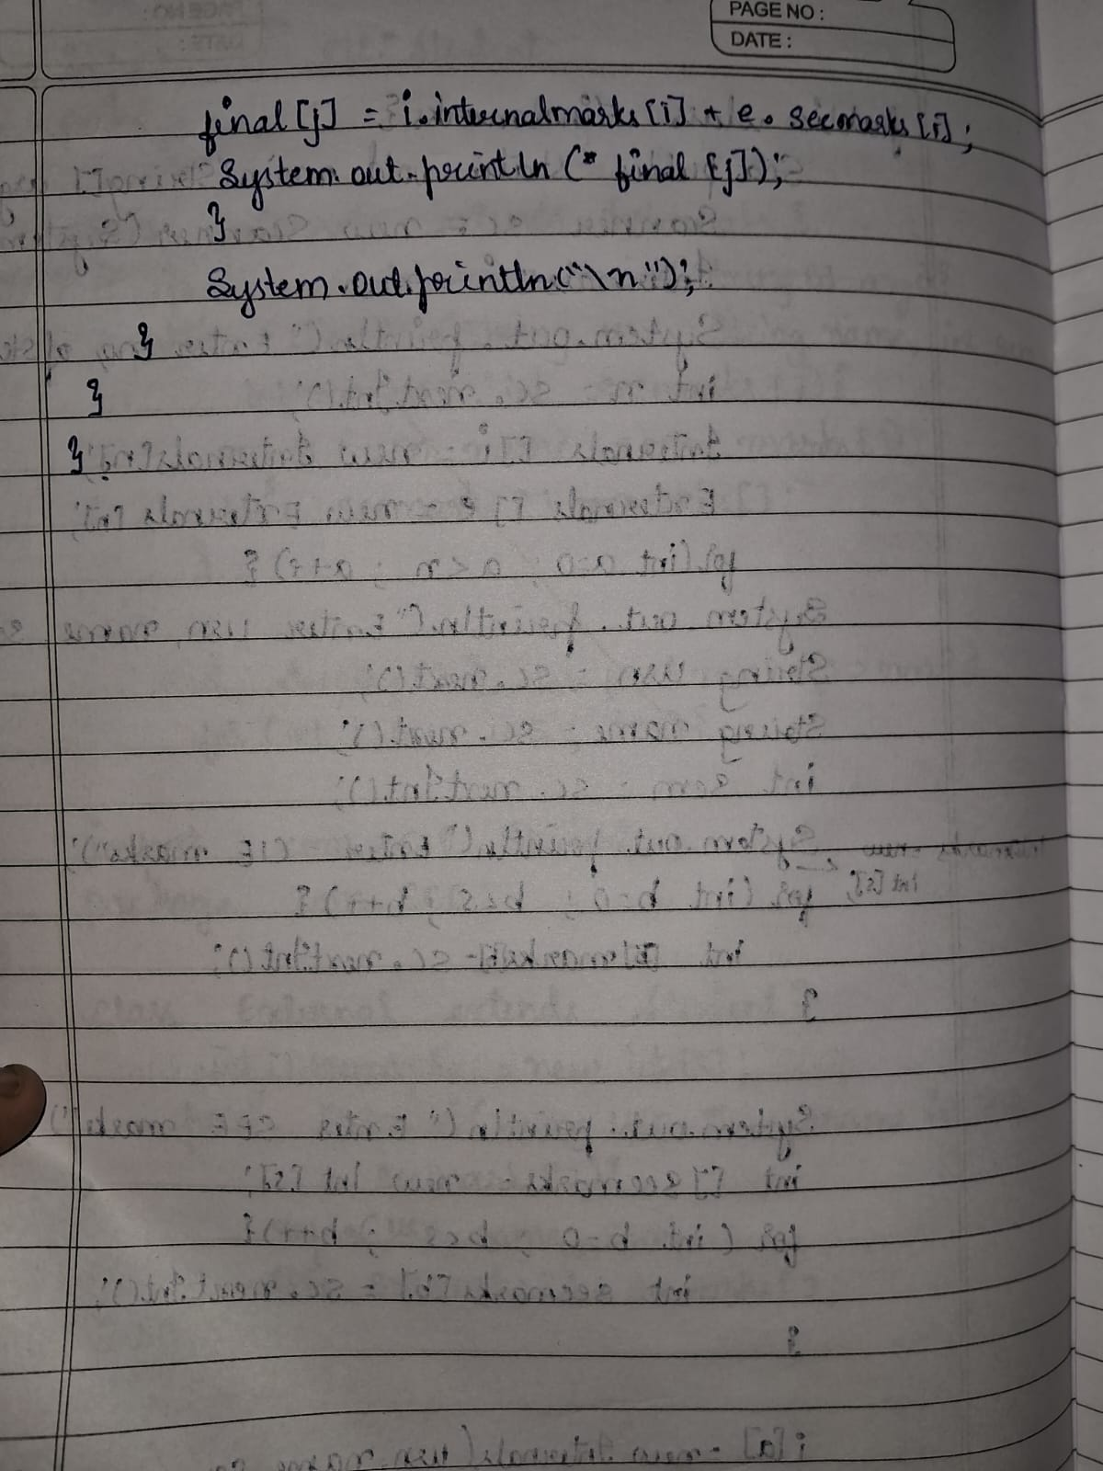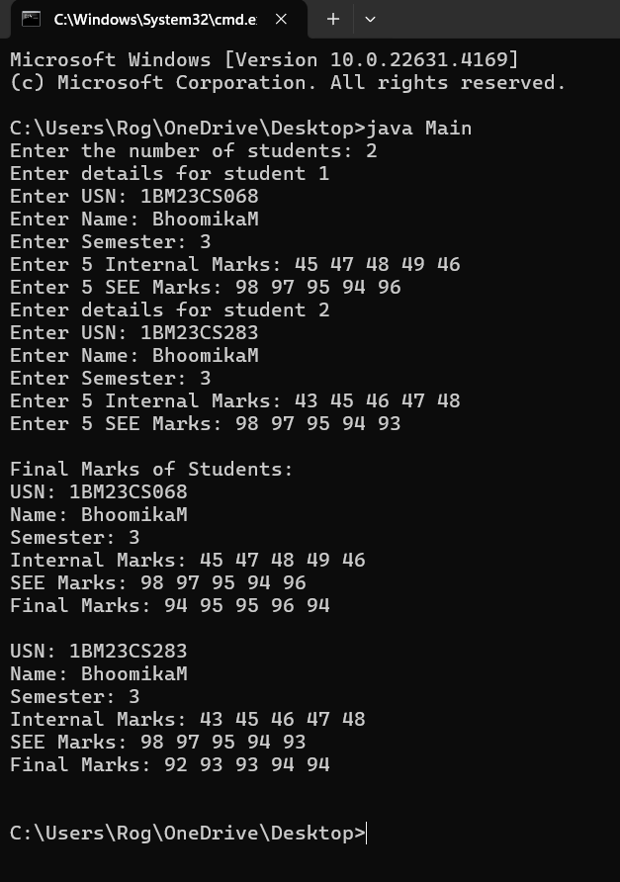

2.Family program: